**Extra Questions on Cell Cycle**

**Q1.**          (a)     The photographs show two stages in mitosis of a plant cell.

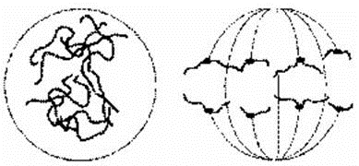

**A**                                                         **B**

Name stages **A** and **B**. In each case describe what is happening to the chromosomes.

(i)      Stage **A** ....................................

.............................................................................................................

.............................................................................................................

.............................................................................................................

**(2)**

(ii)     Stage **B** ....................................

.............................................................................................................

.............................................................................................................

.............................................................................................................

**(2)**

(b)     Describe **two** events during interphase which prepare a cell for mitosis.

1 ...................................................................................................................

......................................................................................................................

2 ...................................................................................................................

......................................................................................................................

**(2)**

**(Total 6 marks)**

**Q2.**          The diagram represents a cell from a fruit fly in which the diploid number is eight.

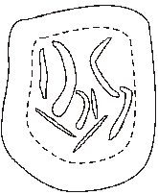

(a)     Draw a diagram to show

(i)      this cell during anaphase of mitosis;

**(2)**

(ii)     the chromosomes in a gamete produced from this cell by meiosis.

**(2)**

(b)     Explain why meiosis is important in sexual reproduction, apart from producing gametes that are genetically different.

......................................................................................................................

......................................................................................................................

......................................................................................................................

......................................................................................................................

**(2)**

**(Total 6 marks)**

 (b)     Name the phase during which DNA replication occurs.

......................................................................................................................

**(1)**

(c)     Bone marrow cells divide rapidly. As a result of a mutation during DNA replication, a bone marrow cell may become a cancer cell and start to divide in an uncontrolled way. A chemotherapy drug that kills cells when they are dividing was given to a cancer patient. It was given once every three weeks, starting at time 0. The graph shows the changes in the number of healthy bone marrow cells and cancer cells during twelve weeks of treatment.

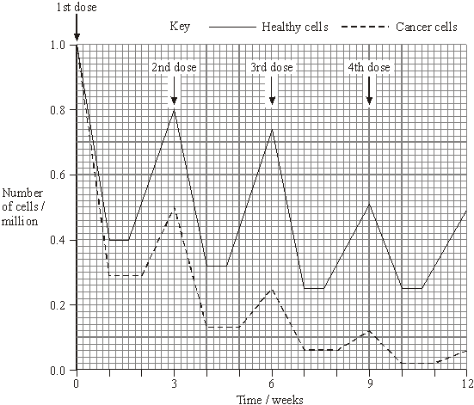

(i)      Using the graph calculate the number of cancer cells present at week 12 as a percentage of the original number of cancer cells. Show your working.

Answer ......................................%

**(2)**

(ii)     Suggest **one** reason for the lower number of cancer cells compared to healthy cells at the end of the first week.

.............................................................................................................

**(1)**

(iii)     Describe **two** differences in the effect of the drug on the cancer cells, compared with healthy cells in the following weeks.

1 ..........................................................................................................

.............................................................................................................

2 ..........................................................................................................

.............................................................................................................

**(2)**

**(Total 8 marks)**

**Q4.**          (a)     Complete the table to describe some of the events during the cell cycle.

|  |  |  |
| --- | --- | --- |
|  | **Stage of cell cycle** | **Main event which takes place** |
|  | Metaphase |  |
|  |  | Chromosomes coil and shorten |
|  |  | Daughter chromosomes move to poles of the cell |
|  | S-phase |  |
|  |  | Nuclear envelope re-forms |

**(5)**

(b)     The diagram shows the life cycle of an organism. The numbers show how many chromosomes are present in one cell at each stage of the life cycle.

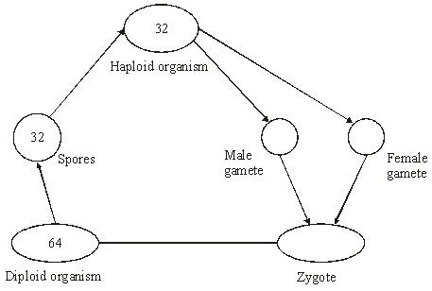

(i)      Name the type of cell division that must be involved in producing the spores.

.............................................................................................................

**(1)**

(ii)     How many chromosomes are there in a male gamete from this organism?

.............................................................................................................

**(1)**

**(Total 7 marks)**

**Q5.**          A student investigated the stages of mitosis in a garlic root. The root tip was placed on a microscope slide with a stain. A cover slip was placed on top and the root tip was firmly squashed.

(a)     Explain why

(i)      a root tip was used;

.............................................................................................................

.............................................................................................................

**(1)**

(ii)     a stain was used;

.............................................................................................................

.............................................................................................................

**(1)**

(iii)     the root tip was firmly squashed.

.............................................................................................................

.............................................................................................................

**(1)**

(b)     The student examined the cells in the garlic root tip under the microscope, and obtained the following data.

|  |  |  |
| --- | --- | --- |
|  | **Stage** | **Number of cells** |
|  | Interphase | 872 |
|  | Prophase | 74 |
|  | Metaphase | 18 |
|  | Anaphase | 10 |
|  | Telophase | 8 |

(i)      Calculate the percentage of these cells in which the chromosomes are visible and would consist of a pair of chromatids joined together. Show your working.

Answer .........................................

**(2)**

(ii)     A different set of results was obtained when the count was repeated on another occasion with a different garlic root tip. Give **two** reasons for the difference in results.

1 ..........................................................................................................

.............................................................................................................

2 ..........................................................................................................

.............................................................................................................

**(2)**

**(Total 7 marks)**

**Q6.**          (a)     In which phase of the cell cycle does DNA replication take place?

......................................................................................................................

**(1)**

(b)     The diagrams show five stages of mitosis.

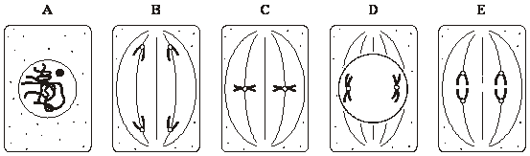

List the stages **A** to **E** in the correct sequence, beginning with the earliest stage.

.....................        .....................        .....................       .....................       .....................

**(1)**

(c)     Describe the role of the spindle during mitosis.

......................................................................................................................

......................................................................................................................

......................................................................................................................

......................................................................................................................

**(2)**

(d)     Meiosis also occurs during the life cycle of organisms. What is the importance of meiosis?

......................................................................................................................

......................................................................................................................

......................................................................................................................

......................................................................................................................

**(2)**

**(Total 6 marks)**

**M1.**          (a)     (i)      prophase;  
chromosomes thickening / becoming visible;

**2**

(ii)     anaphase;  
chromatids / chromosomes moving to opposite poles /   
ends of spindles;

**2**

(b)     DNA replication;  
synthesis or proteins / build-up of energy stores / growth /   
increase in cytoplasm;  
replication of organelles / named example;

**2 max**

**[6]**

**M2.**          (a)     (i)      8 ‘chromatids’ each side;  
spindle drawn;

**2**

(ii)     4 chromosomes;  
1 from each homologous pair;

**2**

(b)     produces haploid cells / chromosome number halved;  
fertilisation maintains the diploid / chromosome number (in next generation);

**2**

**[6]**

**M3.**          (a)     (i)      (D) B E A C;

**1**

(ii)     metaphase;

**1**

(b)     interphase / S phase;

**1**

(c)     (i)      0.06 × 100;  
6(%);

*(correct answer 2 marks)*

**2**

(ii)     more(cancer cells) killed, cancer cells divide more (often)  
(so are more likely to be killed, more susceptible);

**1**

(iii)     longer time to recover;  
reduced rate of mitosis / divide more slowly /   
increased doubling time;

**2**

**[8]**

**M4.**          (a)     Chromosomes attach to equator / middle of cell / spindle;  
Prophase;  
Anaphase;  
DNA replication / synthesis / chromosome copying / duplication;  
Telophase;

**5**

(b)     (i)      Meiosis;

**1**

(ii)     32;

**1**

**[7]**

**M5.**          (a)     (i)      where mitosis / division / growing / occurs  
*(reject growing cells)*

**1**

(ii)     to distinguish chromosomes / chromosomes not visible  
without stain;

**1**

(iii)     to let light through / thin layer;

**1**

(b)     (i)      74 + 18 / 982;  
= 9.4% / 9%;

**2**

*(allow 1 mark for identifying prophase & metaphase i.e.92 or correct method using wrong figures)*

(ii)     genetic differences / different types of garlic;  
time of day;  
chance;  
age of root tip;  
water availability;  
temperature;  
nutrient availability;

*(environmental factors = 1 but cannot be awarded in addition to a named environmental factor)*

**2 max**

**[7]**

**M6.**          (a)     Interphase / S-phase;

**1**

(b)     **A D C E B;**

**1**

(c)     Attachment of centromeres / chromosomes / chromatids; Separation of centromeres / chromatids / chromosomes;

**2**

(d)     Halves chromosome number / haploid;

Diploid / full number restored at fertilisation;

*Allow correct reference to variation*

**max 2**

**[6]**