**Q1.**(a)     Describe how acetylcoenzyme A is formed in the link reaction.

........................................................................................................................

........................................................................................................................

........................................................................................................................

........................................................................................................................

........................................................................................................................

**(2)**

(b)     In the Krebs cycle, acetylcoenzyme A combines with four-carbon oxaloacetate to form six-carbon citrate. This reaction is catalysed by the enzyme citrate synthase.

(i)      Oxaloacetate is the first substrate to bind with the enzyme citrate synthase. This induces a change in the enzyme, which enables the acetylcoenzyme A to bind.

Explain how oxaloacetate enables the acetylcoenzyme A to then bind to the enzyme.

...............................................................................................................

...............................................................................................................

...............................................................................................................

...............................................................................................................

...............................................................................................................

**(2)**

(ii)     Another substance in the Krebs cycle is called succinyl coenzyme A. This substance has a very similar shape to acetylcoenzyme A.

Suggest how production of succinyl coenzyme A could control the rate of the reaction catalysed by citrate synthase.

...............................................................................................................

...............................................................................................................

...............................................................................................................

...............................................................................................................

...............................................................................................................

**(2)**

(c)     In muscles, pyruvate is converted to lactate during anaerobic respiration.

(i)      Explain why converting pyruvate to lactate allows the continued production of ATP during anaerobic respiration.

...............................................................................................................

...............................................................................................................

...............................................................................................................

...............................................................................................................

...............................................................................................................

**(2)**

(ii)     In muscles, some of the lactate is converted back to pyruvate when they are well supplied with oxygen. Suggest **one** advantage of this.

...............................................................................................................

...............................................................................................................

...............................................................................................................

...............................................................................................................

**(1)**

**(Total 9 marks)**

**Q2.**Many sports drinks contain water, sodium chloride and carbohydrates. The manufacturers of the sports drinks claim that carbohydrates provide an energy boost. The sodium chloride is used to increase absorption of glucose in the small intestine.

Scientists investigated the effect of a sports drink on the performance of runners in 5 km races.

They recruited 100 runners who had previously run a 5 km race in similar times. During this race, Race 1, they had water they could drink.

The scientists divided the runners into two equal groups, **P** and **Q**. Both groups ran a second 5 km race, Race 2. During this race:

•        group **P** had water available

•        group **Q** had the sports drink available.

The scientists recorded the mean time for each group to complete this race.

**Figure 1** shows their results.

**Figure 1**

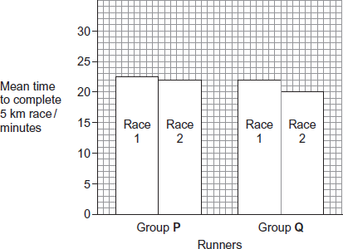

The glycaemic index (GI) is a measure of the increase in blood glucose concentration after eating a given mass of a food compared with eating the same mass of pure glucose. The GI of pure glucose has a value of 100.

The GI of a food depends on several factors such as how much starch and sugars it contains. High GI foods include those containing lots of simple sugars or white flour. The carbohydrates in these foods are rapidly digested and absorbed. Low GI foods include wholegrain bread and breakfast cereals that contain a lot of fibre. The carbohydrates in these foods are digested and absorbed more slowly.

**Figure 2** shows changes in blood glucose concentration after eating meals of high GI food and meals of low GI food.

**Figure 2**

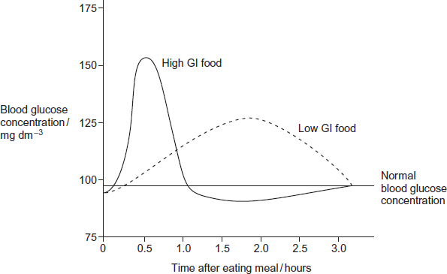

Explain how a sports drink could provide an energy boost when running.

.................................................................................................................................

.................................................................................................................................

.................................................................................................................................

.................................................................................................................................

.................................................................................................................................

.................................................................................................................................

(Extra space) ..........................................................................................................

.................................................................................................................................

.................................................................................................................................

.................................................................................................................................

.................................................................................................................................

**(3)**

**(Total 3 marks)**

**Q3.**          A student investigated the rate of gas exchange in aerobically respiring seeds using the apparatus shown in the diagram. She carried out two experiments.

•        In Experiment **1**, she put potassium hydroxide solution in the beaker. Potassium hydroxide solution absorbs carbon dioxide.

•        In Experiment **2**, she put water in the beaker.

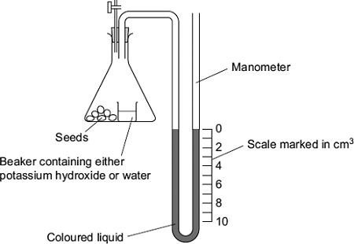

(a)     Both experiments were carried out at the same temperature. Explain why.

........................................................................................................................

........................................................................................................................

........................................................................................................................

........................................................................................................................

........................................................................................................................

**(2)**

(b)     (i)      The level of coloured liquid in the right-hand side of the manometer tube went down during Experiment **1**. Explain why.

...............................................................................................................

...............................................................................................................

...............................................................................................................

...............................................................................................................

...............................................................................................................

...............................................................................................................

*(Extra space)* .......................................................................................

...............................................................................................................

...............................................................................................................

**(3)**

The results from both experiments are shown in the table.

|  |  |  |
| --- | --- | --- |
| **Experiment** | **Solution in beaker** | **Fall in volume of coloured liquid in right-hand side of manometer / cm3** |
| **1** | Potassium hydroxide | 5 |
| **2** | Water | 1 |

(ii)     Use these results to calculate the volume of carbon dioxide produced during Experiment **1**.

                                                  Answer = ..................................... cm3

**(1)**

(c)     The student repeated Experiment 1 using seeds which were respiring anaerobically.  
What would happen to the level of coloured liquid in the right-hand side of the manometer tube? Explain your answer.

........................................................................................................................

........................................................................................................................

........................................................................................................................

........................................................................................................................

........................................................................................................................

**(2)**

**(Total 8 marks)**

**Q4.**A scientist investigated the use of a new source of carbohydrate in the production of ethanol for biofuel. He wanted to find the optimum time to leave a mixture of yeast and this carbohydrate to produce ethanol. The scientist set up an airtight container containing yeast and this carbohydrate. He then measured the oxygen, carbon dioxide and ethanol concentrations over 8 hours.  
The results of his investigation are shown in the graph below.

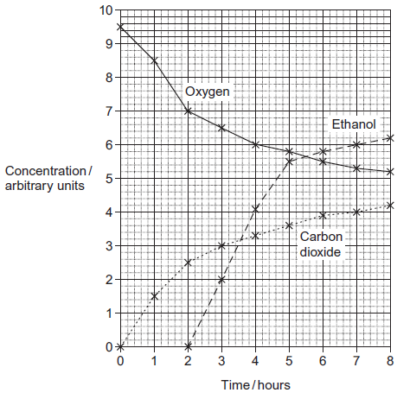

(a)     The scientist used a container that was airtight.  
Give **two** explanations why the container had to be airtight.

1 ......................................................................................................................

.........................................................................................................................

.........................................................................................................................

.........................................................................................................................

2 ......................................................................................................................

.........................................................................................................................

.........................................................................................................................

.........................................................................................................................

**(4)**

(b)     Explain the relationship between the concentration of oxygen and the concentration of carbon dioxide between 0 and 3 hours.

.........................................................................................................................

.........................................................................................................................

.........................................................................................................................

.........................................................................................................................

.........................................................................................................................

.........................................................................................................................

**(2)**

(c)     The scientist concluded that yeast starts to respire anaerobically when the oxygen concentration falls below a certain concentration. What is the oxygen concentration when the yeast starts to respire anaerobically? Explain your answer.

.........................................................................................................................

.........................................................................................................................

.........................................................................................................................

.........................................................................................................................

.........................................................................................................................

**(2)**

(d)     (i)      The scientist worked for a biofuel company. Give **two** suggestions for further work he should do to make sure that the results he presented to the company were reliable.  
Explain how each of your suggestions would make the results more reliable.

Suggestion ............................................................................................

...............................................................................................................

Explanation ...........................................................................................

...............................................................................................................

Suggestion ............................................................................................

...............................................................................................................

Explanation ...........................................................................................

...............................................................................................................

**(4)**

(ii)     The scientist recommended that when the ethanol is produced commercially as biofuel the reaction should be stopped at 6 hours. Use the graph to suggest why.

...............................................................................................................

...............................................................................................................

...............................................................................................................

...............................................................................................................

...............................................................................................................

**(2)**

(iii)    The scientist’s work was funded by a biofuel company. Explain why the source of funding can cause problems with scientific work.

...............................................................................................................

...............................................................................................................

...............................................................................................................

...............................................................................................................

...............................................................................................................

**(2)**

**(Total 16 marks)**

**Q5.**Mountains are harsh environments. The higher up the mountain, the lower the temperature becomes. The diagram shows a forest growing on the side of a mountain.  
The upper boundary of the forest is called the tree line. Trees do not grow above the tree line.

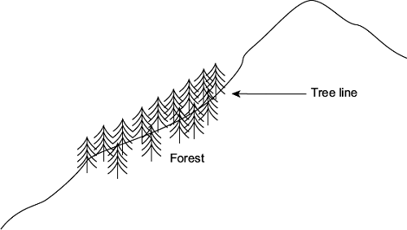

(a)     (i)      The position of the tree line is determined by abiotic factors.  
What is meant by an abiotic factor?

...............................................................................................................

...............................................................................................................

**(1)**

(ii)     Other than temperature, suggest **one** abiotic factor that is likely to affect the position of the tree line on the mountain.

...............................................................................................................

**(1)**

(b)     Scientists measured the concentration of carbon dioxide in the air in one part of the forest. They took measurements at different times of day and at two different heights above the ground. Their results are shown in the bar chart.

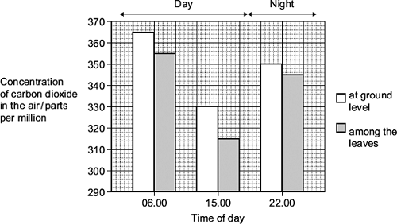

Use your knowledge of photosynthesis and respiration to explain the data in the bar chart.

........................................................................................................................

........................................................................................................................

........................................................................................................................

........................................................................................................................

........................................................................................................................

........................................................................................................................

........................................................................................................................

........................................................................................................................

*(Extra space)* .................................................................................................

........................................................................................................................

........................................................................................................................

........................................................................................................................

**(4)**

(c)     The population of trees in the forest evolved adaptations to the mountain environment.  
Use your knowledge of selection to explain how.

........................................................................................................................

........................................................................................................................

........................................................................................................................

........................................................................................................................

........................................................................................................................

........................................................................................................................

*(Extra space)* .................................................................................................

........................................................................................................................

........................................................................................................................

**(3)**

**(Total 9 marks)**

**Q6.**(a)     ATP is useful in many biological processes. Explain why.

........................................................................................................................

........................................................................................................................

........................................................................................................................

........................................................................................................................

........................................................................................................................

........................................................................................................................

........................................................................................................................

........................................................................................................................

*(Extra space)* .................................................................................................

........................................................................................................................

........................................................................................................................

........................................................................................................................

**(4)**

(b)     Describe how ATP is made in mitochondria.

........................................................................................................................

........................................................................................................................

........................................................................................................................

........................................................................................................................

........................................................................................................................

........................................................................................................................

........................................................................................................................

........................................................................................................................

........................................................................................................................

........................................................................................................................

........................................................................................................................

........................................................................................................................

*(Extra space)* .................................................................................................

........................................................................................................................

........................................................................................................................

........................................................................................................................

........................................................................................................................

........................................................................................................................

**(6)**

(c)     Plants produce ATP in their chloroplasts during photosynthesis. They also produce ATP during respiration. Explain why it is important for plants to produce ATP during respiration in addition to during photosynthesis.

........................................................................................................................

........................................................................................................................

........................................................................................................................

........................................................................................................................

........................................................................................................................

........................................................................................................................

........................................................................................................................

........................................................................................................................

........................................................................................................................

........................................................................................................................

*(Extra space)* .................................................................................................

........................................................................................................................

........................................................................................................................

........................................................................................................................

........................................................................................................................

**(5)**

**(Total 15 marks)**

**Q7.**Doctors compared two tests for lactase deficiency.

Doctors investigated three groups of people. The people in all three groups were not allowed to eat or drink for 8 hours before the test. They each then drank a solution containing 50 g of lactose made with a radioactive form of carbon called 14C.

•        Group **A** were the control group

•        Group **B** were lactase deficient

•        Group **C** had irritable bowel syndrome (IBS)

Both lactase deficieny and irritable bowel syndrome have similar symptoms.

**The carbon dioxide breath test**

In this test the doctors measured the amount of 14C in the carbon dioxide breathed out. The doctors took measurements at intervals for 8 hours after each volunteer had drunk the lactose solution. The following figure shows the mean results for each group.

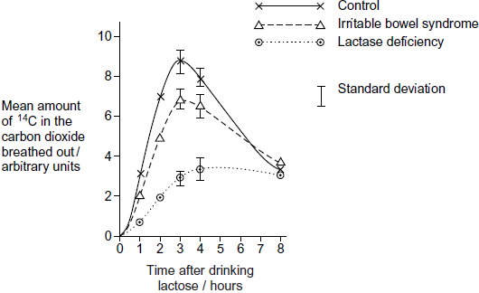

(a)     Describe the common trend shown by **all** the curves in the figure.

........................................................................................................................

........................................................................................................................

........................................................................................................................

**(1)**

(b)     Explain why the doctors stopped measuring the amounts of 14C in the carbon dioxide breathed out after 8 hours.

........................................................................................................................

........................................................................................................................

........................................................................................................................

........................................................................................................................

**(2)**

(c)     Carbon dioxide in the breath contained the radioactive form of carbon, 14C. Explain how 14C in carbon dioxide came from 14C in glucose in the blood.

........................................................................................................................

........................................................................................................................

........................................................................................................................

........................................................................................................................

**(2)**

(d)     The doctors concluded that measuring the amount of 14C in the carbon dioxide in the breath after 3 hours was a better way of diagnosing lactase deficiency than the lactose tolerance test. Do you agree with the doctors’ conclusion? Give the reasons for your answer.

........................................................................................................................

........................................................................................................................

........................................................................................................................

........................................................................................................................

........................................................................................................................

**(2)**

**(Total 7 marks)**

**M1.**(a)     1.      Oxidation of / hydrogen removed from pyruvate and carbon dioxide released;

2.      Addition of coenzyme A.

*Accept: NAD reduced for oxidation*

**2**

(b)     (i)      1.      Change (in shape) of active site / active site moulds around the substrate;

*Reject: reference to inhibitor*

*Accept: change in tertiary structure affecting active site*

2.      (Substrate / active site) now complementary.

*Neutral: references to two active sites*

**2**

(ii)     1.      Is a competitive inhibitor / attaches to active site;

*Neutral: reference to inhibitor forming an enzyme-substrate complex*

2.      Reduces / prevents enzyme-substrate / E-S complex forming.

*Accept: Reduces / prevents acetylcoenzyme A binding to enzyme / citrate synthase*

**2**

(c)     (i)      1.      Regenerates / produces NAD / oxidises reduced NAD;

2.      (NAD used) in glycolysis.

*Accept: description of glycolysis*

*Accept: glycolysis can continue / begin*

**2**

(ii)     (Pyruvate used) in aerobic respiration / (lactate / lactic acid) is toxic / harmful / causes cramp / (muscle) fatigue.

*Accept: (pyruvate) can enter link reaction*

*Accept: reduces cramp / (muscle) fatigue*

*Neutral: ‘reduces muscle aches’*

**1**

**[9]**

**M2.**1.      (Drink) contains carbohydrates / sugars **so** High GI / (drink) contains carbohydrates / sugars **so** raises blood glucose concentration quickly;

*Each alternative requires both aspects for credit*

*The second alternative requires a reference to speed eg ‘quickly’ or ‘immediately’*

2.      Contains salt so glucose more rapidly absorbed;

3.      Increases glucose to muscles for respiration;

4.      More / faster respiration so more / faster energy release;

*Reject reference to energy production*

*Accept more ATP produced*

**[3]**

**M3.**          (a)     1.      Affects enzymes;

*‘respiration involves enzymes’ = two marks*

2.      Affects respiration;

*Ignore reference to controlling a variable*

                 Or

3.      Affects volume / pressure of gases;

*Mark point 4 can only be awarded if mark point 3 has been credited*

4.      Affects readings;

**2 max**

(b)     (i)     1.      Oxygen taken up / used (by seeds);

*Reject air is taken up for mark point 1*

2.      Carbon dioxide (given out) is absorbed by solution / potassium hydroxide;

3.      Decrease in volume / pressure (inside flask);

*Reference to vacuum negates mark point 3*

**3**

(ii)     4;

**1**

(c)     1.      Remains the same;

2.      No oxygen uptake / used;

*Any reference to ‘carbon dioxide* ***not*** *being produced’ disqualifies mark point 2*

**2**

**[8]**

**M4.**(a)     1.      No oxygen can enter;

2.      Ethanol produced during anaerobic respiration;

***OR***

3.      No ethanol / carbon dioxide can escape;

4.      Allows accuracy of measuring;

***OR***

5.      To prevent entry of / contamination with microorganisms;

6.      Prevent competition with yeast;

*Any two pairs of answers*

*Second mark of each pair must be related to the first point of the pair.*

**4 max**

(b)     1.      Yeast respiring aerobically;

2.      Oxygen used equal to carbon dioxide produced;

**2**

(c)     1.      7.0 / 7;

2.      Ethanol production starts;

**2**

(d)     (i)      1.      Repeat;

2.      Identify anomalies / see if results are similar / enough results for statistical test / give more reliable mean;

3.      Carry out statistical test / statistical analysis;

4.      Ensure results are significant / find probability of results being due to chance;

5.      Peer review;

6.      Allows procedure to be checked / see if other scientists get similar results;

*Two pairs of linked points, each pair a suggestion and an explanation. The explanation must relate to the suggestion to gain the second point of the pair.*

**4**

(ii)     1.      Curve levelling off / rate of increase is decreasing / very little extra ethanol produced;

2.      Becomes less cost effective / less profit;

*2. Accept a description of cost effectiveness*

**2**

(iii)    1.      (Funding agency) might want particular results;

2.      Results may be withheld / results may not be published / results may be confidential;

**2 max**

**[16]**

**M5.**         (a)     (i)     Non-living / physical / chemical factor / non biological;

*Do not accept named factor unless general answer given.*

**1**

(ii)     Accept an abiotic factor that may limit photosynthesis / growth;

*Reject altitude / height*

Water

Named soil factor

*Not “soil” / “weather”*

Light

Carbon dioxide

*Accept Oxygen*

Incline / aspect

Wind / wind speed

**1**

(b)     1.      Correct explanation for differences between day and night e.g.  
photosynthesises only during the daytime / no photosynthesis / only respiration at night;

2.      Net carbon dioxide uptake during the day / in light

***OR***

         No carbon dioxide taken up at night / in dark / carbon dioxide released at night / in dark;

3.      At ground level more respiration / in leaves more photosynthesis;

4.      Carbon dioxide produced at ground level / carbon dioxide taken up in leaves;

*Principles*

***Comparing day and night / light and dark***

*1. Explanation in terms of photosynthesis / respiration*

*2. Effect on carbon dioxide production / uptake*

***Comparing leaves with ground level***

*3. Explanation in terms of photosynthesis / respiration*

*4. Effect on carbon dioxide production / uptake*

*2 and 4 must relate to why the change occurs*

**4**

(c)     1.      Variation in original colonisers / mutations took place;

2.      Some better (adapted for) survival (in mountains);

*2. Allow “advantage so able to survive”*

3.      Greater reproductive success;

4.      Allele frequencies change;

*4. Reject gene / genotype*

**3 max**

**[9]**

**M6.**          (a)     1.      Releases energy in small / manageable amounts;

*1. Accept less than glucose*

2.      (Broken down) in a one step / single bond broken immediate energy compound / makes energy available rapidly;

*2. Accept easily broken down*

3.      Phosphorylates / adds phosphate makes (phosphorylated substances) more reactive / lowers activation energy;

*3. Do not accept phosphorus or P on its own*

4.      Reformed / made again;

*4. Must relate to regeneration*

**4**

(b)     1.      Substrate level phosphorylation / ATP produced in Krebs cycle;

*Accept alternatives for reduced NAD*

2.      Krebs cycle / link reaction produces reduced coenzyme / reduced NAD / reduced FAD;

*2. Accept description of either Krebs cycle or link reaction*

3.      Electrons released from reduced / coenzymes / NAD / FAD;

4.      (Electrons) pass along carriers / through electron transport chain / through series of redox reactions;

5.      Energy released;

*5. Allow this mark in context of electron transport or chemiosmosis*

6.      ADP / ADP + Pi;

*6. Accept H+ or hydrogen ions and cristae*

7.      Protons move into intermembrane space;

*7. Allow description of movement through membrane*

8.      ATP synthase;

*8. Accept ATPase. Reject stalked particles*

**6 max**

(c)     1.      In the dark no ATP production in photosynthesis;

*1. In context of in photosynthetic tissue / leaves*

2.      Some tissues unable to photosynthesise / produce ATP;

3.      ATP cannot be moved from cell to cell / stored;

4.      Plant uses more ATP than produced in photosynthesis;

5.      ATP for active transport / synthesis (of named substance);

**5**

**[15]**

**M7.**(a)     Increase in the first 3 – 4 hours and then decrease;

**1**

(b)     Little / no difference (at 8 hours);

Between all groups;

**2**

(c)     Respiration ( produce CO2);

By cells / tissues;

**2**

(d)     Clear differences between the lactose deficient and IBS / control group;

No overlap in SD;

*Accept between all groups*

**2**

**[7]**

**E1.**(a)     Most students obtained one mark and almost fifty percent obtained both marks in this question. Oxidation of pyruvate by removal of hydrogen (or the use of hydrogen to reduce NAD), and the removal of carbon dioxide were described to gain mark point one. Sometimes the release of carbon dioxide or the removal of hydrogen was omitted. There were many good descriptions of the remaining acetyl group combining with coenzyme A to form acetylcoenzyme A. A word equation was quite often included as well as a description. Common errors included; using reduced NAD rather than forming it, using NADP rather than NAD, reducing pyruvate and / or using ATP.

(b)     (i)      Most students showed a good understanding of this example of induced fit by describing the change in shape of the active site so that it became complementary to the acetylcoenzyme A. Fifty percent of students gained both marks. A significant number incorrectly suggested that oxaloacetate was an inhibitor. Marks were also missed when either the term ‘active site’ or ‘complementary’ was not used. There were frequent references to binding sites both on the enzyme and acetylcoenzyme A. The binding of the oxaloacetate to the enzyme also was thought by a significant number of students to change the primary structure of the enzyme.

(ii)     There were many excellent explanations of this example of competitive inhibition with over two thirds of students gaining both marks. However, weaker answers often referred to an active site on succinyl coenzyme A and / or described succinyl coenzyme A binding with acetylcoenzyme A rather than with the enzyme citrate synthase.

(c)     (i)      Surprisingly, although fifty percent of students obtained both marks in this question, almost a third of students scored zero. The best responses provided accurate details of the use of hydrogen from reduced NAD to reduce pyruvate to lactate, the regeneration of NAD, and its use in glycolysis. Incorrect responses included a wide variety of misconceptions including; the formation of reduced NAD in the conversion of pyruvate to lactate, formation of NADP, pyruvate providing phosphate for the formation of ATP and the use of reduced NAD in the electron transport chain despite this question asking about anaerobic respiration.

(ii)     Over seventy percent of students obtained the mark in this question. Many answers referred to the use of pyruvate in aerobic respiration or outlined that its formation prevented the build-up of toxic lactate / lactic acid, preventing cramp. The build-up of lactic acid and the effect on pH on denaturing enzymes was also described. Some students suggested that pyruvate directly entered the Krebs cycle or that it was produced to ‘create energy’.

**E2.**This question was not answered well and, in some cases, not marked well either. Students and assessors alike did not consider responses in the context of an energy *boost*. Words like ‘quickly’, ‘rapidly’, ߢmore’ or ‘respiration’ were frequently lacking. It is vital that assessors appreciate both what a question is asking and the essence of the marking points.

**E3.**          (a)      A significant number of students failed to explain adequately why both experiments were carried out at the same temperature. Their responses were often limited to having a ‘fair test’ or controlling a variable. Students who provided more details often gained a mark for mentioning that temperature affects enzyme-controlled reactions. Better students specifically referred to respiration and obtained the second mark point.

(b)     (i)      This question provided a good spread of marks. The most common scoring point was the absorption of carbon dioxide by potassium hydroxide. Many students gained a second mark for the uptake of oxygen by the seeds. Better students obtained maximum marks by stating that a decrease in volume or pressure in the flask would cause the level of the coloured liquid to go down in the right-hand side of the manometer tube. However, a significant number of students failed to gain this mark as they only referred to a change in pressure or stated that a vacuum was produced. Some students suggested that photosynthesis was taking place with the seeds absorbing carbon dioxide and producing oxygen.

(ii)     Rather surprisingly relatively few students provided the correct answer of 4. The most common incorrect answer was 5, although a full range of numerical values from 0 to 15 was noted by examiners.

(c)      Approximately one in four students gained both marks. These students often clearly explained that no oxygen would be used by the seeds and, as any carbon dioxide produced would be absorbed by the potassium hydroxide, the level of liquid would not change. A third of students gained one mark often for stating that no oxygen uptake would occur. Some students negated this mark point by suggesting that carbon dioxide is not produced during anaerobic respiration. A minority of students suggested ethanol would affect the level of coloured liquid in the tube.

**E5.**          (a)      Part (i) was correctly answered by many as a non-living factor, and most students gave a suitable example for part (ii).

(b)     Answers to this question were frequently very disorganised, with students wasting many lines describing the data before attempting an explanation. The first marking point was often gained, usually for no photosynthesis at night, but students did not then develop the idea and explain that this resulted in no carbon dioxide being taken up at night. The production of carbon dioxide in respiration, and therefore that the uptake in the light was a net movement, was also very rarely mentioned. A few students tried to include the detail of the Calvin cycle to explain the reduction in carbon dioxide levels. Marking point 4 was often awarded for carbon dioxide taken in by leaves. The higher concentration of carbon dioxide at ground level was sometimes explained as being because it is denser than oxygen.

(c)     There were many excellent answers where all four marking points were clearly understood and explained using the correct terminology. Many students could clearly explain that advantageous characteristics allowed trees to survive and reproduce successfully. They gained two marks. The change in allele frequency was also often correctly explained with fewer incorrect references to genes. There was some apparent misunderstanding of germination which seemed to be taken by some students to mean reproduction. There was the occasional account of succession or descriptions of features advantageous to survival in the mountains. Weaker students could say little more than that the trees with an advantage were more likely to survive. There were frequent references to directional and stabilising selection.

**E6.**          (a)     Some good answers were given to this question, with candiates being confident in their understanding of the way in which ATP rapidly releases small, manageable amounts of energy in a single hydrolytic reaction. Marking points 5 and 6 were the least often seen, and the use of ATP to lower activation energy was very rarely seen, although answers frequently referred to activation of glucose in glycolysis.

(b)     Many excellent answers were given in this section that included six or more of the marking points and showed excellent understanding of the processes involved in ATP formation, including chemiosmosis. A significant number gave an account of the whole process of respiration, including glycolysis, using up the space provided and indicating that the answer continued on a separate sheet. One or two included the digestion and absorption of carbohydrates. Weaker students often gained marking points 1, 2 and 6. There was confusion over protons and electrons and hydrogen ions/atoms and molecules. Some students confused the processes of respiration and the light-independent reaction of photosynthesis. Glycerate 3-phosphate (GP) and triose phosphate (TP) were sometimes said to be involved in the Krebs cycle, as was NADP. The movement of protons through the inner mitochondrial membrane into the intermembrane space was often only loosely described, with protons passing into the membrane, along the membrane, or out of the mitochondrion.

(c)     Many students did not appear to have any real understanding of the relationship between photosynthesis and respiration. Statements such as ‘plants have to respire so they can make the carbon dioxide so they can photosynthesise’ were not atypical. The weakest students completely reversed the roles of the two processes. Most commonly, students gained two marks, for referring to the uses of ATP in active transport and synthesis. Marking points 1 and 4 were seen rather less often and marking points 2 and 3 were fairly rarely made. Some students demonstrated good knowledge but not the ability to be selective, giving accounts in some detail of both photosynthesis and respiration which failed to address the question fully.

**E7.**(a)     This was answered well with most candidates scoring the mark. Those who did not offered vague descriptions of trend, referring only to the shape of the curve. This should have been supported with data from the axes.

(b)     This was a very straightforward question and candidates scored well. The commonest error was to refer to curves levelling off without any reference to this happening at the *same* value.

(c)     There were some really good answers here with many candidates scoring the mark for respiration. Better candidates linked this idea to cells but others often confused ventilation and respiration. Statements such as glucose goes to the lungs and gets breathed out were not uncommon.

(d)     Many candidates score the first mark stating there was a clear difference between the lactose deficient group and the IBS or control group. Good candidates achieved the second marking point of there being no overlap between the standard deviations. Candidates appeared to understand that a small standard deviation indicated reliable data. However, they were often uncertain of the implications of overlapping values.

Resource currently unavailable.