**Q1.**          This question should be written in continuous prose, where appropriate.  
Quality of Written Communication will be assessed in the answer.

(a)     Explain how the ventilation mechanism of a fish and the structure of its gills result in the efficient uptake of oxygen from water.

......................................................................................................................

......................................................................................................................

......................................................................................................................

......................................................................................................................

......................................................................................................................

......................................................................................................................

......................................................................................................................

......................................................................................................................

......................................................................................................................

......................................................................................................................

......................................................................................................................

......................................................................................................................

......................................................................................................................

......................................................................................................................

......................................................................................................................

**(6)**

**Table 1** compares some features of water and air.

|  |  |  |
| --- | --- | --- |
| **Feature** | **Water** | **Air** |
| Relative density | 1000 | 1 |
| Maximum concentration of oxygen / cm3 dm–3 | 9 | 130 |

**Table 1**

**Table 2** shows some features of gas exchange in a fish and in a mammal.

|  |  |  |
| --- | --- | --- |
| **Feature** | **Fish** | **Mammal** |
| Percentage of oxygen extracted from water or air | 80 | 25 |
| Oxygen consumption at rest / cm3 kg–1 hour–1 | 100 | 200 |

**Table 2**

(b)     (i)      The fish has a body mass of 0.2 kg. Calculate the volume of water it will need to pass over its gills each hour to supply the oxygen required when resting. Show your working.

Answer ............................................ dm3 / hour–1

**(2)**

(ii)     Ventilation in mammals involves movement of air to and from the gas exchange surface in a tidal pattern. Using information in the tables, explain why it is easier to move water over the gas exchange surface of a fish in one direction rather than in a tidal pattern.

.............................................................................................................

.............................................................................................................

.............................................................................................................

.............................................................................................................

**(2)**

(c)     A rise in the temperature of water decreases the amount of oxygen dissolved in the water. As the water temperature rises, the rate of ventilation in a fish also rises. Explain the advantage of this.

......................................................................................................................

......................................................................................................................

......................................................................................................................

......................................................................................................................

**(2)**

**(Total 12 marks)**

**Q2.**          (a)     When first hatched, the young of some species of fish are less than 2 mm long.  
Explain how these young fish get enough oxygen to their cells without having gills.

......................................................................................................................

......................................................................................................................

......................................................................................................................

......................................................................................................................

**(2)**

(b)     Mackerel are fast swimming fish whereas toadfish only swim slowly. The table shows some features of the gills of these fish.

|  |  |  |
| --- | --- | --- |
|  | **Thickness of lamellae / µm** | **Number of lamellae per mm of gill length** |
| Mackerel | 5 | 32 |
| Toadfish | 35 | 8 |

Use evidence from the table to explain how mackerel are able to swim faster than toadfish.

......................................................................................................................

......................................................................................................................

......................................................................................................................

......................................................................................................................

......................................................................................................................

**(3)**

**(Total 5 marks)**

**Q3.**          (a)     Describe how air is taken into the lungs.

......................................................................................................................

......................................................................................................................

......................................................................................................................

......................................................................................................................

......................................................................................................................

......................................................................................................................

**(3)**

The volume of air breathed in and out of the lungs during each breath is called the tidal volume. The breathing rate and tidal volume were measured for a cyclist pedalling at different speeds. The graph shows the results.

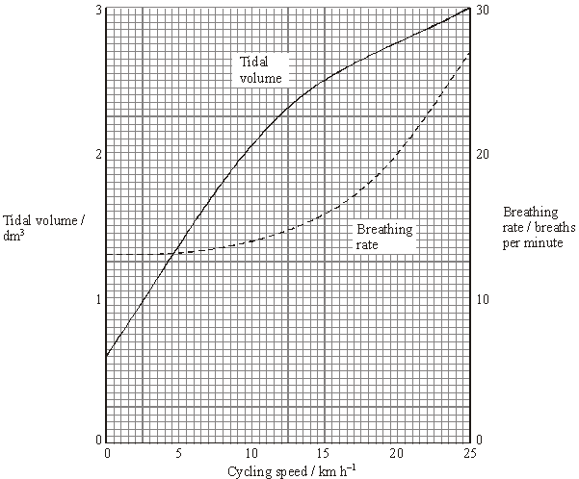

(b)     Describe the **two** curves.

(i)      Tidal volume

.............................................................................................................

.............................................................................................................

.............................................................................................................

(ii)     Breathing rate

.............................................................................................................

.............................................................................................................

.............................................................................................................

**(2)**

(c)     Calculate the total volume of air breathed in and out per minute when the cyclist is cycling at 20 km h–1. Show your working.

........................................ dm3

**(2)**

**(Total 7 marks)**

**Q4.**          (a)     The photograph shows part of the gill of a fish as seen through a light microscope. It is magnified × 400.

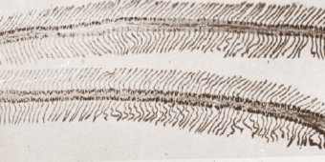

(i)      Explain how the structure of the gill makes oxygen uptake efficient.

.............................................................................................................

.............................................................................................................

.............................................................................................................

.............................................................................................................

**(2)**

(ii)     Water containing dissolved oxygen flows over the gill in the opposite direction to the blood flow inside. Explain why this arrangement is important for efficient oxygen uptake.

.............................................................................................................

.............................................................................................................

.............................................................................................................

.............................................................................................................

**(2)**

(b)     There is a one-way flow of water over the gills of a fish whereas there is a two-way flow of air in the lungs of a mammal. Suggest **one** advantage to a fish of this one-way flow of water over its gills.

......................................................................................................................

......................................................................................................................

**(1)**

**(Total 5 marks)**

**Q5.**          (a)     **Figure 1** shows a section through the root of a young plant.

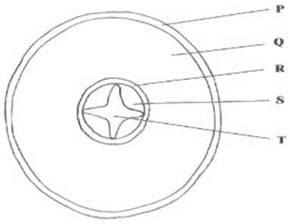

**Figure 1**

(i)      Name the part of the plant labelled **R**.

.............................................................................................................

**(1)**

(ii)     Give the letter which labels a tissue that transports solutes from the leaves.

Answer ......................................

**(1)**

(iii)     Give the letter which labels a tissue that prevents the movement of water through the apoplast pathway.

Answer ......................................

**(1)**

(b)     **Figure 2** shows a single stoma and surrounding cells from the leaf of a xerophytic plant.

**Figure 2**

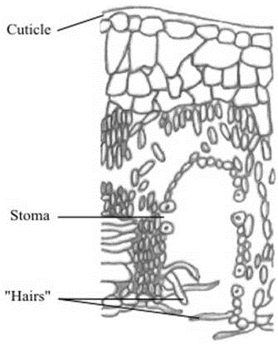

(i)      Explain how the cuticle reduces water loss.

.............................................................................................................

.............................................................................................................

**(1)**

(ii)     Explain how **one** of the other labelled parts reduces water loss.

.............................................................................................................

.............................................................................................................

.............................................................................................................

.............................................................................................................

**(2)**

**(Total 6 marks)**

**Q6.** Lung cancer, chronic bronchitis and coronary heart disease (CHD) are associated with smoking. **Tables 1** and **2** give the total numbers of deaths from these diseases in the UK in 1974.

**Table 1 Men**

|  |  |  |  |
| --- | --- | --- | --- |
| **Age/years** | **Number of deaths (in thousands)** | | |
|  | lung cancer | chronic bronchitis | coronary heart disease |
| 35 - 64 | 11.5 | 4.2 | 31.7 |
| 65 - 74 | 12.6 | 8.5 | 33.3 |
| 75+ | 5.8 | 8.1 | 29.1 |
| Total (35 - 75+) | 29.9 | 20.8 | 94.1 |

**Table 2 Women**

|  |  |  |  |
| --- | --- | --- | --- |
| **Age/years** | **Number of deaths (in thousands)** | | |
|  | lung cancer | chronic bronchitis | coronary heart disease |
| 35 – 64 | 3.2 | 1.3 | 8.4 |
| 65 – 74 | 2.6 | 1.9 | 18.2 |
| 75+ | 1.8 | 3.5 | 42.3 |
| Total (35 – 75+) | 7.6 | 6.7 | 68.9 |

(i)      Using an example from the tables, explain why it is useful to give data for men and women separately.

......................................................................................................................

......................................................................................................................

......................................................................................................................

**(2)**

(ii)     Data like these are often given as percentages of people dying from each cause.

Explain the advantage of giving these data as percentages.

......................................................................................................................

......................................................................................................................

......................................................................................................................

......................................................................................................................

**(2)**

**(Total 4 marks)**

**Q7.** The graph shows how pulmonary ventilation changes during a period of exercise.

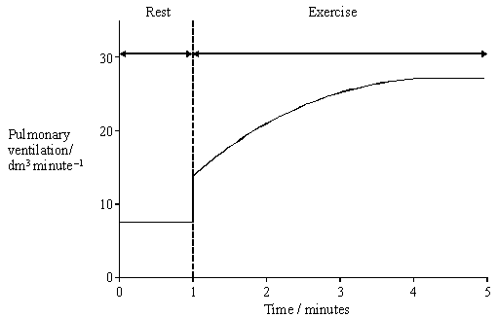

(a)     Describe how pulmonary ventilation changed during the period of exercise.

......................................................................................................................

......................................................................................................................

......................................................................................................................

**(1)**

(b)     After 4 minutes of exercise, the breathing rate was 20 breaths per minute. Explain how you could use this information and the graph to calculate tidal volume.

......................................................................................................................

......................................................................................................................

......................................................................................................................

......................................................................................................................

**(2)**

(c)     When a person starts to breathe out, the percentage of oxygen in the air first exhaled is the same as the percentage of oxygen in the atmospheric air. Explain why.

......................................................................................................................

......................................................................................................................

......................................................................................................................

**(2)**

**(Total 5 marks)**

**Q8.** The drawing shows an electron micrograph of a section through part of an alveolus from a lung.

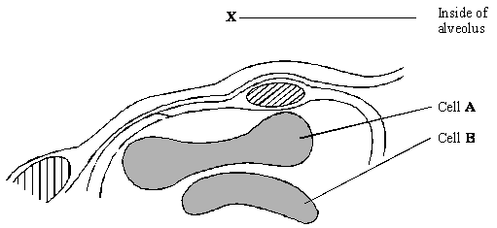

(a)     Describe the path of a molecule of oxygen from the air in the alveolus at **X** to the plasma membrane of cell **A**.

......................................................................................................................

......................................................................................................................

**(1)**

(b)     Cell **A** is a eukaryotic cell. Give **two** features that may be found in a prokaryotic cell which are not found in cell **A**.

1 ...................................................................................................................

......................................................................................................................

2 ...................................................................................................................

......................................................................................................................

**(2)**

(c)     Cells **A** and **B** are biconcave discs. Explain **one** advantage of a biconcave disc over a spherical cell of the same volume in transporting oxygen.

......................................................................................................................

......................................................................................................................

......................................................................................................................

......................................................................................................................

**(2)**

(d)     The diameter of a human red blood cell is 7 µm.

(i)      Calculate the magnification of the drawing. Show your working.

Magnification = ...............................

**(2)**

(ii)     In calculating the magnification, what assumption did you have to make about how the section was cut?

.............................................................................................................

.............................................................................................................

**(1)**

**(Total 8 marks)**

**Q9.**          Gas exchange surfaces allow efficient diffusion of gases. Fick’s law states:

Rate of diffusion is proportional to 

(a)     In the gill of a fish, describe how

(i)      a large surface area is provided;

.............................................................................................................

.............................................................................................................

**(1)**

(ii)     a concentration gradient is maintained.

.............................................................................................................

.............................................................................................................

.............................................................................................................

.............................................................................................................

**(2)**

(b)     Land-dwelling insects lose water from their gas exchange surface. Use Fick’s law to explain why they lose less water when the air is humid.

......................................................................................................................

......................................................................................................................

......................................................................................................................

......................................................................................................................

**(2)**

**(Total 5 marks)**

**Q10.**          (a)     Describe the part played by the diaphragm in causing air to enter the lungs during breathing.

......................................................................................................................

......................................................................................................................

......................................................................................................................

......................................................................................................................

......................................................................................................................

......................................................................................................................

**(3)**

Seals are mammals. They have lungs and must breathe air. They can dive and remain under water for a long time. The table shows the flow of blood to the lungs and to the diaphragm in a seal when it is on land and when it is under water.

|  |  |  |  |
| --- | --- | --- | --- |
|  | **Organ** | **Blood flow / cm3 min–1 g–1** | |
|  | **On land** | **Under water** |
|  | Lungs | 0.88 | 0.52 |
|  | Diaphragm | 0.21 | 0.02 |

(b)     Explain why the figures in the table are given per gram of tissue.

......................................................................................................................

......................................................................................................................

......................................................................................................................

......................................................................................................................

**(2)**

(c)     Calculate the percentage by which blood flow to the lungs is reduced when a seal is swimming under water. Show your working.

Answer ............................................

**(2)**

(d)     There is a greater percentage reduction in blood flow to the diaphragm than to the lungs during a dive. Explain the advantage to a diving seal of

(i)      blood continuing to flow to the lungs;

.............................................................................................................

.............................................................................................................

**(1)**

(ii)     a large reduction in blood flow to the diaphragm.

.............................................................................................................

.............................................................................................................

.............................................................................................................

.............................................................................................................

**(2)**

**(Total 10 marks)**

**Q11.**          A person was sitting at rest and breathing normally. A recording was made of the changes in the volume of air in his lungs over a ten-second period. The diagram shows this recording.

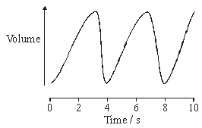

(a)     Describe the part played by muscles in bringing about the change between 3 and 4 seconds.

......................................................................................................................

......................................................................................................................

**(1)**

(b)     Describe how an increase in lung volume leads to air entering the lungs.

......................................................................................................................

......................................................................................................................

**(1)**

**(Total 2 marks)**

**Q12.**          In the lungs, the alveoli are the site of gas exchange.

(a)     A large number of small alveoli is more efficient in gas exchange than a smaller number of larger alveoli. Explain why.

......................................................................................................................

......................................................................................................................

......................................................................................................................

......................................................................................................................

**(2)**

(b)     The diagram shows part of an alveolus and a capillary.

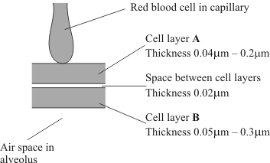

(i)      Name the type of cells in layer **B**.

.............................................................................................................

**(1)**

(ii)     What is the minimum distance a molecule of carbon dioxide diffuses from the blood plasma to the air space in the alveolus?

.............................................................................................................

**(1)**

(c)     Just before a person starts to exhale, the composition of the air in an alveolus differs from the composition of the air in the trachea.

(i)      Give **two** ways in which the composition would differ.

1 ..........................................................................................................

2 ..........................................................................................................

**(1)**

(ii)     Explain what causes this difference in composition between the air in the alveolus and the air in the trachea.

.............................................................................................................

.............................................................................................................

**(1)**

(d)     The partial pressure of a gas is a measure of the amount of gas that is present.   
The partial pressure of carbon dioxide in blood going to the lungs is 6.3 kPa.   
The partial pressure of carbon dioxide in an alveolus is 5.3 kPa.

(i)      Through which vessel does blood leave the heart to go to the lungs?

.............................................................................................................

**(1)**

(ii)     Suggest why blood returning to the heart from the lungs contains some carbon dioxide.

.............................................................................................................

.............................................................................................................

.............................................................................................................

.............................................................................................................

**(2)**

**(Total 9 marks)**

**Q13.**          Many insects release carbon dioxide in short bursts even though they produce it at a constant rate. The diagram shows how this is achieved in one particular insect.

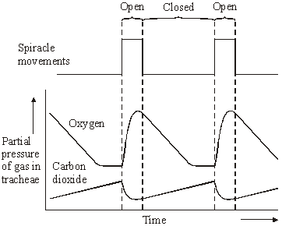

(a)     Using information from the diagram, suggest what stimulates the spiracles to open.

......................................................................................................................

......................................................................................................................

**(1)**

(b)     Explain what causes the oxygen concentration in the tracheae to fall when the spiracles are closed.

......................................................................................................................

......................................................................................................................

......................................................................................................................

......................................................................................................................

**(2)**

(c)     The insect lives in dry conditions. Suggest an advantage of the pattern of spiracle movements shown in the diagram.

......................................................................................................................

......................................................................................................................

......................................................................................................................

......................................................................................................................

**(2)**

**(Total 5 marks)**

**Q14.**          In an investigation, a locust was given alternating supplies of atmospheric air and pure carbon dioxide. The rate of pumping movements of the insect’s abdomen was measured.

The graph shows the results.

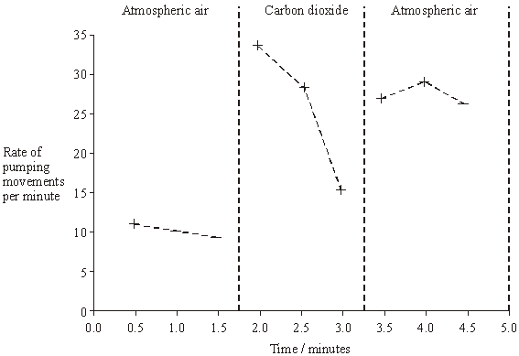

(a)     Explain what caused

(i)      the rise in the rate of abdominal pumping movements between 1.5 and 2.0 minutes,

.............................................................................................................

.............................................................................................................

**(1)**

(ii)     the fall in the rate of abdominal pumping movements between 2.0 and 3.0 minutes.

.............................................................................................................

.............................................................................................................

.............................................................................................................

.............................................................................................................

**(2)**

(b)     The rate of abdominal pumping movements increases between 3.0 and 3.5 minutes. Suggest the advantage of this change to the locust.

......................................................................................................................

......................................................................................................................

**(1)**

**(Total 4 marks)**

**Q15.**          The drawing shows part of the lower leaf epidermis of sorghum.

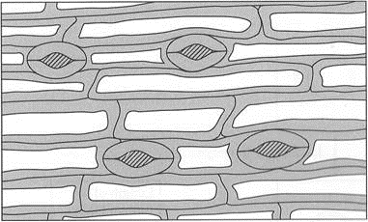



(a)     Calculate the number of stomata per mm2 of the leaf surface. Show your working.

Answer ....................................... stomata per mm2

**(2)**

(b)     Sorghum has few stomata per mm2 of leaf surface area. Explain how this is an adaptation to the conditions in which sorghum grows.

......................................................................................................................

......................................................................................................................

......................................................................................................................

......................................................................................................................

......................................................................................................................

......................................................................................................................

**(3)**

**(Total 5 marks)**

**Q16.**          (a)     The diagram represents the flow of water and blood through the gills of a fish. The figures give relative oxygen concentrations.

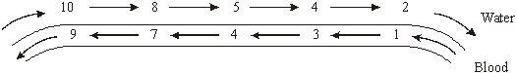

Use the information in diagram to explain the advantage of the countercurrent flow.

......................................................................................................................

......................................................................................................................

......................................................................................................................

......................................................................................................................

......................................................................................................................

**(2)**

(b)     In the ventilation cycle of a fish, water enters the mouth cavity and then passes through the gills into the opercular cavity. The graph shows the difference in pressure between the mouth cavity and the opercular cavity.

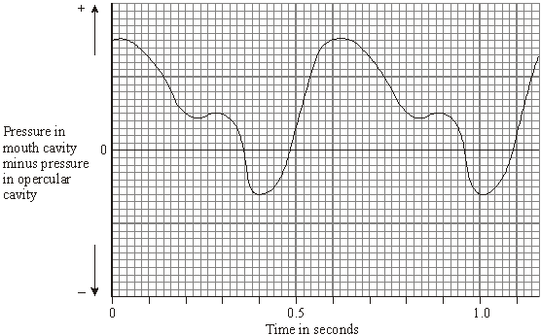

Calculate the number of ventilation cycles per minute of the fish. Show your working.

Answer ......................................

**(2)**

**(Total 4 marks)**

**M1.**          (a)     *(explanation must be linked to structures to gain second mark for each linked pair)*

|  |  |
| --- | --- |
| filaments / lamellae ; | large SA; |
| gill plates or secondary lamellae; |  |
| large number of capillaries; | to remove oxygen / to maintain a gradient; |
| thin epithelium; | short diffusion pathway; |
| pressure changes; | to bring in more water / to maintain gradient; |
| countercurrent flow (or description); | exchange / diffusion along whole length / concentration gradient maintained / equilibrium not achieved / blood always meets water with higher oxygen concentration; |

**6**

(b)     (i)      requires 20 cm3 of oxygen / extracts 7.2 cm3 of oxygen /

*reject if referring to volume of water*

**;

2.7 / 2.8 (dm3h–1);

*(correct answer award 2 marks)*

**2**

(ii)     high (relative) density / heavy;  
requires large input of energy as difficult to push back out;

**2**

(c)     (*for each pair second point must be linked to first*)  
to provide same amount of oxygen;   
need to have more water flowing over gills;  
OR  
metabolic rate / respiration increases (with increase in temperature);  
so more oxygen required;

**2 max**

**[12]**

**QWC 1**

**M2.**          (a)     exchange / diffusion across body surface / skin;  
short diffusion pathway / distance / large SA:V ratio;

**2**

(b)     large numbers of lamellae so large SA;  
lamellae thin so short (diffusion) pathway to blood / capillaries;  
high rate of oxygen uptake for respiration / energy release;

*(accept more oxygen)*

**3**

**[5]**

**M3.**          (a)     contraction of (diaphragm) muscles flattens diaphragm;  
contraction of intercostal muscles raises ribcage;  
increase in volume decreases pressure;

**3**

(b)     (i)      tidal volume increases steeply, then increase slows down after 10 to 15 km h-1;

**1**

(ii)     breathing rate increases slowly then steeply after 10 to 15 km h-1;

*(max 1 if no reference to speed where change occurs in either (i) or (ii))*

**1**

(c)     20 × 2.75 = 55 dm2;

*(award 1 mark for correct method i.e. tidal volume × rate);*

**2**

**[7]**

**M4.**          (a)     (i)      one feature;

then linked Explanation;

(many) filaments / lamellae / secondary lamellae;

so large surface area;

large number of capillaries; (NOT “good blood supply”)

maintains a diffusion gradient / removes oxygen;

thin epithelium / lamellae wall;

short diffusion pathway;

**2**

(ii)     maintains diffusion / concentration gradient / equilibrium  
not reached;

diffusion occurs across whole length (of lamellae / gill);

**2**

(b)     less energy needed / continuous flow of water or O2;

**1**

**[5]**

**M5.**          (a)     (i)      Endodermis(reject pericycle / suberin);

*(accept endodermis and / containing Casparian strip)*

**1**

(ii)     S;

**1**

(iii)     R;

**1**

(b)     (i)      (waxy so) impermeable to water / waterproof / stops water  
passing through;

**1**

(ii)     reference to hairs / position of stomata (sunken stomata /   
stomata in pits )  
LINKED to reduced air movement / trap layer of air /   
trap water vapour (*reject water) /* maintains humidity;

reduces diffusion gradient / concentration gradient of water /   
water potential gradient;

*OR*

stoma can close;  
reduces area for evaporation or transpiration;

**2**

**[6]**

**M6.**          (i)     Because there are big differences;  
any correct named example e.g. lung cancer / bronchitis much lower  
in women than in men;

**2**

(ii)     easier to compare if sample size effectively the same;  
different numbers of people in each group;

**2**

**[4]**

**M7.**          (a)     Immediate / rapid increase, steady rise and plateau clearly identified;

*Ignore references to rest period if clearly identified as such*

**1**

(b)     Find value of pulmonary ventilation from graph / 26-28;  
Divide by breathing rate / 20;

**2**

(c)     Air is from nose / trachea / bronchi / not been in alveoli / dead space;  
Gas exchange / diffusion only in alveoli / not in these structures;

**2**

**[5]**

**M8.**          (a)     Epithelium of alveolus, capillary wall / epithelium / endothelium, plasma;

**1**

(b)     Cell wall;  
Capsule;  
Flagellum;  
Mesosomes;  
Plasmid;  
Genetic material / DNA / nucleoid;  
Ribosomes;

*Accept references to size only if some idea of range is given*

**max 2**

(c)     Large (surface) area;  
For diffusion;  
     or  
Short distance to centre of cell / to all haemoglobin;  
For diffusion;

**2**

(d)     (i)      Correct answer of approximately 7800 / 8000 = 2 marks  
Incorrect answer but clearly derived by  
dividing diameter of cell A by 7                        = 1 mark

**2**

(ii)     Idea of cut through maximum diameter / middle;

**1**

**[8]**

**M9.**          (a)     (i)      ***Many*** gill lamellae / gill filaments;

*(ignore refs to ‘highly divided’)*

**1**

(ii)     Counter-current mechanism / blood and water flow in opposite  
directions;  
Not enough time for equalisation of concentrations / maintains  
concentration gradient over length of gills / never reaches  
equilibrium;

**max 2**

(b)     Humidity reduces difference in concentration of water (vapour)  
between body and air;  
reduces rate of diffusion (of water vapour)(as are proportional);

**2**

**[5]**

**M10.**          (a)     Diaphragm (muscle) contracts;  
Flattens / Increases volume of chest;  
Reduced pressure allows air to enter;

**3**

(b)     Allows comparison;  
As organs differ in size / as larger organs will need more blood;

**2**

(c)     2 marks for 40.91 / 40.9 / 41  
1 mark for 59.09 / 59.1 / 59

**2**

(d)     (i)      Some oxygen still in lungs (which will enter the blood) /   
removal of carbon dioxide (from blood);

**1**

(ii)     More blood available for other organs;  
Supplying oxygen / glucose / removing carbon dioxide;  
OR  
Diaphragm muscles not contracting (as not breathing);  
Will not require (as much) oxygen / glucose;

**2**

**[10]**

**M11.**         (a)     Muscles (associated with breathing) relax;

**1**

(b)     Produces lower pressure (and air moves in down pressure gradient);

**1**

**[2]**

**M12.**          (a)     (Small alveoli with) large surface area;  
For diffusion;

**2**

(b)     (i)      Epithelium / epithelial / squamous / pavement cells;  
*Reject endothelium.*

**1**

(ii)     0.11 μm;

**1**

(c)     (i)      Less oxygen / more carbon dioxide / more water vapour;  
*Two differences required, but only one mark for this part  
of the question.*

**1**

(ii)     Gas exchange takes place in alveoli / does not take place  
in trachea;

**1**

(d)     (i)      Pulmonary artery;

**1**

(ii)     Concentrations reach equilibrium / become equal;  
Diffusion occurs when there is a concentration gradient  
(so some will remain in blood);  
OR  
Lung cells / vessel cells respire;  
Add / produce carbon dioxide;

**2**

**[9]**

**M13.**          (a)     increasing carbon dioxide concentration / partial pressure;  
*(decrease in oxygen negates)*

**1**

(b)     (oxygen is used in) respiration therefore diffuses (from tracheae) to tissues;  
oxygen unable to enter organism;

**2**

(c)     spiracles not open all the time;  
therefore there is less water loss  
(by diffusion through spiracles);

**2**

**[5]**

**M14.**          (a)     (i)      high / higher CO2 concentration / lack of oxygen;

**1**

(ii)     CO2 asphyxiates / is toxic;  
lack of oxygen for (aerobic) respiration;  
OR  
lack of energy / ATP (for pumping movements);  
reduced muscle function / muscle fatigue

**2 max**

(b)     removal of (excess) CO2 / oxygen to break down lactate / to  
repay oxygen debt / to enable aerobic respiration;

**1**

**[4]**

**M15.**          (a)     235–240;;  
*(one mark for an answer between 200-300  
based on 2 - 3 stomata in 0.01mm2Alternatively, one mark for calculating the area of the  
rectangle correctly as 0.016 – 0.017mm2)*

**2**

(b)     grows in arid / dry conditions;  
less surface area;  
(rate of) transpiration / water loss would be reduced;

**3**

**[5]**

**M16.**          (a)     (diffusion) gradient will be maintained all the way along the gill / the amount of oxygen in the water is always higher than in the blood / the numbers in the water are always higher than in the blood;  
more oxygen will diffuse into the blood;

**2**

(b)     100 cycles per minute;

*(principle of 60 / x or 0.6 seen gains one mark)*

**2**

**[4]**

**E1.**          (a)     There were some excellent answers to this question with many candidates gaining full marks. Examiners were looking for each feature being linked to how it fulfils its function. Marks were therefore lost by candidates who failed to specify the functional advantage of a described feature. Imprecise descriptions including ‘thin gills’ and ‘good blood supply’ also failed to gain credit. The countercurrent principle was well understood and most candidates were aware of filaments and lamellae, but very few included details of secondary lamellae or gill filaments.

(b)     The calculation was beyond most candidates, with very few even attempting it. Some did calculate 20 cm³ but then gave it as the actual answer. A majority of candidates realised water is denser than air, but only the better candidates linked this to energy input. Very few referred to difficulty in pushing the water back out. Some candidates associated tidal movement with decreased efficiency of the countercurrent mechanism.

(c)     This question was not well answered, most candidates giving vague descriptions of ‘more oxygen being absorbed’. Only the very best candidates appreciated the increased amount of water flowing resulted in the same amount of oxygen being extracted.

**E2.**          (a)     Many candidates scored one mark most commonly for recognition of the short diffusion pathway, which was often related to the SA:V ratio. Surprisingly few answers then went on to relate this to exchange occurring across the body surface.

(b)     Again, only the very weakest candidates failed to gain the surface area mark, usually omitting to link the increased surface area to number of lamellae present. Only the better candidates explained fully the short diffusion pathway in relation to the blood capillaries. Poor expression with reference to respiration and ‘synthesising energy’ appeared in a number of weaker answers.

**E3.**          (a)     This was surprisingly poorly answered with many candidates providing descriptions of a standard lower than that expected for GCSE. There was generally a lack of a clear sequence in the descriptions with links not being made between an action and its effect, such as contraction of intercostal muscles and raising of the ribcage. The link between an increase in volume and a decrease in pressure was often omitted, as was the required reference to diaphragm muscle. Some candidates concentrated on a description of the nervous control of breathing which was not part of this module.

(b)     This was considered a more straightforward question and was usually well-answered. Marks were lost by poor terminology, candidates sometimes describing a decrease in tidal volume rather than a slowing down in the rate of increase. A minority attempted to explain the curves without offering a description.

(c)     The majority of candidates gained the principle mark but only the better candidates gave the correct answer. A significant number was unable to read the data correctly. The most common mistake was to read off both the tidal volume and breathing rate from where one of the lines crossed the *x* axis at 20 km h-1, producing answers of 40 (2 × 20) or 77.5 - 77.6 (2.75 × 27.5). Some candidates having correctly obtained the data then carried out the wrong calculation.

**E4.**          The quality of the answers here were very centre-specific.

(a)     Candidates frequently scored high marks in part (i), but some candidates failed to mention a specific feature. The most common answer was that filaments or lamellae increased the surface area. In part (ii), the idea of maintaining the gradient was often recognised, but not over the whole length of the gill.

(b)     There was only an occasional reference to energy or that there would be a continuous flow. There were many vague answers to ‘it being less efficient’.

**E5.**          (a)     This was generally very well answered, with many candidates attaining maximum marks. The most common error was to name part **R** as the endothelium or epithelium rather than the endodermis.

(b)     The role of the cuticle was well known. Some candidates failed to gain marks through incomplete answers such as ‘the cuticle reduces transpiration’ rather than relating water loss to the impermeable nature of the cuticle. In part (ii), most candidates were able to describe a feature that reduces water loss, but only the more able candidates explained how the feature reduces transpiration by affecting the water diffusion gradient.

**E6.**          In part (i) most candidates were aware that there are differences in the figures for men and women. However, despite being asked to use an example from the tables, many failed to do so. In part (ii) many candidates were aware that percentages lead to ease of comparison, but few referred to differing sample sizes.

**E7.**          (a)     The pattern of change consisted of three phases, an immediate increase followed by a slower rise to a plateau. The performance descriptors for AS biology recently released by QCA indicate that the ability to describe trends and patterns in data is held to be indicative of a grade E candidate. Despite this, large numbers of candidates show little competence with this skill, either in theory papers or in their coursework. The main problems encountered in this particular question were a failure to distinguish between rest and activity, and the frequency of responses based on such simplistic ideas as that “during exercise the rate of pulmonary ventilation goes up”.

(b)     The relationship between pulmonary ventilation, breathing rate and tidal volume created something of a challenge. Although better candidates could generally re-arrange the equation, they still experienced difficulty in explaining how the value for the pulmonary ventilation could be obtained from the graph. Less able candidates frequently incorporated stroke volume or time into the account and multiplied or divided by these quantities.

(c)     Many candidates were able to offer lucid explanations of the information provided and showed familiarity with the concept of dead space. Others, not always the weaker candidates, confused this concept with residual volume. Otherwise sound answers were sometimes marred by imprecise expression. The term “throat” was often used, for example, to refer to the airways.

**E8.**          (a)     Only the best candidates interpreted the diagram correctly and, having done this, were able to describe the pathway in appropriate biological language. There were rather too many references to walls and membranes to be sure of understanding. In addition, there was some interpretation of the question as requiring a reference to the mechanism involved. This resulted in some lengthy explanations of the process of diffusion.

(b)     Common correct answers were the possession of a capsule and a cell wall, but there was a disappointing number of incorrect responses. These tended to arise either because the candidate sought to compare a prokaryotic cell with an unspecified eukaryotic cell, or because references were made to features such as nuclei and mitochondria which were absent from prokaryotic cells. Many of the responses made in this question clearly highlighted the perils of failing to read the question carefully.

(c)     Candidates who explained the advantage of a disc shape in terms of increased surface area encountered few problems in equating this property to diffusion. Others were less successful, either because they were unable to explain the flattened shape of the cell in terms of a short diffusion pathway, or because they constructed inappropriate arguments based on the amount of haemoglobin present or the flexibility of the cells.

(d)     Despite the frequency of such calculations in Unit tests, candidates met with only limited success in part (i). This part of the question gave rise to two problems which created particular difficulties. Candidates had to select the right measurement to represent the diameter and they had to convert this measurement to micrometres. Both tasks presented major hurdles to those of more limited ability. Further difficulties arose from a failure to calculate magnification from the data provided. Part (ii), however, was generally answered well, although there were those who sought to offer explanations based on resolution or the orientation of the specimen, perhaps relying on uncertain memories of previous mark schemes.

**E9.**          (a)     In part (i), candidates were frequently uncertain as to the names of the various structures that make up a gill. However, most were aware that, whatever their name, there were a lot of them and that this large number of small structures gave the gill its large surface area. In part (ii), nearly all candidates knew of the counter-current system that operates within the gill, although some called it a counter-current multiplier, clearly confusing it with the system operating in the loop of Henle. Fewer made the points that, because of this system, equilibration of concentrations is not reached or that a ventilation system operates to move the water over the gills.

(b)     This was a question where candidates needed to pay attention to what they were asked. Too many candidates failed to score any marks when, with a little more care, they could probably have scored both. Given the equation for Fick’s law and the fact that a humid atmosphere reduces water loss from the insects, candidates were clearly required to say more than “a reduced concentration gradient would cut down water loss”. Both those pieces of information are effectively given in the question. Better candidates did identify that there was a reduced concentration gradient *between insect and atmosphere*, which would *reduce the diffusion rate*.

**E10.**          (a)     Answers were either of an excellent standard, describing succinctly how the action of the diaphragm led to an increase in thoracic volume and a decrease in pressure, or they demonstrated a limited and confused understanding of the principles involved. Many less able candidates wrote about both inhalation and exhalation. The examiners ignored irrelevant material where possible but could not do so where information concerning exhalation contradicted that given for inhalation. Considerable uncertainty was demonstrated over the precise change in shape of the diaphragm during inhalation. It was often described as moving upwards or outwards, answers which suggested confusion with movement of the ribs.

(b)     Incorrect responses to this question could be divided into two categories. Many candidates obviously failed to interpret the data correctly, not noticing that they concerned a single animal. Answers referring to allowing a comparison between the organs of different sized animals were thus, clearly, incorrect. Others failed to identify the intended emphasis in the question and explained such points as why grams rather than kilograms were selected; why units were in grams rather than in cubic centimetres, or why they related to tissue. Good candidates went beyond the idea of a”fair test” and referred to differences in size of the organs concerned.

(c)     It is of concern that so many A level biologists fail to attempt any question which involves numbers, particularly when it involves the straightforward calculation of a percentage. There were many correct responses but others showed working which revealed a lack of understanding of what was involved, seemingly selecting figures at random and carrying out mathematical manipulations which proved impossible to follow or to comprehend. The large number of candidates who subtracted the data for the seal under water from that for the animal on land made the first step towards an answer and gained some credit.

(d)     Candidates who appreciated that an air-breathing seal would be unable to continue breathing while under water were usually able to make some progress with this question. Such candidates generally noted in part (i) that continued blood flow to the lungs would result in removal of residual oxygen. Surprisingly many candidates encountered difficulties here because they based their answers on the transfer of oxygen to the lungs in order to allow breathing to continue. Where common sense prevailed, answers to part (ii) usually involved some reference to the diaphragm not contracting, allowing blood to be diverted elsewhere. It was not uncommon to find answers where cause and effect were confused, and there were a number of accounts in which candidates clearly saw a reduction in blood flow as the key feature in preventing diaphragm contraction under water.

**E11.**          (a)     The quality of the answers to part (a) were very much centre-based and often reflected completion of the relevant subject matter from the specification rather than an inherent lack of understanding. Better candidates had clearly encountered muscles and could give some account of their role in breathing. Even among these candidates, however, errors and lack of precision were apparent. There were still far too many references to ‘messages’ or to nerves ‘telling’ various organs what to do.

(b)     Most candidates were correctly able to link an increase in lung volume with a reduction in pressure, although there were many who were of the opinion that air is drawn into the lungs against a pressure gradient.

**E12.**          (a)     It was disappointing to observe that few candidates appeared to take note of the mark allocation for this part of the question. Two marks should have suggested that rather more was required than ‘large surface area’. To gain full credit it was necessary to link this aspect of the exchange surface with diffusion.

(b)     AQA apologises for the error in the diagram accompanying this question. Clearly, the diameter of the red blood cell should have been given as 7.5 mm, not 0.75 mm. This information was not required for the calculation so it was felt safer to remove it completely, hence the erratum notice. In part (i), most candidates recognised cell layer **B** as epithelium although there were occasional incorrect references to endothelium or epidermis. Part (ii), however, created problems for many in that they either chose to calculate the maximum thickness or encountered difficulties with the decimal point.

(c)     In part (i), those candidates who understood the meaning of the word ‘composition’ were generally able to refer correctly to the concentrations of oxygen and carbon dioxide, although occasional poor expression left the examiners uncertain as to whether the concentrations quoted referred to the alveoli or to the trachea. However, there were many who clearly did not understand what was meant by composition and referred to such features as ‘the percentage of the air’ or pressure differences. There were many comprehensive answers to part (c)(ii) although some candidates again experienced difficulties in expressing their ideas.

(d)     Although most answers were correct, there were occasional references to the pulmonary vein and to various chambers of the heart in part (i). In part (ii), the best candidates clearly appreciated that the lung cells would be respiring and would produce carbon dioxide, or that the concentration of carbon dioxide in the blood would reach equilibrium with that in the alveoli. Others produced responses that, even if not gaining credit, were at least biologically sound. What was disturbing, however, were the many answers along such lines as ‘the heart needs oxygen to continue beating so it changes some into carbon dioxide’ or ‘there is not enough oxygen in the lungs to replace all the carbon dioxide’.

**E13.**          (a)     Most candidates correctly spotted the rise in the partial pressure of carbon dioxide.

(b)     Most candidates produced a good logical account and achieved both marks.

(c)     Again most candidates clearly knew what was expected and produced clear logical answers.

Many candidates who produced answers that did not actually relate water loss to spiracles movements failed to gain the second mark. Some candidates confused spiracles with stomata.

**E14.**          (a)     The question asked candidates to explain what caused the given changes in pumping movements of the locust’s abdomen in the different gases. Many candidates interpreted this as the purpose the locust had in mind and scored no marks. In part (i), since the only parameter changed was to replace normal atmospheric air with pure carbon dioxide, then the increase in carbon dioxide concentration (or possibly the reduction in oxygen concentration) should have been the obvious cause of the changed abdominal pumping frequency. In (ii), some very strange hypotheses were proposed about the locust becoming ‘adapted’ to breathing pure carbon dioxide or that the level of this pure carbon dioxide was somehow declining with time.   Some realised there would be a lack of oxygen for respiration and, hence, less energy available to power the muscles involved in driving the pumping movements.

(b)     Since a possible advantage to the locust was asked for here then ideas relating to outcome were appropriate in this case. Sensible suggestions included expulsion of the excess carbon dioxide or the provision of more oxygen enabling aerobic respiration or the breakdown of lactate.

**E15.**          (a)     Very few candidates correctly worked out the area as 0.0167mm2 and many seemed to have a basic problem with calculating areas. It was common to see 0.1 x 0.1 = 0. l mm2. Many candidates failed to gain credit by carrying out calculations that were not clearly identified. A common approach was to estimate the number of stomata in an area 0. 1mm x 0. 1mm, which gained credit if done correctly. Many gave answers that were clearly incorrect, such as 20-25 or even 0.25!

(b)     Most candidates picked up the 2 marking points but some failed to gain the second point by incorrectly stating that ‘fewer stomata prevent water loss’. Few answers referred to the idea of there being a reduced surface area.

**E16.**          There were mixed responses to this question on ventilation in fish.

(a)     Few candidates gained full marks. Many of them simply stated that the diffusion gradient was maintained, or failed to appreciate that the fish obtain more oxygen.

(b)     Many candidates gained two marks for the number of ventilation cycles in a minute. The most common mistake was 2 cycles per minute.