Q1. This question should be answered in continuous prose.
Quality of Written Communication will be assessed in these answers.
(a) Describe and explain four ways in which the structure of a capillary adapts it for the exchange of substances between blood and the surrounding tissue.
......................................................................................................................
......................................................................................................................
......................................................................................................................
......................................................................................................................
......................................................................................................................
......................................................................................................................
......................................................................................................................
......................................................................................................................
(4)

(b) Explain how tissue fluid is formed and how it may be returned to the circulatory system.
......................................................................................................................
......................................................................................................................
......................................................................................................................
......................................................................................................................
......................................................................................................................
......................................................................................................................
......................................................................................................................
......................................................................................................................
......................................................................................................................
......................................................................................................................
......................................................................................................................
......................................................................................................................
(6)
(Total 10 marks)

Q2. (a) The graph shows a dissociation curve for human haemoglobin at pH 7.4. The position of the curve is different at pH 7.2.
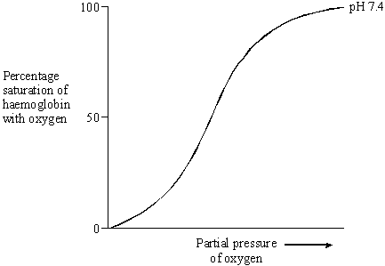
(i) Sketch a curve on the graph to show the likely position of the dissociation curve at pH 7.2.
(1)

(ii) Explain how a change in pH from 7.4 to 7.2 affects the supply of oxygen by haemoglobin to the tissues.
.............................................................................................................
.............................................................................................................
.............................................................................................................
.............................................................................................................
.............................................................................................................
.............................................................................................................
(2)

(b) Explain what causes the pH to be reduced from 7.4 to 7.2 in a tissue.
......................................................................................................................
......................................................................................................................
......................................................................................................................
......................................................................................................................
......................................................................................................................
......................................................................................................................
(3)
(Total 6 marks)

Q3. The graph shows changes in pressure in the aorta, left ventricle and left atrium during one heart beat.
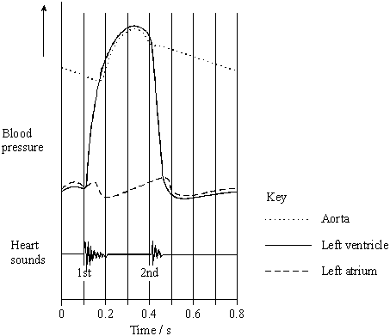
(a) The maximum pressure in the left atrium is lower than the maximum pressure in the left ventricle. What causes this difference in maximum pressure?
......................................................................................................................
......................................................................................................................
(1)

(b) A stethoscope can be used to listen to the sounds made by the heart.
(i) What is the evidence from the graph that the first heart sound is caused by the atrioventricular valve closing?
.............................................................................................................
.............................................................................................................
(1)

(ii) What causes the second heart sound? Give the reason for your answer.
.............................................................................................................
.............................................................................................................
.............................................................................................................
.............................................................................................................
(2)
(Total 4 marks)

Q4. The diagram shows some blood vessels in muscle tissue.
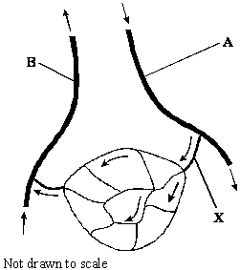
(a) (i) Which type of blood vessel is X?
.............................................................................................................
(1)

(ii) Name two substances which are at a higher concentration in the blood at A than in the blood at B.
1 ..........................................................................................................
2 ..........................................................................................................
(1)

(b) The table shows the mean diameter of the lumen and the rate of blood flow in some types of human blood vessel.

Type of blood vessel | Mean diameter of lumen /  μm | Rate of blood flow /  cm s^{–1}
Artery | 400 | 10 – 40
Arteriole | 30 | 0.1 – 10
Capillary | 8 | less than 0.1

Using information in the table, explain what causes the rate of blood flow to be slower in capillaries than in other vessels.
......................................................................................................................
......................................................................................................................
......................................................................................................................
......................................................................................................................
(2)

(c) (i) Which type of blood vessel has most elastic tissue in its wall?
.............................................................................................................
(1)

(ii) How does this elastic tissue help to smooth out the flow of blood in the blood vessel?
.............................................................................................................
.............................................................................................................
.............................................................................................................
.............................................................................................................
(2)
(Total 7 marks)

Q5. The graph shows dissociation curves for haemoglobin in a fetus and in an adult.
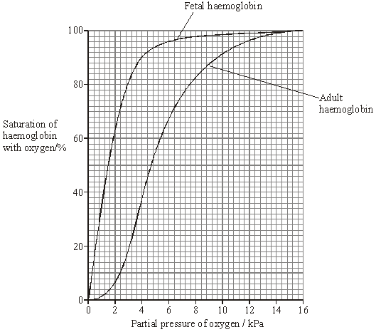
(a) (i) What is the difference in percentage saturation between fetal haemoglobin and adult haemoglobin at a partial pressure of 3 kPa?
.............................................................................................................
(1)

(ii) Explain the advantage of the curve for fetal haemoglobin being different from the curve for adult haemoglobin.
.............................................................................................................
.............................................................................................................
.............................................................................................................
.............................................................................................................
(2)

(b) The dissociation curve for adult haemoglobin changes during vigorous exercise.
(i) Sketch on the graph the position of the curve during vigorous exercise.
(1)

(ii) Explain the advantage of this change in position.
.............................................................................................................
.............................................................................................................
.............................................................................................................
.............................................................................................................
(2)
(Total 6 marks)

Q6. Lung cancer, chronic bronchitis and coronary heart disease (CHD) are associated with smoking. Tables 1 and 2 give the total numbers of deaths from these diseases in the UK in 1974.
Table 1 Men

Age/years | Number of deaths  (in thousands)
 | lung cancer | chronic bronchitis | coronary heart disease
35 - 64 | 11.5 | 4.2 | 31.7
65 - 74 | 12.6 | 8.5 | 33.3
75+ | 5.8 | 8.1 | 29.1
Total (35 - 75+) | 29.9 | 20.8 | 94.1

Table 2 Women

Age/years | Number of deaths  (in thousands)
 | lung cancer | chronic bronchitis | coronary heart disease
35 – 64 | 3.2 | 1.3 | 8.4
65 – 74 | 2.6 | 1.9 | 18.2
75+ | 1.8 | 3.5 | 42.3
Total (35 – 75+) | 7.6 | 6.7 | 68.9

(i) Using an example from the tables, explain why it is useful to give data for men and women separately.
......................................................................................................................
......................................................................................................................
......................................................................................................................
(2)

(ii) Data like these are often given as percentages of people dying from each cause.
Explain the advantage of giving these data as percentages.
......................................................................................................................
......................................................................................................................
......................................................................................................................
......................................................................................................................
(2)

(Total 4 marks)

Q7. S In an investigation, the effects of caffeine on performance during exercise were measured. One group of athletes (A) was given a drink of decaffeinated coffee. Another group (B) was given a drink of decaffeinated coffee with caffeine added. One hour later the athletes started riding an exercise bike and continued until too exhausted to carry on. Three days later the same athletes repeated the experiment, with the drinks exchanged.
(a) (i) The researchers added caffeine to decaffeinated coffee. Explain why they did not just use normal coffee.
.............................................................................................................
.............................................................................................................
(1)

(ii) The performance of the athletes might have been influenced by how they expected the caffeine to affect them. How could the researchers avoid this possibility?
.............................................................................................................
.............................................................................................................
(1)

During the exercise the concentrations of glycerol and fatty acids in the blood plasma were measured. The results are shown in the table.

Drink | Mean time to exhaustion  /minutes | Mean  concentration of  blood glycerol/  mmol dm^{–3} | Mean  concentration of  blood fatty acids/  mmol dm^{–3}
With caffeine | 90.2 | 0.20 | 0.53
Without caffeine | 75.5 | 0.09 | 0.31

(b) (i) Describe the effect of caffeine on exercise performance.
.............................................................................................................
.............................................................................................................
(1)

(ii) Suggest one explanation for the higher glycerol and fatty acid concentrations in the blood plasma of the athletes after they were given caffeine.
.............................................................................................................
.............................................................................................................
.............................................................................................................
.............................................................................................................
(2)

(c) The researchers measured the volumes of carbon dioxide exhaled and oxygen inhaled during the exercise. From the results they calculated the respiratory quotient (RQ), using the formula
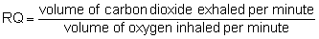
When a person is respiring carbohydrate only, RQ = 1.0
When a person is respiring fatty acids only, RQ = 0.7
(i) The basic equation for the respiration of glucose is
C₆H₁₂O₆ + 6O₂ → 6CO₂ + 6H₂O
Explain why the RQ for glucose is 1.0.
.............................................................................................................
.............................................................................................................
.............................................................................................................
.............................................................................................................
(2)

(ii) The researchers found that, when the athletes were given the drink containing caffeine, their mean RQ was 0.85. When given the drink without caffeine their mean RQ was 0.92.
The researchers concluded that when the athletes had caffeine they used glycogen more slowly than when they did not have caffeine, and that the store of glycogen in their muscles was used up less quickly during the exercise.
Explain the evidence from the information above and from the table which supports these conclusions.
.............................................................................................................
.............................................................................................................
.............................................................................................................
.............................................................................................................
.............................................................................................................
.............................................................................................................
(3)
(Total 10 marks)

M1. (a) 1. permeable capillary wall / membrane;
2. single cell thick / thin walls, reduces diffusion distance;
3. flattened (endothelial) cells, reduces diffusion distance;
4. fenestrations, allows large molecules through;
5. small diameter / narrow, gives a large surface area to volume / short diffusion distance;
6. narrow lumen, reduces flow rate giving more time for diffusion;
7. red blood cells in contact with wall / pass singly, gives short diffusion distance / more time for diffusion;
(allow 1 mark for 2 features with no explanation)
4 max

(b) 1. (hydrostatic) pressure of blood high at arterial end;
2. fluid / water / soluble molecules pass out (reject plasma);
3. proteins / large molecules remain;
4. this lowers the water potential / water potential becomes more negative;
5. water moves back into venous end of capillary (reject tissue fluid) by osmosis / diffusion;
6. lymph system collects any excess tissue fluid which returns to blood / circulatory system / link with vena cava / returns tissue fluid to vein;
6
[10]
QWC 1

M2. (a) (i) curve to right of curve for pH 7.4;
1
(ii) more oxygen unloaded / given up / affinity decreased / reduced saturation; oxyhaemoglobin dissociates at higher oxygen concentration / partial pressure / more oxygen unloaded at the same ppO₂;
2

(b) (aerobic) respiration will produce carbon dioxide / anaerobic respiration produces lactate;
carbon dioxide dissolves in blood forming acid;
increases hydrogen ion concentration;
3
[6]

M3. (a) less muscle / thin(ner) wall in left atrium;
1
(b) (i) pressure of left ventricle higher than pressure of left atrium;
1
(ii) closing of the semi-lunar valves / pocket valves;
pressure in artery / aorta is higher than ventricle;
2
[4]

M4. (a) (i) arteriole;
1
(ii) any two
oxygen / glucose / amino acids / fatty acids / glycerol / minerals;
1

(b) small diameter / lumen / small mean cross sectional area / increase in
(total) cross sectional area;
more surface in contact with blood / greater friction / resistance;
2

(c) (i) artery;
1
(ii) stretches / expands to accommodate increase in blood
volume / when ventricle contracts / increase in blood pressure;
recoils when blood volume decreases / when ventricle
relaxes / blood pressure decreases;
2
[7]

M5. (a) (i) 62
ignore units
1
(ii) fetal haemoglobin has higher affinity for oxygen / takes up oxygen
(becomes saturated) at lower partial pressure;
at partial pressures when adult haemoglobin dissociates fetal
haemoglobin takes up oxygen;
2

(b) (i) new ‘S’ shaped curve draw to the right of the adult curve;
1
(ii) haemoglobin dissociates / unloads more readily /
more oxygen delivered to cell / muscles / respiring tissue;
at a particular partial pressure more oxygen is released;
2
[6]

M6. (i) Because there are big differences;
any correct named example e.g. lung cancer / bronchitis much lower
in women than in men;
2
(ii) easier to compare if sample size effectively the same;
different numbers of people in each group;
2

[4]

M7. (a) (i) in case normal coffee differs in some other way /
to control concentration of caffeine;
1
(ii) not telling them what the drink contained / purpose of experiment;
1

(b) (i) able to continue for longer; (not just increases performance)
(disqualify if also refers to fatty acids and glycerol)
1
(ii) breakdown of fats;
at increased rate / by mobilisation of fat stores;
2

(c) (i) idea that volumes of oxygen and carbon dioxide the same;
reference to equal moles, or quotient as 1 divided by 1 / or 6 by 6;
2
(ii) glycogen is a carbohydrate / broken down to glucose, linked to RQ;
with no caffeine, RQ nearer 1.0 / less carbon dioxide exhaled and
more oxygen inhaled (or vice versa) / with caffeine higher proportion of fats / fatty acids respired;
increased time to exhaustion suggests slower use of glycogen:
3
[10]

