**Q1.**Scientists studied the rate of carbon dioxide uptake by grape plant leaves. Grape leaves have stomata on the lower surface but no stomata on the upper surface.

The scientists recorded the carbon dioxide uptake by grape leaves with three different treatments:

**Treatment 1** − No air-sealing grease was applied to either surface of the leaf.

**Treatment 2** − The lower surface of the leaf was covered in air-sealing grease that prevents gas exchange.

**Treatment 3** − Both the lower surface and the upper surface of the leaf were covered in air–sealing grease that prevents gas exchange.

The scientists measured the rate of carbon dioxide uptake by each leaf for 60 minutes in light and then for 20 minutes in the dark.

The scientists’ results are shown in the diagram below.

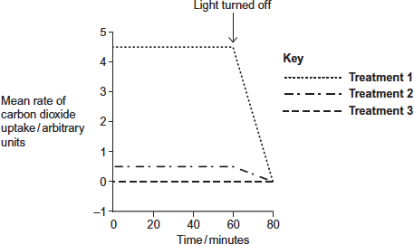

(a)     Suggest the purpose of each of the three leaf treatments.

**Treatment 1** ..................................................................................................

........................................................................................................................

........................................................................................................................

**Treatment 2** ..................................................................................................

........................................................................................................................

........................................................................................................................

**Treatment 3** ..................................................................................................

........................................................................................................................

........................................................................................................................

**(3)**

(b)     (i)      Describe the results shown for **Treatment 1**.

...............................................................................................................

...............................................................................................................

...............................................................................................................

...............................................................................................................

...............................................................................................................

**(2)**

(ii)     The stomata close when the light is turned off.

Explain the advantage of this to the plant.

...............................................................................................................

...............................................................................................................

...............................................................................................................

...............................................................................................................

...............................................................................................................

**(2)**

(c)     (i)      **Treatment 2** shows that even when the lower surface of the leaf is sealed there is still some uptake of carbon dioxide.

Suggest how this uptake of carbon dioxide continues.

...............................................................................................................

...............................................................................................................

...............................................................................................................

**(1)**

(ii)     In both **Treatment 1** and **Treatment 2**, the uptake of carbon dioxide falls to zero when the light is turned off.

Explain why.

...............................................................................................................

...............................................................................................................

...............................................................................................................

...............................................................................................................

...............................................................................................................

**(2)**

**(Total 10 marks)**

**Q2.**(a)     On islands in the Caribbean, there are almost 150 species of lizards belonging to the genus *Anolis*. Scientists believe that these species evolved from two species found on mainland USA. Explain how the Caribbean species could have evolved.

**(6)**

(b)     *Anolis sagrei* is a species of lizard that is found on some of the smallest Caribbean islands. Describe how you could use the mark-release-recapture method to estimate the number of *Anolis sagrei* on one of these islands.

**(4)**

(c)     Large areas of tropical forest are still found on some Caribbean islands. The concentration of carbon dioxide in the air of these forests changes over a period of 24 hours and at different heights above ground.

Use your knowledge of photosynthesis and respiration to describe and explain how the concentration of carbon dioxide in the air changes:

•        over a period of 24 hours

•        at different heights above ground.

**(5)**

**(Total 15 marks)**

**Q3.**Scientists measured the rate of respiration in **three** parts of an ecosystem.

They did this by measuring carbon dioxide released into the air by:

•        leaves of plants

•        stems and roots of plants

•        non-photosynthetic soil organisms.

The table below shows the scientists’ results for these three parts of the ecosystem.

|  |  |  |  |
| --- | --- | --- | --- |
|  | **Part of ecosystem** | **Mean rate of carbon dioxide production / cm3 m−2 s−1** | **Percentage of total carbon dioxide production measured by the scientists** |
|  | Leaves of plants | 0.032 | 25.0 |
|  | Stems and roots of plants | 0.051 |  |
|  | Non- photosynthetic soil organisms | 0.045 |  |

(a)     Complete the table to show the percentage of total carbon dioxide production by each part of the ecosystem.

Show your working.

**(2)**

(b)     A student who looked at the data in the table concluded that plants carry out more respiration than non-photosynthetic organisms in the ecosystem.

Use the information provided to suggest why these data may **not** support the student’s conclusion.

........................................................................................................................

........................................................................................................................

........................................................................................................................

........................................................................................................................

**(2)**

(c)     What measurements would the scientists have made in order to calculate the rate of carbon dioxide production?

........................................................................................................................

........................................................................................................................

........................................................................................................................

........................................................................................................................

**(2)**

(d)     The scientists calculated the mean rate of carbon dioxide production of the leaves using measurements of carbon dioxide release in the dark.

Explain why they did **not** use measurements taken in the light.

........................................................................................................................

........................................................................................................................

........................................................................................................................

........................................................................................................................

**(2)**

Another group of scientists measured the mean rate of respiration in soil under trees and soil not under trees in the same wood. They also measured the mean rate of photosynthesis in the trees.

They took measurements at different times of day during the summer.

The figure below shows the scientists’ results.

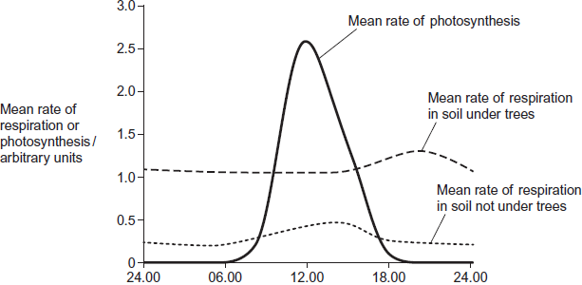  
          Time of day

(e)     (i)      Describe **two** ways in which the mean rate of respiration in soil under trees is different from soil not under trees.

1 ............................................................................................................

...............................................................................................................

2 ............................................................................................................

...............................................................................................................

**(2)**

(ii)     Suggest **one** explanation for the differences in the mean rate of respiration in soil under trees and soil not under trees between 06.00 and 12.00.

...............................................................................................................

...............................................................................................................

...............................................................................................................

...............................................................................................................

**(2)**

(f)     The scientists suggested that the rise in the mean rate of photosynthesis was the cause of the rise in the mean rate of respiration in soil under trees.

(i)      Suggest how the rise in the mean rate of photosynthesis could lead to the rise in the mean rate of respiration in soil under trees.

...............................................................................................................

...............................................................................................................

...............................................................................................................

...............................................................................................................

**(2)**

(ii)     Suggest why there is a delay between the rise in the mean rate of photosynthesis and the rise in the mean rate of respiration.

...............................................................................................................

...............................................................................................................

**(1)**

**(Total 15 marks)**

**Q4.**Scientists investigated the effect of the water potential of soil water on plant growth. They investigated the effect of this water potential on several plant processes.

The figure below shows their results in the form they were presented. The bars show whether or not each process was occurring.

The plants stopped growing when the water potential of the soil water was below –0.7 mPa. All of the changes in the plants were related to the ability of the roots to take up water from the soil.

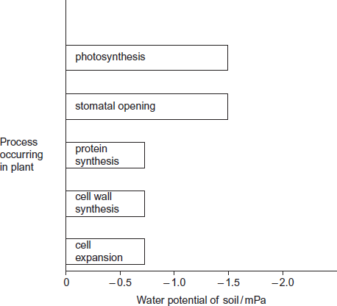

(a)     Describe the results in the figure.

........................................................................................................................

........................................................................................................................

........................................................................................................................

........................................................................................................................

........................................................................................................................

**(2)**

(b)     Explain the relationship between stomatal opening and photosynthesis.

........................................................................................................................

........................................................................................................................

........................................................................................................................

........................................................................................................................

........................................................................................................................

**(2)**

(c)     Although photosynthesis is still occurring, plants stop growing when the soil water potential falls below –0.7 mPa.

Use information from the figure above to suggest two reasons why.

........................................................................................................................

........................................................................................................................

........................................................................................................................

........................................................................................................................

........................................................................................................................

........................................................................................................................

**(3)**

**(Total 7 marks)**

**Q5.**Scientists investigated the effect of iron deficiency on the production of triose phosphate in sugar beet plants. They grew the plants under the same conditions with their roots in a liquid growth medium containing all the necessary nutrients. Ten days before the experiments, they transferred half the plants to a liquid growth medium containing no iron. The scientists measured the concentration of triose phosphate produced in these plants and in the control plants:

•        at the end of 6 hours in the dark

•        then for 16 hours in the light.

Their results are shown in the graph.

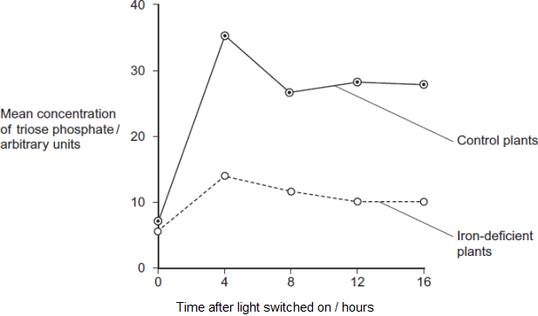

(a)     (i)      The experiments were carried out at a high carbon dioxide concentration. Explain why.

...............................................................................................................

...............................................................................................................

...............................................................................................................

**(1)**

(ii)     Explain why it was important to grow the plants under the same conditions up to ten days before the experiment.

...............................................................................................................

...............................................................................................................

...............................................................................................................

**(1)**

(iii)    The plants were left in the dark for 6 hours before the experiment. Explain why.

...............................................................................................................

...............................................................................................................

...............................................................................................................

**(1)**

(b)     Iron deficiency reduces electron transport. Use this information and your knowledge of photosynthesis to explain the decrease in production of triose phosphate in the iron-deficient plants.

........................................................................................................................

........................................................................................................................

........................................................................................................................

........................................................................................................................

........................................................................................................................

........................................................................................................................

........................................................................................................................

........................................................................................................................

*(Extra space)*.................................................................................................

........................................................................................................................

........................................................................................................................

........................................................................................................................

**(4)**

(c)     Iron deficiency results in a decrease in the uptake of carbon dioxide. Explain why.

........................................................................................................................

........................................................................................................................

........................................................................................................................

........................................................................................................................

**(2)**

**(Total 9 marks)**

**Q6.**Some species of crop plant produce a substance called glycinebetaine (GB).

Scientists transferred the gene for GB into a species of crop plant that does not normally produce GB. These genetically modified plants then produced GB.

The scientists grew large numbers of the same crop plant with and without the gene at different temperatures. After 3 days, they found the increase in dry mass of the plants.

**Figure 1** shows their results.

**Figure 1**

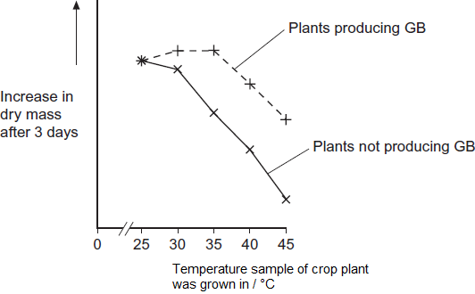

(a)     Describe the effect on growth of transferring the gene for GB into this plant.

........................................................................................................................

........................................................................................................................

........................................................................................................................

........................................................................................................................

........................................................................................................................

**(2)**

(b)     The scientists measured the rate of photosynthesis in plants that produce GB and plants that do not produce GB at 25°C, 35°C and 45°C.

**Figure 2** shows their results.

**Figure 2**

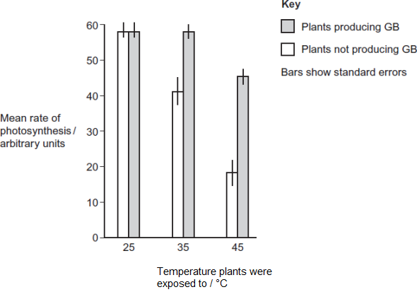

(i)      The scientists concluded that the production of GB protects photosynthesis from damage by high temperatures.

Use these data to support this conclusion.

...............................................................................................................

...............................................................................................................

...............................................................................................................

**(1)**

(ii)     Use the data from **Figure 2**  for plants that do not produce GB to explain the effect of temperature on changes in dry mass of the plants shown in **Figure 1.**

...............................................................................................................

...............................................................................................................

...............................................................................................................

...............................................................................................................

...............................................................................................................

...............................................................................................................

...............................................................................................................

...............................................................................................................

*(Extra space)*........................................................................................

...............................................................................................................

...............................................................................................................

...............................................................................................................

**(4)**

Rubisco activase is an enzyme found in chloroplasts. It activates the light-independent reaction of photosynthesis.

The scientists discovered that, as temperature increased from 25°C to 45°C, rubisco activase began attaching to thylakoid membranes in chloroplasts and this stopped it working.

(c)     Rubisco activase stops working when it attaches to a thylakoid.

Use your knowledge of protein structure to explain why.

........................................................................................................................

........................................................................................................................

........................................................................................................................

........................................................................................................................

........................................................................................................................

**(2)**

(d)     The scientists investigated the effect of GB on attachment of rubisco activase to thylakoid membranes at different temperatures.

**Figure 3** shows their results.

**Figure 3**

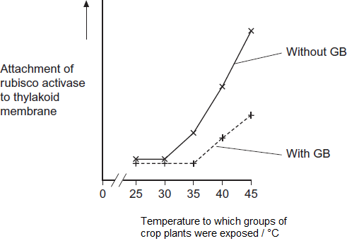

Use information from **Figure 2** and **Figure 3** to suggest how GB protects the crop plant from high temperatures.

........................................................................................................................

........................................................................................................................

........................................................................................................................

........................................................................................................................

........................................................................................................................

........................................................................................................................

........................................................................................................................

........................................................................................................................

*(Extra space)*..................................................................................................

........................................................................................................................

........................................................................................................................

........................................................................................................................

**(4)**

(e)     The scientists’ hypothesis at the start of the investigation was that crop plants genetically engineered to produce GB would become more resistant to high environmental temperatures.  
The scientists developed this hypothesis on the basis of previous research on crops that are grown in hot climates.

Suggest how the scientists arrived at their hypothesis.

........................................................................................................................

........................................................................................................................

........................................................................................................................

........................................................................................................................

........................................................................................................................

**(2)**

**(Total 15 marks)**

**Q7.**Plants have pigments that absorb light energy for photosynthesis. These pigments include two types of chlorophyll and a group of pigments known as carotenoids. Different species of plant contain different amounts of these pigments. The pigments that each plant species has are adaptations to where and how they live; their ecological niche.

**Figure 1** shows the absorption of light of different wavelengths by chlorophyll a, chlorophyll b and carotenoids.

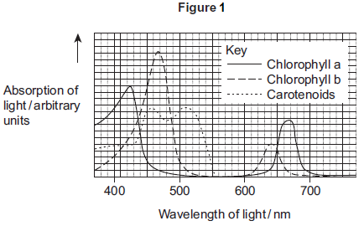

A scientist investigated the energy in light of different wavelengths reaching the ground in a forest. She measured the energy in

•        direct sunlight

•        sunlight that had passed through the leaves of trees.

**Figure 2** shows her results.

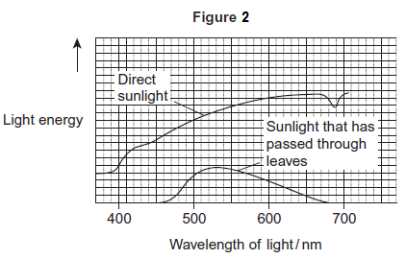

(a)     Use **Figure 1** to describe the absorption of light of different wavelengths by chlorophyll a.

.........................................................................................................................

.........................................................................................................................

.........................................................................................................................

.........................................................................................................................

.........................................................................................................................

**(2)**

(b)     Few species of plant can live below large trees in a forest.  
Use the information in **Figure 1** and **Figure 2** to suggest why.

.........................................................................................................................

.........................................................................................................................

.........................................................................................................................

.........................................................................................................................

.........................................................................................................................

.........................................................................................................................

*(Extra space)* ..................................................................................................

.........................................................................................................................

.........................................................................................................................

**(3)**

(c)     In leaves at the top of trees in a forest, carbon dioxide is often the limiting factor for photosynthesis.  
Use your knowledge of photosynthesis to suggest and explain **one** reason why.

.........................................................................................................................

.........................................................................................................................

.........................................................................................................................

.........................................................................................................................

.........................................................................................................................

**(2)**

**(Total 7 marks)**

**Q8.**Beech trees have two types of leaves called sun leaves and shade leaves. Sun leaves grow on branches exposed to direct sunlight, shade leaves grow on branches exposed to light that has passed through leaves. An ecologist collected sun leaves and shade leaves from beech trees and determined the mean mass of each photosynthetic pigment in both types of leaf. His results are shown the table below.

|  |  |  |  |
| --- | --- | --- | --- |
|  | **Photosynthetic pigment** | **Mean mass of each pigment per m2 of leaf area / μg (± standard deviation)** | |
|  | **Sun leaves** | **Shade leaves** |
|  | Chlorophyll a | 299.3 (± 2.1) | 288.9 (± 0.1) |
|  | Chlorophyll b | 290.7 (± 2.1) | 111.1 (± 0.1) |
|  | Chlorophyll c | 0.10 (± 0.01) | 0.07 (± 0.01) |

(a)     Describe how you would present the data in the table as a graph.

.........................................................................................................................

.........................................................................................................................

.........................................................................................................................

.........................................................................................................................

.........................................................................................................................

**(2)**

(b)     The ecologist collected shade leaves at random from a branch.  
Suggest a method he could have used to collect shade leaves at random from a branch.

.........................................................................................................................

.........................................................................................................................

.........................................................................................................................

.........................................................................................................................

.........................................................................................................................

**(2)**

(c)     The ecologist concluded that there is a significant difference between the amounts of chlorophyll b in sun leaves and shade leaves of beech trees.

Do you agree with this conclusion?

.........................................................................................................................

.........................................................................................................................

.........................................................................................................................

.........................................................................................................................

.........................................................................................................................

**(2)**

(d)     Each type of chlorophyll is produced by a specific enzyme-controlled pathway.  
Use this information to suggest how the same beech tree can produce more chlorophyll b in some leaf cells than others.

.........................................................................................................................

.........................................................................................................................

.........................................................................................................................

.........................................................................................................................

.........................................................................................................................

**(2)**

**(Total 8 marks)**

**M1.**(a)     1.      (No grease)

            means stomata are open

            OR

            allows normal CO2 uptake;

*Allow ‘gas exchange’ for CO2 uptake.*

*‘As a control’ is insufficient on its own.*

2.      (Grease on lower surface)

seals stomata

OR

stops CO2 uptake through

stomata

OR

to find CO2 uptake through

stomata

OR

shows CO2 uptake through cuticle / upper surface;

3.      (Grease on both surfaces) shows sealing is effective

OR

stops all CO2 uptake.

**3**

(b)     (i)      1.      (Mean rate of) carbon dioxide uptake was constant *and* fell after the light turned off;

*Ignore absence of arbitrary units in both marking points.*

*Both ideas needed for mark.*

*Accept ‘stayed at 4.5’ as equivalent to ‘was constant’.*

2.      Uptake fell from 4.5 to 0 / uptake started to fall at 60 minutes and reached lowest at 80 minutes / uptake fell over period of 20 minutes;

*One correct use of figures required.*

*Accept fell to nothing / no uptake for 0.*

**2**

(ii)     1.      (Because) water is lost through stomata;

2.      (Closure) prevents / reduces water loss;

3.      Maintain water content of cells.

*This marking point rewards an understanding of reducing water loss e.g. reduce wilting, maintain turgor, and is not related to photosynthesis.*

**2 max**

(c)     (i)      (Carbon dioxide uptake) through the upper surface of the leaf / through cuticle.

**1**

(ii)     1.      No use of carbon dioxide in photosynthesis (in the dark);

2.      No diffusion gradient (maintained) for carbon dioxide into leaf / there is now a diffusion gradient for carbon dioxide out of leaf (due to respiration).

**2**

**[10]**

**M2.**(a)     1.      Geographic(al) isolation;

2.      Separate gene pools / no interbreeding / gene flow (between populations);

*Accept: reproductive isolation*

*This mark should only be awarded in context of during the process of speciation. Do not credit if context is after speciation has occurred.*

3.      Variation due to mutation;

4.      Different selection pressures / different abiotic / biotic conditions / environments / habitats;

*Neutral: different conditions / climates if not qualified*

*Accept: named abiotic / biotic conditions*

5.      Different(ial) reproductive success / selected organisms (survive and) reproduce;

*Accept: pass on alleles / genes to next generation as equivalent to reproduce*

6.      Leads to change / increase in allele frequency.

*Accept: increase in proportion / percentage as equivalent to frequency*

**6**

(b)     1.      Capture / collect sample, mark and release;

2.      Method of marking does not harm lizard / make it more visible to predators;

3.      Leave sufficient time for lizards to (randomly) distribute (on island) before collecting a second sample;

4.      (Population =) number in first sample × number in second sample divided by number of marked lizards in second sample / number recaptured.

**4**

(c)     1.      High concentration of / increase in carbon dioxide linked with respiration at          night / in darkness;

2.      No photosynthesis in dark / night / photosynthesis only in light / day;

*Neutral: less photosynthesis*

3.      In light net uptake of carbon dioxide / use more carbon dioxide than produced / (rate of) photosynthesis greater than rate of respiration;

4.      Decrease in carbon dioxide concentration with height;

*More carbon dioxide absorbed higher up*

*Accept: less carbon dioxide higher up / more carbon dioxide lower down*

5.      (At ground level)

         less photosynthesis / less photosynthesising tissue / more respiration / more micro-organisms / micro-organisms produce carbon dioxide.

*Neutral: less leaves unqualified or reference to animals*

**5**

**[15]**

**M3.**(a)

|  |  |  |  |
| --- | --- | --- | --- |
|  | **Part of ecosystem** | **Mean rate of carbon dioxide production /  cm3 m−2 s−1** | **Percentage of total carbon dioxide production measured by the scientists** |
|  | Leaves of plants | 0.032 | 25.0 |
|  | Stems and roots of plants | 0.051 | **39.8** |
|  | Non- photosynthetic soil organisms | 0.045 | **35.2** |

2 correct = 2 marks;;

Adding rates to get 0.128 = 1;

*If rounded to 40 and 35 in table;*

*•    but working shows decimal points, then award 2 marks   
•    but no working shown, then 1 max*

**2 max**

(b)     1.      Data only include (heterotrophic) soil organisms;

2.      Doesn’t include animals (above ground) / other (non-soil) organisms;

3.      Doesn’t take into account anaerobic respiration;

*Award points in any combination*

*Accept for 1 mark idea that CO2 for leaves doesn’t take into account photosynthesis – not told in dark until part (d)*

**2 max**

(c)     **All three** of following = 2 marks;;

**Two** of them = 1 mark;

Volume of carbon dioxide given off

(From known) area / per m2 / m-2

In a known / set time

*Ignore ‘amount’ / concentration of CO2*

*Accept per second / per unit time*

**2**

(d)     1.      (In the light) photosynthesis / in the dark no photosynthesis;

2.      (In light,) carbon dioxide (from respiration) being used / taken up (by photosynthesis);

**2**

(e)     (i)      (Rate of respiration)

*Assume “it” means soil under trees*

1.      In soil under trees (always) higher;

*Accept converse for soil not under trees*

*Accept ‘in the shade’ means under the trees*

2.      In soil under trees does not rise between 06.00 and 12.00 / in the middle of the day / peaks at 20:00-21.00 / in the evening;

3.      In soil **not** under trees, peaks at about 14:00-15:00 / in middle of day;

*2. and 3. No mm grid, so accept ‘between 18.00 and 24.00’ or ‘between 12.00 and 18.00’*

**2 max**

(ii)     (Between 06.00 and 12.00, (No Mark))

Respiration higher in soil under tree, (No mark)

*Do not mix and match mark points*

*No list rule*

1.      Tree roots carry out (a lot of) respiration;

2.      More / there are roots under tree;

*Accept converse for soil not under trees*

***OR***

3.      More food under trees;

4.      So more active / greater mass of / more organisms (carrying out respiration);

*Accept converse for soil not under trees*

***OR***

Soil not under trees respiration increases (No mark)

5.      Soil in sunlight gets warmer;

6.      Enzymes (of respiration) work faster;

*Accept converse for soil under trees*

**2 max**

(f)      (i)      1.      Photosynthesis produces sugars;

2.      Sugars moved to roots;

*Do not penalise named sugars other than sucrose*

3.      (Sugars) are used / required for respiration;

**2 max**

(ii)     Takes time to move sugars to roots;

*Look for movement idea in (i) – can carry forward to (ii)*

**1**

**[15]**

**M4.**(a)     1.      Protein synthesis **and** cell wall synthesis **and** cell expansion   
         stop at −0.7 / at a *higher* water potential than other two;

*If all 3 are correctly identified in marking point 1, accept ‘the others / the other two’ in marking point 2, and vice versa*

2.      Photosynthesis **and** stomatal opening stop at -1.5 / at a *lower* water potential than other three;

*Correct processes must be named in at least one of marking point 1 or marking point 2*

*Where reference to water potential differences are made, they must be comparative, eg ‘higher’*

**2**

(b)     1.      Stomata allow uptake of carbon dioxide;

2.      Carbon dioxide used in / required for photosynthesis;

**2**

(c)     1.      Growth involves cell division / cell expansion / increase in mass;

*Marking point 1 is for the principle*

2.      Protein synthesis stops **so** no enzymes / no membrane proteins / no named protein (for growth / division);

*Marking points 2, 3 and 4 require appreciation of ‘why’ before credit can be awarded*

*‘named’ protein must relate to proteins involved in growth or cell division*

3.      Cell wall synthesis stops **so** no new cells can be made;

*Full credit is possible without a statement of the principle   
(marking point 1)*

4.      No cell expansion / increase in mass **because** (cells) stop taking up water;

**3 max**

**[7]**

**M5.**(a)     (i)    So it / CO2 is not a limiting factor (on growth / photosynthesis);

*Accept: CO2 is a limiting factor*

**1**

(ii)     So any difference is due to iron (deficiency);

*Accept: iron is the variable*

**1**

(iii)    Amount of triose phosphate / TP will be similar / same / low (at start);

*Accept: to allow triose phosphate to stabilise / become constant*

*Reject: so all triose phosphate is used up*

*Reject: so no triose phosphate*

**1**

(b)     1.      (Less) ATP produced;

*Accept: alternatives for reduced NADP ie NADP with hydrogen / s attached*

2.      (Less) reduced NADP produced;

3.      ATP / reduced NADP produced during light-dependent reaction;

4.      (Less) GP to triose phosphate / TP;

**4**

(c)     1.      Less triose phosphate converted to RuBP;

*Accept: less triose phosphate so less RuBP*

2.      CO2 combines with RuBP;

**2**

**[9]**

**M6.**(a)     1.      No effect at 25°C

*The question only refers to plants with GB*

*1. Reject same mass*

2.      Keeps growing at 30°C and 35°C / up to 35°C (more than without GB);

3.      Above 35°C, falls but grows more than plant without GB;

*3. Accept at all temperatures above 25°C more growth than without GB*

**2 max**

(b)     (i)      Significantly different / SEs do not overlap ;

*Accept converse without GB*

**1**

(ii)     (As temperature increases,)

1.      Enzyme activity reduced / (some) enzymes denatured;

2.      Less photosynthesis, so fewer sugars formed;

3.      Less respiration / less energy / ATP for growth;

4.      Less energy for named function associated with growth

*4. Eg mitosis, uptake of mineral ions*

**4**

(c)     1.      (Rubisco activase attaches to thylakoid and) this changes shape / tertiary structure (of enzyme) / blocks active site / changes active site;

*Note - question states enzyme stops working when it attaches to thylakoid, not before*

*1. Accept rubisco in this context*

2.      (This) prevents substrate / RuBP entering active site / binding;

*2. Accept prevents ES complex forming*

*2. Accept no longer complementary to substrate / RuBP*

**2**

(d)     1.      GB prevents / reduces binding of rubiscoactivase to (thylakoid membrane);

*1. Accept enzyme instead of rubiscoactivase. Accept rubisco*

2.      (Prevents it) up to 35°C;

3.      (So) rubiscoactivase / enzyme remains active;

4.      (So) photosynthesis / light-independent stage still happens;

*4. Accept descriptions of light-independent stage*

5.      Above 35°C, some binding still occurs but less than without GB, so less reduction in growth;

**4 max**

(e)     1.      Looked for information / journals, on crop plants that grow at high temperatures;

*1. “other research” is minimum accepted*

*1. Accept previous experiments research with temperature resistant crops*

*Ignore simple references to looking at previous studies / other plants - need to relate to this context*

2.      (Crop plants cited in this research) contain / make GB;

3.      So assumed making plants produce GB makes them resistant to high temperatures;

**2 max**

**[15]**

**M7.**(a)     1.     Peaks at 420-430 and 660-670;

2.      No absorption of light between approximately 500 and 600;

3.      Highest peak at 420-430;

**2 max**

(b)     1.     Less (light) energy passes through leaves / reaches ground;

2.      Smaller range of wavelengths passes through leaves;

*Accept reference to only green (and yellow) light pass through*

3.      Little light for chlorophyll to absorb;

*Accept carotenoids can absorb this light*

4.      So insufficient photosynthesis (for growth);

*Sufficient photosynthesis for plants with carotenoids*

5.      Photosynthesis unlikely to exceed respiration;

**3 max**

(c)     1.     Light not limiting / lots of light (as no shading);

2.     Light-dependent reaction not limiting / fast;

***OR***

3.     Temperature not limiting / Warm (as no shading);

4.     Fast reactions of enzymes in light-independent reaction;

***OR***

5.     High use of CO2;

6.     Light-independent reaction is limiting;

*Mark as a pair*

**2**

**[7]**

**M8.**(a)     1.      Bar chart;

2.      Error bars to represent standard deviation (of mean);

3.      Photosynthetic pigment on *x* axis and mass of pigment on *y* axis;

*Accept suitable sketch*

**2 max**

(b)     1.      Number leaves on the branch;

2.      Use random number table / calculator / pick numbers from bag to determine which leaf to pick;

*Accept use of random number generator*

***OR***

3.      Collect large number of leaves;

4.      Pick out of bag with some idea of randomness;

**2**

(c)     No (no mark)

1.      No stats test carried out;

2.      Standard error / 95% confidence interval calculation identified;

*If awarded, student scores 2 marks – for points 1 and 2*

Yes (no mark)

3.      No overlap shown by the standard deviations;

4.      Ranges around mean stated;

*88.6-92.8 and 111.0-111.2 (1 × SD) or 86.5-94.9 and 110.9-111.3   
(2 × SD)*

**2 max**

(d)     In shade leaves:

1.      Greater amount of enzyme / enzyme activity (for production of chlorophyll b);

2.      Greater gene expression / transcription of the gene / more mRNA produced / gene switched on;

3.      Greater translation;

4.      Enzyme / substrate is light sensitive – faster rate of reaction with lower light;

**2 max**

**[8]**

**E1.**(a)     Most students gave reasonable suggestions for the purpose of treatments 1 and 2 but found the purpose of treatment 3 more difficult to explain. In this question and in question (c)(i), it was important that students had read the information in Resource B stating that these leaves have stomata only on their lower surface.

(b)     (i)      Students still find it difficult to describe a trend on a graph such as this accurately. Many students failed to state clearly that the rate stayed constant for the first 60 minutes and then fell (as required for mark point 1).

(ii)     Some students were not explicit enough in their answer that the water is lost through the stomata in order to achieve mark point 1.

(c)     (i)      Students who stated that there were stomata on the upper surface of the leaf could not be awarded this mark, as Resource B stated that these leaves have stomata only on their lower surface.

(ii)     Most students achieved mark point 1 but only better answers went on to explain why this meant there was no uptake of carbon dioxide.

**E2.**(a)     This question proved to be a very effective discriminator despite similar questions on speciation occurring previously in this component. The vast majority of students obtained the mark for geographical isolation / separation. However, many students only referred to the lack of interbreeding after the new species had been formed rather than during the process of speciation. These responses did not obtain the equivalent mark point. Variation and mutation were not always linked or one of these was omitted. Mutations were occasionally caused by the environment or by variation. Different selection pressures were well known although sometimes there were vague references to ‘different conditions’ or ‘different climates’. Most students understood that differential reproductive success resulted in a change in allele frequency although weaker students referred to ‘alleles reproducing’. Less than five percent of students managed to miss every marking point, sometimes after writing a whole page in response. These answers often described succession or directional selection.

(b)     As expected this question was very well answered with over seventy percent of students obtaining three out of the four marks available and just over a third obtaining maximum marks. Although there was some variation in which marking points were omitted, a significant number of students did not mention leaving time for lizards to distribute randomly in the population before obtaining a second sample. Other common errors included omitting any reference to releasing the lizards after they were initially captured and / or providing an incorrect equation for calculating the final population. Most students appreciated that the method of marking the lizards should not cause harm or make them conspicuous to predators.

(c)     This was another question which proved to be a good discriminator and provided a good spread of marks. There were some excellent answers with these students providing a detailed account of the relative effects of photosynthesis and respiration on the concentration of carbon dioxide in a forest over a period of 24 hours and at different heights above the ground. These answers included reference to the greater rate of photosynthesis than respiration during the day, a concept that was not found in the vast majority of scripts. At the other end of the range ability, students often only gained credit for linking an increase in concentration of carbon dioxide at night to respiration. Better answers did refer to ‘no photosynthesis’ at night for a second mark but a surprising number of students referred to ‘less photosynthesis’ at night, suggesting that it was still occurring. The information about heights above ground tended to be less clear and often failed to include more or less (respiration or photosynthesis). A surprising number of students suggested there was a greater carbon dioxide concentration higher up linked with more photosynthesis, despite previously giving correct descriptions of carbon dioxide uptake for photosynthesis and its release from respiration and gaining some of the earlier marking points. References to microorganisms were rare. A minority of answers described and explained changes in oxygen levels. Some students believed that the light-independent reaction could occur at night. A few responses described carbon dioxide levels in the upper layers of the atmosphere (troposphere, stratosphere).

**E3.**(a)    About three quarters of students obtained both marks for the calculation in this part. Some students only scored one mark because of incorrect rounding of numbers in their calculations or answers.

(b)     This part proved far more challenging than intended. It was hoped that students would note that only (plants and) non-photosynthetic soil organisms are mentioned in the study and point out that there are lots of other organisms / animals that are not mentioned. The examiners accepted statements that carbon dioxide from leaves did not take into account effects of photosynthesis, because students were not told until (d) that measurements were taken in the dark. Quite a few students treated the leaves of plants and the stems and roots of plants as separate organisms, rather than different parts of the same organisms. Nearly three quarters of students failed to score any marks.

(c)     To obtain two marks in this part, students had to identify three measurements: volume of carbon dioxide, from a given / known area, in a set time. If they identified two of these, they obtained one mark. A quarter of students obtained two marks and about half failed to score. There were many vague references to *amount* of carbon dioxide and *time* unqualified and many students missed out area altogether.

(d)     This part was done well by many students and three quarters obtained both marks. They were able to state that there is no photosynthesis in the dark and photosynthesis would take up carbon dioxide. Some students were confused about whether it was photosynthesis or respiration that produces carbon dioxide, or uses it.

(e)    (i)       Most students noted that respiration in soil under trees is always higher in this part. Over a third went on to describe a difference in the peak times of respiration in soil under trees and soil not under trees. Although a 2 mm grid was not given on the graph, the examiners expected some attempt to describe time frames, rather than just *earlier* or *later*.

(ii)     Correct answers to this part usually revolved around respiration in soil not under trees increasing because the soil gets warmer in sunshine and this leads to faster enzyme activity. Very few looked back to the table and noted the high rate of respiration in roots of plants, of which there would be a lot under trees. Many students thought that photosynthesis by the trees would make more oxygen available in the soil under the trees. Others thought that photosynthesis by the soil not under the trees would increase during the day.

(f)      As the final interpretive question on the final paper, this part was intended to be challenging and so it proved. Very few students appear to appreciate the relationship between photosynthesis and respiration in plants in terms of respiratory substrate. This was tested last year and proved challenging then. Students should appreciate that plants make their own respiratory substrates via photosynthesis. Those students who did score in this part did understand this. Given that many students treated leaves and roots of plants as separate organisms in (b), it was perhaps not surprising that very few students suggested it takes time for sugars to travel from leaves to roots. Some got ‘close’ by suggesting it took time for oxygen from photosynthesis to travel to the roots.

**E4.**(a)     Some of the lower-scoring students failed to access this question. Credit was available for stating that the relative processes stopped at particular values. Reference to processes happening at those values was insufficient, unless qualified by giving the range of values over which the processes happened. Some assessors incorrectly gave credit where positive, rather than negative, values were shown.

(b)     This question proved accessible to most but some explanations were unnecessarily complicated by reference to transpiration.

(c)     Many students found this question challenging. They were expected to suggest how growth was prevented when the processes stopped. Merely stating that they stopped was unworthy of a mark. Credit was inappropriately given by some assessors when the potential role of proteins as enzymes or membrane proteins, or the *naming* of a specific protein, had not been given. Some students failed to explain that a lack of cell wall synthesis would affect new cell production and consequently prevent growth. Higher-scoring students frequently achieved full credit.

**E5.**(a)     (i)      Three out of four students gained this mark by stating that carbon dioxide is a limiting factor on photosynthesis. Inadequate responses often simply stated that carbon dioxide was needed for photosynthesis.

(ii)     Twenty percent of students gained this mark by indicating that any difference in growth during the experiment would be due to iron deficiency. There was a large variety of incorrect responses but the majority referred to a ‘fair test’, ‘similar growth’ or ‘same level of TP’.

(iii)    Only the better responses included the realisation that the period in the dark was to ensure that the levels of triose phosphate were similar / low in both groups of plants at the start of the experiment. Many who did mention triose phosphate thought that it would all have been used up or converted to glucose / RuBP, ignoring the evidence from the graph. Weaker responses only referred to preventing the light-dependent reaction, or just preventing photosynthesis.

(b)     This question proved to be a very effective discriminator and produced a good range of marks. Most students gained a mark for ATP being produced during electron transport. Although many students then gained a mark for the production of reduced NADP, a significant minority incorrectly referred to NAD. The decrease in production of triose phosphate was not always linked to a decrease in glycerate-3-phosphate. Only better responses referred to ATP and reduced NADP being produced during the light-dependent reaction. Despite the stem of the question stating ‘knowledge of photosynthesis’ a number of students described electron transport during respiration.

(c)     This question caused some difficulty for students, with almost forty percent gaining no marks. It was surprising to find a number of students referring to respiration in their answers and confusing the Calvin cycle with the Krebs cycle. Some students with a better understanding failed to gain credit as they limited their explanation to the Calvin cycle being reduced. Students gaining one mark often referred to the role of RuBP in combining with carbon dioxide. Only the best responses linked iron deficiency to a reduction in the amount of triose phosphate and therefore less RuBP.

**E6.**As a whole, this question tested students’ understanding of the relationship between photosynthesis and the growth of plants. The questions were marked on outcome; this is to say that the examiners expected answers of A-level standard.

(a)     Many students failed to read the y axis carefully enough. All of the samples of plants increased in dry mass after 3 days, they all grew but some less than others. GB had no effect at 25°C, compared with plants without GB. Few students noted this and quite a number stated that GB produced more growth at all temperatures. Relatively few students made reference to the protection given to growth by GB up to 35°C. However, quite a few noted that growth was reduced less above 35°C with GB.

(b)     (i)      There was only one mark available for this question and, with this in mind, students were required to refer to the standard error bars not overlapping, or to state that there was a significant difference between plants producing GB and those that weren’t.

(ii)     Over a third of students obtained one mark, usually for linking a reduction in photosynthesis to a reduction in glucose (simple sugar) production. Some were also given credit for suggesting that the reduction could be linked to reduced enzyme activity. This was as far as most students went. Indeed, quite a large number wrote about reduced photosynthesis producing ‘less food for the plant’. This was disappointing at A-level. For most students, their statement about reduced glucose production was simply followed by ‘therefore growth falls’. There were very good answers that linked reduced glucose production to less respiratory substrate and thus less ATP / energy for growth. Others displayed understanding that sugars from photosynthesis form the basis for production of other organic substances and that these add to dry mass.

(c)     This was another question where some students failed to read the question carefully. A large majority correctly suggested that *when* the enzyme attaches to the thylakoid, this changes the shape of the enzyme, and / or its active site. They then went on to link this to a failure to bind to its substrate. Those who did not read carefully suggested that the enzyme was changed *before* binding to the thylakoid. This did not preclude them from scoring marks but made it less likely.

(d)     It was pleasing to see that the chain of evidence and logic was seen by most students. The number of marks they obtained tended to be a question of how much of the story they gave.

(e)     Many students ignored the statement in the stem that the hypothesis was developed on the basis of previous research. Instead, they reiterated the evidence from the study in the question. Good answers included the idea that research might have shown that crops in hot climates naturally produce GB.

**E7.**(a)     This was answered well by many students, although some failed to identify the peaks accurately.

(b)     This was answered well, with many scoring three marks. Only better answers noted that at all wavelengths less light energy was passing through, for mark point 1. Very few went on to point out that photosynthesis would not exceed respiration (mark point 5). Some students stated that none of the pigments could absorb the wavelengths that pass through, rather than specifying chlorophyll.

(c)     Many students gained one mark here but few achieved both. Many identified that light or temperature would not be limiting but did not go on to describe how this would affect the biochemistry of photosynthesis. Some mentioned the use of carbon dioxide in the light-independent reaction but did not link this to the high use of carbon dioxide, to gain both mark points 5 and 6. Several answers were seen with a clear misunderstanding that a higher concentration of oxygen causes a lower concentration of carbon dioxide.

**E8.**(a)     This was generally answered well. Some references to error bars without mention of representing standard deviation were seen, and these answers were not given credit for mark point 2.

(b)     This was generally answered well. There were some inappropriate uses of grids and coordinates and some trees shaken or beaten to remove leaves; neither method was credited.

(c)     The vast majority of students pointed out that there was no overlap of standard deviations (or 2 × the standard deviation) for mark point 3 but did not go any further to gain the second mark. Although the range was calculated correctly by many for mark point 4, very few correctly identified that it was not possible to draw a conclusion without a statistical test result. Many students referred to standard error without appreciating that this had not been given and could not be worked out without knowing the sample size.

(d)     This question provided an opportunity for students to shine and express their understanding correctly in the context of the information provided. Many answers were seen, however, relating to sun leaves being warmer and therefore having more enzyme activity to produce chlorophyll. These were in the wrong context and did not gain the marks.

Resource currently unavailable.