**Q1.**          This question should be answered in continuous prose.  
Quality of Written Communication will be assessed in the answer.

(i)      Starting with mRNA, describe how the process of translation leads to the production of a polypeptide.

......................................................................................................................

......................................................................................................................

......................................................................................................................

......................................................................................................................

......................................................................................................................

......................................................................................................................

......................................................................................................................

......................................................................................................................

**(4)**

(ii)      Normal tomato plants have an enzyme that softens tomatoes as they ripen. Genetically engineered tomatoes ripen and soften more slowly. A gene was inserted which reduces the amount of softening enzyme produced.

The diagram shows matching parts of the base sequences for the mRNA produced by the gene for the softening enzyme and that produced by the inserted gene.

Softening gene mRNA                 …AAUCGGAAU…

Inserted gene mRNA                   …UUAGCCUUA…

Suggest how the inserted gene reduces the production of the softening enzyme.

......................................................................................................................

......................................................................................................................

......................................................................................................................

......................................................................................................................

**(2)**

**(Total 6 marks)**

**Q2.**          (a)     (i)      What is the role of RNA polymerase in transcription?

.............................................................................................................

.............................................................................................................

**(1)**

(ii)     Name the organelle involved in translation.

.............................................................................................................

**(1)**

(b)     **Figure 1** shows some molecules involved in protein synthesis.

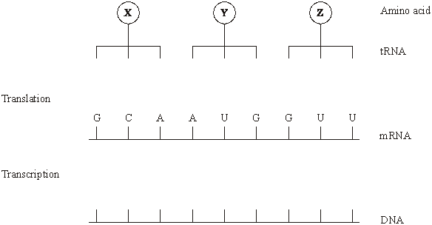**Figure 1**

Complete **Figure 1** to show

(i)      the bases on the DNA strand from which the mRNA was transcribed;

(ii)     the bases forming the anticodons of the tRNA molecules.

**(2)**

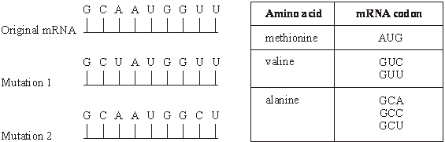**Figure 2** shows the effects of two different mutations of the DNA on the base sequence of the mRNA. The table shows the mRNA codons for three amino acids.

**Figure 2**

(c)     Name the type of mutation represented by mutation 1.

......................................................................................................................

**(1)**

(d)     Use the information in the table to

(i)      identify amino acid **X** in **Figure 1**;

.............................................................................................................

**(1)**

(ii)     explain how each mutation may affect the polypeptide for which this section of DNA is part of the code.

Mutation 1 ...........................................................................................

.............................................................................................................

.............................................................................................................

.............................................................................................................

**(2)**

Mutation 2 ...........................................................................................

.............................................................................................................

.............................................................................................................

.............................................................................................................

**(2)**

**(Total 10 marks)**

**Q3.**          The diagram shows part of a DNA molecule.

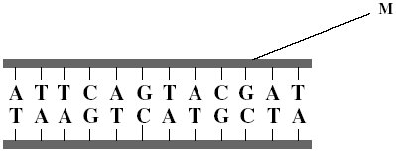

(a)     Name the **two** components of the part of the DNA molecule labelled **M**.

1 ...................................................................................................................

2 ...................................................................................................................

**(2)**

(b)     What is the maximum number of amino acids for which this piece of DNA could code?



**(1)**

(c)     Scientists calculated the percentage of different bases in the DNA from a species of bacterium. They found that 14% of the bases were guanine.

(i)      What percentage of the bases in this species of bacterium was cytosine?

Answer .......................................

**(1)**

(ii)     What percentage of the bases in this species of bacterium was adenine?

Answer .......................................

**(1)**

(d)     The scientists found that, in a second species of bacterium, 29% of the bases were guanine.

Explain the difference in the percentage of guanine bases in the two species of bacterium.

......................................................................................................................

......................................................................................................................

......................................................................................................................

......................................................................................................................

**(2)**

**(Total 7 marks)**

**Q4.**          (a)     Complete the table to show the differences between DNA, mRNA and tRNA.

|  |  |  |
| --- | --- | --- |
| **Type of nucleic acid** | **Hydrogen bonds present () or not present ()** | **Number of polynucleotide strands in molecule** |
| DNA |  |  |
| mRNA |  |  |
| tRNA |  |  |

**(2)**

(b)     The diagram shows the bases on one strand of a piece of DNA.

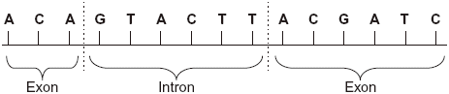

(i)      In the space below, give the sequence of bases on the pre-mRNA transcribed from this strand.

**(2)**

(ii)     In the space below, give the sequence of bases on the mRNA produced by splicing this piece of pre-mRNA.

**(1)**

**(Total 5 marks)**

**Q5.**          (a)     **Figure 1** shows the exposed bases (anticodons) of two tRNA molecules involved in the synthesis of a protein.

**Figure 1**

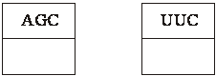

Complete the boxes to show the sequence of bases found along the corresponding section of the coding DNA strand.

(b)     Describe the role of tRNA in the process of translation.

......................................................................................................................

......................................................................................................................

......................................................................................................................

......................................................................................................................

......................................................................................................................

......................................................................................................................

**(3)**

(c)     **Figure 2** shows the sequence of bases in a section of DNA coding for a polypeptide of seven amino acids.

**Figure 2**

TACAAGGTCGTCTTTGTCAAG

The polypeptide was hydrolysed. It contained four different amino acids. The number of each type obtained is shown in the table.

|  |  |
| --- | --- |
| **Amino acid** | **Number present** |
| Phe | 2 |
| Met | 1 |
| Lys | 1 |
| Gln | 3 |

Use the base sequence shown in **Figure 2** to work out the order of amino acids in the polypeptide. Write your answer in the table below.

|  |  |  |  |  |  |  |
| --- | --- | --- | --- | --- | --- | --- |
| Met |  |  |  |  |  |  |

**(2)**

**(Total 7 marks)**

**Q6.**          (a)     Complete the table to show the differences between DNA, mRNA and tRNA.

|  |  |  |
| --- | --- | --- |
| **Type of nucleic acid** | **Hydrogen bonds present () or not present ()** | **Number of polynucleotide strands in molecule** |
| DNA |  |  |
| mRNA |  |  |
| tRNA |  |  |

**(2)**

(b)     The diagram shows the bases on one strand of a piece of DNA.



(i)      In the space below, give the sequence of bases on the pre-mRNA transcribed from this strand.

**(2)**

(ii)     In the space below, give the sequence of bases on the mRNA produced by splicing this piece of pre-mRNA.

**(1)**

**(Total 5 marks)**

**Q7.**          (a)     **Table 1** shows some of the events which take place in protein synthesis.

|  |  |  |
| --- | --- | --- |
|  | **A** | tRNA molecules bring specific amino acids to the mRNA molecule |
|  | **B** | mRNA nucleotides join with exposed DNA bases and form a molecule of mRNA |
|  | **C** | The two strands of a DNA molecule separate |
|  | **D** | Peptide bonds form between the amino acids |
|  | **E** | The mRNA molecule leaves the nucleus |
|  | **F** | A ribosome attaches to the mRNA molecule |

**Table 1**

(i)      Write the letters in the correct order to show the sequence of events during protein synthesis, starting with the earliest.

................  ................  ................  .................  .................  .................

**(2)**

(ii)     In which part of a cell does **C** take place?

.............................................................................................................

**(1)**

(iii)     Which of **A - F** are involved in translation?

.............................................................................................................

**(1)**

(b)     **Table 2** shows some mRNA codons and the amino acids for which they code.

|  |  |  |
| --- | --- | --- |
|  | **mRNA codon** | **Amino acid** |
|  | GUU | Valine |
|  | CUU | Leucine |
|  | GCC | Alanine |
|  | AUU | Isoleucine |
|  | ACC | Threonine |

**Table 2**

(i)      A tRNA molecule has the anticodon UAA.  Which amino acid does the tRNA molecule carry?

.............................................................................................................

**(1)**

(ii)     Give the DNA base sequence that codes for threonine.

.............................................................................................................

**(1)**

**(Total 6 marks)**

**M1.**          (i)      mRNA attaches to ribosome;  
codon on mRNA;  
binds to an anti-codon on tRNA;  
each tRNA brings a specific amino acid;  
sequence of codons / bases on mRNA determines order of amino acids;  
formation of peptide bonds / amino acids joined by condensation   
reactions;

**4 max**

(iii)     inserted gene / mRNA complementary to normal gene / mRNA;  
binds to it to prevent protein synthesis / form double strand / prevents   
mRNA binding to ribosomes;  
will not stop all translation, some mRNA reaches ribosomes /   
because not all mRNA is bound by inserted gene mRNA;

**2 max**

**[6]**

**M2.**          (a)     (i)      join / attach nucleotides, to form a strand / along backbone / phosphodiester bonds;

*(reject reference to H bonds, complementary base pairing)*

**1**

(ii)     ribosome / RER;

**1**

(b)     (i)      CGTTACCAA;

**1**

(ii)     CGU UAC CAA;

**1**

(c)     substitution;

**1**

(d)     (i)      alanine;

**1**

(ii)     (mutation 1)  
no change(to sequence of amino acids);  
codon for alanine / degenerate codon / same amino acid coded for;

**2**

(mutation 2)  
(change in sequence) valine replaced by alanine / codon for alanine;  
folding / shape / tertiary structure / position of bonds may change;

*(reject peptide bonds)*

**2**

**[10]**

**M3.**          (a)     Phosphate;

Deoxyribose;

***Q*** *Candidates must specify deoxyribose. This term is a specification requirement.  
Ignore anything that is not incorrect.*

**2**

(b)     4;

**1**

(c)     (i)      14;

**1**

(ii)     36;

*If (c)(i) incorrect accept [50 – (c)(i)]*

**1**

(d)     Different genes;

Different (DNA) base sequences;

**2**

**[7]**

**M4.**          (a)

|  |  |  |
| --- | --- | --- |
| DNA |  | 2 |
| mRNA |  | 1 |
| tRNA |  | 1 |

*One mark for each correct column  
Regard blank as incorrect in the context of this question  
Accept numbers written out: two, one, one*

**2**

(b)     (i)      Marking principles  
1 mark for complete piece transcribed;

*Correct answer  
UGU CAU GAA UGC UAG*

1 mark for complementary bases from sequence transcribed;

*but allow 1 mark for complementary bases from section transcribed, providing all four bases are involved*

**2**

(ii)     Marking principle  
1 mark for bases corresponding to exons taken from (b)(i)

*Correct answer  
UGU UGC UAG  
If sequence is incorrect in (b)(i), award mark if section is from exons. Ignore gaps.*

**1**

**[5]**

**M5.**          (a)     AGC; TTC;

**2**

(b)     anticodon complementary to codon / reads message on mRNA;

specific amino acid;

carried / transferred (to ribosome);

correct sequence of amino acids along polypeptide;

**3 max**

(c)

|  |  |  |  |  |  |  |
| --- | --- | --- | --- | --- | --- | --- |
| (Met) | Phe | Gln | Gln | Lys | Gln | Phe |

**2**

*(three / four / five correct 1 mark; six correct 2 marks)*

**[7]**

**M6.**          (a)

|  |  |  |
| --- | --- | --- |
| DNA |  | 2 |
| mRNA |  | 1 |
| tRNA |  | 1 |

*One mark for each correct column  
Regard blank as incorrect in the context of this question  
Accept numbers written out: two, one, one*

**2**

(b)     (i)      Marking principles  
1 mark for complete piece transcribed;

*Correct answer  
UGU CAU GAA UGC UAG*

1 mark for complementary bases from sequence transcribed;

*but allow 1 mark for complementary bases from section transcribed, providing all four bases are involved*

**2**

(ii)     Marking principle  
1 mark for bases corresponding to exons taken from (b)(i)

*Correct answer  
UGU UGC UAG  
If sequence is incorrect in (b)(i), award mark if section is from exons. Ignore gaps.*

**1**

**[5]**

**M7.**          (a)     (i)      C → B → E → F → A → D

*Mark links: 5 correct = 2, 4 correct = 1, <4 correct = 0*

**2**

(iii)     nucleus;

**1**

(iii)     A, D, F;    *(ignore E if evident)*

**1**

(b)     (i)      Isoleucine;

**1**

(ii)     TGG;

**1**

**[6]**