**Eye Past Paper Questions**

**Q1.**          The diagram shows part of the retina in a human eye.

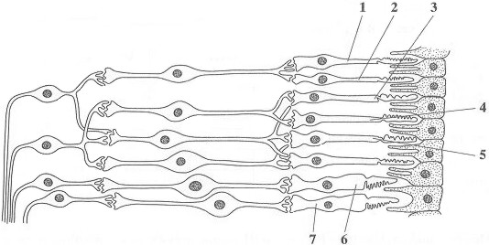

(a)     Explain each of the following observations.

(i)      When light falls on cells **1** and **2**, only one spot of light is seen. But, when light falls on cells **2** and **3**, two spots of light are seen.

.............................................................................................................

.............................................................................................................

**(1)**

(ii)     When one unit of light energy falls on cell **3**, no light is seen. But, when one unit of light energy falls on cell **3**, one unit falls on cell **4** and one unit falls on cell **5**, light is seen.

.............................................................................................................

.............................................................................................................

.............................................................................................................

.............................................................................................................

.............................................................................................................

.............................................................................................................

**(3)**

(b)     Cells of the same type as cells **6** and **7** are found in large numbers at the fovea. This results in colour vision with high visual acuity.

Explain what causes vision using the fovea.

(i)      to be in colour;

.............................................................................................................

.............................................................................................................

**(1)**

(ii)     to have high visual acuity.

.............................................................................................................

.............................................................................................................

**(1)**

**(Total 6 marks)**

**Q2.**          The diagram shows the distribution of cone cells across the retina of a human eye.

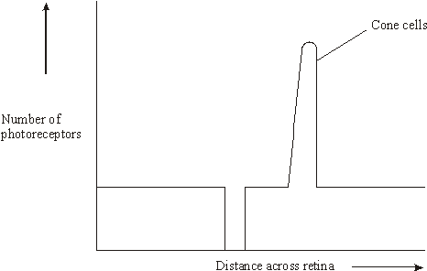

(a)     On the diagram draw a line to show the distribution of rod cells across the retina.

**(2)**

(b)     Nocturnal mammals are active at night. Describe how the number and distribution of rods and cones across the retina would differ in a nocturnal mammal from the number and distribution in a human. Explain your answer.

......................................................................................................................

......................................................................................................................

......................................................................................................................

......................................................................................................................

......................................................................................................................

......................................................................................................................

**(3)**

**(Total 5 marks)**

**Q3.**          After moving from bright light into darkness, it takes several minutes for the rod cells to recover their sensitivity. Researchers measured the ability of the rod cells to detect small spots of light of different colours and intensity after a person moved into darkness. The results are shown in **Figure 1**.

**Figure 2** shows the amount of light of different wavelengths that rhodopsin absorbs.

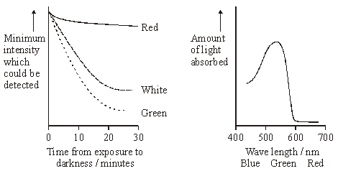

**Figure 1**                                                    **Figure 2**

(i)      Explain why it takes time for the rod cells to recover their sensitivity to light after moving into darkness.

......................................................................................................................

......................................................................................................................

......................................................................................................................

......................................................................................................................

**(2)**

(ii)      Use information in **Figures 1** and **2** to explain the differences in sensitivity of rod cells to red and green light.

......................................................................................................................

......................................................................................................................

......................................................................................................................

......................................................................................................................

**(2)**

(iii)     Suggest an explanation for the difference in sensitivity of rod cells to the white and green spots after 30 minutes.

......................................................................................................................

......................................................................................................................

**(1)**

**(Total 5 marks)**

**Q4.**          When a person looks directly at an object, its image is focused on the fovea.

(a)     When the image is focused on the fovea, the person sees the object in colour.  
Explain why.

......................................................................................................................

......................................................................................................................

......................................................................................................................

......................................................................................................................

......................................................................................................................

......................................................................................................................

(*Extra space*) ...............................................................................................

......................................................................................................................

......................................................................................................................

**(3)**

(b)     Vision using the fovea has high visual acuity but low sensitivity to light compared with vision using other parts of the retina.

(i)      Explain why vision using the fovea has high visual acuity.

.............................................................................................................

.............................................................................................................

**(1)**

(ii)     Explain why vision using other parts of the retina has high sensitivity to light.

.............................................................................................................

.............................................................................................................

.............................................................................................................

.............................................................................................................

.............................................................................................................

.............................................................................................................

*(Extra space)* ......................................................................................

.............................................................................................................

.............................................................................................................

**(3)**

**(Total 7 marks)**

**M1.**          (a)     (i)      1 and 2 share neurone but 2 and 3 have separate neurones (to brain);

*Ignore wrong names of neurones*

**1**

(ii)     1 unit is sub-threshold / 3 units are above threshold / give sufficient  
depolarisation;  
(1 unit) No impulses / no action potential / in (sensory) neurone /   
does not stimulate (sensory) neurone / 3 units → impulses;  
(Spatial) summation / sufficient neurotransmitter released / from  
3 receptors / insufficient N-T from one;  
*Reject ‘temporal’*

**3**

(b)     (i)      (Three) different types of (cone) cells / types 6 and 7 sensitive  
to different wavelengths / different frequencies / different colours;

(ii)     Impulses along separate neurone from each receptor cell / each  
receptor cell connects to separate neurone;

**2**

**[6]**

**M2.**          (a)     no rods at blind spot or fovea;

greater distribution of rods at edge;

**2**

(b)     more rods and no / fewer cones present;

rods at the fovea / rods not mainly at periphery;

rods have high sensitivity / show retinal convergence /   
converse for cones;

rhodopsin ‘bleached’ at low light intensities / iodopsin ‘bleached’;

at high light intensities;

**3 max**

**[5]**

**M3.**          (i)      rhodopsin bleached / broken down by light;  
time for resynthesis;

**2**

(ii)      rhodopsin / pigment absorbs green light more readily than red / is  
more sensitive to green light;  
(after resynthesis) less (intense) green light needed to break down  
rhodopsin (than red);

**2**

(iii)     white has (high proportion of) wavelengths to which rhodopsin not  
sensitive;

**1**

**[5]**

**M4.**         (a)     Colour detected by cone cells;Fovea contains (only / mainly) cone cells;Three types of cone / cells described / each sensitive to different  
wavelength / to red or green or blue;

*Max 2 if ‘rods‘ and ‘cones‘ confused consistently*

**3**

(b)     (i)      Each receptor (in fovea)/each cone connected to separate  
neurone / rods/cells in other parts share a neurone;

*Accept nerve cell / nerve fibre*

**1**

(ii)     Many rods in other parts of retina;Rhodopsin / pigment in receptors / rod cells very sensitive to light/works in low light;Receptors / rods connected in groups to ganglion cell / neurone;Summation;Description of summation, eg if enough light above threshold  
hits any cells in the group, then get nerve impulses to brain/along  
optic nerve;

**3 max**

**[7]**