**Q1.**          The diagram shows the life cycle of a fly.

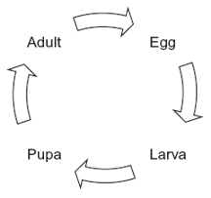

When the larva is fully grown, it changes into a pupa. The pupa does not feed. In the pupa, the tissues that made up the body of the larva are broken down. New adult tissues are formed from substances obtained from these broken-down tissues and from substances that were stored in the body of the larva.

(a)     Hydrolysis and condensation are important in the formation of new adult proteins.  
Explain how.

......................................................................................................................

......................................................................................................................

......................................................................................................................

......................................................................................................................

**(2)**

(b)     Most of the protein stored in the body of a fly larva is a protein called calliphorin.  
Explain why different adult proteins can be made using calliphorin.

......................................................................................................................

......................................................................................................................

**(1)**

The table shows the mean concentration of RNA in fly pupae at different ages.

|  |  |  |
| --- | --- | --- |
|  | **Age of pupa as percentage of total time spent as a pupa** | **Mean concentration of RNA / μg per pupa** |
|  | 0 | 20 |
|  | 20 | 15 |
|  | 40 | 12 |
|  | 60 | 17 |
|  | 80 | 33 |
|  | 100 | 20 |

(c)     Describe how the concentration of RNA changes during the time spent as a pupa.

......................................................................................................................

......................................................................................................................

......................................................................................................................

......................................................................................................................

**(2)**

(d)     (i)      Describe how you would expect the number of lysosomes in a pupa to change with the age of the pupa. Give a reason for your answer.

.............................................................................................................

.............................................................................................................

.............................................................................................................

.............................................................................................................

**(2)**

(ii)     Suggest an explanation for the change in RNA concentration in the first 40% of the time spent as a pupa.

.............................................................................................................

.............................................................................................................

.............................................................................................................

.............................................................................................................

.............................................................................................................

**(2)**

(e)     Suggest an explanation for the change in RNA concentration between 60 and 80% of the time spent as a pupa.

......................................................................................................................

......................................................................................................................

......................................................................................................................

......................................................................................................................

......................................................................................................................

**(2)**

(f)      The graph shows changes in the activity of two respiratory enzymes in a fly pupa.

•        Enzyme **A** catalyses a reaction in the Krebs cycle

•        Enzyme **B** catalyses the formation of lactate from pyruvate

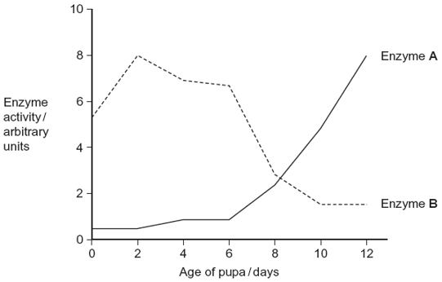

During the first 6 days as a pupa, the tracheae break down. New tracheae are formed after 6 days. Use this information to explain the change in activity of the two enzymes.

......................................................................................................................

......................................................................................................................

......................................................................................................................

......................................................................................................................

......................................................................................................................

......................................................................................................................

*(Extra space)* ................................................................................................

......................................................................................................................

......................................................................................................................

......................................................................................................................

**(4)**

**(Total 15 marks)**

**M1.**          (a)     1.      Hydrolysis breaks proteins / hydrolyses proteins / produces amino acids (from proteins);

2.      Protein synthesis involves condensation;

**2**

(b)     Amino acids (from calliphorin) can be joined in different sequences /   
rearranged;

**1**

(c)     1.      Fall, rise and fall;

2.      Rise after 40 and fall after 80;

*Ignore concentration values.*

**2**

(d)     (i)      Fall / increase then fall;

Lysosomes associated with tissue breakdown;

**2**

(ii)     1.      Tissues / cells are being broken down;

2.      RNA is digested / hydrolysed / broken down;

3.      By enzymes from lysosomes;

4.      New proteins not made / no new RNA made;

**2 max**

(e)     1.      (RNA) associated with making protein;

2.      New / adult tissues are forming;

**2**

(f)      1.      In the first 6 days no / little oxygen supplied / with breakdown of tracheae, no / little oxygen supplied;

2.      (Without tracheae) respire anaerobically;

3.      Anaerobic respiration involves reactions catalysed by enzyme **B**  / conversion of pyruvate to lactate / involves lactate production;

4.      Enzyme **A** / Krebs cycle is part of aerobic respiration;

*Or, with emphasis on aerobic respiration:*

*1. Tracheae supply oxygen / after 6 days oxygen supplied;*

*2. (With tracheae) tissues can respire aerobically.*

**4**

**[15]**

**E1.**          This question was intended to be synoptic and as such required a basic understanding of principles established in other units. There were some outstanding answers but it was also disappointing to note that there were many candidates who clearly had little idea of the functions of cell organelles or of the role of ribosomes and RNA in protein synthesis.

(a)     There were, perhaps inevitably, candidates who confused condensation and hydrolysis but most were able used the terms appropriately in the context of protein digestion and synthesis.

(b)     Those who understood protein structure usually gained credit, but almost two-thirds of all candidates made no progress here. While the most frequent problems stemmed from confusing amino acids with bases, others appeared uncertain that proteins could be digested.

(c)     Most, but by no means all, candidates identified the overall trend of decrease, increase, decrease but rather fewer supported this with data from the table relating to the age of the pupa. Where the age was quoted, it was not uncommon to see it given in days or years. A little common sense might have excluded the latter.

(d)     Answers to part (i) might have been better had more candidates distinguished between the roles of lysosomes and ribosomes. There were many responses associating an increase in lysosomes with increased protein synthesis towards the end of the time spent as a pupa.

Others linked lysosomes with disease and answered in terms of increased exposure to bacterial infection. A major misconception in the answers to part (ii) was that protein synthesis would decrease RNA concentration as it was “used up” in the process.

(e)     Although some of the candidates answering this part of the question were unable to identify the trend in the table, most recognised that tissue formation involved protein synthesis and hence the increase in RNA.

(f)      This question discriminated very effectively over the range of available marks but, at all levels of ability, candidates appeared to find difficulty with spelling the words aerobic and anaerobic. Examiners try to avoid being unnecessarily pedantic over the spelling of technical terms but the onus is on candidates to make their intentions clear, particularly when the words concerned are closely similar. A considerable number of candidates failed to equate tracheae with insect gas exchange and wrote of breathing and the lungs.