**Q1.**          The diagram shows part of the gut wall of an animal.

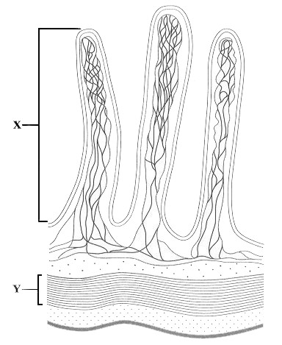

(a)     (i)      Name the structure labelled **X**.

.............................................................................................................

**(1)**

(ii)     Describe the function of the layer labelled **Y**.

.............................................................................................................

.............................................................................................................

.............................................................................................................

.............................................................................................................

**(2)**

(b)     Describe and explain how **two** features shown in the diagram increase the rate of absorption of digested food.

Feature 1

Description

......................................................................................................................

......................................................................................................................

Explanation

......................................................................................................................

......................................................................................................................

Feature 2

Description

......................................................................................................................

......................................................................................................................

Explanation

......................................................................................................................

......................................................................................................................

**(4)**

**(Total 7 marks)**

**Q2.**          Lactose is a disaccharide found in milk. In the small intestine, it is digested into glucose and galactose by the enzyme lactase. Molecules of lactase are located in the plasma membranes of cells lining the small intestine.

(a)     What evidence in the paragraph suggests that galactose is a monosaccharide?

......................................................................................................................

......................................................................................................................

**(1)**

(b)     (i)      Name **one** other digestive enzyme that is located in the plasma membranes of cells lining the small intestine.

.............................................................................................................

**(1)**

(ii)     Give an advantage of lactase and other digestive enzymes being located in the plasma membranes of cells lining the small intestine, rather than being secreted into the lumen of the small intestine.

.............................................................................................................

.............................................................................................................

**(1)**

(c)     The absorption of galactose from the small intestine is reduced if the absorbing cells are treated with a respiratory inhibitor, such as cyanide. Suggest an explanation for this.

......................................................................................................................

......................................................................................................................

......................................................................................................................

......................................................................................................................

**(2)**

**(Total 5 marks)**

**Q3.          S**       The figure belowshows the processes involved in absorbing amino acids into a capillary from the small intestine.

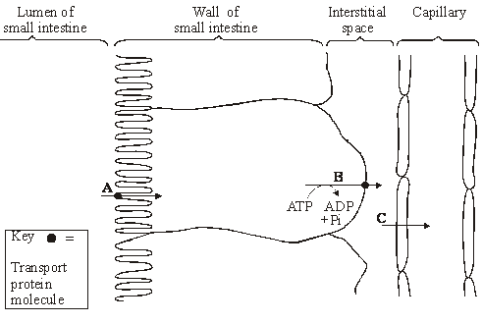

(i)      Name processes **A**, **B** and **C**. In each case, give the evidence for your answer.

**A**       Process ...............................................................................................

Evidence .............................................................................................

............................................................................................................

**B**       Process ..............................................................................................

Evidence .............................................................................................

............................................................................................................

**C**       Process ..............................................................................................

Evidence .............................................................................................

.............................................................................................................

**(3)**

(ii)      Explain how process **B** creates the conditions for process **A** to occur.

......................................................................................................................

......................................................................................................................

......................................................................................................................

......................................................................................................................

**(2)**

**(Total 5 marks)**

**Q4.**          (a)     Dietary recommendations are that lipid intake should make up 30% of energy intake. The recommended energy intake for most women aged 19-49 is 8100 kJ day–1.The energy content of lipid is 37.8 kJ g–1. Calculate the recommended lipid intake per day for these women. Show your working.

Answer ................................................... g

**(2)**

In humans, triglycerides are the main form of dietary lipids. They are digested in the gut and the products of digestion are absorbed by the small intestine.

**S**       (b)     Describe a biochemical test that could be performed on a sample of food to determine whether it contained triglycerides.

......................................................................................................................

......................................................................................................................

......................................................................................................................

......................................................................................................................

**(2)**

(c)     The diagram shows the events that occur in the absorption of monoglycerides and fatty acids. These molecules enter the epithelial cells of the small intestine by diffusion. Once inside they are reassembled into triglycerides in organelle **Q**. The triglyceride molecules are formed into chylomicrons in organelle **T**. Chylomicrons are made from many triglyceride molecules surrounded with protein molecules. The chylomicrons leave the cell and enter vessel **S**.

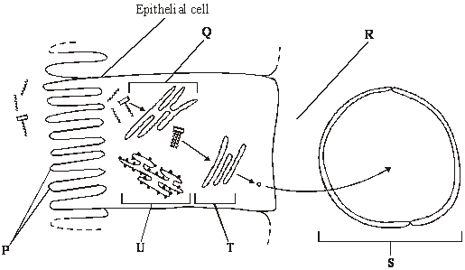

**S**       (i)      Explain the importance of the structures labelled **P**.

.............................................................................................................

.............................................................................................................

**(1)**

(ii)     Name

**R**; .......................................................................................................

**S**. ........................................................................................................

**(2)**

**S**       (iii)     Describe the role played by organelle **U** in the formation of chylomicrons.

.............................................................................................................

.............................................................................................................

.............................................................................................................

.............................................................................................................

**(2)**

**S**       (iv)    Suggest how the chylomicrons leave the epithelial cell. Give a reason for your answer.

.............................................................................................................

.............................................................................................................

.............................................................................................................

.............................................................................................................

**(2)**

**(Total 11 marks)**

**Q5.**Scientists investigated the effect of lipase and a 3% bile salts solution on the digestion of triglycerides. The graph below shows their results.

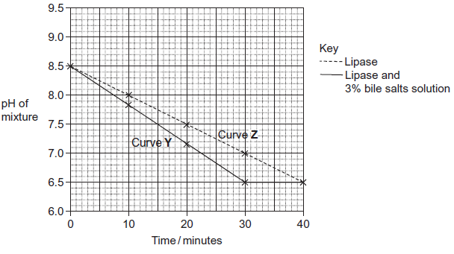

The scientists also incubated triglycerides with different concentrations of bile salts. After 30 minutes they measured the diameter of the triglyceride droplets. They used the results to calculate the mean radius of the droplets at each concentration. The table below shows their results.

|  |  |  |  |  |  |  |  |
| --- | --- | --- | --- | --- | --- | --- | --- |
|  | Concentration of bile salts /% | 0 | 1 | 2 | 3 | 4 | 5 |
|  | Mean radius of triglyceride droplet / μm | 6 | 5 | 4 | 3 | 2 | 1 |

(a)     Describe how you would use a microscope to find the mean diameter of triglyceride droplets on a slide.

.........................................................................................................................

.........................................................................................................................

.........................................................................................................................

.........................................................................................................................

.........................................................................................................................

.........................................................................................................................

*(Extra space)* ..................................................................................................

.........................................................................................................................

.........................................................................................................................

**(3)**

(b)     (i)      The ratio of mean radius of triglyceride droplets in bile salts at a concentration of 0% to the mean radius in bile salts at a concentration of 3% is 2 : 1.

What is the ratio of their surface areas? Show your working.

You can calculate the surface area of a droplet from the formula

A = 4*π*r2

Where  A = surface area  
    r = radius  
   *π* = 3.14

**(2)**

(ii)     Use the data in the table to explain the difference between curves **Y** and **Z** in the graph.

...............................................................................................................

...............................................................................................................

...............................................................................................................

...............................................................................................................

...............................................................................................................

...............................................................................................................

*(Extra space)* ........................................................................................

...............................................................................................................

...............................................................................................................

**(3)**

**(Total 8 marks)**

**Q6.**Some people are lactose intolerant. The lactose in milk and milk products, such as cheese, causes digestive discomfort in these people.

Scientists gave 159 adult volunteers, who had dia gnosed themselves as lactose intolerant, a questionnaire to complete. The volunteers were asked,

•        do you eat the food?

•        if you eat the food, do you feel discomfor t after eating it?

The results are shown in the table.

|  |  |  |  |  |  |  |
| --- | --- | --- | --- | --- | --- | --- |
|  | **Food** | **Typical lactose content / g per serving** | **Percentage of people who** | | | |
|  | **A** do not eat the food | **B** feel discomfort after eating the food | **C (= A + B)** do not eat the food or feel discomfort after eating the food | **D** feel no discomfort after eating the food |
|  | Hard cheese | 1.2 | 11.1 | 39.9 | 51.0 | 49.0 |
|  | Pizza | 3.0 | 10.4 | 57.8 | 68.2 | 31.8 |
|  | Soft cheese | 3.6 | 25.1 | 53.0 | 78.1 | 21.9 |
|  | Ice cream | 6.0 | 14.6 | 68.2 | 82.8 | 17.2 |
|  | Milk | 9.9 | 27.0 | 67.1 | 94.1 | 5.9 |

(a)     The scientists investigated the relationship between the lactose content of the food and the amount of digestive discomfort.

(i)      The figures in columns **A** and **B** were used to produce those in column **C**.  
The scientists used column **C** rather than column **B** in their analysis. Suggest why.

...............................................................................................................

...............................................................................................................

**(1)**

(ii)     Describe the relationship between the lactose content of the food and the data in column **C**.

...............................................................................................................

...............................................................................................................

**(1)**

(iii)    The scientists could **not** conclude that the discomfort was caused by the increase in lactose content of the food. Explain why.

...............................................................................................................

...............................................................................................................

...............................................................................................................

...............................................................................................................

...............................................................................................................

**(2)**

(b)     Suggest **two** reasons why the data in this table may be unreliable.

1 .....................................................................................................................

........................................................................................................................

2 .....................................................................................................................

........................................................................................................................

**(2)**

**(Total 6 marks)**

**Q7.**Biologists divided new-born rats randomly into four groups.

They fed the rats in each group on a standard diet which only differed in the carbohydrate content. When these rats were adult, the biologists measured the activity of lactase in the digestive system of the rats. The following table shows the mean results for each group.

|  |  |  |
| --- | --- | --- |
|  | **Diet** | **Mean lactase activity / µ mol of lactose digested per  hour (± standard deviation)** |
|  | Low sucrose | 57.9 (± 14.5) |
|  | High sucrose | 184.2 (± 30.8) |
|  | Low starch | 86.9 (± 13.3) |
|  | High starch | 221.4 (± 25.4) |

(a)     Give **one** piece of evidence from the table that indicates lactase activity is affected by diet.

........................................................................................................................

........................................................................................................................

**(1)**

(b)     Some students suggested from these data that increasing starch in the diet was the most effective way to increase lactase activity in lactase deficient people. Is this conclusion valid? Explain your answer.

........................................................................................................................

........................................................................................................................

........................................................................................................................

........................................................................................................................

........................................................................................................................

**(2)**

**(Total 3 marks)**

**M1.**          (a)     (i)      villus; (*reject microvilli*)

**1**

(ii)     contracts / peristalsis;  
moves / pushes / forces food through gut;

**2**

(b)     many / projecting villi (X) (*no double penalty for microvilli*);  
large surface area (for absorption);  
large / good blood supply / many capillaries / blood vessels;  
maintains concentration gradients / efficient removal of digested products;  
thin outer layer / blood vessels near to surface;  
short diffusion pathway;

**4 max**

**[7]**

**M2.**          (a)     Digestion / hydrolysis / breakdown of a disaccharide into monosaccharides;  
OR  
(glucose and galactose form lactose) glucose is a monosaccharide;

**max 1**

(b)     (i)      Dipeptidase / disaccharidase / named disaccharidase;

**1**

(ii)     Enzymes not lost (with gut contents) / more effective absorption  
of products formed by these enzymes;

**1**

(c)     No ATP formed / no energy released by respiration;

*[reject “making” energy]*

Link ATP to active transport (of galactose) into cells;

**2**

**[5]**

**M3.**          (i)      In all cases reject ‘energy’ unless qualified

A –  facilitated diffusion as transport protein needed but ATP not needed;

B –  active transport ‘energy’ unless as (transport protein and) ATP needed; qualified

C –  (simple) diffusion as neither ATP nor transport protein needed;

*(Ignore all references to concentration gradients)*

**3**

(ii)      creates low concentration of amino acids / Na+ in cell concentration gradient established between lumen and cell (of amino acids or Na+)

**2**

**[5]**

**M4.**          (a)     Two marks for correct answer of 64.285 / 64.3 / 64;

*(allow 1 mark for (8100 / 100 × 30) / 37.8)*

**2**

(b)     dissolve in / add ethanol then mix with water;  
emulsion / white colour indicates triglycerides present;

**2**

(c)     (i)      increase the surface area for absorption;

*(ignore wrong ref. to name)*

**1**

(ii)     **R** = tissue fluid / interstitial fluid / extracellular fluid / intercellular space;  
**S** = lymph(atic) vessel / lymph capillary / lacteal;

**2**

(iii)     proteins are synthesised by **U**;  
involvement of ribosomes;  
protein isolation / transport (inside RER);  
vesicle formation;

**2 max**

(iv)    exocytosis / description of;  
because of size / too large to leave by other methods;

**2**

**[11]**

**M5.**(a)     Measure with eyepiece graticule / scale;  
Calibrate with stage micrometer / scale on slide / object of known size;   
Repeats and calculate the mean;  
***OR***Use a ruler to estimate the field diameter under microscope;  
How many droplets go across the field;  
Repeats and calculate mean;

*Accept references to radius*

**3**

(b)     Two mark for correct answer of 4 : 1;;  
One mark for incorrect answer but working shows that candidate has clearly attempted to compare values of r2 / 62 and 32 / 36 and 9;

*Idea of comparing ratios  
A ratio of 1 : 4 should gain 1 mark*

**2**

(c)     Small droplets have a larger surface area to volume ratio;

More surface for lipase (to act), leading to faster digestion of triglycerides;

Fatty acids are produced more quickly so pH will drop more quickly in curve **Y** / with bile salts / less fatty acids in curve **Z** / without bile salts so pH drop more slowly;

**3**

**[8]**

**M6.**(a)     (i)      Assumed that did not eat due to discomfort in the past;

**1**

(ii)     Positive correlation / as lactose concentration increases the data in column C increases / percentage who do not eat the food or feel discomfort after eating the food increases;

**1**

(iii)    Correlation does not mean that there is a causal relationship;

May be due to some other factor / example of factor;

*Do not accept casual*

**2**

(b)     1.      People self-diagnosed lactose intolerant condition;

2.      Discomfort may be due to other factor / infection / other component of diet / is subjective;

3.      Large variation in lactose content of specific food items / e.g. variation in lactose content of different soft cheeses;

4.      Amount in a serving may vary;

5.      Untruthful responses / demand characteristics;

*Sample size = neutral.*

**2 max**

**[6]**

**M7.**(a)     High sucrose / starch diet leads to increase in lactase activity;

**1**

(b)     Not valid / cannot be certain because overlap in SD between high sucrose and high starch;

Study based on rats (not human) so may not apply to human;

**2**

**[3]**