Superconductors

# Typical Temperatures for Superconductors

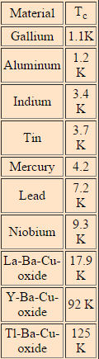Superconductors are metals or metal alloys that when they are cooled to a certain temperature (critical temperature) their resistivity drops to zero. This change from resistive to complete non-resistive is a very sudden change and it almost appears to be a change in the state of matter. This superconducting phase is described by the BCS theory, several materials exhibit this property at different low temperatures, the highest was about 23K (-250.15C) until 1986, when a few high temperature superconductors where discovered.



The materials with critical temperatures anywhere in the range of 120K (-153.15C) are of particular interest as they can be kept at this temperature using liquid nitrogen (77K [-196.15C]).



### High Temperature Superconductors

Ceramic materials are normally insulators and definitely not conductors, however in 1986 George Bednorz and Alex Muller found , when investigating the conductivity of Lanthanum-barium-copper oxide, that it had a superconductivity critical temperature of 30K (-243.15C), the highest discovered at that time, but their research led many more to be found the current highest being 125K (-148.15C).



### Why High Temperature Superconductors are exciting:

The reason that high temperature superconductors are so exciting is that they have 0 resistance meaning no energy is lost when a current is put through it, this could lead to 100% efficiency within circuits saving lots or resources and money, as long as a materials superconductivity temperature can be maintained.



Feedback Prompts:

* Opening… reminder that this wasn’t an exam style question.

How well have the following been included?

* Definition of Superconductivity.
* Examples of Superconducting metals with critical temperatures.
* Examples of current real world uses of Superconductors identified.
* Examples of future uses of High (room) temperature Superconductors discussed.
* Final comment about the originality of the work / Plagiarism / Referencing