How to use Microsoft™ Sound Recorder

- Most computers running Microsoft™ Windows will have sound recorder installed on them. All you need is a computer capable of playing sound and a microphone.

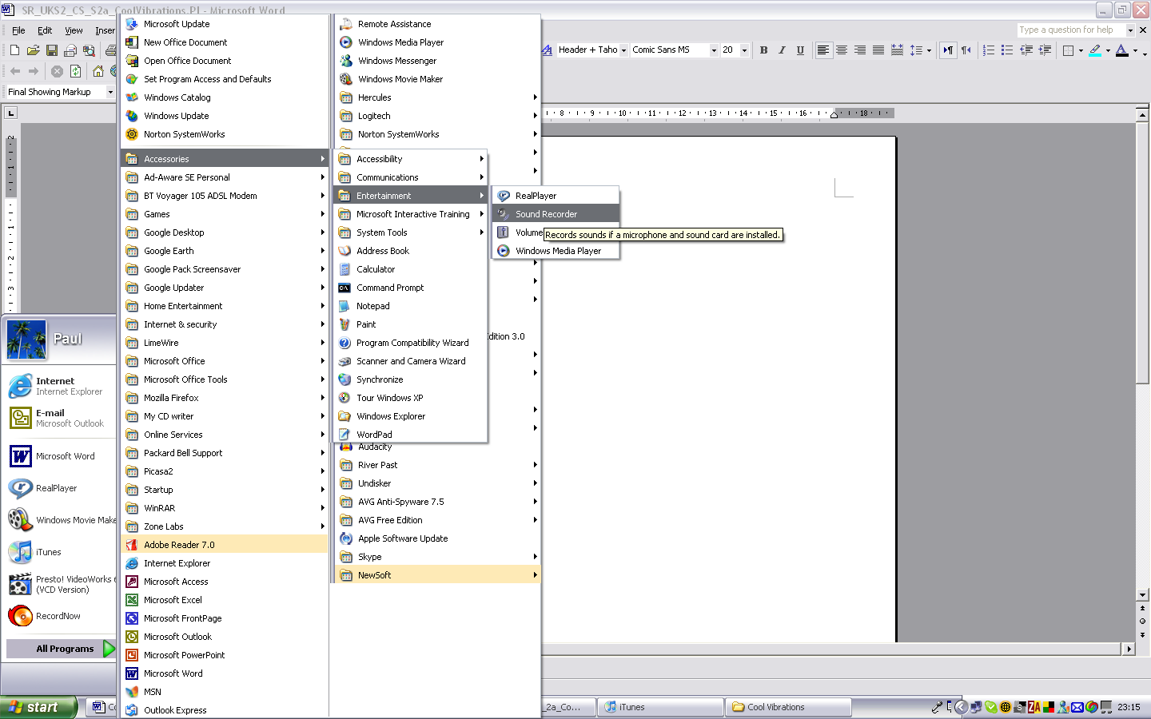
1. Click start
2. Click all programs
3. Select Accessories
4. Select Entertainment
5. Double click on Sound Recorder

2, When the sound recorder is open you are ready to record.

With the microphone plugged in, a simple click on the record button (red dot) will have you recording! When you have finished your recording click the stop button. The stop button can also be used at any time to pause your recording before you continue.

Click ‘Play’ to listen to your recording.

Before you exit remember to save your recording. Click on File and then Save as… (choose a sensible folder to save it into) your recording is then saved in the .wav format.

You can now go to your saved file and double click on it to open your file and listen again.

‘Fast Forward’ and ‘Rewind’ do just that!

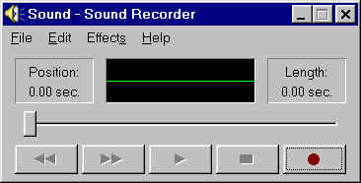

Rewind Fast Forward Play Stop Record

What else can Sound Recorder do?

The Effects Menu allows you to increase/decrease volume, increase/decrease speed and even reverse the recording or add an echo.

The Edit Menu allows you to insert sounds or mix files.

Have a go and experiment!

