*Levels of Measurement - Activity*

Below are several methods for measuring dependent variables. For each method decide what level of measurement is being used.

Choose from:

1. Nominal 2. Ordinal 3. Interval/Ratio

|  |  |
| --- | --- |
| **Description of Data** | **Level of Measurement/data** |
| People are interviewed in the street and, on the basis of their replies are recorded as either pro-hanging, undecided or anti-hanging. |  |
| Judges give their marks on an ice skating contest for style and presentation on a scale of 1 – 10. |  |
| Photographs are organised by participants according to level of attractiveness as follows:  Photos: F C B G E A H D  Most Attractive Least Attractive |  |
| The time taken to sort cards into categories |  |
| The distance two participants stand apart when asked to take part in an intimate conversation, measured from photos. |  |
| Critical Life events given positions 1 – 10 according to their perceived importance to each participant. |  |
| Participants sense of self-worth, estimated on a scale of 1 – 10. |  |
| Number of people who read: *The Sun, The Times or The* Guardian. |  |

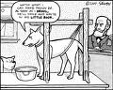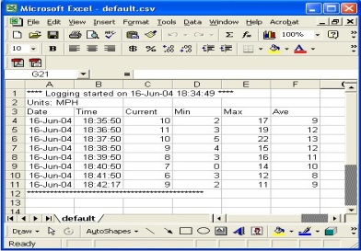

*Levels of Measurement - Extension Activities*

1. Use the information in the table below to answer the following questions:
2. At what level are the measurements in each column of the table being made?
3. Which of the columns , a – d, contains the most sensitive or informative level of measurement?

|  |  |  |  |
| --- | --- | --- | --- |
| 1. **Placings of top 5 riders in Tour de France** | 1. **Time taken, so far, in whole race** | 1. **Popularity rating (max 20)** | 1. **Riders still in the race** |
| Yates 1  Bortolami 2  Museuw 3  Andreu 4  Vanzella 5 | 28hr, 44m, 22s  28hr, 44m, 23s  28hr, 44m, 26s  28hr, 44m, 27s  28hr, 44m, 28s | 18  15  12  10  13 | In race Dropped  Out  121 77 |
| **Level of Measurement:** | **Level of Measurement:** | **Level of Measurement:** | **Level of Measurement:** |

1. Your friend argues that, since she came top in each of the three maths tests held in her class this term, she must be far better than all her other classmates. What might you want to point out to her?
2. Identify three ways to measure driving ability, one using nominal level data, one ordinal and one interval/ratio level data:

|  |  |
| --- | --- |
| **Level of Measurement** | **Method of measuring driving ability** |
| **Nominal** |  |
| **Ordinal** |  |
| **Interval/Ratio** |  |