Probability - True or False?
- In pairs, decide whether each statement is a true or false.
- Write down your reasons for your decision.
- Join together with another pair and try to reach an agreement as a four.
Statement | True or False
When you roll a six sided die it is harder to roll a six than a four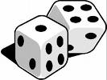

Scoring a total of three with two dice is twice as likely as scoring a total of two.

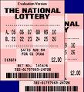 In a lottery the six numbers 3,12,26,37,44,45 are more likely to come up than the six numbers 1,2,3,4,5,6.

Two equally matched teams decide to play a game of football. There are three outcomes in a football match: win, lose or draw. The probability of winning is therefore 1/3. 

If you toss a coin five times and get five heads in a row, the next time you toss a coin it is more likely to show a tail than a head.

 In a group of ten psychology students, the probability of two psychology students being born on the same day of the week is 1.

If a family has already got four boys, then the next baby is more likely to be a girl than a boy.


