

AS PAPER 2
RESEARCH METHODS
Booklet 3

Psychology
Department

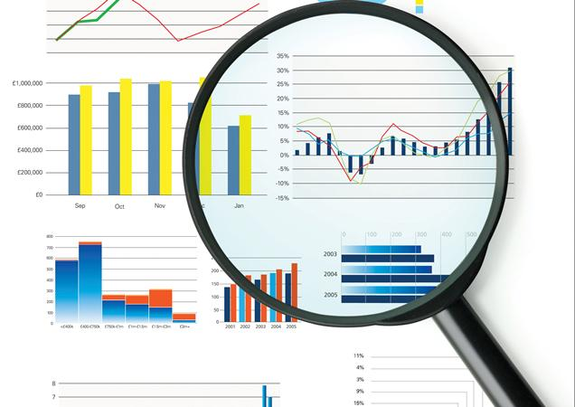

DATA HANDLING AND ANALYSIS

- Quantitative and qualitative data
- Primary and secondary data including meta-analysis
- Descriptive statistics: measures of central tendency – mean, median and mode. Measures of dispersion – range and standard deviation. Calculation of percentages.
- Presentation and display of quantitative data: graphs, tables, scattergrams, bar charts
- Distributions: normal and skewed
- Statistical testing: the Sign test

Quantitative data: This is data which is in numerical form. For example, age, how many hours you work in a week, ratings of TV programmes.
Quantitative and Qualitative Data

Qualitative data: This is data in non-numerical, descriptive form. For example this data may include transcripts from interviews, detailed descriptions of what has been observed or the written responses to questions.

Both forms of data can be used collectively to give deeper insight into research findings. Qualitative data can also be converted into quantitative data through content analysis and then presented in quantitative form such as tables and graphs and analysed by numerical means such as statistical tests.

Comparison / evaluation:
Quantitative | Qualitative
Used for measuring behaviour. | Used for attitudes, opinions and beliefs.
Easy to analyse and formulate statistical conclusions / identify patterns and compare trends. | Difficult to analyse as harder to summarise statistically and identify patterns & trends to compare.
Objective measurement as precise numerical measures used that are not open to interpretation. | Subjective bias can occur as imprecise non-numerical measures are used which are open to interpretation.
High reliability as measurements can be shown to be consistent. | Low in reliability as measurements are difficult to replicate.
Superficial in nature therefore lacks detail as participants not given the flexibility to expand upon their answers / give reasons for behaviour. | Rich, detailed descriptions gained as more scope for participants to develop their thoughts & feelings on various subjects therefore higher external validity.
Tends to be collected in an artificial setting therefore may fail to represent real life. | Tends to be collected in real life settings therefore more meaningful in the real world.

Method | Quantitative Data or Qualitative Data
Experiments | Tend to produce quantitative data as the researchers are very accurately measuring the DV to see the difference between the conditions. However participants may be interviewed afterwards about the study, which will probably provide qualitative data. However these responses may then be analysed further possibly converting them into quantitative responses
Observational Methods | Structured Observations, which usually involve the researchers documenting the observed behaviour in highly structured categories tend to produce quantitative data.  Less structured observations might just make detailed notes of all relevant behaviours, therefore producing qualitative data.
Correlational Analysis | The co-variables are quantified to plot them onto a scatter graph. Also a Correlation Coefficient is calculated to provide more information about the strength and direction of the correlation. Therefore this method uses quantitative data.
Questionnaires | Closed questions in questionnaires will result in quantitative data, whereas open questions will result in qualitative data.
Interviews | Closed questions in interviews will result in quantitative data, whereas open questions will result in qualitative data. Unstructured interviews are likely to only produce qualitative data as they use very open and broad questions.
  Case Studies | Can produce quantitative data, but are much more likely to produce qualitative data as they are using highly detailed and descriptive accounts of the case.
Content analysis | Content Analysis converts qualitative data into quantitative data in order to observe patterns and trends within a data set. This is achieved by categorising and counting the number of times a particular event or behaviour occurs.

Primary and Secondary data
Primary data refers to original data which has been collected in order to investigate a specific research aim and has not been published before. It is collected first hand from the participants themselves eg by experiment, questionnaire, interview or observation.

Secondary data refers to data that has already been collected by someone other than the person conducting the research. It has already been subjected to statistical testing and published eg journal articles, books, websites and government statistics.

Meta-analysis is a statistical technique for combining the findings of several studies that have involved the same methods of research. The researcher may alternatively carry out just a qualitative analysis where they simply discuss the findings / conclusions of the studies. If using a quantitative approach, this will involve calculating an effect size which is the dependent variable of the meta-analysis, giving an overall statistical measure of difference between variables across a number of studies.

Comparison / evaluation
Primary data | Secondary data
This is authentic data that is obtained from participants themselves for the purpose of the particular investigation eg questionnaires and interviews can be designed in such a way that they specifically target the information that is required. | There may be substantial variation in the quality and accuracy of secondary data, some information may appear valuable initially but may be outdated or incomplete.
It takes time and effort to produce primary data eg conducting an experiment. | Inexpensive as minimal effort needed to access data. Desired information may already exist so no need to conduct primary research.
Descriptive Statistics

Measures of Central Tendency: Mean, Median and Mode (Measures of central tendency provide information about the most typical value in a set of data, or the value around which all other values are clustered)

Mean (The average): All the values of the set of data are added together and divided by the total number of values. Most appropriately used with continuous data (e.g. time, speed, temperature)

2 + 4 + 3 + 9 + 8 + 4 + 7 + 3 + 3 + 7 = 50/10 = 5 Mean = 5

Find the mean of the following:
2 4 5 5 6 6 6 7 8 10 Mean = 7.5

Strengths of using the mean | Weaknesses of using the mean
Uses all scores in a data set - This means that the mean value is representative of all the scores and not just a select few.  The most accurate measure of central tendency– it uses the interval level of measurement where the units of measurement are of equal size. | Affected by extreme scores - For example, one extreme score in a data set could vastly affect what the mean score is.  It may not be a whole number - For example, it is possible the mean score might include a decimal point (e.g. 7.5.)

Median (The central value): All the values in a set of data are arranged in order, the middle value is the median. Most appropriately used with ranked data (e.g. scores in a memory test, ratings of attractiveness)

2, 3, 3, 3, 4, 4, 7, 7, 8, 9, 11 Median = 4
If there is an even number of values then add together the two middle values and divide by 2.

2, 3, 3, 3, 4, 4, 7, 7, 8, 9 4 + 4 = 8 8/2 = 4 Median = 4

Find the median of the following:
21 41 25 53 64 36 68 57 81 100 Median = 55

Strengths of using the median | Weaknesses of using the median
Not affected by an extreme score - This is because the median only takes the middle scores into account when being calculated.  Easier to calculate than the mean – Unlike the mean, you do not need a calculator to work out the median score  Can be used with ordinal data - unlike the mean. | Does not take all scores into account – Because only the middle numbers are used to calculate the median this means the other scores are ignored making it less sensitive.  May be unrepresentative if there are few scores – For example, if a data set only includes three or four scores which are very varied, it is unlikely that the median score will be representative of data set.

Mode (The most frequent value): The value in a set of data which occurs most frequently. Most appropriately used with category data (e.g. numbers of smokers of a certain brand, favourite newspaper)

2, 3, 3, 3, 4, 4, 7, 7, 8, 9 Mode = 3

7 7 7 8 8 8 9 9 10 10 Mode = 7 and 8

Strengths of using the mode | Weaknesses of using the mode
Not affected by an extreme score – When the mode is calculated only the most frequent scores are taken into account, this means extremes scores will not affect the mode.  Easier to calculate than mean – Similarly to the median you do not need a calculator to work out the median score. | It is not useful for small data sets – Similarly to the median if a data set only includes three or four scores which are very varied, it is unlikely that the median score will be representative of data set.  There may be more than one answer – If more than one score is most frequent it is possible to have more than one mode.  Less sensitive – it does not use all the scores.

Measures of Dispersion: Range and Standard Deviation (Measures of dispersion provide information about how the values in a set of data are spread out)

Range: Tells us over how many numbers the data is spread. It is the difference between the highest and lowest values in a set of data. To allow for any statistical error you should add 1 to the difference. The range is most appropriately used with the median.

2, 3, 3, 3, 4, 4, 7, 7, 8, 9 (9 – 2) = 7 (+ 1) = 8 Range = 8

Strengths of using the range | Weaknesses of using the range
Easy to calculate – No complex calculations are needed to work out the range, compared to the standard deviation.  Gives a basic indication of the spread of scores – Takes account of extreme values. | Distorted by extreme scores – Similarly to the mean, one extreme can vastly affect the range and make the score unrepresentative of the data set.  Does not indicate how scores are grouped around the mean – Although the range is easy to work out, it does not show much about the dispersion of the score; the standard deviation can tell researcher much more.

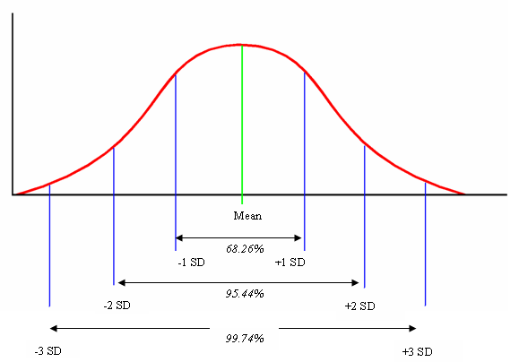
Normal Distribution Curve
Standard Deviation: An accurate and powerful measure of the spread of scores around the mean value.

Large standard deviations are obtained when there is a wide spread of scores.

Small standard deviations are obtained when the scores are closely clustered around the mean.

Strengths of using the standard deviation | Weaknesses of using the standard deviation
Most sensitive measure of dispersion – as all scores are taken into account.  It allows for the interpretation of individual scores – you can see where a score falls in relation to all others eg anybody with an IQ of 121 is in the top 5% of the population between +2 and +3 sd’s | Can be difficult to calculate – The standard deviation requires a fairly complex calculation, which is time consuming compared to the calculation of the range.  Relies on a normal distribution – can be less meaningful if data is not normally distributed.

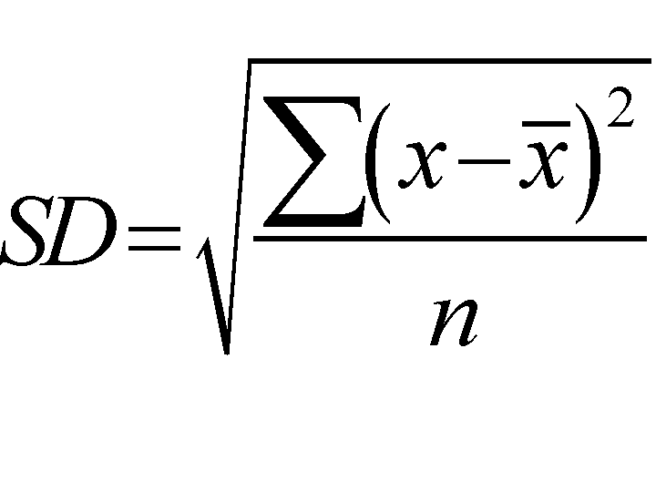
Calculating Standard Deviation

- Add all the scores together and divide by the number of scores to calculate the mean.
- Subtract the mean from each individual score.
- Square each of these scores.
- Add all the squared scores together.
- Divide the sum of the squares by the number of scores minus 1. This is the variance.
- Use a calculator to work out the square root of the variance. This is standard deviation.
Percentages

These are a type of descriptive statistic that shows the rate, number or amount of something within every 100. Data can be converted into percentages by multiplying them as a factor of 100 eg:
your score on a Psychology benchmark test x 100 = percentage score
maximum test score

Converting a percentage to a decimal

To convert a percentage to a decimal, the % sign is removed and the decimal point is moved two places to the left eg 37% is 37.0 then becomes 0.37

Converting a decimal to a fraction

If there are two decimal places then you divide by 100 eg 0.24 becomes 24/100. If there are three decimal places then you divide by 1000 eg 0.875 becomes 875/1000. The fraction can be further reduced by finding the lowest common denominator, the biggest number that divides evenly into both parts of the fraction. In the second example, both numbers divide by 25 so that the fraction then becomes 35/40.

Using ratios

Information can also be expressed as a ratio. This could be a “part to whole” ratio eg if 13 out of 20 participants obeyed in an experiment, it would be 13:20. It can also be written as a “part to part” ratio ie if 13 obeyed and 7 did not obey, it would be expressed as 13:7. The lowest common denominator should always be found when expressing the ratio.

Estimations

It may be necessary to comment on the central tendency or dispersion of a set of data which may require estimating the answer. If, for example, the highest score in a set of data is 206 and the lowest 59, an estimate of the range using rounded figures of 200 and 60 would be 140. Estimations of this type are called order of magnitude calculations.

Use of significant figures

A long number is rounded off to the nearest thousand or million eg 432,765 to two significant figures is 430,000. When many numbers occur after a decimal point we may round this off to 1, 2 or 3 significant figures eg 0.003245 to two significant figures is 0.0032. When the final digit is 5 or above, the previous digit is rounded up and rounded down if the final digit is less than 5.

Presentation of quantitative data: Graphs and tables

Quantitative data can be represented pictorially in graphs and charts to summarise the results and show (at a glance) any trends or patterns. The type of graph used is dependent on the type of data you have collected.

Summarising data in a table

One way of representing data is in the form of a summary table. When tables appear in the Results section of a scientific report, they are not raw scores but have been converted into descriptive statistics. Eg:

Table showing the mean number of words recalled in quiet conditions compared to noisy conditions

 | Quiet | Noise
Mean | 29 | 14
Standard Deviation | 0.58 | 4.5

It is standard practice to include a summary paragraph beneath the table explaining the results. Eg: It appears that on average people were able to recall more words when in a quiet room and that noise negatively affected memory. Scores were however more dispersed in the noise condition showing some people were much more affected by the noise than others whereas in the quiet condition, scores were much more clustered and similar.

Bar Charts

Bar charts are used to represent the frequencies of non-continuous (or category) data. The x axis illustrates the groups or categories and the y axis illustrates the frequencies. There are gaps between the bars to illustrate that the data is not continuous.

Example Data
 | Standard Police interview | Cognitive interview
Median number of items recalled accurately | 12 | 22

Histograms
In a histogram the bars touch each other as they are used to represent continuous data rather than discrete as in a bar chart. The x axis is made up of equal sized intervals of a single category eg percentage scores in a Maths test broken down into intervals such as 0-9, 10-19, 20-29 etc. The y axis represents the frequency within each interval. If there was a zero frequency for one of the intervals the interval remains but without a bar.
Example: Do students tend to show anxiety prior to exams?

Example Data
 | 0-10 | 11-20 | 21-30 | 31-40 | 41-50
Frequency of scores | 6 | 9 | 15 | 16 | 8

Example Graph

Line graphs (Frequency polygon)
These also represent continuous data, typically the IV is plotted on the x axis and the DV on the y axis. The graph is produced by drawing a line from the mid-point top of each bar in a histogram. With a line graph, two or more frequency distributions can be compared on the same graph.
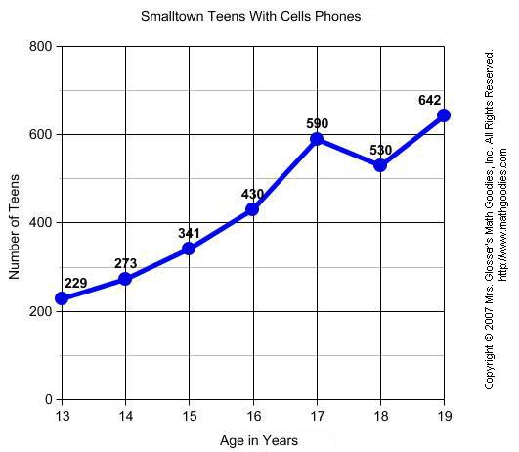

Scattergrams are covered under Correlations in booklet 1.

Distributions: Normal and skewed

When certain characteristics are measured such as height, weight or IQ of large numbers of people within a population, the frequency of the measurements should form what is known as a bell shaped curve. This is known as normal distribution and is a symmetrical shape when plotted on a frequency polygon (line graph). Normal distribution is found when the data is continuous, each score is the result of randomly distributed effects and there are large numbers of scores drawn randomly from the population.

There are several ways the data can be checked to see if it is normally distributed: 1. Examine visually to see if most scores are clustered around the mean. 2. Calculate measures of central tendency to see if the mean, median and mode are the same. 3. Plot the frequency distribution on a histogram to see if it forms a bell shaped curve.
Normal Distribution
(bell shaped curve)

Skewed Distribution

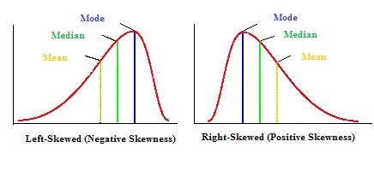

Sometimes data is not symmetrical and can become skewed by outlying scores. A positive skew is where most of the distribution is concentrated towards the left of the graph therefore most participants scored on the low side of average. A negative skew is the opposite. When data is skewed the mode remains towards the highest peak, the median comes next and the mean has been dragged the furthest from the centre.

Skewed distribution can result from: 1. A small number of scores being taken 2. A biased sample 3. One end of the scale has a cut off point eg reaction time as at the fast end it is not possible to better 0 seconds.

The purpose of statistical testing is to see whether differences or relationships have occurred due to chance or whether the IV has had a significant effect on the DV (in an experiment).
Statistical Testing

Probability is identified by the letter p and is a measure of how likely the difference or relationship between two sets of data is a real (significant) difference/relationship or whether it has just occurred by chance. Probability is expressed either as a percentage or on a scale from 0 to 1. The accepted level of probability in Psychology where a result will be regarded as significant is 5% or 0.05. This means that there is a 5% probability that the results in a particular study occurred by chance and a 95% probability that the results were due to the IV (if it was an experiment).

Significance levels: Significance refers to whether the results of the study will be accepted as down to chance or as an effect of the IV. When looking at the size of the difference between conditions, there has to be an agreed point at which it will be accepted as significant. There is never a 100% certainty that differences/relationships are beyond the boundaries of chance so it is impossible to prove something beyond all doubt. The accepted cut off point in Psychology to regard findings as significant is 5% which means you are 95% certain your results were not down to chance, leaving a 5% possibility of error. 5% or 0.05 is therefore known as the accepted level of significance. In some circumstances researchers may need to be even more confident that their results were not due to chance eg where there could be a serious negative effect on individuals such as drug testing. They therefore may use a 1% or 0.01 level of significance as this leaves only a 1% chance of error.

There are a large number of statistical tests all of which have their own specific criteria for use. One test is the SIGN TEST. This requires a repeated measures design, at least nominal level data and is used when looking for a difference. To calculate a sign test, follow the instructions on pg 300 of Lawton et al or pg 199 of Flanaghan et al.

Once the observed / calculated value has been obtained, this is compared to the critical table value for the appropriate statistical test. When looking up this value the researcher needs to know whether a directional or non-directional hypothesis was chosen and the number of participants in the study.

For some tests to be significant, the observed value has to be greater than the critical value but for the Sign Test it has to be equal to or less than the critical table value.

Interpretation of significance: Once you have calculated your observed value, turn to pg 198 of the Flanaghan text book or pg 300 of the Lawton text book and decide whether you have a significant result. If your observed value is equal to or less than the critical value at the 5% level of significance, you can accept your experimental hypothesis and reject the null hypothesis. If your observed value is greater than the critical value at the 5% level, you must accept the null hypothesis and reject the experimental hypothesis.

Levels of Measurement
The level of data produced by a research study affects which statistical test will be chosen.
- Nominal data – involves placing participants into categories and counting the numbers within each category. It is the crudest, most uninformative type of data. Eg how many people said yes v no
- Ordinal data – this is ranked data eg who finished 1st, 2nd, 3rd in a race etc. Rating scales are also regarded as ordinal data. It gives more information than nominal data but is not as informative as interval as we do not know the precise distance between each ranked place.
- Interval / ratio data – this involves standardised measurements on a scale of equal intervals eg time, weight, temperature. It is the most accurate and informative measurement. Interval and ratio are classed together but the difference is that ratio has an absolute zero point (eg weight).

Questions relating to this booklet

- Which of the following would produce qualitative data and which quantitative data:
- Students rate their enjoyment of research methods on a scale of 1 – 10
- A teacher interviews year 10 students about their ideas of what Psychology is.
- A researcher categorises the social behaviour of children into one of 3 categories.
- Which of the research methods you have studied produce quantitative data and which produce qualitative?
- Which of the following would be classed as primary and which secondary data:
- A researcher searches through newspapers to see if there is a relationship between daily temperature and the number of violent incidents.
- A researcher asks cinemagoers leaving a horror movie if they feel more murderous after seeing the film.
- What graphical display would be most appropriate to represent the following:
- The change in a person’s body temperature over the course of a day.
- The difference in average annual rainfall between Manchester and Paris.
- The relationship between daily temperature and people’s ratings of how happy they are.
- The frequency of people who chose “snow” as their favourite weather condition broken down into sub-categories of age.
- Estimate the range of a set of data where the highest number is 322 and the lowest 57?

Exam Questions

- Explain one strength and one limitation of qualitative data (6 marks)
- Explain what is meant by the term meta-analysis. In your answer, refer to one example of a meta-analysis (3 marks)
- Identify 3 features of a normal distribution (3 marks)
- Using an example, explain the difference between a positive and a negative skew (3 marks)
- Identify one type of graph and explain when it would be appropriate to use it to display data (3 marks)
- James scored 18 out of 20 in a memory test as part of a Psychology experiment.
- Express James’s mark as a percentage (2 marks)
- Express James’s mark as a decimal (1 mark)
- Express James’s mark as a fraction of the maximum mark (2 marks)
- Express the value 0.01678365 to three decimal places (1 mark)
- Write out the following equation in words: 1 << 1,000,000 (1 mark)
- Identify three conditions that would need to be met in order to use the sign test (3 marks)
- What is the accepted level of probability in psychological research? (1 mark)
- Outline two circumstances in which a researcher might employ the 1% level of significance. (2 marks)
- Identify three pieces of information that are required when reading a table of critical values. (3 marks)

