**Psychology AS Approaches Checklist**

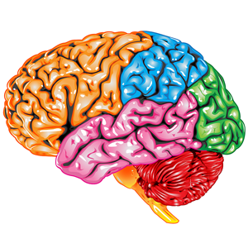

|  |  |  |  |
| --- | --- | --- | --- |
| Specification | Lesson | Independent Work | Revised |
| Origins of psychology: Wundt, introspection and the emergence of psychology as a science. |  |  |  |
| Learning approach: the behaviourist approach, including classical conditioning and Pavlov’s  research, operant conditioning, types of reinforcement and Skinner’s research. |  |  |  |
| Learning approach: social learning theory including imitation, identification, modelling, vicarious reinforcement, the role of mediational  processes and Bandura’s research. |  |  |  |
| The cognitive approach: the study of internal mental processes, the role of schema, the use of  theoretical and computer models to explain and make inferences about mental processes. The  emergence of cognitive neuroscience. |  |  |  |
| The biological approach: the influence of genes, biological structures and neurochemistry on  behaviour. Genotype and phenotype, genetic basis of behaviour, evolution and behaviour. |  |  |  |
|  |  |  |  |
| The divisions of the nervous system: central and peripheral (somatic and autonomic). |  |  |  |
| The structure and function of sensory, relay and motor neurons. The process of synaptic  transmission, including reference to neurotransmitters, excitation and inhibition. |  |  |  |
| The function of the endocrine system: glands and hormones. |  |  |  |
| The fight or flight response including the role of adrenaline. |  |  |  |