The Human Brain and Behaviour

1. Colour and label the lobes and structures of the brain

1) A)

2) B)

3) C)

4) D)

5)

6)

1. 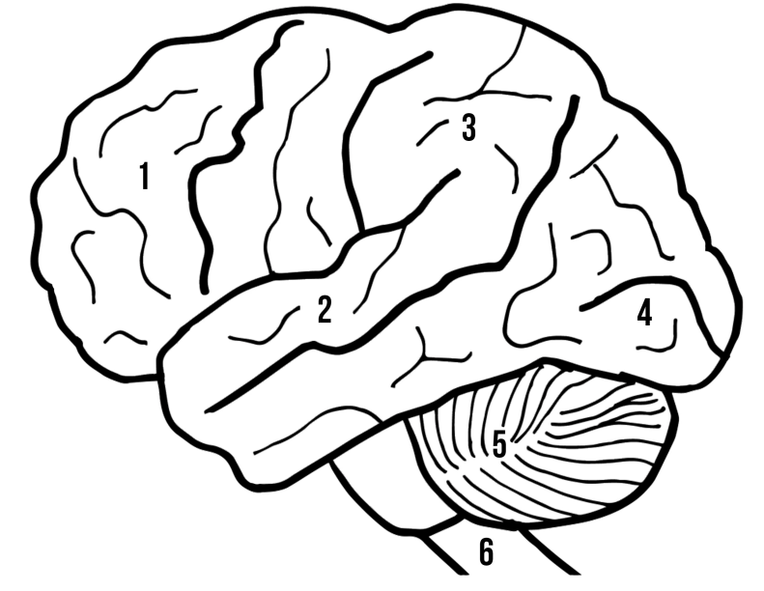Annotate the lobes and structures of the brain with their primary functions

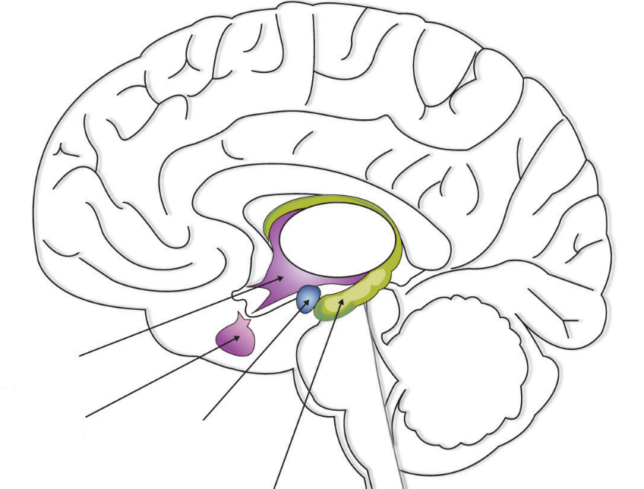

A

D

C

B