* **Classical conditioning** – Learning by _________________

-Pavlov (1902) *Pavlov’s Dog*

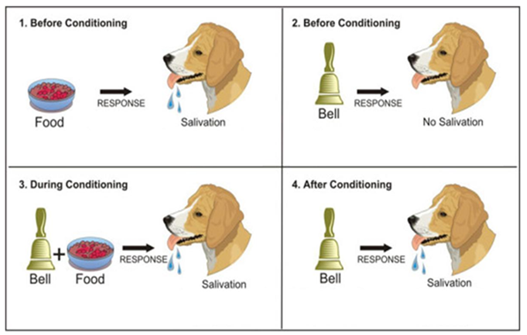

|  |  |
| --- | --- |
| * **Unconditioned Stimulus (UCS) x2** * **Unconditioned Response (UR) x2** * **Neutral Stimulus (NS) x2** | * **Conditioned Stimulus (CS) x1** * **Conditioned Response (CR) x1** * **No Response (NR) x1** |

-Watson and Rayner (1920) *Little Albert*

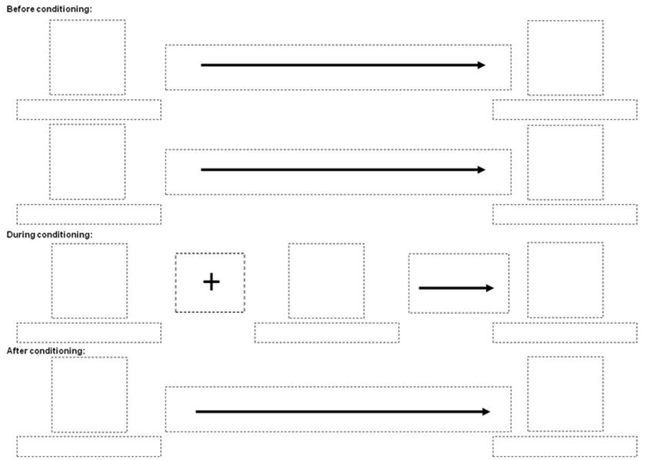

* **Operant Conditioning** – Learning by _________________

Decide if each of these scenarios is an example of positive reinforcement, negative reinforcement or punishment:

1. A man with a toothache visits the dentist and suffers more pain. He does not go back.
2. A girl goes to the dentist with toothache and it is sorted out. She then has regular check-ups.
3. A young man wears deodorant for the first time when going out. He finds that people talk to him and he continues to wear deodorant.
4. A student smokes in bed, setting fire to her room and destroying her Harry Potter DVD collection. She never smokes in bed again.
5. A boy does his homework for the first time and is praised by his teacher. After this he does his homework every week.
6. A student is allowed to drop a boring subject. Her effort in other subjects improve.

Behaviourism - AO3 Evaluation

