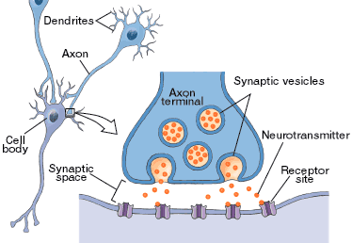**PROCESS OF SYNAPTIC TRANSMISSION**