**Approaches in Psychology – The Psychodynamic Approac**

The Conscious:

The Unconscious:

The Preconscious:



**The Structure of the Personality:**

ID:

EGO:

SUPEREGO:

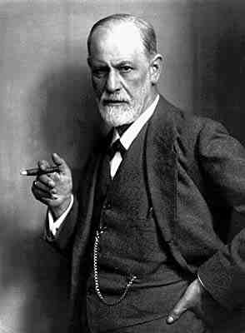

**Task –** Read the scenarios below. Apply your knowledge of the ID, EGO & SUPEREGO to explain what each part would be saying in the given scenario.

Scenario 1: ***Laura’s maths exam is in 2 weeks’ time. Laura know that she needs to revise for her exam but she has been invited out by her friends every night for the next 2 weeks.***

What would the ID say?

What would the SUPEREGO say?

What would the EGO say?

Scenario 2: ***You are sat on a bus and notice someone has left a wallet full of £50 notes.***

What would the ID say?

What would the SUPEREGO say?

What would the EGO say?

Scenario 3: ***You are just leaving work and your boss asks you to stay an extra hour.***

What would the ID say?

What would the SUPEREGO say?

What would the EGO say?

Scenario 4 – write your own scenario:

…………………………………………………………………………………………………………………………………………………………………………………………………………………………………………………………………………………………………………………………………………………………………………..

What would the ID say?

What would the SUPEREGO say?

What would the EGO say?

**Defence Mechanisms:**

The Ego uses a number of defence mechanisms to help reduce the conflict between the demands of the Id and Superego:

* **Repression**
* **Denial**
* **Displacement**

These defence mechanisms are unconscious and ensure the ego is able to prevent us from being overwhelmed by temporary threats or traumas. However, they involve some distortion of reality and as a long term solution are regarded as unhealthy.

|  |  |  |
| --- | --- | --- |
| **Defence Mechanism** | **Description** | **Effect on Behaviour** |
| Repression |  |  |
| Denial |  |  |
| Displacement |  |  |

**Question:**

Repression, denial and displacement are all examples of defence mechanisms.

Match each example below to one of these defence mechanisms:

1. Continuing to turn up to work even though you’ve been sacked
2. An individual forgetting the trauma of their favourite pet dying
3. Slamming the door after a row with your girlfriend

**Psychosexual Stages of Development:**

* Freud claimed that child development occurred in 5 stages
* The underlying unconscious drive is sexual in nature
* Each stage (apart from latency) is characterised by a different conflict that the child must resolve in order to progress successfully to the next stage
* Any unresolved conflict leads to ***fixation*** where the child becomes ‘*stuck*’ and carries these conflicts with them into adult life

|  |  |  |
| --- | --- | --- |
| **Stage & Age** | **Description** | **Consequences of unresolved conflict** |
| Oral |  |  |
| Anal |  |  |
| Phallic |  |  |
| Latent |  |  |
| Genital |  |  |

**Some Sample Questions:**

1. Using an example, explain the *role of the unconscious*. (3 marks)
2. Identify **one** Freudian defence mechanism and explain how it would affect behaviour. (3 marks)
3. Discuss the psychodynamic approach. Refer to at least **two** other approaches in your answer. (16 marks)