Biopsychology **2**

Localisation

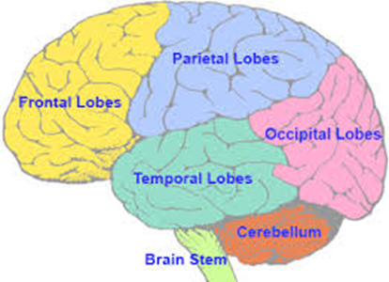

Fill in the gaps in the passage below, choosing the correct words from the list provided. Then label the brain with the information you have gleaned.

The brain is a very complex organ and has different regions specialised for different jobs. This is called____________________. The area which is responsible for interpreting what we see is called the____________________ cortex. It is found at the ____________________ of the brain. The area which receives and interprets sounds is the ____________________ cortex. It is located just above where the ears are on the outside of the head. The sensorimotor cortex is located in a band running over the top of the head and down each side. The ____________________ area is towards the front, and the____________________ area is towards the back.

The sensory area has regions in proportion to the sensitivity of our ____________________ indifferent parts of the body, so there is relatively ____________________ of the sensory cortex devoted to the lips than to the knees.

The motor area also differs in the amount of brain area relating to different parts of the body. This relates to how finely we can control each part. For example, there is____________________ motor cortex for the back than for the fingers. In these areas, the left-hand side of the body is represented on the ____________________-hand side of the brain, and the righthand side of the ____________________ is represented on the left-hand side of the brain.

In most respects, the left and right sides of the brain are very similar. One difference, however, is the presence of the ____________________ areas, which are only found on the ____________________- hand side. There are two important areas: ____________________ area (located towards the ____________________ of the brain) is responsible for converting thought into speech; and

____________________ area (located towards the ____________________ of the brain) plays an important role in understanding other people’s speech and producing speech which makes sense.

The differences in function between the left and right hemispheres is called ____________________ or cortical specialisation. Whereas the left side is specialised for language, the right hemisphere is important in visual abilities such as the perception of people’s ____________________. Musical abilities and emotions are also localised to the ____________________. These differences have been studied using ____________________ patients who have had their corpus callosum cut. As a result, their two hemispheres function ____________________.

**Worksheet**

**Auditory back back**

**Body Broca’s faces**

**Front language lateralisation**

**Left less localisation**

**More motor right**

**Right sensory separately**

**Skin split-brain visual Wernicke’s**

