Biological structures

Biological structures are components of our physiology which psychologists are interested to study because they affect our psychology – our thoughts, feelings and behaviour.

The most important structures for the biological approach are :
- The neuron or nerve cell.
- The central nervous system
- The peripheral nervous system
- The endocrine system.

1. The neuron or nerve cell.

The basic unit of the brain and nervous system is the neuron or nerve cell. The nervous system is composed of specialised cells called neurones. The neurones form ‘pathways’ in the brain and throughout the body. At the junction between one brain cell and the next lies a very, very small gap (called a synapse). Synapses enable the electrochemical process of neural transmission (one cell passing information on to the next) to take place, and are the site at which most of the drugs that affect the nervous system operate.

Understanding the action of neurotransmitters is fundamental to understanding many aspects of physiological psychology, but especially the actions of drugs.

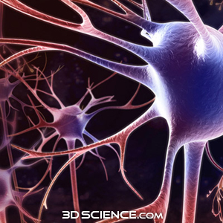

2. The Central Nervous System (CNS)

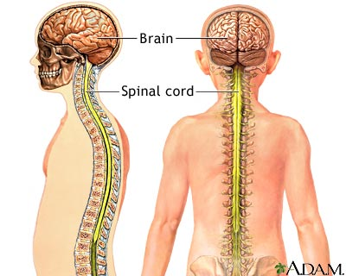

The Central Nervous System (CNS) includes all the nerves in the brain and spinal cord. It is concerned with actions and reactions of the body to information which is received through the senses and with co-ordinating other functions of the body, such as sleeping, waking, eating and so on. It is also involved in complex functions such as thinking, memory and attention.
The CNS has three main parts : The brain stem, the cerebellum and the cerebral hemispheres. Each part plays a different role in influencing our thoughts, feelings and behaviour.

3. The Peripheral Nervous System

The Peripheral Nervous System consists of the nerves leading to and from the brain and spinal cord to other parts of the body. This is divided into:
The somatic nervous system – the nerves of this system transmit information about external stimulation from the skin, muscles and joints to the CNS. These nerves make us aware of pain, pressure, temperature variation etc. They also carry impulses from the CNS back to the parts of the body where they initiate action. These nerves also control muscles used in making voluntary movements, as well as involuntary adjustments in posture and balance.
The autonomic nervous system – the nerves of this system run to and from the internal organs regulating such processes as respiration, heart rate and digestion. It is particularly involved in emotions such as fear and stress. The autonomic nervous system can be subdivided into two further parts: the sympathetic division and the parasympathetic division.
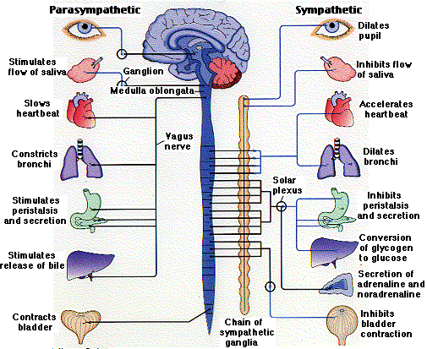

4.The endocrine system

The endocrine system also has an important role to play in regulating behaviour along with the autonomic nervous system. The endocrine system is responsible for the production of hormones in the body (like testosterone or oestrogen) and is stimulated by the action of the autonomic nervous system. Much research has been devoted to gaining a fuller understanding of endocrine systems as they mediate behaviours such as those involved in stress (the so-called ‘fight or flight syndrome’), and in sexual and parental behaviour.

