Animal Studies – Lorenz (1935)

Imprinting:

Procedure:

Findings:

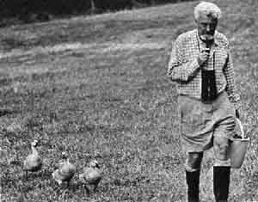

Evaluation - Weaknesses

Evaluation - Strengths