Cultural Variations in Attachments
Grossman and Grossman -Germany (Lawton mask book pg 126)
Research into Cultural Variations in Attachment
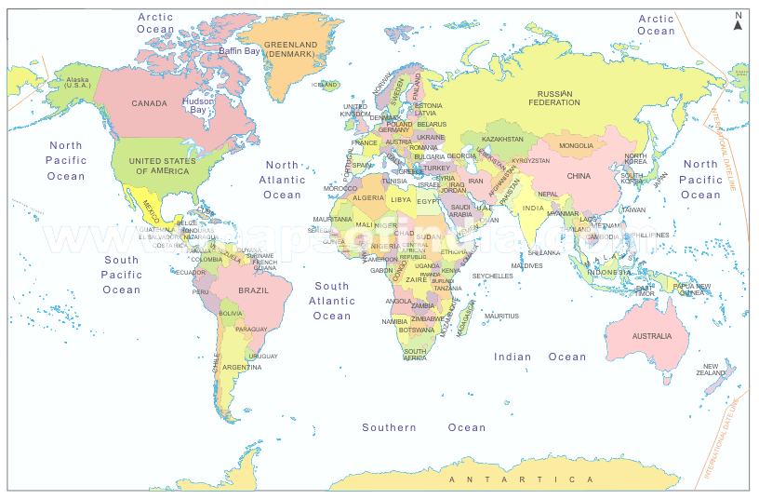

Ainsworth & Bell (North America)
Using the Strange Situation they found…
Insecure Avoidant – 22%
Securely attached – 66%
Insecure Resistant – 12%
See SS NOTES for evals

Van Ijzendoorn & Kroonenberg (blue booklet)

Fox –Israel (blue booklet)

