Q1. An electric motor in a machine drives a rotating drum by means of a rubber belt attached to pulleys, one on the motor shaft and one on the drum shaft, as shown in the diagram below.
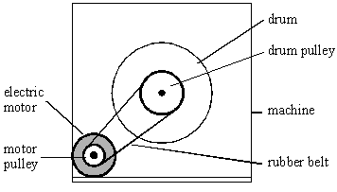
(a) The pulley on the motor shaft has a diameter of 24 mm. When the motor is turning at 50 revolutions per second, calculate
(i) the speed of the belt,
.............................................................................................................
.............................................................................................................
.............................................................................................................
.............................................................................................................

(ii) the centripetal acceleration of the belt as it passes round the motor pulley.
.............................................................................................................
.............................................................................................................
.............................................................................................................
.............................................................................................................
.............................................................................................................
(5)

(b) When the motor rotates at a particular speed, it causes a flexible metal panel in the machine to vibrate loudly. Explain why this happens.
......................................................................................................................
......................................................................................................................
......................................................................................................................
......................................................................................................................
......................................................................................................................
(2)
(Total 7 marks)

Q2.A chemical centrifuge consists of two test-tube holders which can be spun round in a horizontal circular path at very high speed as shown. The centrifuge runs at a steady speed of 3000 revolutions per minute and the test-tube holders are horizontal.
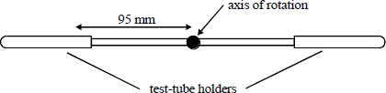

(a) Calculate the angular speed of the centrifuge in rad s^{–1}.
........................................................................................................................
........................................................................................................................

(b) Calculate the magnitude of the acceleration at a point on the centrifuge 95 mm from the axis of rotation.
........................................................................................................................
........................................................................................................................

(c) State the direction of the acceleration in part (ii).
........................................................................................................................
(Total 5 marks)

Q3.The figure below shows a dust particle at position D on a rotating vinyl disc. A combination of electrostatic and frictional forces act on the dust particle to keep it in the same position.
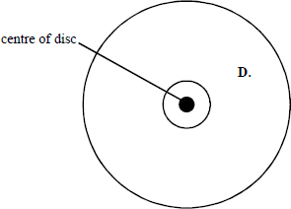
The dust particle is at a distance of 0.125 m from the centre of the disc. The disc rotates at 45 revolutions per minute.

(a) Calculate the linear speed of the dust particle at D.
(3)

(b) (i) Mark on the diagram above an arrow to show the direction of the resultant horizontal force on the dust particle.
(1)

(ii) Calculate the centripetal acceleration at position D.
(2)

(c) On looking closely at the rotating disc it can be seen that there is more dust concentrated on the inner part of the disc than the outer part. Suggest why this should be so.
........................................................................................................................
........................................................................................................................
........................................................................................................................
........................................................................................................................
........................................................................................................................
........................................................................................................................
(3)
(Total 9 marks)

M1. (a) (i) r = 0.012 (m) (1)
(use of v = 2πfr gives) v = 2π50 × 0.012 (1)
= 3.8 m s^{–1} (1) (3.77 m s^{–1})
(ii) correct use of a = or a = 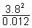 (1)
= 1.2 × 10³ m s^{–2} (1)
[or correct use of α = ω²r]
(allow C.E. for value of v from (i)
5

(b) panel resonates (1)
(because) motor frequency = natural frequency of panel (1)
2
QWC 2
[7]

M2.(a) f = 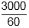 = 50 (Hz) (1)
ω (= 2πf) = 314 (rad s^{–1}) (1)

(b) α = (rω²) = 95 × 10^{–3} × 314² = 9.4 × 10³ m s^{–2} (1)

(c) (inwards) towards axis of rotation (1)
[5]

M3.(a) v = ωr or v = or v = 2πrf
C1
ω = 2π × 45 / 60 or correct substitutions for v
C1
0.59 ms^{–1}
A1
(b) (i) radial arrow from D towards centre of disc
B1

(ii) a = or a = ω²r condone a = ω²x but not a = – (2πf)²x
2.78 m s^{–2} but not if shm equation clearly used
A1

(c) recognition that closer toward centre particles need
smaller centripetal force
B1
support for this: v ∝ r or ω = constant along disc
B1
idea that friction / electrostatic forces are sufficient to meet
the requirements of particles close to centre but not for
those further away
B1
[9]

