**1.6.17.2 Centripetal Acceleration - Derivation**

The motion of an object in a circular path at constant speed is known as **uniform circular motion** (UCM). An object in UCM is constantly changing direction, and since velocity is a vector and has direction, you could say that an object undergoing UCM has a constantly changing velocity, even if its speed remains constant. And if the velocity of an object is changing, it must be accelerating. Therefore, an object undergoing UCM is constantly accelerating. This type of acceleration is known as **centripetal acceleration**.

**Question**: If a car is accelerating, is its speed increasing? ( Answer at bottom )

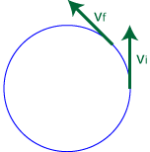

Just as importantly, we need to figure out the direction of the object's acceleration, since acceleration

is a vector. To do this, let's draw an object moving counter-clockwise in a circular path, and show its velocity vector at two different points in time. Since we know acceleration is the rate of change of an object's velocity with respect to time, we can determine the direction of the object's acceleration by finding the direction of its change in velocity, Δv.

To find its change in velocity, Δv, we must recall that deltav-exp.

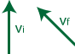

Therefore, we need to find the difference of the vectors vf and vi graphically, which can be re-written as deltav-exp2.

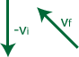

Recall that to [add vectors graphically](http://www.aplusphysics.com/courses/regents/mathreview/regents_math_review.html#vectscal), we line them up, tip-to-tail, and then draw our resultant vector from the starting point (tail) of our first vector to the ending point (tip) of our last vector.

UCMIll4

So, the acceleration vector must point in the direction shown above. If I show this vector back on our original circle, lined up directly between our initial and final velocity vector, it's easy to see that the acceleration vector points toward the center of the circle.

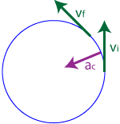

You can repeat this procedure from any point on the circle... no matter where you go, the acceleration vector always points toward the center of the circle. In fact, the word *centripetal* in centripetal acceleration means "center-seeking!"

So now we know the direction of an object's acceleration (toward the center of the circle), but what about its magnitude? Magnitude of an object's centripetal acceleration can be found on the reference table, and is given by the formula:

ac-form

**\*Answer**: It depends. Its speed could be increasing, or it could be accelerating in a direction opposite its velocity (slowing down). Or, its speed could remain constant yet still be accelerating if it is traveling in uniform circular motion.