Q1. The Hubble space telescope was launched in 1990 into a circular orbit near to the Earth.
It travels around the Earth once every 97 minutes.
(a) Calculate the angular speed of the Hubble telescope, stating an appropriate unit.

answer = .....................................
(3)

(b) (i) Calculate the radius of the orbit of the Hubble telescope.

answer = ................................ m
(3)

(ii) The mass of the Hubble telescope is 1.1 × 10⁴ kg. Calculate the magnitude of the centripetal force that acts on it.

answer = ................................ N
(2)
(Total 8 marks)

M1. (a) ω 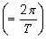 = 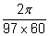 [or 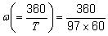]
= 1.1 × 10^{–3} (1.08 × 10^{–3}) (1) [= 6.2 (6.19) × 10^{–2}]
rad s^{–1} [accept s^{–1}] (1) [degree s^{–1}]
3

(b) (i) 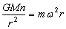 or 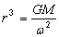 (1)
gives r³ = 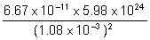 (1)
r = 6.99 × 10⁶ (m) (1)
3

(ii) F (= mω²r) = 1.1 × 10⁴ × (1.08 × 10^{–3})² × 6.99 × 10⁶ (1)
= 9.0 × 10⁴ (8.97 × 10⁴) (N) (1)
[or 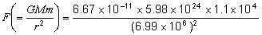 (1)
= 9.0 × 10⁴ (8.98 × 10⁴) (N) (1)]
2
[8]

