NAME ............................................ Chemistry Class .........................

Student Number ……….

#### titrationMOLES III (Solutions)

0.10

Read burette to 2 d.p.

Answers

24.75

**Topic 5: Formulae, Equations and   
Amounts of Substance**

25

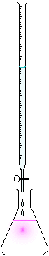

1. be able to write balanced full and ionic equations, including state symbols,   
   for chemical reactions
2. be able to calculate amounts of substances (in mol) in reactions involving

mass, volume of gas, volume of solution and concentration

*These calculations may involve reactants and/or products*.

1. be able to calculate solution concentrations, in mol dm-3 and g dm-3, including   
   simple acid-base titrations using a range of acids, alkalis and indicators

The use of both phenolphthalein and methyl orange as indicators will be   
expected.

1. be able to:
   * 1. calculate measurement uncertainties and measurement errors in   
        experimental results
     2. comment on sources of error in experimental procedures
2. understand how to minimise the percentage error and percentage

uncertainty involving measurements

1. understand risks and hazards in practical procedures and suggest

appropriate precautions where necessary.

Fill so bottom of meniscus is on the marked line

Allow to drain by holding against glass so all but the final drop is sucked out by capillary action

Phenolphthalein

Pink in alkali

End point is permanent pale pink



[Quantitative analysis](http://en.wikipedia.org/wiki/Quantitative_analysis_(chemistry)) is the branch of Chemistry in which the amount of a chemical is found out by a practical method.

A widely used technique is that of titrations; this is sometimes called [volumetric analysis](http://en.wikipedia.org/wiki/Titration) because it depends on reacting accurate volumes of solution with one another.

In this method, the concentration of an unknown solution can be found by reacting it with a standard solution.

If the volumes of the two solutions which exactly react with each other are measured, e.g. an acid and an alkali, the concentration of one can be calculated if the concentration of the other is known.

A standard solution is one with an accurately known concentration.

This topic leads on from your work on moles; we will recap moles calculations as they apply to solutions then learn the technique of titrations and associated calculations. Finally you will complete an assessed practical involving a titration.

Some helpful resources can be found:-

New Reference**Textbook**

Facer AS Chemistry p205 – 211

p326 – 329

**Department website Factsheets**

|  |  |
| --- | --- |
| 07 | Moles and Volumetric Analysis |
| 23 | How To Answer Questions on Titration Calculations |
| 59 | Titration Calculations: Revision Summary |

**Titration animation program** in All Programs/Dept applications/Chemistry /Titrations 4.

Unfortunately this can only be used from within College – at the moment.

This is fun to watch the animations and see the effects of altering the solutions and indicator used. The pH graphs lead on to A2 level work.

<http://www.dartmouth.edu/~chemlab/techniques/titration.html>

This site gives a very good explanation of the apparatus and practical techniques used.

<http://www.avogadro.co.uk/chemist.htm>

Go to the section on Titration apparatus, technique and calculation. This animation provides useful revision.

**THE METHOD**

1. Balanced equation

Check that it is balanced

1. Calculate the moles

You must be able to calculate the moles of something! -see page 8

1. Molar ratio

Ratio:-

What you know : what you need to find out

1. Deduce moles

Means a simple halving, doubling according to the molar ratio.

1. Calculate the answer

From a manipulated moles equation

YOU NEED TO WRITE STATEMENTS FOR STEPS 2-5.

FINALLY CONSIDER SIG.FIGS.

**CONCENTRATION OF SOLUTIONS**

**New Reference**Refer to: Facer AS Chemistry pages 72-73

**SOLUTIONS**

A solution is formed when a solid, the [SOLUTE](http://www.google.co.uk/search?hl=en&rlz=1T4ADBF_en-GBGB278GB279&defl=en&q=define:solvent&sa=X&oi=glossary_definition&ct=title), is dissolved in a [SOLVENT](http://www.google.co.uk/search?hl=en&rlz=1T4ADBF_en-GBGB278GB279&defl=en&q=define:solvent&sa=X&oi=glossary_definition&ct=title).

An AQUEOUS SOLUTION is formed when the solute is dissolved in WATER.

Not all substances dissolve in water. There is a whole range of organic solvents, such as those used   
in the dry cleaning industry, which dissolve substances that are insoluble in water. You will come   
across ethanol used as a solvent. Such solutions are described as ethanolic or alcoholic solutions.

**CALCULATING CONCENTRATIONS OF SOLUTIONS**

The concentration of a solution is normally given in **moles per cubic decimetre**, (**mol dm-3**.)

This is also known as the **molarity** of the solution.

A one molar solution (1.0 M solution) contains one mole in a cubic decimetre.

Remember 1 dm3 = 1000 cm3 = 1 litre

Concentration / molarity in mol dm-3 = number of moles x 1000cm3

Volume in cm3

New exercise

What is the concentration in mol dm-3 of the following?

|  |
| --- |
| 1) 2 moles of KOH in 1 dm3  conc = 2 x 1000 = 2 mol dm-3  1000 |
| 2) 1 mole of NaOH in 500 cm3  conc = 1 x 1000 = 2 mol dm-3  500 |
| 3) 0.5 moles HCl in 100 cm3  conc = 0.5 x 1000 = 5.0 mol dm-3  100 |
| 4) 0.05 moles CaCl2 in 250 cm3  conc = 0.05 x 1000 = 0.20 mol dm-3  250 |

We also need to be able to work out concentrations in **grams per cubic decimetre (**g dm-3.) You might remember from moles that

Mass = no moles x RMM

So: **g dm-3 = mol dm-3 x RMM**

e.g. In question 1) above:

If there are 2 moles of KOH in 1 dm3 - it has a concentration (molarity) of 2 mol dm-3 . Its concentration in g dm-3 is:-

2 x (RMM KOH) = 2 x 56.1 = 112.2 g dm-3

From the answers to questions 2)-4) work out the concentration in g dm-3

|  |
| --- |
| 2) 1 mole of NaOH in 500 cm3  2.00 mol dm-3 2.00 x 40 = 80 g dm-3 |
| 3) 0.5 moles HCl in 100 cm3  5.0 mol dm-3 5.0 x 36.5 = 182.5 g dm-3 |
| 4) 0.05 moles CaCl2 in 250 cm3  0.20 mol dm-3 0.20 x 111.1 = 22.22 g dm-3 |

When a substance is **dissolved** in a **solvent** (e.g. water) to make a **solution** its **concentration** can be expressed in several ways. In Chemistry we most commonly use:

* **Grams per litre (dm3)** of solution **g dm-3**
* **Moles per litre (dm3)** of solution **mol dm-3 (or M)**

**NOTE: 1 dm3 = 1000 cm3**

To change from grams per litre to moles per litre, use the formula below:

**mol dm-3 = g dm-3**

**RMM**

For **very dilute solutions** we sometimes use **parts per million** or **ppm.**

**Parts per million = number of grams of solute in 1000000g of solvent (or mg per 1000g)**

**STANDARD SOLUTIONS**

A **STANDARD SOLUTION** is a solution which is made to an **accurately known concentration.** A standard solution is prepared by taking a **known mass** of **solute** and making this up to a **known volume of solution** in a **volumetric flask**

.

**EXAMPLE – PREPARATION OF A STANDARD SOLUTION OF SODIUM CHLORIDE**

Your task is to prepare **250cm3** of a standard **sodium chloride** solution of **concentration 0.1 M.**

**Calculation of mass needed:**

RMM of sodium chloride = 58.5

Grams per litre = moles per litre x RMM = 0.1 x 58.5 = 5.85 g litre-1

Therefore grams needed for 250cm3 solution = 250 x 5.85 = 1.46g

1000

**Preparation of the solution:**

It is extremely important that the correct procedure is followed so that all of the solid is transferred to the volumetric flask and that no impurities are present. This procedure will be demonstrated by your teacher first and then you will practise making up your own solution, following the diagrams and explanation on the next page.

Mass of NaCl actually used = 1.46 g

**MAKING A STANDARD SOLUTION**

<http://www.dartmouth.edu/~chemlab/techniques/q_transfer.html>

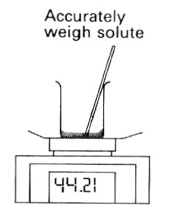A solution of known concentration can be made up if the solid substance is weighed out and the mass is measured in grams.

Accurately weigh solute

1.46

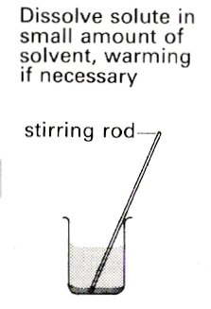

Dissolve solute in a small amount of solvent, warming if necessary

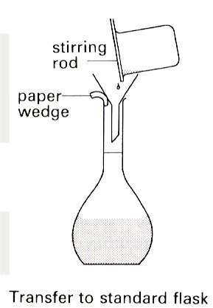

Transfer to a volumetric flask.

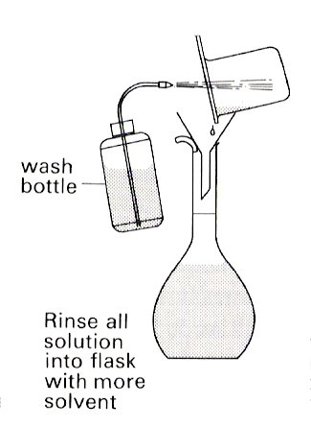

Rinse all solution into flask with more solvent.

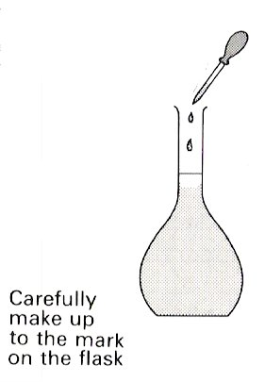

Carefully make up to the mark on the flask.

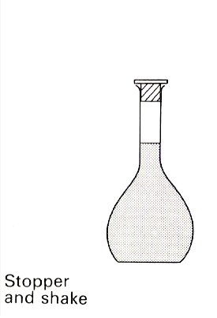

Stopper and invert 5 times to mix

Having made up your solution add any extra prompt points to the diagrams to help you in future.

**Note:**

This can be used to make a [standard solution](http://en.wikipedia.org/wiki/Standard_solution) if the chemical is very pure, does not gain moisture from the air and has a relatively high molar mass so weighing errors are minimised.

**CALCULATING CONCENTRATION OF SOLUTIONS**

Remember, **moles = grams** Therefore, **mol dm-3 = g dm-3**

**RMM RMM**

**1.** Calculate the concentration in mol dm-3 of each of the following solutions:

1. 3.65g of HCl in 1000 cm3 of solution

Relative molar mass of HCl = 36.5

Therefore moles in 1000 cm3 = 3.65 = 0.10 mol

36.5

1. 6.62g of Pb(NO3)2 in 250 cm3 of solution

Relative molar mass of Pb(NO3)2  = 331.2

Therefore moles in 250 cm3 solution = mass/RMM = 6.62 = 0.01998

331.2

Therefore moles in 1000 cm3 solution = 1000 x 0.01998 = 0.07995 mol dm-3

250

1. 1.96g of H2SO4 in 300 cm3 of solution

RMM H2SO4 = 98.1

Moles H2SO4 = 1.96 = 0.019979

98.1

Concentration = 1000 x 0.019979 = 0.06054 mol dm-3

330

1. 25.0g of CuSO4.5H2O in 250 cm3

RMM CuSO4.5H2O = 249.6

Moles CuSO4.5H2O = 25.0 = 0.10016

249.6

Concentration = 1000 x 0.10016 = 0.40064 mol dm-3

250

Remember,

**Number of moles in solution= vol in cm3x concentration in mol dm-3**

**1000**

1. Calculate the number of moles of solute in each of the following volumes of solution:
2. 25 cm3 of 0.50 mol dm-3 HCl.

Moles = 25 x 0.50 = 0.0125 mol

1000

1. 250 cm3 of 0.25 mol dm-3 HCl

Moles = 250 x 0.25 = 0.0625 mol

1000

1. 25 cm3 of 0.10 mol dm-3 AgNO3

Moles = 25 x 0.10 = 0.0025 mol

1000

1. 22 cm3 of 1.0 mol dm-3 NaOH

Moles = 22 x 1.0 = 0.022 mol

1000

1. Calculate the mass in grams of the solute in each of the following solutions:
2. 50 cm3 of 0.50 mol dm-3 NaCl

Relative molar mass of NaCl = 58.5

Moles of NaCl in the 50cm3 solution = 50 x 0.50 = 0.025 mol

1000

Therefore mass of NaCl present = 0.025 x 58.5 = 1.46g

1. 100 cm3 of 0.10 mol dm-3 Pb(NO3)2

Relative molar mass of Pb(NO3)2 = 331.2

Moles of Pb(NO3)2 in the 100cm3 solution = 100 x 0.10 = 0.010 mol

1000

Therefore mass of Pb(NO3)2 present = 0.010 x 331.2 = 3.312g

**4**. For each of the solutions in Q 3 calculate the concentration in g dm-3

a) Mass of NaCl in 50 cm3 = 1.46g (calculated above)

Therefore mass of NaCl in 1000 cm3 = 1.46g x 1000 = 29.2 g dm-3

50

b) Mass of Pb(NO3)2 in 100 cm3 = 3.312g (calculated above)

Therefore mass of Pb(NO3)2 in 1000 cm3 = 3.312g x 1000 = 33.12 g dm-3

100

New exercise**More calculation practice - Moles and mass of substances in solution**

1. Calculate the moles of solute and mass of solute in each of the following solutions:

|  |  |  |  |  |  |
| --- | --- | --- | --- | --- | --- |
|  | **Volume** | **Concentration**  **(mol dm-3)** | **Solute** | **Moles** | **Mass (g)** |
| a) | 2 dm3 | 0.1 | NaCl | Moles = vol(cm3) x conc  1000  = 2 x 0.1 = 0.2 | RMM= 58.5  Mass = moles x RMM  = 0.2 x 58.5  = 11.7 g |
| b) | 250 cm3 | 0.2 | KMnO4 | Moles = vol(cm3) x conc  1000  = 250 x 0.2 = 0.05  1000 | RMM= 158  Mass = moles x RMM  = 0.05 x 158  = 7.9 g |
| c) | 50 cm3 | 1.2 | Na2CO3.10H2O | Moles = vol(cm3) x conc  1000  = 50 x 1.2 = 0.06  1000 | RMM= 286  Mass = moles x RMM  = 0.06 x 286  = 17.16 g |
| d) | 200 cm3 | 0.11 | NaOH | Moles = vol(cm3) x conc  1000  = 200 x 0.11 = 0.022  1000 | RMM= 40  Mass = moles x RMM  = 0.022 x 40  = 0.88 g |

1. Calculate the concentration in mol dm-3 and g dm-3 of each of the following solutions

|  |  |  |  |  |  |
| --- | --- | --- | --- | --- | --- |
|  | **Volume** | **Mass (g)** | **Solute** | **Grams per dm3**  **(g dm-3)** | **Moles per dm3**  **(mol dm-3)** |
| a) | 1 dm3 | 8.50 | AgNO3 | conc (g dm3)  = Mass x 1000  vol (cm3)  = 8.50 x 1000  1000  = 8.50 g dm-3 | Moles = mass  RMM  RMM = 169.9  In 1dm3 there are  Moles = 8.50  169.9  = 0.05 mol dm-3 |
| b) | 250 cm3 | 5.35 | KIO3 | conc (g dm3)  = Mass x 1000  vol (cm3)  = 5.35 x 1000  250  = 21.4 g dm-3 | Moles = mass  RMM  RMM = 214  In 1dm3 there are  Moles = 21.4  214  = 0.10 mol dm-3 |
| c) | 50 cm3 | 5.60 | Pb(NO3)2 | conc (g dm3)  = Mass x 1000  vol (cm3)  = 5.60 x 1000  50  = 112 g dm-3 | Moles = mass  RMM  RMM = 331.2  In 1dm3 there are  Moles = 112  331.2  = 0.34 mol dm-3 |
| d) | 100 cm3 | 4.99 | CuSO4.5H2O | conc (g dm3)  = Mass x 1000  vol (cm3)  = 4.99 x 1000  100  = 49.9 g dm-3 | Moles = mass  RMM  RMM = 249.6  In 1dm3 there are  Moles = 49.9  249.6  = 0.20 mol dm-3 |

**ALL SPECIES OF MOLES or look at the METHOD on page 0**

As you have seen molar calculations involve solids, solutions and gases. Calculations often involve more than one sort.

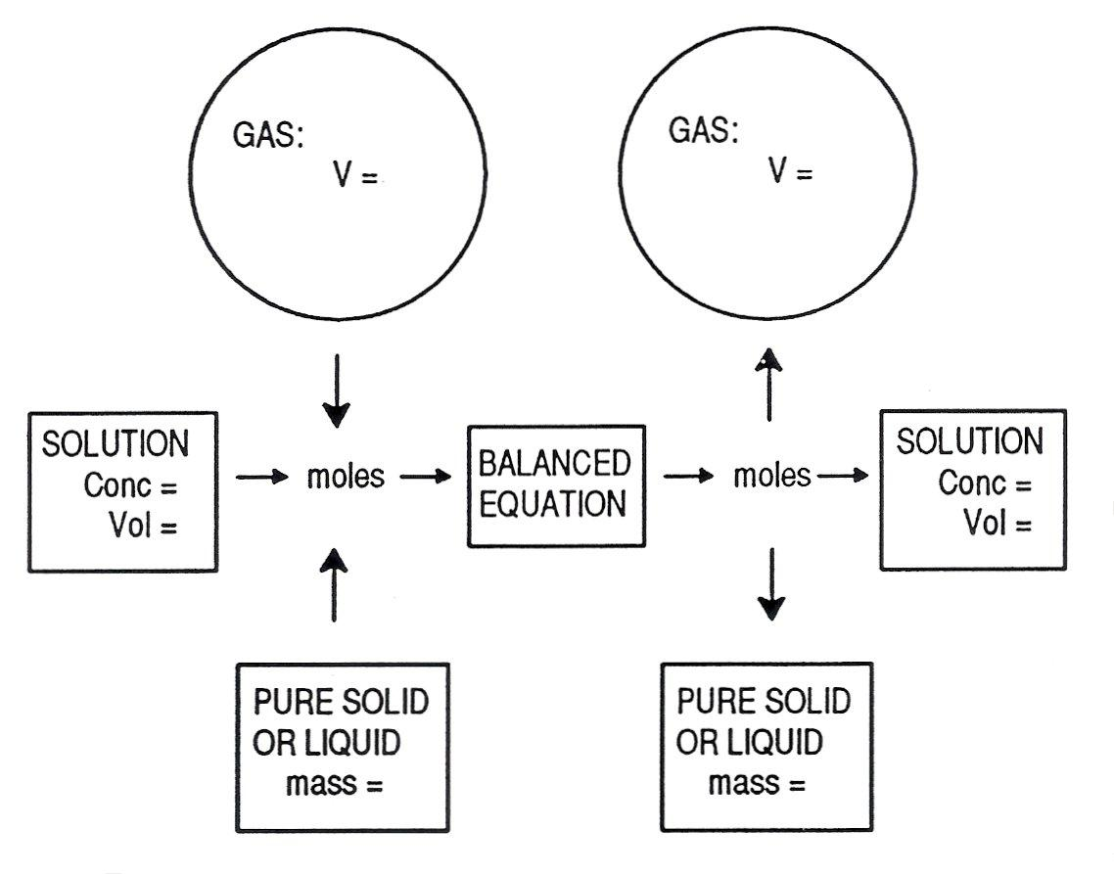The diagram below is a visual summary of the overall picture which will help you to work your way through more complex calculations.

**CHECK LIST OF FORMULAE**

SOLIDS: **number of moles = mass** (g)

Or **pure** liquids **RMM** (g mol‑1)

**number of moles = number of particles**

**Avogadro constant**

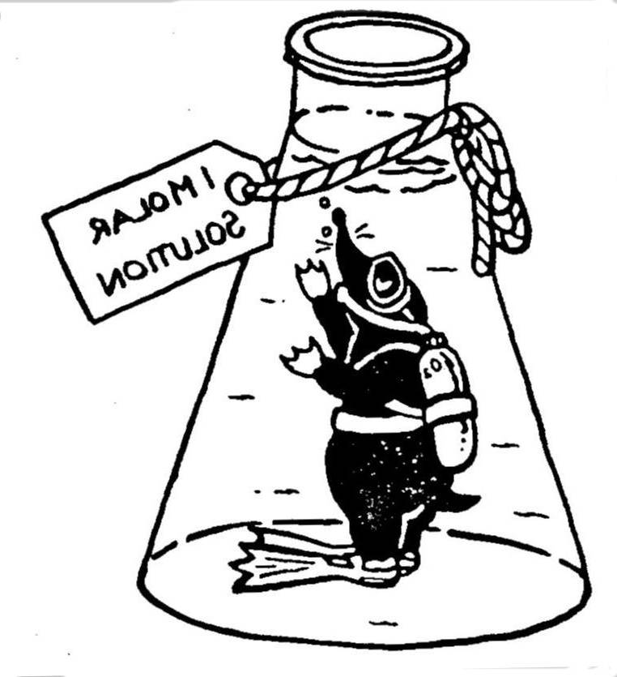

SOLUTIONS: **number of moles = vol** (cm3)**x Molarity** (mol dm-3)

**1000**

Use the Molar volume given in the question.

Both volume units need to be the same

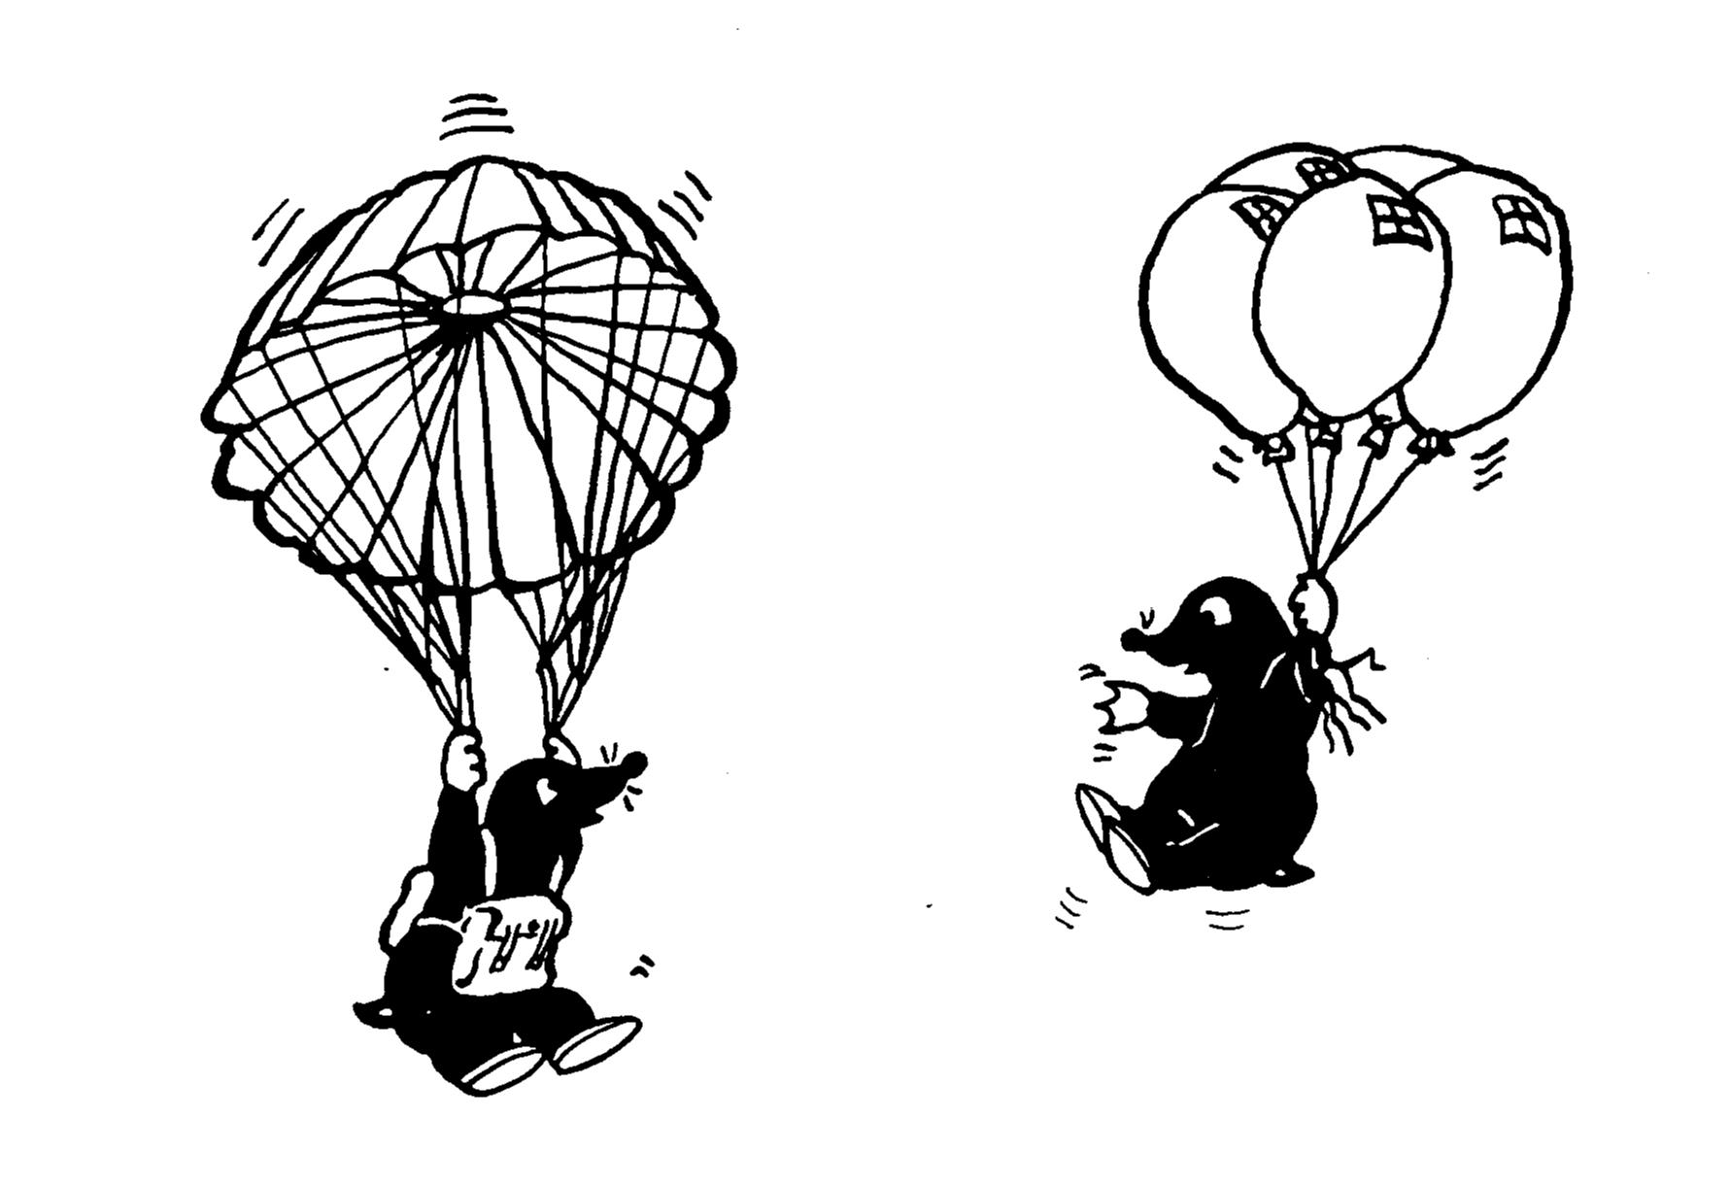GASES: **number of moles = vol** (dm3)

**Molar volume** (dm3)

**number of moles, n = PV**

From PV = nRT

**RT**

PURE LIQUIDS: **number of moles = density** (g cm-3) **× volume** (cm3)

**RMM**  (g mol‑1)

HINT: mass = density × volume density = mass

g = g cm-3 × cm-3 volume

REMEMBER your starting point is ALWAYS the solid/solution /gas for which you have the data to work out the missing piece of information in its molar equation.

**CALCULATION OF CONCENTRATIONS OF STANDARD SOLUTIONS (Revision)**

**Example**

New exerciseWhat is the concentration in mol dm-3 of a solution made by dissolving 10.0g NaOH in 200 cm3 of distilled water?

RMM NaOH = 40

No of moles of NaOH in 10.0g = 10/40 = 0.25

∴200 cm3 solution contains ……0.25……. moles

so 1000 cm3 solution contains 0.25 x 1000 moles

200

Therefore concentration = 1.25 mol dm-3 (Units?)

What is the molar concentration of the solution made in the following examples?

**1**) 4.0g NaOH in 500 cm3

RMM NaOH = 40

Moles = 4.0 = 0.10

40

Conc = 0.10 x 1000 = 0.20 mol dm-3

500

**2**) 2.0 g CaBr2 in 25 cm3

RMM CaBr2 = 199.9

Moles = 2.0 = 0.010

199.9

Conc = 0.010 x 1000 = 0.40 mol dm-3

25

**3**) 40.0 g CuSO4 in 2.0 dm3

RMM CuSO4 = 159.6

Moles = 40.0 = 0.25

159.6

Conc = 0.25 x 1000 = 0.125 mol dm-3

2000

**4**) 11.9 g CuSO4.5H2O in 500 cm3

RMM CuSO4.5H2O = 249.6

Moles = 11.9 = 0.0476

249.6

Conc = 0.0476 x 1000 = 0.0954 mol dm-3

500

**5)** What mass of sodium carbonate crystals Na2CO3.10H2O must be dissolved in 250cm3 of water to give a concentration of 0.05M?

Moles Na2CO3 = 250 x 0.05 = 0.0125

1000

Mass Na2CO3.10H2O = 0.0125 x 286 = 3.575 g

Which of the solutions above would make a good standard solution? Na2CO3.10H2O or . CuSO4.5H2O

Why? They are obtainable as pure crystals which are stable and do not decompose or absorb moisture from the atmosphere. Also they have a high RMM decreasing the mass error

**CALCULATING REACTING AMOUNTS (QUANTITATIVE ANALYSIS)**

**New exercise**

We can use these solution calculations to calculate how much of a substance is needed to react or how much can be produced. The branch of practical chemistry which finds out **how much** of a substance is present is called **QUANTITATIVE ANALYSIS**.

1) What mass of barium sulfate would be produced by adding excess barium chloride solution to 20cm3 of a 0.1 M solution of copper(II) sulfate?



Equation

CuSO4(aq) + BaCl2(aq) 🡪 BaSO4(s) + CuCl2(aq)

CuSO4moles = vol x M = 20 x 0.1 = 0.002



1000 1000

molar ratios CuSO4 : BaSO4

1 : 1

∴ moles BaSO4 = 0.002



Mass = moles x RMM

= 0.002 x 233.1

= 0.4662



= 0.47 g (2 s.f.)

2) What is the maximum mass of calcium carbonate that will react with 25cm3 of a 2M solution of hydrochloric acid?

Equation

CaCO3(s) + 2HCl(aq) 🡪 CaCl2(aq) + H2O(l) + CO2(g)



HClmoles = vol x M = 25 x 2 = 0.05



1000 1000

molar ratios HCl : CaCO3

2 : 1

∴ moles CaCO3= 0.025

Mass = moles x RMM

= 0.025 x 100.1



= 2.5 g

3) What is the minimum volume of 0.5M sulfuric acid needed to react with 0.24g of magnesium?

Equation

Mg(s) + H2SO4(aq) 🡪 MgSO4(aq) + H2(g)



Mgmoles = mass = 0.24 = 0.009876



RMM 24.3

molar ratios Mg : H2SO4

1 : 1

∴ moles H2SO4 = 0.009876



Vol = moles x 1000 / conc

= 0.009876 x 1000

0.5



= 19.753 = 19.8 cm3(3 s.f.)

4) What is the minimum volume of 2M HCl needed to react with 1.25g of magnesium carbonate?



Equation

MgCO3(s) + 2HCl(aq) 🡪 MgCl2(aq) + H2O(l) + CO2(g)

MgCO3moles = mass = 1.25 = 0.014928



RMM 84.3

molar ratios MgCO3 : HCl

1 : 2

∴ moles HCl = 0.014928 x 2

Vol = moles x 1000 / conc

= 0.029656 x 1000

2



= 14.83 cm

**TITRATIONS**

This is a form of **quantitative analysis** when a **solution of known concentration** is used to find the concentration of another solution with which it reacts.

It is possible to achieve extremely accurate results by a careful methodical approach:-

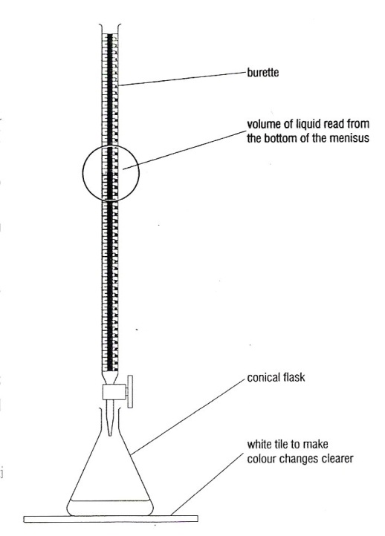A step by step guide is shown [here](http://www.dartmouth.edu/~chemlab/techniques/titration.html).

ALWAYS WEAR SAFETY SPECTACLES

* ALWAYS label beakers containing colourless solutions.
* ONLY TAKE small quantities – do not waste solutions.
* NEVER return solutions to the stock bottles.
* RINSE the burette with a small quantity of the solution you are going to use to fill it.
* Place a plastic filter funnel in the top of the burette.
* ENSURE the tap on the burette is closed.
* FILL the burette with the solution you are using (In general avoid using alkaline solutions in the burette if possible as they corrode joints).
* Run a little bit of solution through the burette into a waste beaker so that the space beneath the tap is full of solution too.
* THERE IS NO NEED FOR THE BURETTE TO READ EXACTLY ZERO.
* 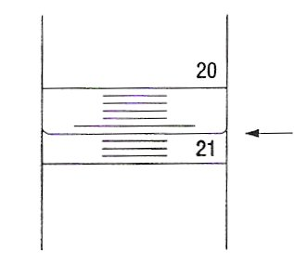Read the BOTTOM of the meniscus at eye level. Burettes can be read to 0.05 cm3 and EVERY READING must be recorded to 2 decimal places. Readings should be recorded as soon as they are taken.

Reading

20.60

* RINSE the pipette with a small quantity of the solution you are going to use – USE A SAFETY FILLER.
* FILL the pipette with the solution – the bottom of the meniscus should be on the fill line. Pipettes are ± 0.05 cm3.
* Transfer the solution to a clean (rinse with distilled water) conical flask – touch the tip to the side of the flask to remove the last drop.
* Place a white tile under the conical flask.
* If you do not know the indicator colours do preliminary tests.
* Add 2/3 drops of indicator – just sufficient to clearly show any colour.
* HOLD the conical flask in your right hand and swirl gently whilst manipulating the tap with your left hand. (Reverse if necessary).
* DO THE FIRST RUN QUICKLY TO OBTAIN A ROUGH GUIDE FOR THE TOTAL VOLUME REQUIRED.
* For later titrations, add the solution drop by drop as the end point approaches.
* If in doubt about the endpoint, take a reading and add two more drops – then decide.
* Repeat until you have two readings within 0.20 cm3 – these are the readings you should average and use in any calculation.
* Rinse all the glassware with tap water.

RINSE THE BURETTE WITH DISTILLED WATER AND LEAVE IT UPSIDE DOWN IN THE STAND WITH THE TAP OPEN .

To determine the end point of a titration we use an indicator. An **indicator** is a chemical which is one colour in acid and another in alkali.

|  |  |  |  |
| --- | --- | --- | --- |
| **Indicator** | Colour in acid | Endpoint | Colour in alkali |
| Methyl orange | red | orange | yellow |
| Methyl red | red | orange | yellow |
| Phenolphthalein | colourless | Very faint permanent pink | pink |

There is one other titration type that you will study in Topic 3, a redox titration using starch as an indicator. These types of titrations will be covered in the Redox pack.

**Titration calculations**

Titration calculations involve 2 solutions, the simplest type is:-

The concentration of one of the solutions is known and the volume of the other needed to react with it is determined by titration so enabling its concentration to be determined.

This calculation is carried out in 3 stages:-

1. Work out the number of moles of the reagent of known concentration.
2. Deduce the number of moles of the other reagent from the balanced equation.
3. Calculate the concentration of the other reagent.

E.g.

In a titration 25cm3 of 0.1M HCl required 26.8cm3 of NaOH to neutralise it. What is the concentration of the acid in mol dm-3?

1. Work out the number of moles of the reagent of known concentration:

25/1000 x 0.1 = 0.0025 moles of HCl

2) Calculate the number of moles of the other reagent from the balanced equation:

NaOH + HCl NaCl + H2O

So the molar ratio is 1:1 therefore:-

No moles NaOH = No Moles HCl

Therefore there are 0.0025 moles of NaOH in 26.8cm3

3) Calculate the concentration of the other reagent:

Concentration = (1000/26.8) x 0.0025 = 0.0933 mol dm-3

**For more practice**

**Worksheet**See titration calculations (hard) and solution calculations 2 / 3 (easy)

Other titration calculation types are covered in Titration dry labs

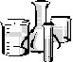

**TITRATION EXPERIMENT 1**

**To find the molar concentration of a solution of hydrochloric acid**

In this experiment the amount of hydrochloric acid in solution is estimated by neutralizing it with   
an alkali in the presence of an indicator. The same technique can be used to find the concentration   
of any acid in solution.

**METHOD**

You will be following the general titration procedure outlined on a previous page.

The burette will be filled with the acid solution.

The pipette will be filled with 0.1 M sodium hydroxide solution.

The indicator you will be using is phenolphthalein.

**1.** Put a small amount of the sodium hydroxide solution in a test tube. Add a drop of indicator.   
Note the colour in the table below. Add the acid solution. Note the colour at the end-point when   
the acid has neutralized the alkali - and the colour in acid solution in the table below.

**2.** Fill the burette with acid following the procedure given. Note the burette reading.

**3.** Using a safety filler pipette 25 cm3 0.1 M NaOH (aq) into a conical flask. Add 2/3 drops of   
indicator until the colour can clearly be seen.

**4.** Carry out the titration. Repeat until you have at least two readings within 0.20 cm3.

**5.** Clear away – you *must rinse out the burette* with distilled water before upending with tap open   
to dry.

**RESULTS**

|  |  |
| --- | --- |
| Colour of phenolphthalein in alkali | Pink |
| Colour of phenolphthalein at end-point | Very pale permanent pink |
| Colour of phenolphthalein in acid | Colourless |
| Solution in conical flask | 0.10 M NaOH |
| Solution in burette | ?M HCl |

|  |  |  |  |  |  |
| --- | --- | --- | --- | --- | --- |
|  | Titration 1 | Titration 2 | Titration 3 |  |  |
| Burette reading (final) |  |  |  |  |  |
| Burette reading (initial) |  |  |  |  |  |
| Titre/cm3 |  |  |  |  |  |

Asterisk those titrations you are using to calculate:-

Average volume added using titres within 0.20 cm3 =

24.10 cm3

**ANALYSIS/CALCULATION**

ALWAYS begin the calculation with the substance for which you know BOTH the volume and the molarity.

USE the equation for the reaction.

The balanced equation for the reaction of hydrochloric acid with sodium hydroxide is:

HCl(aq) + NaOH(aq) 🡪 NaCl(aq) + H2O(l)

The substance for which you know both the volume and the molarity in this case is the sodium   
hydroxide solution – you used 25 cm3 0.1 M NaOH (aq)

Number of moles of NaOH(aq) = 25.0 × 0.1

1000

= 0.0025

From the equation the molar ratio of NaOH **:** HCl = 1 **: 1**

Therefore number of moles of HCl(aq) = 0.0025

…24.10 cm3 (average titre)

So cm3 of HCl(aq) contains 0.0025 moles

Hence 1000 cm3 of HCl(aq) contains 0.0025 x 1000 = 0.104 moles

24.10

This is the MOLARITY of the acid solution (i.e. concentration in mol dm-3)

RMM HCl(aq) = 36.5

Therefore concentration of HCl in g dm-3 is: 36.5 x 0.104 = 3.796 g dm-3

= 3.80 g dm-3 (3 s.f.)

**Evaluation of technique.** (operator errors = blunders)

How do your results compare with:-

your partner? Difference due to pipette technique, reading burette meniscus level.

the class average? Burette pipette rinsed / cleaned

Can you think of any reasons for this?

Which aspects of the titration did you find most difficult? Reading burette to 0.05,

pipetting technique, end point colour fades with phenolphthalein.



**TITRATION EXPERIMENT 2**

**To find the concentration of sulfuric acid in a sample of acid rain**

The level of toxic or harmful substances in the environment needs to be monitored. We need to   
know how much of a substance signifies a danger level. This may be applied for example to   
monitoring acid pollution in a stream or river.

If sulfur dioxide escapes into the atmosphere it reacts with oxygen and water to form a solution of   
sulfuric (VI) acid according to the equation:

2SO2 (g) + 2H2O(l) + O2 (g) 🡪 2H2SO4 (aq)

In this experiment you are making up a standard solution of anhydrous sodium carbonate and using   
this to find out the concentration of sulfuric acid in the acid rain sample provided.

1. Write a balanced equation for the reaction of sulfuric(VI) acid with sodium carbonate.

H2SO4(aq) + Na2CO3(aq) 🡪 Na2SO4(aq) + H2O(l) + CO2(g)

1. If the acid rain is approximately 0.1 mol dm-3, what concentration does the sodium carbonate solution need to be?

H2SO4 : Na2CO3 1:1 0.1 mol dm-3

1. You are required to make up 250cm3 of the anhydrous sodium carbonate solution. What mass is required?



If you did not weigh out 2.65g exactly  
then moles = mass/106  
and conc = moles x 1000

250

Moles = 250 x 0.1 = 0.025

1000

Mass = moles x RMM

= 0.025 x 106

2.65 g

**METHOD**

1. Weigh a small beaker, record its mass. Weigh the required mass of anhydrous sodium   
   carbonate into the beaker and record the mass of beaker and sodium carbonate.
2. Follow the procedure described for making up a solution (see page 3) using a 250cm3   
   volumetric flask.
3. Pipette a 25cm3 sample of sodium carbonate into a conical flask and add 2 drops of methyl   
   orange indicator.
4. Fill the burette with ‘acid rain’ and note the initial reading.
5. Carry out the titration. Repeat until you have 2 readings within 0.2 cm3.

**RESULTS**

|  |  |
| --- | --- |
| Colour of methyl orange in alkali | Yellow |
| Colour of methyl orange at end-point | Orange |
| Colour of methyl orange in acid | red |
| Mass of empty beaker/g |  |
| Mass of beaker and Na2CO3 /g |  |
| Mass of Na2CO3/g | 2.65 g |

|  |  |  |  |  |  |
| --- | --- | --- | --- | --- | --- |
|  | Titration 1 | Titration 2 | Titration 3 |  |  |
| Burette reading (final) |  |  |  |  |  |
| Burette reading (initial) |  |  |  |  |  |
| Titre/cm3 |  |  |  |  |  |

Average volume added using titres within 0.20 cm3 =

24.78 cm3

Pipetted into flask

Your **new concentration** if you did not weigh out 2.65g

**ANALYSIS**

Calculate the moles of Na2CO3 used = 25 x 0.10 = 0.0025

1000

Na2CO3 + H2SO4 🡪 Na2SO4 + H2O + CO2

Therefore moles of sulfuric acid in average titration volume = 0.0025

Concentration of sulfuric acid in mol dm-3 = molesx1000 = 0.0025 x1000

mean titre 24.78

= 0.10088782 = 0.101 mol dm-3

**EVALUATION** *read the following section on quantifiable errors first.*

**Calculation of measurement uncertainty/errors in the experiment**

|  |  |  |  |
| --- | --- | --- | --- |
| **Procedure** | **Measurement** | **Error/Uncertainty** | **Percentage Error/Uncertainty** |
| Mass of Carbonate (2 balance readings) | 2.65 g | ± 0.005g x2 = ± 0.01g | * 1. x 100 = 0.38   2.65 |
| Volumetric flask | 250cm3 | ± 0.2cm3 | 0.2 x 100 = 0.08  250 |
| Pipette | 25cm3 | ± 0.1cm3 | 0.1 x 100 = 0.40  25 |
| Titre –  2 burette readings (initial and final) | Average titration volume | ± 0.05cm3 x 2  = ± 0.10cm3 | * 1. x 100 = 0.40   24.78 |
| **TOTAL** |  |  | 1.26 % |

Calculated concentration of sulfuric acid in mol dm-3 = 0.1005 mol dm-3

Therefore actual error in concentration of acid rain (in mol dm-3) = 0.1005 ± 0.001 mol dm-3

**New exerciseQualitative errors/limitations of procedure and assessment of the relative significance of all the errors:**

*This should be written clearly on lined paper and attached to your work.*

* Discuss any **limitations** of your **procedure** other than measurement uncertainties.
* Discuss and **explain** which of ALL the errors is likely to have had the **most significance   
  on your result** for the concentration of the acid.
* Is titration an **accurate** and **reliable** method to find the concentration of the acid? Explain   
  why you have drawn this conclusion. How has your method ensured that the data you have collected is **precise** and **reliable**?

Quantifiable errors

Refer to Facer AS Chemistry p326-327

[Experimental errors explained](http://www.rod.beavon.clara.net/err_exp.htm)

Several types of error are recognizable:-

**Operator error = ‘blunders’**

These are due to carelessness or misuse of apparatus; careful work is needed at all times.   
Errors due to misreading apparatus can be avoided if figures are written down in a systematic fashion as they are taken, and then checked. Such errors cannot be quantified.

**Instrument calibration errors**

Different readings may be obtained using different items of the same equipment. This is particularly true of thermometers - if absolute values of temperature are required rather than differences it may be necessary to check the readings of thermometers against each other.   
Cheap thermometers may vary by 0.5oC – 1oC. However, the error when temperature   
*differences* are measured may reasonably be ignored.

**Precision errors**

Precision errors are the only types that show a reasonable degree of experimental   
reproducibility. Such errors may therefore be quantified.

Individual pieces of equipment are built to specified standards. The higher the degree of precision, the greater the cost of the apparatus. Here are some examples:

Balances**.**  Different types with ranges of precision from 0.1g to 0.0001g are available.   
In college laboratories the balances have a precision of 0.01g so the precision error is +/- 0.005g **per reading.**

Measuring Cylinders. A100 cm3 cylinder will usually enable a volume to be measured to +/- 1 cm3.

Pipettes  These will measure volume to 0.1cm3 if the item is of type B.

(Type A pipettes are much more expensive but will measure volumes to   
+/- 0.05 cm3.)

BurettesThe divisions are 0.1cm3 but it is possible to estimate +/- 0.05 cm3

Thermometers.Most measure to 1oC. For enthalpy changes of reaction you should use a thermometer with a precision of 0.1oC or 0.2 oC.

**Uncertainties in readings** should be recorded using ± or significant figures,

for example 36.3 oC ± 0.1 oC.

or 36.3oC (3 s.f.) – this is more appropriate after calculations from data.

**Treatment of errors in calculations**

##### Adding or subtracting measured quantities

##### The maximum absolute uncertainty is the sum of the individual uncertainties. Thus if the numerical values of two temperatures are 36.3 oC ± 0.1 oC and 56.3 oC ± 0.1 oC, the difference is 20.0 oC ± 0.2 oC. (The first temperature may be as low as 36.2 oC, the second as high as 56.4 oC, giving a maximum difference of 20.2 oC,)

##### Multiplying or dividing measured quantities

The maximum fractional or percentage uncertainty is the sum of the percentage uncertainties for   
each of the individual quantities. Thus, if the heating capacity of a calorimeter is (50 ± 1) J K-1   
and in an experiment a temperature rise of 4.0 K± 0.2 K is obtained:

the error in the heating capacity is l J K-1, i.e. 1/50 x 100% = 2%;

the error in the temperature reading is 0.2/4.0 x 100% = 5%.

The maximum percentage uncertainty in the energy transferred is thus:

2% + 5% = 7%

**New exercise**i.e., the energy transferred = 50 X 4.0 J = (200 ± 14) J (as 7% of 200 is 14).

**Using information on the previous page**,

Calculate the % error if a student uses a measuring cylinder to measure out 25cm3 of liquid

Volume measured will be 25 ± 1 cm3

The error will be 1 x 100 = 4%

25

Compare this to the % error if a 25cm3 pipette had been used.

Volume measured will be 25.0 ± 0.1 cm3

The error will be 0.1 x 100 = 0.4%

25

Would you expect a burette to give as high a level of accuracy?

Although both pipettes and burettes measure volumes to 0.1cm3

there is uncertainty associated with start and final burette readings so these uncertainties need to be added leading to an overall uncertainty of 0.2cm3

The maximum uncertainty is the sum of individual uncertainties e.g. 25.00±0.2cm3

Burette readings from a series of titrations are: -

|  |  |  |  |  |
| --- | --- | --- | --- | --- |
|  | First titration | Second titration | Third titration | Fourth titration |
| First reading (cm3) | 0.05 | 14.30 | 28.15 | 0.15 |
| Second reading (cm3) | 14.30 | 28.15 | 42.15 | 14.20 |
| Volume used (cm3) | 14.25 | 13.85 | 14.00 | 14.05 |

Which readings should be used? 2, 3 and 43 and 4

Calculate the average 13.85 + 14.00 + 14.05 = 13.966

33

The uncertainty associated with a (type A) burette is ±0.05cm3 **for each volume reading.**

Therefore, what **range** is possible for the value of the average volume used? 13.97 ± 0.10 cm3

Calculate the **percentage measurement error** in the average volume used: 0.10 x 100 = 0.72%

13.967

**Questions on measurement uncertainties**

**New exercise1** A burette is labelled as having an accuracy of ± 0.05cm3. In an acid base titration the burette   
reading at the start was 0.05 cm3, at the end of the titration it was 27.40 cm3. What is the percentage error?

Start reading ±0.05

Final reading ±0.05

Total error ±0.10

% error = 0.10 x 100 = 0.366 %

27.35

**2** A pipette is labelled as having an accuracy of ± 0.1cm3. A student measures out 25cm3 of solution what is the percentage error?

% error = 0.10 x 100 = 0.4 %

25.0

**3** A thermometer is labelled as having an accuracy of ± 0.20C . In an enthalpy reaction she got the following results

|  |  |
| --- | --- |
| Temperature before | 17.40C |
| Temperature after | 24.50C |
| Mass of solution | 100 g |
| Specific heat capacity | 4.18 J g-1 0C-1 |

Calculate the percentage error caused by the thermometer and hence the error in the evaluation of the heat produced.

Temperature difference = 7.1 ±0.4 oC

% error = 0.4 x 100 = 5.63%

7.1

H = m.c.T = 100 x 4.18 x 7.1 = 2967.8 ± 5.63% J

Actual error = 5.63 x 2967.8 = 166.2 J

100

So actual value H = 2967.8 ± 166.2 J need to consider sig figs

= 2970 ± 170 J

In the above experiment the student used a measuring cylinder to measure out the solution. Explain the effect of this on the error calculation

% error = 1 x 100 = 1 %

100

This leads to a total error of 5.63 + 1.0 = 6.63 %

So actual value H = 2967.8 ± 196.7 J

= 2970 ± 197 J



**TITRATION EXPERIMENT 3**

**Finding the relative molecular mass of a Group 2 carbonate**

You are provided with:

* Compound A, which is a carbonate of a Group II metal
* Standard 1.00 mol dm-3 hydrochloric acid solution
* Standard 0.20 mol dm-3 sodium hydroxide solution
* Methyl Red indicator

**METHOD**

**1.** Pipette exactly 50.0 cm-3 of 1.00 mol dm-3 hydrochloric acid into a 250 cm3 conical flask.

**2.** Weigh accurately between 1.55 and 1.65 g of compound A in a beaker. Record the mass of   
beaker plus compound A in the results table below.

**3.** Carefully transfer A into the conical flask and reweigh the empty beaker, recording its mass.

**4.** Wait until the effervescence has stopped and pour the solution in the conical flask into a   
250 cm-3 volumetric flask through a funnel.

**5.** Rinse the conical flask thoroughly with distilled water and transfer all washings into the   
volumetric flask. Make the solution up to the mark with distilled waster.   
Invert the flask several times.

**6.** Pipette 25 cm-3 of the solution in the volumetric flask into a conical flask and add a few drops   
of methyl red indicator.

**7.** Titrate the solution with 0.20 mol dm-3 sodium hydroxide solution until the yellow colour is   
obtained. Repeat until you have two readings within 0.20 cm3.

**RESULTS**

|  |  |
| --- | --- |
| Colour of methyl red in alkali | Yellow |
| Colour of methyl red at end-point | Orange |
| Colour of methyl red in acid | red |
| Mass of beaker and compound A /g |  |
| Mass of empty beaker after transferring solid /g |  |
| Mass of compound A /g | 1.60 g |
| Solution in conical flask | ? M HCl (unreacted acid) |
| Solution in burette | 0.2 M NaOH |

|  |  |  |  |  |  |
| --- | --- | --- | --- | --- | --- |
|  | Titration 1 | Titration 2 | Titration 3 |  |  |
| Burette reading (final) |  |  |  |  |  |
| Burette reading (initial) |  |  |  |  |  |
| Titre/cm3 |  |  |  |  |  |

16.72 cm3

Average volume added using titres within 0.20 cm3 =

**ANALYSIS**

The equations for the reactions are:

MCO3(s) + 2HCl(aq) → MCl2(aq) + H2O(l) + CO2(aq)

(M stands for the unknown Group II element)

NaOH(aq) + HCl(aq) → NaCl(aq) + H2O(l)

Number of moles of NaOH(aq) = 16.72 × 0.20

to neutralise the sample 1000

= 0.003344

From the equation the molar ratio of NaOH **:** HCl = 1 **:** 1

Therefore number of moles of HCl(aq) present in the 25.0 cm3 sample = 0.003344

So 250 cm3 of the carbonate/acid solution contains 0.03344 moles of HCl(aq)

Thus the number of moles of HCl(aq) that did not react with the carbonate = 0.03344

The number of moles of HCl(aq) added to compound A = 50 × 1.00

1000

= 0.0500

The number of moles of HCl(aq) that reacted = 0.0500 - 0.03344 = 0.01656

From the equation the molar ratio of MCO3 **:** HCl = 1 : 2

So the number of moles of MCO3 present in the sample of compound A was 0.00828

So the RMM of MCO3 present in the sample of compound A, was = 1.60 = 193.26

0.00828

Hence the RMM of the Group II metal is = 193.26 – 60 = 133

The Group II metal is therefore:-Barium RMM 137

Give 3 possible sources of error. Inaccurate transfer of solid when making up of solution.

Inaccurate pipetting or reading burette. Impure solid.

**TITRATION CALCULATIONS**

**New exerciseRemember to write a correctly balanced equation before you start each question.**

1. 12.5 cm3 of 0.5 mol dm-3 sulfuric acid neutralised 50cm3 of a solution of sodium hydroxide. What is the concentration of the alkali in mol dm-3?

H2SO4 + 2NaOH 🡪 Na2SO4 + 2H2O

Moles H2SO4 = 12.5 x 0.5

1000

= 6.25 x 10-3

Molar ratio H2SO4 : NaOH 1 : 2

Moles NaOH = 12.5 x 10-3

Conc. NaOH = mole x 1000/vol

= 12.5 x 10-3 x 1000

50

= 0.25 mol dm-3

1. 25.0 cm3 of calcium hydroxide solution was neutralised by 24.0 cm3 of 1.0 mol dm-3 solution of hydrochloric acid. What is the concentration of the alkali in mol dm-3?

Ca(OH)2 + 2HCl 🡪 CaCl2 + 2H2O

Moles HCl = 24.0x 1.0

1000

= 24.0 x 10-3

Molar ratio HCl : Ca(OH)2 2 : 1

Moles Ca(OH)2 = 12.0 x 10-3

Conc. Ca(OH)2 = moles x 1000

vol

= 12.0 x 10-3 x 1000 = 0.48 mol dm-3

25

1. 25.0 cm3 of a solution of sodium carbonate required 17.5 cm3 of 0.05 mol dm-3 solution of sulfuric acid to neutralise it. Calculate the concentration of the sodium carbonate solution in both mol dm-3 and g dm-3.

Na2CO3 + H2SO4 🡪 Na2SO4 + CO2 + H2O

Moles H2SO4 = 17.5 x 0.05

1000

= 0.875 x 10-3

Molar ratio H2SO4 : Na2CO3 1 : 1

Moles Na2CO3 = 0.875 x 10-3

Conc. Na2CO3 = moles x 1000

vol

= 0.875 x 10-3 x 1000/25

= 0.035 mol dm-3 = 0.035 x 106

= 3.71 g dm-3

1. 2.5 g of anhydrous sodium carbonate were made up to 500 cm3 of aqueous solution. How many cm3 of 0.1 mol dm-3 hydrochloric acid will be needed to neutralise completely 25.0 cm3 of this solution?

2HCl + Na2CO3 🡪 2NaCl + CO2 + H2O

Moles Na2CO3 = 2.5 in 500 cm3

106

= 0.04717 mol dm-3

Moles in 25 cm3 = 25 x 0.04717

1000

= 1.1792 x 10-3

Molar ratio Na2CO3 : HCl 1 : 2

Moles HCl = 1.1792 x 10-3 x 2

= 2.3584 x 10-3

Vol HCl = moles x 1000

conc

= 2.3584 x 10-3 x 1000

0.10

= 23.58 cm3

1. 8.58 g of washing soda crystals (hydrated sodium carbonate) was made up into 250cm3 of solution. 25.0 cm3 of this solution required 30.0 cm3 of 0.20 mol dm-3 solution of hydrochloric acid for neutralisation. Calculate the moles and mass of anhydrous sodium carbonate in the 250 cm3 of solution and from this the mass of water of crystallisation in the washing soda. Therefore determine the value of x in the formula Na2CO3.xH2O for the washing soda crystals.

2HCl + Na2CO3 🡪 2NaCl + CO2 + H2O

Moles HCl = 30.0x 0.20 = 6.0 x 10-3

1000

Molar ratio HCl : Na2CO3 2 : 1

Moles Na2CO3 = 3.0 x 10-3 in 25 cm3

so 30.0 x 10-3 moles in 250cm3

Mass Na2CO3 = 30.0 x 10-3 x 106

= 3.18 g

Mass H2O = 8.58 – 3.18 = 5.4 g

Moles H2O = 5.40 / 18 = 0.30

Ratio Na2CO3 : H2O

30.0 x 10-3 : 0.30

1 : 10

Na2CO3.10H2O

Worksheet

See **Additional questions on titration practical methods** Titration dry labs

New exercise

**Revision page**

Make yourself a page/revision cards/poster/power point to cover the main points of this topic.

* You need to remember the main **practical tips** – perhaps the ones you had difficulty with?
* Also you need to be confident of the **calculation methods** – perhaps make yourself a   
  flow chart to allow you to tackle any problem that involves titrations.

(Look inside the front cover ‘The Method’ and page 8 for summaries

* You also need to be able to evaluate the **measurement uncertainties.**

The format and contents are largely up to you – the important thing is that you look over and   
review this work before tackling the questions.

**Your Revision Page**

**Multiple choice Exam Questions**

**1.** Calculate the volume of dilute sulfuric acid, concentration 0.500 mol dm-3, required to   
neutralize 20.0 cm3 aqueous sodium hydroxide, concentration 0.100 mol dm-3.

H2SO4 + 2NaOH → Na2SO4 + 2H2O

**A** 2.0 cm3 **✓**

**B** 4.0 cm3

**C** 8.0 cm3

**D** 20.0 cm3

(Total 1 mark)

**2.** 20 cm3 of sulfuric acid, concentration 0.25 mol dm-3, was neutralized in a titration with barium hydroxide, concentration 0.50 mol dm-3. The equation for the reaction is

Ba(OH)2(aq) + H2SO4(aq) → BaSO4(s) + 2H2O(l)

(a) The volume of barium hydroxide required was

**A** 10 cm3 **✓**

**B** 20 cm3

**C** 25 cm3

**D** 40 cm3

(1)

(b) During the titration, the barium hydroxide was added until it was present in excess. The electrical conductivity of the titration mixture

**A** increased steadily.

**B** decreased steadily.

**C** increased and then decreased.

**D** decreased and then increased. **✓**

(1)

(Total 2 marks)

3. 10.0 cm3 of 0.250 mol dm-3 potassium hydroxide solution was placed in a conical flask and   
titrated with 0.200 mol dm-3 hydrochloric acid solution, using phenolphthalein as an indicator.

(a) What colour would phenolphthalein turn at the end-point in this titration?

**A** Colourless **✓**

**B** Pink

**C** Yellow

**D** Orange

(1)

(b) The best piece of apparatus to accurately measure out 10.0 cm3 is a

**A** pipette. **✓**

**B** burette.

**C** syringe.

**D** measuring cylinder.

(1)

(c) What volume of 0.200 mol dm-3 hydrochloric acid solution was added by the end-point?

**A** 8.00 cm3

**B** 10.00 cm3

**C** 12.50 cm3 **✓**

**D** 25.00 cm3

(1)

(Total 3 marks)

**4.** Methyl orange is red in acidic solutions and yellow in alkaline solutions. What is the colour of   
the indicator at the end point of a titration of aqueous sodium hydroxide solution with hydrochloric acid?

**A** red

**B** pink

**C** orange **✓**

**D** yellow

(Total 1 mark)

**5.** The volume, in cm3, of 0.25 mol dm-3 hydrochloric acid required to neutralise 100 cm3 of 0.125 mol dm-3 barium hydroxide solution, Ba(OH)2(aq), is

**A** 25

**B** 50

**C** 100 **✓**

**D** 200

(Total 1 mark)

Structured Questions

**1.** (a) Describe how to use the technique of **volumetric analysis** to determine the concentration   
of aqueous sodium hydroxide given a burette containing 0.100 mol dm-3 sulfuric acid.

Rinse **pipette** with **NaOH** and transfer 25cm3 to conical flask. Ensure bottom of meniscus is level with line and allow to drain against side of flask.

Add a **named indicator**, phenolphthalein to flask

Jan 04 3B Q3

**Technique** Add acid to flask with swirling, dropwise/slower near end-point.

White tile underneath.

**End point** is where there is a permanent pale pink. One drop will change the colour.

Ensure **consistent results** by repeating until two burette readings within 0.20 cm3

Despite the question wording calculation processes are not required as they are covered in the next section

**(5)**

(b) 25 cm3 of an aqueous solution of sodium hydroxide, concentration 0.100 mol dm-3 was titrated with 0.100 mol dm-3 sulfuric acid.

(i) Write the equation for the complete reaction of sodium hydroxide and sulfuric acid.

2NaOH + H2SO4 🡪 Na2SO4 + 2H2O

(1)

(ii) Calculate the volume of the 0.100 mol dm-3 sulfuric acid needed to exactly neutralise 25.0 cm3 of 0.100 mol dm-3 aqueous sodium hydroxide.

Moles NaOH = 25.0 x 0.10 = 2.5 x 10-3

1000

Molar ratio NaOH : H2SO4 2 : 1

Moles H2SO4 = 2.5 x 10-3 = 1.25 x 10-3

2

Vol = moles x 1000 = 1.25 x 10-3 x 1000 = 12.5 cm3

Conc 0.100

(2)

(c) A careless student used a conical flask to store the alkali and did not wash it clean before   
use in the titration. Assuming that ‘emptying’ the conical flask actually left 0.20 cm3 of alkali adhering to the inside of the flask.

Calculate the percentage error in the titration result.

0.20 x 100

25.0

= 0.8 % Any logical calculation that results in 0.8 % is acceptable

(2)

**(Total 10 marks)**

**2.** A laboratory technician is given the task of making up 5 dm3 of aqueous sodium hydroxide of concentration 0.100 mol dm-3. The technician finds the following data on sodium hydroxide.

|  |
| --- |
| Formula NaOH |
| Soluble in water |
| Solid which absorbs moisture and acidic gases from the air |
| Solid is corrosive |
| Reacts with acids in aqueous solution e.g. 2NaOH(aq) + H2SO4 (aq)  Na2SO4 (aq) + 2H2O(l) |

The technician prepares the solution and checks its concentration, following the procedure outlined below.

**I** The technician calculates the mass of sodium hydroxide needed to make 5 dm3 of 0.100 mol dm-3 solution.

**II** The technician adds 5 dm3 of water to a plastic bucket.

**III** The technician weighs the calculated mass of sodium hydroxide, transfers it to the   
plastic bucket and stirs until the sodium hydroxide has dissolved.

**IV** The technician titrates 25.0 cm3 samples of the sodium hydroxide solution with   
0.0500 mol dm-3 sulfuric acid.

**V** The mean titre is 23.50 cm3 of 0.0500 mol dm-3 sulfuric acid.

(a) Calculate the mass of sodium hydroxide that the technician needs to take, to make   
5 dm3 of solution of concentration 0.100 mol dm-3.

Moles NaOH = 5 x 1000 x 0.100 = 0.5 mol

1000

Mass = moles x RMM

0.500 x 40 = 20.0g

(2)

(b) Calculate the concentration, in mol dm3, of the sodium hydroxide solution from the   
titration results in **IV** and **V**.

Moles H2SO4 = 23.5 x 0.05 = 0.001175

1000

Molar ratio H2SO4 : NaOH 1:2

Moles NaOH = 0.001175 x 2 = 0.00235

Concentration = 0.00235 x 1000 =0.094 mol dm-3

25

Moles H2SO4 = 23.5 x 0.05 = 0.001175

1000

Molar ratio H2SO4 : NaOH 1:2

Moles NaOH = 0.001175 x 2 = 0.00235

Concentration = 0.00235 x 1000 =0.094 mol dm-3

25

(3)

(c) The actual concentration of the sodium hydroxide solution is not exactly 0.100 mol dm-3   
as the technician intended.

(i) Suggest ONE reason for this, which is a consequence of the way in which the technician makes up the solution.

Adds 5dm3 water (to bucket) it was not made up to 5dm3 in total. OR

NaOH container not reweighed, solid may have been left in its container

(1)

(ii) Suggest ONE reason for this, which is a consequence of the chemical properties   
of the sodium hydroxide.

NaOH absorbs CO2 from air and solid NaOH absorbs moisture

(So 20 g weighed out will not be pure NaOH)

(1)

(d) (i) Explain the meaning of the term **corrosive** as applied to solid sodium hydroxide.

Can damage surfaces, destroy living tissue on contact

(1)

(ii) Suggest a safety precaution that the technician should take (apart from wearing a laboratory coat and eye protection) when weighing out the sodium hydroxide.

Wear gloves **(1)**

(Total 9 marks)

**3.** A 1.62 g sample of **impure** sodium carbonate was dissolved in distilled water and then made   
up to 250 cm3. 25.0 cm3 of this solution was put into a conical flask and three drops of methyl orange indicator added. This was titrated against a 0.105 mol dm-3 solution of hydrochloric acid until the end point was reached. The titration was repeated three more times. The results are shown below.

June 03 3B Q5

|  |  |  |  |  |
| --- | --- | --- | --- | --- |
|  | 1 | 2 | 3 | 4 |
| Burette reading (final) | 25.30 | 25.30 | 25.85 | 25.95 |
| Burette reading (at start) | 0.00 | 0.50 | 0.75 | 1.25 |
| Titre/cm3 | 25.30 | 24.80 | 25.10 | 24.70 |

The equation for the reaction is:

Na2CO3 + 2HCl 2NaCl + H2O + CO2

(a) (i) The student was supplied with a burette that may not have been clean. What precautions should be taken before filling it with the standard hydrochloric acid solution?

Rinse through with distilled water

Then with hydrochloric acid

(2)

(ii) Describe the colour change that tells when the end point has been reached.

Solution in flask will go from yellow(alkali) to orange

(If excess acid added it will turn red)

(2)

(b) (i) Select the appropriate titres and calculate their mean.

Titres 24.80 and 24.70 (first one possibly inaccurate due to unwashed burette)

Mean = 24.75 (need 2d p)

(2)

(ii) Calculate the amount (in moles) of hydrochloric acid solution in the mean titre.

Moles HCl = 24.75 x 0.105

1000

= 0.00260 (need 3-4 s.f.)

(1)

(iii) Calculate the amount (in moles) of **pure** sodium carbonate in 25.0 cm3 of solution.

Molar ratio HCl : Na2CO3 2 : 1

Moles Na2CO3 = 0.00260 =0.00130

2

(1)

(iv) Calculate the amount (in moles) of **pure** sodium carbonate in 250 cm3 of solution.

Moles Na2CO3 = 0.00130 x 250 = 0.0130

25

(1)

(v) Calculate the mass of **pure** sodium carbonate, Na2CO3, taken.

Mass = moles x RMM

= 0.0130 x 106

= 1.378 g (3-4 s.f.)

(2)

(vi) Calculate the percentage purity of the sample of sodium carbonate.

% purity 1.378 x 100 = 85.0 % (3 s.f.) 85.0 % or 85.1%

1.62

(1)

(Total 12 marks)

NAME ...........................……... HOMEWORK DEADLINE .....................

Student Number ………… Chemistry Class ………

Student targets from **previous pack**

Moles III

|  |  |
| --- | --- |
| **Task** | Mark |
| Notes | /10 |
| Revision Notes /Summary page | /10 |
| Exam questions | /39 |
| Overall Grade for this work | A B C D E U |

Student comments

Tutor comments

Tutor signature Date

Student targets for **next pack**