**NAME ............................................ Chemistry Class** .**..........................**

Student Number ……….

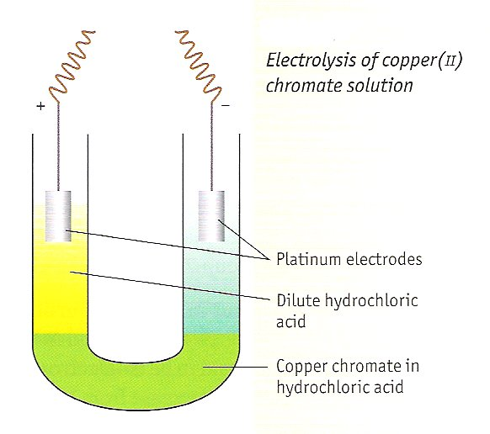Bonding I Ionic

answers

**Bonding**

**Topic 2B: Structure**

23. Know that giant lattices are present in:

i ionic solids (giant ionic lattices)

**Topic 2A: Bonding**

1. Know that ionic bonding is the strong electrostatic attraction between oppositely charged ions

2. Understand the effects that ionic radius and ionic charge have on the strength of ionic bonding

3. Understand the formation of ions in terms of electron loss or gain

4. Be able to draw electronic configuration diagrams of cations and anions using dot and-cross diagrams

5. Understand reasons for the trends in ionic radii down a group and for a set of isoelectronic ions, e.g. N3– to Al3+

6. Understand that the physical properties of ionic compounds and the migration of ions provide evidence for the existence of ions

21. Understand factors that influence the choice of solvents, including:

i water, to dissolve some ionic compounds, in terms of the hydration of the ions.

**Topic 5: Formulae, Equations and amounts of substance**

6. Be able to write balanced full and ionic equations, including state symbols, for chemical reactions.

15. be able to relate ionic and full equations, with state symbols, to observations from simple test tube reactions, to include:

i displacement reactions

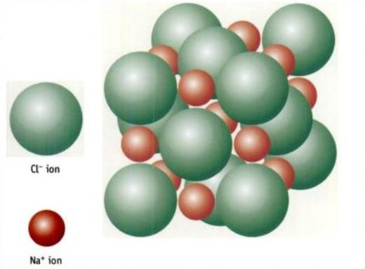ii reactions of acids

iii precipitation reactions

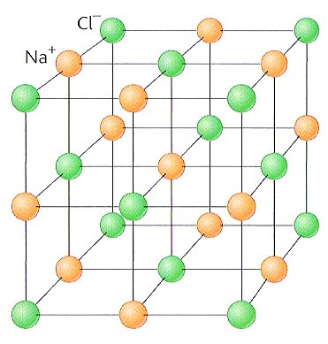

**New ReferenceRefer to:-** Facer AS Chemistry Chapter 6

**Factsheets – on Department website**

|  |  |
| --- | --- |
| 05 | Bonding |
| 06 | Structure of Elements and Compounds |
| 96 | Relating Properties of Crystal Structures to Structure and Bonding |

**Class videoVideos**

Ionic and Covalent bonding [e-stream 317](http://estream.godalming.ac.uk/View.aspx?ID=317)

Ionic Bonding [e-stream 1769](http://estream.godalming.ac.uk/View.aspx?ID=1769)

**MCj04247820000[1]Websites**

<http://www.chemguide.co.uk/atommenu.html#top>

A good site to support your AS and A level studies

<http://www.chemistryrules.me.uk/found/found3.htm#title>

A site giving basic information about ionic bonding

<http://www.creative-chemistry.org.uk/molecules/structures.htm>

A summary of the structures (which can be rotated) and their properties of some giant structures

<http://www.chem.ox.ac.uk/vrchemistry/GainLossElectrons/Pages/home.htm>

Extension material on the topic of ions

<http://www.mp-docker.demon.co.uk/as_a2/topics/ionic_and_covalent_bonding/index.html>

Some quizzes to test your knowledge

**IONIC BONDING**

Class video<http://www.chemguide.co.uk/atoms/bonding/ionic.html>

Video [Ionic and Covalent bonding e-stream 317](http://estream.godalming.ac.uk/View.aspx?ID=317) 10.42 – 12.00

New ReferenceRefer to: Facer AS Chemistry p104 - 107

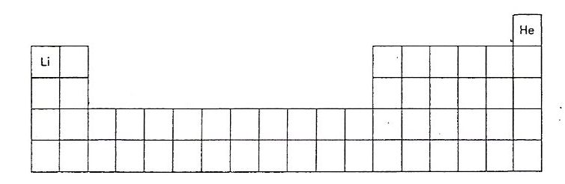

**DEFINITION**: An ionic bond is an **electrostatic attraction** between **oppositely charged** positive cations and negative anions. It is usually formed by **electron transfer** from a metal atom to a non metal.

**CATIONS – positively charged ions.**

Which group of elements will have the greatest tendency to lose their outer shell electrons? Group I

Which is the second most likely group to lose outer shell electrons? Group II

Explain why. Group I have a large atomic radius, outer electrons are readily lost, Hi(1) is low.

Group II have a fairly large atomic radius, outer electrons are readily lost, Hi(1+2) is fairly low.

One element in this second group does not in fact readily give up electrons. Identify this element and explain why it behaves differently.

Be – very small ionic radius, a Be2+ ion has a very high charge density and polarises the larger anion (pulls electron cloud towards itself and away from the anion) 🡪 a covalent bond.

Avoiding this element, label and colour these two groups of the periodic table above in red.

Since these species have more protons than electrons, they are no longer neutral atoms but charged particles called ions. What kind of charge do these ions have? positive

This kind of ion is called a CATION as they move towards the cathode (negative electrode) during electrolysis.

**ANIONS – negatively charged ions**

Which group of elements will have the greatest tendency to gain outer shell electrons? Group VII

Which is the second most likely group to gain outer shell electrons? Group VI

Explain why. Fairly small atomic radius, if they gained one or two electrons they would be ISOELECTRONIC with a noble gas and stable.

Label and colour these two groups blue on the periodic table.

Since these species have more electrons than protons, they are no longer neutral atoms but charged particles called ions. What kind of charge do these ions have? negative

Class videoThis kind of ion is called an ANION as they move towards the anode (positive electrode) during electrolysis.

Video [Ionic Bonding e-stream 1769](http://estream.godalming.ac.uk/View.aspx?ID=1769) 0.00 – 8.00

Typical ionic bonds are formed when metals in groups I and II react with non-metals in groups VI and VII.

<http://myweb.tiscali.co.uk/chemteach/swf/ionic.swf>

When these atoms react, they tend to do so in such a way that they attain a noble gas configuration, which is stable. To achieve this, electrons are transferred from elements on the left hand side of the periodic table to those on the right hand side.

Example: **sodium chloride** (you will need to use a periodic table to find the atomic numbers)

* Show only outer shell electrons in the dot and cross diagrams.
* New exerciseUse dots and crosses for electrons from different atoms (even though all electrons are identical)

|  |  |  |
| --- | --- | --- |
| Electron configurations: | Na atom . 2,8,1 | Cl atom . 2,8,7. |
| Dot & cross diagrams:  Be consistent with **outer shell electrons**  either follow blue system or red system |  | Remember the ions have a **charge**, this can either be put in the centre of the ion or in square brackets outside the ion |
| Electron configurations: | Na+ ion: . 2,8 | Cl- ion: 2,8,8 |
| Dot & cross diagrams:  The cations are **smaller** than the corresponding atom |  | The anions are **larger** than the corresponding atom |

Which noble gas has the same electron configuration (is isoelectronic) with:-

Na+ …… Neon ………... Cl- …… Argon …………

**Magnesium oxide**

|  |  |  |
| --- | --- | --- |
| Electron configurations: | Mg atom . 2,8,2. | O atom .. 2,6 |
| Dot & cross diagrams: |  |  |
| Electron configurations: | Mg2+ ion: .. 2,8 | O2- ion: . 2,8 |
| Dot & cross diagrams: |  |  |

Formula of magnesium oxide … MgO **Sodium oxide**

|  |  |  |
| --- | --- | --- |
| Electron configurations: | 2 Na atoms ... 2,8,1. | O atom .... 2,6. |
| Dot & cross diagrams: |  |  |
| Electron configurations: | 2 Na+ ions: ... 2,8 | O2- ion: ... 2,8 |
| Dot & cross diagrams: |  |  |

Formula of sodium oxide Na2O

**Magnesium chloride**

|  |  |  |
| --- | --- | --- |
| Electron configurations: | Mg atom 2,8,2 | 2 Cl atoms 2,8,7 |
| Dot & cross diagrams: |  |  |
| Electron configurations: | Mg2+ ion: 2,8 | 2 Cl- ions: 2,8,8 |
| Dot & cross diagrams: |  |  |

Formula of magnesium chloride MgCl2

Further examples of ionic bonding <http://myweb.tiscali.co.uk/chemteach/swf/ions_gen.swf>

**IONS WHICH DO NOT HAVE NOBLE GAS ELECTRON CONFIGURATIONS**

While the elements in groups I,II,VI and VII form ions with the same electron arrangement as noble gases, other metals form ions which do not (e.g. Transition metals)

Examples: Zn2+, Ag+, Pb2+, Cu2+, Cu+, Fe2+, Fe3+

Other ions are **complex ions** made up of a group of atoms with an overall charge.

Examples: NH4+, SO42-, NO3-,CO32-

**It is vital that you learn the charges, formulae and names of these ions** (See list in pre-course work pack). You cannot work them out from the electron configuration.**IONIC LATTICES / CRYSTALS**

New exerciseThese **oppositely charged ions are attracted to one another by strong electrostatic forces called ionic bonds.** They form a **giant ionic lattice** where each ion becomes surrounded by a number of ions of the opposite charge.

Example:- sodium chloride

What will be the ratio of Na+ ions to Cl- ions in this structure? …1 : 1…….

So what will be the formula of sodium chloride? …NaCl…

Complete the diagram of sodium chloride opposite, by giving it a key.



How many Cl- are round each Na+? 6

How many Na+ are round each Cl-? 6

We describe this as having 6;6 **co-ordination number**

**You need to be able to draw and label this.** <http://www.chemguide.co.uk/atoms/structures/ionicstruct.html#top>

Compare this with the space filling model on the front cover. Why is the space filling model a better representation (though more difficult to draw)?

Space filling more accurate but expanded diagram easier to follow

What 2 factors does the co-ordination numbers in a lattice depend on?

1. charge on the ions involved
2. radius of the ions involved (actually the sum of the ionic radii)

**Sizes of ions**

The ionic radius is usually measured in nanometres (nm). 1 nm = 1 x 10-9 =10-10m

Look at the back of your coloured Periodic Table.

Compare the sizes of atoms and the **cations** that they form. State and explain the difference.

Cations are smaller. Loss of electron(s) may result in loss of outer shell

Cation now has more positive protons than electrons so electrons will be attracted more.

Likewise compare the sizes of atoms and respective **anions**. State and explain this difference.

Anions are larger. Gain of electron(s) so e- > p+. electrons repel each other, held less strongly.

Why do the cations and anions increase in radius as a group is descended?

* More protons
* But more shielding by complete inner shells of electrons so less attraction of e‑to p+.
* Another complete inner shell with successive periods

**Isoelectronic ions** are those having same electron configuration

Complete the table by giving the **formula and charge** of the ions which are isoelectronic with Neon in increasing atomic number order

|  |  |  |  |  |  |  |  |
| --- | --- | --- | --- | --- | --- | --- | --- |
| Proton number | 7p+ | 8p+ | 9p+ | 10p+ | 11p+ | 12p+ | 13p+ |
| Symbol | N3- | O2- | F- | Ne | Na+ | Mg2+ | Al3+ |
| Diagram |  |  |  |  |  |  |  |
| Ionic radius  /nm | 0.171 | 0.140 | 0.133 | 0.141 | 0.095 | 0.065 | 0.050 |

Explain the pattern. Decrease in radius L 🡪 R same electron configuration but..

one more proton in nucleus so the electrons are attracted more strongly.

Learn the order:- A3- > A2- > A- > A > A+ > A2+ > A3+ A = an atom

**Strength of the ionic bond**

This depends on two main factors:-

* The charge on the ions
* The radius of the ions involved

Looking back at the examples of ionic bonding that you drew ions for on page 3, which ionic compound do you expect to have the strongest bonds? MgO

Give two reasons Mg+2 charge compared to Na+, also Mg+2 will have a smaller radius

Cl- has a lower charge and is larger than O2- both result in stronger electrostatic attraction.

What physical properties do you expect to depend on the strength of the ionic bond?

Melting and boiling points.

**Evidence for the migration of ions:-**

Class videoIn molten solids e.g. electrolysis of PbBr2

[Video Ionic and Covalent Bonding e-stream 317](http://estream.godalming.ac.uk/View.aspx?ID=317) 12.00 – 12.50

<http://myweb.tiscali.co.uk/chemteach/swf/electrolysis2.swf>

Demonstration

Demonstration

Electrolysis of aqueous copper(II) chromate solution

<http://www.rsc.org/Education/EiC/issues/2007July/ExhibitionChemistry.asp>

<http://chemistry.slss.ie/downloads/ch_pr_ionicmovement.pdf>



Describe the colour of solution in the U tube before the current has been switched on.



State the ions present in copper(II) chromate(VI) and give their colours



* Cu2+is blue



* CrO42- is yellow



Have the ions migrated to the expected electrode?



The chromate ions have migrated to the positive electrode because they are negatively charged.

The copper ions have migrated to the negative electrode because they are positively charged.

The positive electrode is called an anode and the negative ions attracted are known as anions

The negative electrode is called a cathode and the positive ions attracted are known as cations

**PROPERTIES OF IONIC COMPOUNDS**

Ionic compounds typically have the following physical properties

High melting temperatures

Brittleness

Poor electrical conductivity when solid but good when molten or in solution

Often soluble in water

<http://www.chemguide.co.uk/atoms/structures/ionicstruct.html#top>

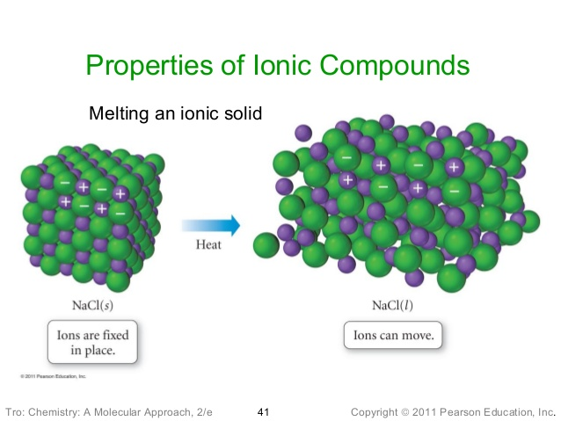New exerciseExplain why ionic solids:-

Have **high melting points** Video [Ionic Bonding e-stream 1769](http://estream.godalming.ac.uk/View.aspx?ID=1769) 12.04 – 12.41

When heated ions vibrate more in fixed positions until enough E allows them to separate.

A lot of heat energy is needed to overcome the strong electrostatic forces of attraction between oppositely charged ions to melt the solid.

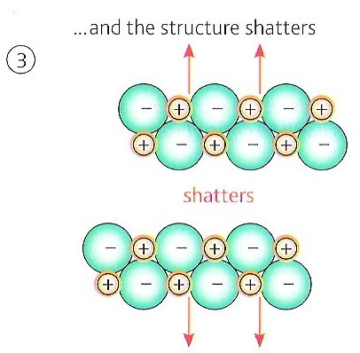Have a **hard and brittle structure**

Video [Ionic Bonding e-stream 1769](http://estream.godalming.ac.uk/View.aspx?ID=1769) 11.03 – 12.03

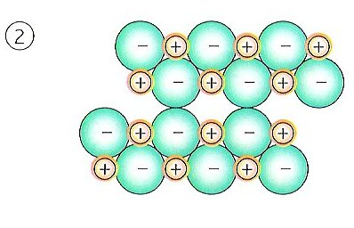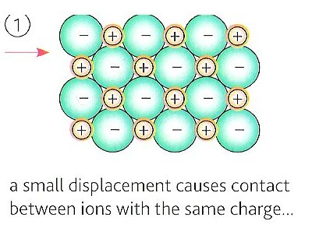

Class videoHard – strong electrostatic forces of attraction in 3D.

Class videoBrittle - When hit with enough force ions are knocked out of alignment so ending next to similarly charged ions which then repel each other.

They usually **dissolve in water**:

Video [Ionic and Covalent Bonding e-stream 317](http://estream.godalming.ac.uk/View.aspx?ID=317) 13.34 – 15.19

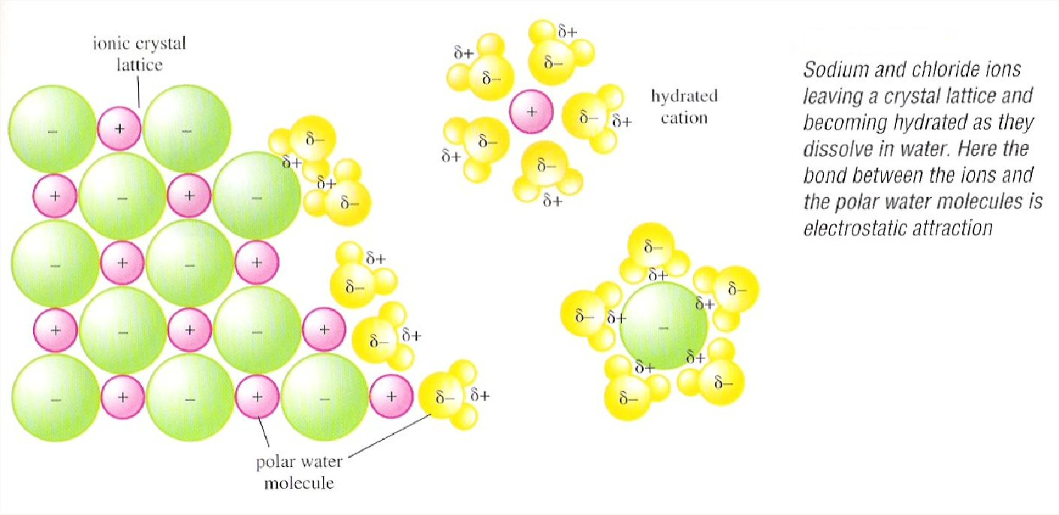

Sodium and chloride ions leaving a crystal lattice and becoming hydrated as they dissolve in water. Here the bond between the ions and the polar water molecules is electrostatic attraction.

hydrated cation

polar water molecule attracted to cation

ionic crystal lattice

Water molecules are polar, the - side clusters around cations and the + side around anions so hydrating the ions releasing energy; this is enough energy to overcome the electrostatic attractions so separating the ions from the lattice.

**Conduct electricity** when molten, but not in the solid state

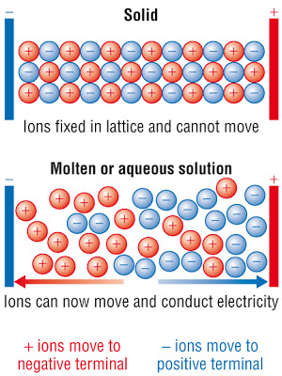

.

Video [Ionic and Covalent Bonding e-stream 317](http://estream.godalming.ac.uk/View.aspx?ID=317) 15.20 – 15.58

Video [Ionic Bonding ` e-stream 1769](http://estream.godalming.ac.uk/View.aspx?ID=1769) 12.42 – 16.00

When molten or dissolved in solution ions are free to move, +ve ions to the cathode, -ve ions to the anode, so conducting electricity.

When solid the ions are held in fixed positions in the lattice …

**New ReferenceIONIC EQUATIONS AND SPECTATOR IONS**

**Refer to** Facer AS Chemistry p52 – 54 and p317

Many of the chemicals, which you study, are *ionic* and in these cases it is the ions which react, not the compound. For instance, copper(II) sulfate is usually written as CuSO4 but it is more often only the ion Cu2+ which reacts.

When you write an ionic equation you include only the ions which **actually take part in the reaction** **to form precipitates, elements,** (e.g. metals) **gas molecules** (e.g H2, CO2) **and liquid molecules** (e.g. H2O)

Let us look at an equation and see how it may be converted into an ionic equation. For example, look at the reaction between iron(II) sulfate solution and aqueous sodium hydroxide.

FeSO4(aq) + 2NaOH(aq) → Fe(OH)2(s) + Na2SO4(aq)

In water, the iron (II) sulfate and the sodium hydroxide are in the form of freely moving ions. When the two solutions are mixed together, we see a green precipitate of iron (II) hydroxide solid. Remaining in solution will be a mixture of sodium ions and sulfate ions.

Fe2+(aq) + 2OH-(aq) → Fe(OH)2(s)

Also when silver nitrate solution reacts with sodium chloride solution the changes do not involve the nitrate ion from the silver nitrate or the sodium ion from the sodium chloride. These are referred to as ‘**spectator ions**’. The equation for this reaction can be written

Ag+(aq) + Cl–(aq) → AgCl(s)

This equation represents the reaction between **any** aqueous solution containing silver ions and **any** aqueous solution containing chloride ions. This is the equation for the test for a chloride ion in solution.

You can work out an ionic equation as follows using the example of the reaction of iron(II) sulfate solution with excess sodium hydroxide solution:-

**1** Write down the balanced equation

FeSO4(aq) + 2NaOH(aq) → Fe(OH)2(s) + Na2SO4(aq)

**2** Convert those chemicals that are ions **in solution** into their ions

Fe2+(aq) + SO42- (aq) + 2Na+(aq) + 2OH-(aq) → Fe(OH)2(s) + 2Na+(aq) + SO42-(aq

**3** Cross out those ions that appear on both sides of the equation as they have not changed during the reaction. They started in solution and they finished in the solution. To give the ionic equation:

Fe2+(aq) + ~~SO~~~~4~~~~2-~~ ~~(aq)~~ + ~~2Na~~~~+~~~~(aq)~~ + 2OH-(aq) → Fe(OH)2(s) + ~~2Na~~~~+~~~~(aq)~~ + ~~SO~~~~4~~~~2-~~~~(aq~~

**4.** Check that the atoms **and** the charges balance giving the Net Ionic Equation.

Fe2+(aq) + 2OH-(aq) → Fe(OH)2(s)

Try writing ionic equations for the following reactions:

New exercise

Sodium chloride solution + silver nitrate solution 🡪 silver chloride solid precipitate + sodium nitrate solution.

Full symbol equation:

………………………………………………………………………………………………………



Ionic equation with ALL the **ions** identified:



………………………………………………………………………………………………………



Cross out spectator ions in the equation above and write the resulting ionic equation:

………………………………………………………………………………………………………



1. Copper sulfate solution + zinc 🡪 zinc sulfate solution + copper

Full symbol equation:

………………………………………………………………………………………………………



Ionic equation with ALL the **ions** and **atoms** identified:

………………………………………………………………………………………………………



Cross out spectator ions in the equation above and write the resulting ionic equation:

………………………………………………………………………………………………………



1. Sulfuric acid solution + zinc 🡪 zinc sulfate solution + hydrogen gas

Full symbol equation:

………………………………………………………………………………………………………



Ionic equation with ALL the **ions, atoms** and **molecules** identified:

………………………………………………………………………………………………………



Cross out spectator ions in the equation above and write the resulting ionic equation:

………………………………………………………………………………………………………



1. Sodium carbonate solution + hydrochloric acid solution 🡪 sodium chloride solution + carbon dioxide + water

Full symbol equation:

………………………………………………………………………………………………………



Ionic equation with ALL the **ions** and **molecules** identified:



………………………………………………………………………………………………………



Cross out spectator ions in the equation above and write the resulting ionic equation:

………………………………………………………………………………………………………



**IONIC EQUATIONS FOR PRECIPITATION REACTIONS**

How do you know which ions participate in the bond forming process and which don’t?

In precipitation reactions:-

* **Nitrate(V) ions are never involved** – all nitrates are soluble in water.
* **Group I ions are never involved** – all group I salts are soluble in water.
* **Look for a precipitate** **forming**– this will be formed from oppositely charged ions reacting together to form an uncharged insoluble solid.
* **Coloured precipitates** usually either have a transition metal cation or the anion contains a transition metal e.g. the dichromate(VI) ion Cr2O72-

**LEARN THESE RULES** and use this information to complete the following table.

* **New exercise**Take one ion from each solution to form a precipitate (participating ions)
* Take one ion from each solution to stay in solution (soluble spectator ions)

|  |  |  |  |  |  |
| --- | --- | --- | --- | --- | --- |
| **Reacting Solutions** | **Soluble spectator ions** | | **Participating ions** | | **Ionic equation**  **(including state symbols)** |
| Copper(II) nitrate(V)  and sodium hydroxide | Na+(aq) | NO3-(aq) | Cu2+(aq) | OH-(aq) | Cu2+(aq) + 2OH-(aq) 🡪  Cu(OH)2(s) |
| Potassium chloride  and silver nitrate(V) | K+(aq) | NO3-(aq) | Ag+(aq) | Cl-(aq) | Ag+(aq) + Cl-(aq) 🡪  AgCl(s) |
| Sodium carbonate  and lead(II) nitrate(V) | Na+(aq) | NO3-(aq) | Pb2+(aq) | CO32-(aq) | Pb2+(aq) + CO32-(aq) 🡪  PbCO3(s) |
| Sodium sulfate(VI)  and barium chloride | Na+(aq) | Cl-(aq) | Ba2+(aq) | SO42-(aq) | Ba2+(aq) + SO42-(aq) 🡪  BaSO4(s) |
| Copper(II) nitrate(V)  and sodium carbonate | Na+(aq) | NO3-(aq) | Cu2+(aq) | CO32-(aq) | Cu2+(aq) + CO32-(aq) 🡪  CuCO3(s) |
| Sodium iodide  and silver nitrate(V) | Na+(aq) | NO3-(aq) | Ag+(aq) | I-(aq) | Ag+(aq) + I-(aq) 🡪 Agl(s) |
| Sodium chromate(VI)  and silver nitrate(V) | Na+(aq) | NO3-(aq) | Ag+(aq) | CrO42-(aq) | 2Ag+(aq) + CrO42-(aq) 🡪  Ag2CrO4(s) |

Some ionic reactions resulting in the formation of a precipitate are very useful because they can be used for diagnostic purposes – they tell us which ions are present in solutions. This branch of Chemistry is known as qualitative analysis.

This forms the basis of the experiment on the next page

MCj04247820000[1]More practice at writing ionic equations:-

<http://www.chem.vt.edu/RVGS/ACT/notes/net_ionic_rxns/net_ionic_rxns.html>

<http://antoine.frostburg.edu/chem/senese/101/reactions/ionic-equations-quiz.shtml>

<http://www.mp-docker.demon.co.uk/as_a2/topics/formulae_and_equations/quiz_1.html>

### PRACTICAL – IONIC EQUATIONS

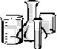

The aims of this experiment are:

* To gain practice in writing ionic equations for precipitation reactions, displacement reactions and the reactions of acids.

**Method**

**1.** To a small quantity ( 2 cm3) of one solution in a test tube, add the second solution drop by drop from a teat pipette or the piece of metal required.

* Do not contaminate stock solutions
* Do not waste chemicals as they are expensive and need to be disposed of safely

**2.** Complete the tables on the following pages

**3.** **Observations** should be as full as possible.

An acceptable abbreviation for precipitate is ppt.

**4. Inferences** are what you can conclude from your observations.

Work out which are the spectator ions and which are the participating ions based on your observations.

From this write the full equation for the reaction (remember state symbols)

From this write the ionic equation for the reaction. (remember state symbols)

### New experimentPrecipitation reactions

|  |  |  |
| --- | --- | --- |
| **METHOD** | **OBSERVATIONS** | **INFERENCE** |
| HARMFUL  **SULFATE(V1) IONS**  Add barium chloride solution drop by drop to 0.5 cm3 of sodium sulfate solution | Immediate thick **White Ppt formed** | Full Equation BaCl2(aq) + Na2SO4(aq) 🡪 BaSO4(s) + 2NaCl(aq)  Ionic equation: Ba2+(aq) + SO42-(aq) 🡪 BaSO4(s) |
| **CHLORIDE IONS**  Add silver nitrate(V) solution  drop by drop to 0.5 cm3 of sodium chloride solution | Fine **White ppt** formed turned grey in light | Full Equation NaCl(aq) + AgNO3(aq) 🡪 NaNO3(aq) + AgCl(s)  Ionic equation: Cl-(aq) + Ag+(aq) 🡪 AgCl(s) |
| **BROMIDE IONS**  Add silver nitrate solution  drop by drop to 0.5 cm3 of potassium bromide solution. | Fine **Cream ppt** formed | Full Equation KBr(aq) + AgNO3(aq) 🡪NaNO3(aq) + AgBr(s)  Ionic equation: Br-(aq) + Ag+(aq) 🡪 AgBr(s) |
| **IODIDE IONS**  Add silver nitrate solution  drop by drop to 0.5 cm3 of potassium iodide solution | **Yellow ppt** formed | Full Equation KI(aq) + AgNO3(aq) 🡪NaNO3(aq) + AgI(s)  Ionic equation: I-(aq) + Ag+(aq) 🡪 AgI(s) |
| TOXIC  **LEAD(II) IONS**  Add potassium iodide solution drop by drop to 0.5 cm3 of lead(II)  nitrate(V) solution. | **Bright Yellow** ppt formed | Full Equation 2KI(aq) + PbNO3(aq) 🡪 2KNO3(aq) + PbI2(s)  Ionic equation: 2I-(aq) + Pb2+(aq) 🡪 PbI2(s) |
| **COPPER(II) IONS**  CORROSIVE  Add sodium hydroxide  solution drop by drop  to 0.5 cm3 of copper(II)  sulfate(V1) solution | **Blue** jelly-like **ppt** formed | Full Equation CuSO4(aq) + 2NaOH(aq) 🡪 Cu(OH)2(s)+Na2SO4(aq)  Ionic equation: Cu2+(aq) + 2OH-(aq) 🡪 Cu(OH)2(s) |

### DISPLACEMENT REACTIONS (REDOX)

|  |  |  |
| --- | --- | --- |
| **METHOD** | **OBSERVATIONS** | **INFERENCE** |
| **ZINC and COPPER II**  Add a small spatula of Zinc to 2 cm3 of copper II sulfate solution | Blue copper sulfate solution colour fades, **solution eventually turns colourless**, a pink/ **black solid** formed | Full equation Zn(s) + CuSO4(aq) 🡪 ZnSO4(aq) + Cu(s)  Ionic equation: Zn(s) + Cu2+ (aq) 🡪 Zn2+(aq) + Cu(s) |
| MAGNESIUM and ZINC II  Add a small piece of Mg ribbon to 2cm3 of a zinc II sulfate solution | Solution gets **warm** with **effervescence** magnesium **ribbon gets smaller** | Full equation Mg(s) + ZnSO4(aq) 🡪 MgSO4(aq) + Zn(s)  Ionic equation: Mg(s) + Zn2+(aq) 🡪 Mg2+ (aq) + Zn(s) |
| MAGNESIUM and COPPER II  Add a small piece of magnesium ribbon to 2cm3 of copper II sulfate solution | Solution gets **warm** with **effervescence**, blue copper sulfate solution fades, eventually **turns colourless** and a pink/ **black solid** is formed | Full equation Mg(s) + CuSO4(aq) 🡪 MgSO4(aq) + Cu(s)  Ionic equation: Mg(s) + Cu2+(aq) 🡪 Mg2+ (aq) + Cu(s) |

**REACTIONS OF ACIDS**

|  |  |  |
| --- | --- | --- |
| **METHOD** | **OBSERVATIONS** | **INFERENCE** |
| **CARBONATE and ACID**  Put a small spatula of sodium carbonate into a boiling tube, carefully add sulphuric acid until no further changes occur | **Effervescence**, **white solid ‘disappears**’ to leave a colourless solution | Full Equation  Na2CO3(s) + H2SO4(aq) 🡪 CO2(g) + H2O(l) + Na2SO4(aq)  Ionic equation (2 options)  Na2CO3(s) + 2H+ (aq) 🡪 CO2(g) + H2O(l) + 2Na+(aq)  CO32- (s) + 2H+(aq) 🡪 CO2(g) + H2O(l) |
| **HYDROGENCARBONATE and ACID**  To 2 cm3 of Sodium hydrogencarbonate add drop by drop sulphuric acid until no further changes occur | **Effervescence**, **white solid ‘disappears**’ to leave a colourless solution | Full Equation  NaHCO3(aq) + H2SO4(aq) 🡪 Na2SO4(aq) + H2O(l) + CO2(g)  Ionic equation  HCO3-(aq) + 2H+ 🡪 H2O(l) + CO2(g) |
| **ALKALI and ACID**  To 2cm3 of hydrochloric acid add 2cm3 of sodium hydroxide solution, note any temperature change | **Becomes warmer** no other observations | Full Equation  HCl(aq) + NaOH(aq) 🡪 H2O(l) + NaCl(aq)  Ionic equation  H+(aq) + OH- (aq) 🡪 H2O(l) |
| **METAL and ACID**  To 2 cm3 of sulphuric acid add a small strip of magnesium ribbon | **Effervescence** and became **warmer**, **magnesium** metal gets smaller ‘**disappears**’ | Full Equation  Mg(s) + H2SO4(aq) 🡪 MgSO4(aq) + H2(g)  Ionic equation  Mg(s) + 2H+(aq) 🡪 Mg2+(aq) + H2(g) |

New exerciseRevision notes

*Include the following*

Cations and anions

Define ionic bond

Dot and cross diagrams – sometimes called Lewis structures

3D diagram of sodium chloride

Trends in ionic radii

Factors affecting the strength of an ionic bond

Evidence for ions migration of ions in electrolysis

Properties of ionic compounds (including an explanation):-

M Pt

Hard and brittle

Dissolve in water

Conduct electricity when molten or aqueous

How to write ionic equations for:- precipitation reactions,

displacement reactions

reactions of acids

**Multiple choice questions**

Circle the correct answer.

**1.** The bonding in magnesium oxide, MgO, is:-

**A** ionic.

**B** metallic and ionic.

**C** ionic and covalent.

**D** metallic and covalent.

(Total 1 mark)

**2.** Which of the following has the smallest ionic radius?

**A** F–

**B** Na+

**C** Mg2+

**D** O2–

(Total 1 mark)

**3.** A drop of concentrated nickel(II) sulfate solution, which is green, is placed on moist filter paper on a microscope slide and the ends of the slide are connected to a 24 V DC power supply. After ten minutes,

**A** a blue colour has moved towards the negative terminal and a yellow colour towards the positive terminal.

**B** a blue colour has moved towards the positive terminal and a yellow colour towards the negative terminal.

**C** a green colour has moved towards the negative terminal but there is no other visible change.

**D** a green colour has moved towards the positive terminal but there is no other visible change.

(Total 1 mark)

Leave blank

W10.1.12

W09.1.18

W10.1.11

**Structured questions**

**4.** (a) Sodium chloride and sodium iodide both have the same crystal structure.

(i) Use your knowledge of the structure of solid sodium chloride to draw a labelled

diagram of the three-dimensional structure of solid **sodium iodide.**

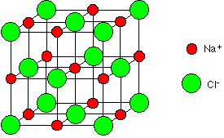

I-

**(2)**

(ii) What are the TWO major factors that affect the strength of an ionic bond?

Ionic radius of cation and anion

Charge on ions.

**(2)**

(iii) Suggest why sodium iodide has a lower melting temperature than that of

sodium chloride.

Iodide ion has a larger ionic radius than chloride ion which results in weaker electrostatic attraction

Requiring less heat energy to overcome the forces of attraction

**(2)**

(b) Explain why molten sodium iodide conducts electricity but solid sodium iodide does not.

When solid, ions are held in fixed positions by strong electrostatic attractions of oppositely charged ions around them, (electrons are localised on each ion so they cannot move either);

When molten **ions** are free to move, +ve ions to the cathode, -ve ions to the anode, so conducting electricity.

**(2)**

(c) Suggest why molten sodium iodide and molten sodium chloride have very high boiling temperatures.

Each sodium ion is electrostatically attracted to six chloride ions in 3 dimensions

Require a lot of heat energy to overcome these forces of attraction.

**(1)**

**Total 9 marks**

Leave blank

June 08 Unit 1 Q4

June 08 Unit 1 Q4

**5.** (a) Sodium chloride is a crystalline solid, melting point 801 C. It is soluble in water.

(i) State the type of bonding present in sodium chloride. …………………………….

(1)

(ii) Describe, in terms of the motion and arrangement of the particles, what happens when solid sodium chloride is steadily heated from room temperature until it melts.

Na+ ions and Cl- ions vibrate around fixed positions, heat energy causes them to vibrate more

Until ions gain enough heat energy to break free from the lattice, moving freely throughout the liquid.

(2)

(iii) Account for the relatively high melting point of sodium chloride and explain why it dissolves in water at room temperature.

Each sodium ion is electrostatically attracted to six chloride ions in 3 dimensions/ throughout the crystal.

Require a lot of heat energy to overcome these forces of attraction.

Water molecules are polar, the - side clusters around cations and the + side around anions so hydrating the ions releasing energy.

This is enough energy to overcome the electrostatic attractions so separating the ions from the lattice.

(3)

Total 6 marks

**6.** This question is about the properties of ions and ionic compounds.

(a) Solid calcium carbonate, CaCO3, has a giant ionic structure.

(i) Draw a diagram (using dots or crosses) for a calcium **ion**. Show **ALL** the electrons and the charge on the ion.

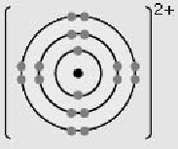electrons (1)  
charge (1)

(2)

(ii) Complete the electronic configuration for a calcium **ion**.

1s22s22p63s23p6.

(1)

Leave

blank

June 99 Unit 1 Q2

(iii) Would you expect a calcium ion to be bigger, smaller or the same size as a calcium atom? Give TWO reasons to explain your answer.

S10.1.15

Smaller Because it has one less (sub) shell of electrons / orbital / energy level **(1)**

And the ratio of protons : electrons has increased / more protons than electrons / greater net force on remaining electrons (so remainder of electrons held more closely) / greater effective nuclear charge **(1)**.

**(2)**

(iv) Explain why ionic compounds have relatively high melting temperatures.

Any two from:  
Strong (electrostatic) forces / attractions / bonds (between ions) **(1)**

(ions) held in giant lattice / **many** (ionic) attractions / forces / bonds **(1)**

So large amount of energy needed (to break apart ions) **(1)**

(2)

(b) Changes in the concentration of ions in a solution can be estimated by measuring the electrical conductivity of the solution.

(i) Explain why solutions of ions are able to conduct electricity.

Because the **ions** are free to move (when a potential difference is applied).

(1)

(ii) Suggest why aqueous solutions of calcium chloride, CaCl2(aq), and barium chloride, BaCl2(aq), of the same molar concentration, have different electrical conductivities.

The cations / barium and calcium (ions) are different sizes

Ignore any discussion of reasons

(could select either the calcium ion because it has more water  
molecules associated with it OR the barium ion because it has  
more shells of electrons and so larger).

(1)

Total 9 marks

Leave blank

**7.** This question is about magnesium and magnesium oxide.

(a) Describe the bonding in magnesium and explain why it is a good conductor of electricity.

(Lattice of) positively charged ions/ ions with 2+charge **(1)**

held together by (electrostatic) attraction to delocalised electrons **(1)**

Delocalised electrons /free electrons/ electrons in sea of electrons  
are free to move and carry charge / current **(1)**

(3)

(b) Draw a diagram (using dots or crosses) for the ions in magnesium fluoride showing all the electrons and the ionic charges on:

(i) the magnesium ion

Mg2+ shown as 2,8 **(1)**

(1)

(ii) the fluoride ion.

F– shown as 2,8 **(1)**

(1)

(c) Under what conditions does magnesium fluoride conduct electricity?

Explain your answer.

When molten/ when dissolved in water so that ions can move/  
lattice breaks down **(1)**

**(1)**

Leave blank

SP Unit 1 Q15

(d) The mass spectrum of a sample of magnesium is shown below.



(i) Use the data above to estimate the percentage isotopic composition of the sample of magnesium. Hence calculate the average atomic mass of the sample of magnesium.

77% 24Mg, 10% 25Mg, 13% 26Mg **(1)**

Average atomic mass  
 = 24.36 = 24.4 g **(1)**

(2)

(ii) Why do the three isotopes have the same chemical properties?

Have same electron configuration

(1)

Leave blank

(e) (i) Oceanographers studying plankton found that a sample of seawater contained 1.20 nanomol dm-3 of chlorophyll, C55H77MgN4O5. (1 nanomol = 1 × 10-9 mol)

What mass of magnesium would be present in 1.00 cm3 of this sample of seawater? Give your answer to three significant figures.

1.20 × 10–9 mol of Mg per dm3 **(1)**(1.20 × 10–9 × 24.3 × 10–3) =  
2.92 × 10–11 / 29.2 × 10–12 (g) **(1)**max 1 for more/less than 3 significant figures eg 2.916

(2)

(ii) X-ray diffraction can be used to locate atoms or ions in molecules like chlorophyll.  
X-rays are scattered by the electrons in atoms and ions. In chlorophyll the atoms of one of the elements still cannot be located with certainty by this technique.

Suggest which element is most difficult to locate.

Hydrogen because it has the least number of electrons per atom

(1)

(Total 12 marks)

**8.** This question is about the preparation of the alum, potassium aluminium sulfate, KAl(SO4)2.12H2O. It is a double salt consisting of potassium ions, aluminium ions, sulfate ions, and water of crystallization.

The first step of the preparation involves adding an excess of aluminium foil to 10 cm3

of 2 mol dm−3 potassium hydroxide to form potassium aluminate.

The equation for this reaction is

2Al(s) + 2KOH(aq) + 2H2O(l) 🡪 2KAlO2(aq) + 3H2(g)

Write a balanced **ionic** equation for this reaction.

2Al(s) + 2OH-(aq) + 2H2O(l) 🡪 2AlO2-(aq) + 3H2(g)

(1)

Leave blank

**2015**

**NAME ...........................……... HOMEWORK DEADLINE .....................**

**Student Number ………… Chemistry Class ………**

Student targets from **previous pack**

Ionic Bonding

|  |  |
| --- | --- |
| **Task** | Mark |
| Notes | /10 |
| Revision Notes | /10 |
| Exam questions | /40 % |
| Overall Grade for this work | A B C D E U |

Student comments

Tutor comments

Tutor signature Date

Student targets for **next pack**