NAME ............................................ Chemistry Class ...........................

Student Number ……….

Bonding II Covalent & Metallic Answers

**Topic 2B: Structure**

7. Know that a covalent bond is the strong electrostatic attraction between two nuclei and the shared pair of electrons between them.

8. Be able to draw dot-and-cross diagrams to show electrons in covalent substances, including:

i molecules with single, double and triple bonds

ii species exhibiting dative covalent (co-ordinate) bonding, including Al2Cl6 and ammonium ion

9. Understand the relationship between bond lengths and bond strengths for covalent bonds

22. Know that metallic bonding is the strong electrostatic attraction between metal ions and the delocalised electrons

23. Know that giant lattices are present in:

ii covalently bonded solids, such as diamond, graphite and silicon(IV) oxide (giant covalent lattices)

iii solid metals (giant metallic lattices)

24. Know that the structure of covalently bonded substances such as iodine, I2, and ice, H2O, is simple molecular

25. Know the different structures formed by carbon atoms, including graphite, diamond and graphene

26. Be able to predict the type of structure and bonding present in a substance from numerical data and/or other information

27. Be able to predict the physical properties of a substance, including melting and boiling temperature, electrical conductivity and solubility in water, in terms of:

i the types of particle present (atoms, molecules, ions, electrons)

ii the structure of the substance

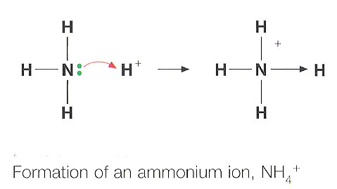

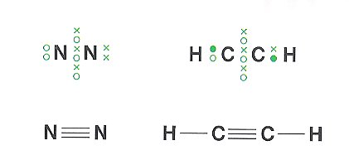

COVALENT BONDING

MCj04247820000[1]**Structure and Bonding General Websites**

<http://www.avogadro.co.uk/structure/chemstruc/structure.htm>

A way of organising chemical structures and their physical properties

Department website factsheets

|  |  |
| --- | --- |
| 05 | Bonding |
| 06 | Structure of elements and compounds |

Websites - also other links shown throughout the pack

<http://www.chemguide.co.uk/atoms/structsmenu.html#top>

A good site to support your AS and A level studies

<http://www.chemistryrules.me.uk/found/found3.htm#covalent>

A site giving basic information about covalent bonding

<http://www.creative-chemistry.org.uk/molecules/structures.htm>

A summary of the structures (which can be rotated) and their properties of some giant structures

<http://www.chem.ox.ac.uk/vrchemistry/electronsandbonds/intro1.htm>

Extension material on the topic of covalent bonding

<http://www.mp-docker.demon.co.uk/as_a2/topics/ionic_and_covalent_bonding/index.html>

Some quizzes to test your knowledge

<http://chemed.chem.purdue.edu/genchem/topicreview/bp/ch8/valenceframe.html>

**a really useful refresher page to help you with the concepts covered in this pack**

**COVALENT BONDS**

In the Electron structure pack, you learnt that it becomes more and more difficult to remove electrons from an atom to form positive ions, a process that requires increasing amounts of energy. Loss of one or two electrons is not a problem, loss of three represents the limit of what can be realistically achieved, but losing four electrons in a chemical reaction simply does not happen as there is no compensating, energy releasing process. Atoms also require increasing amounts of energy in order to gain additional electrons and form negative ions.

In order to overcome these problems and to attain a stable, noble gas electron configuration, atoms can **share a pair of electrons**, so forming a **covalent bond**.

**A covalent bond** is a shared pair of electrons one from each donor atom

**Covalent bonding** is the electrostatic attraction between the nuclei and the bonding pair of electrons which holds the 2 nuclei together.

The **Bond length** is the distance between the nuclei of the two atoms that are covalently bonded together.

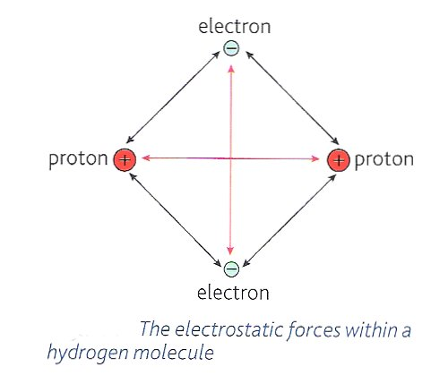

The electrostatic forces of attraction and repulsion within a hydrogen molecule are depicted:-

* Label the forces of attraction and repulsion
* Draw 2 vertical lines through the 2 nuclei.

*NOTE:* Electron density anywhere between these 2 lines

will hold the 2 nuclei together making a covalent bond.

As a general rule the shorter the bond length the stronger the bond

|  |  |  |
| --- | --- | --- |
| Bond | Bond Length/nm | Bond Strength/ kJmol-1 |
| I-I | 0.267 | 151 |
| Br-Br | 0.228 | 193 |
| Cl-Cl | 0.198 | 243 |

Class video

See also Video clip e-stream 1772 1.00 – 6.00 [Introduction to covalent bonding](http://estream.godalming.ac.uk/View.aspx?ID=1772)

Demonstration**Optional Demonstration**

Your teacher may demonstrate the strength of covalent bonds by making water from H2 and O2. The strength of the covalent bond is demonstrated by the amount of energy, in the form of light and sound that is released by the formation of two O-H covalent bonds.

**Dot and cross diagrams**

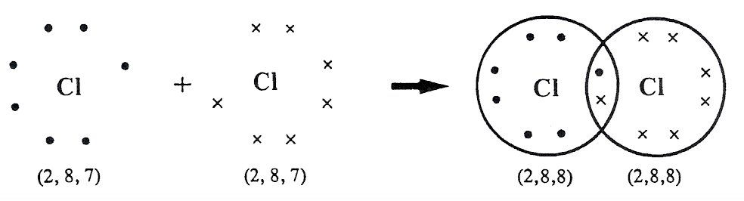

Lone pairs of electrons

Shared pair of electrons

Eg.Chlorine, Cl2

Electron configuration

Label a) the shared pair of electrons

b) a lone/unbounded pair of electrons

What advantage has each chlorine atom gained from forming this covalent bond?

Each chlorine atom gains a full outer shell of electrons

Construct **dot and cross diagrams** for the following compounds from atoms of New exercisetheir constituent elements

1. H2O

Identify **lone pairs** of electrons



1. NH3



Identify **lone pairs** of electrons

1. HCl



1. CH4



1. C2H6



A **double** covalent bond is one in which two pairs of electrons are shared between two atoms.

Class video

Examples of double and triple bonds Video 1772 – [Double and triple bonds](http://estream.godalming.ac.uk/View.aspx?ID=1772)

Example (i) CO2



(ii) O2



(iii) C2H4

A **triple** covalent bond is one in which three pairs of electrons are shared between two atoms.

Example (i) N2



(ii) C2H2



New Reference**DATIVE COVALENT BONDING** (CO-ORDINATE BONDING)

Refer to:- Facer AS Chemistry p121-122

Look again at the dot and cross diagram of an ammonia molecule, NH3.

* There are 5 electrons in the outer shell of the nitrogen atom.
* Three unpaired electrons form normal covalent bonds, one with each hydrogen atom.
* There is a pair of non-bonding (un-bonded) electrons remaining known as a **lone pair**.
* New exerciseA hydrogen ion, H+, has an empty electron shell. It will bond with the lone pair of the NH3 molecule to form a **dative covalent bond**, represented by an arrow **from** the donating pair of electrons **to** the atom which accepts them (see diagram below).

Draw out dot and cross diagrams below the formulae to represent the reaction:

H

N

H

H

H

+



NH3 + H+ 🡪



**A dative covalent bond** is a shared pair of electrons both from one donor atom

**N.B.** The dative covalent bond will be indistinguishable from the normal covalent bonds.

It will:



AlCl3

* have the same strength (bond energy)
* be the same length.

**Aluminium chloride:**

Draw out a **dot and cross diagram** to represent the molecule AlCl3.

How many pairs of electrons does the Al have in its outer shell? …3..

How many electron pairs represent a full outer shell? ……4

This compound is described as **electron deficient**.

Two molecules of aluminium chloride combine with each other to achieve full outer shells. Draw a dot and cross diagram to show the electrons in the bonds.



**Carbon monoxide:**



Draw in the dot and cross diagrams for:



Carbon atom Oxygen atom Carbon monoxide molecule

**Some more difficult Dot and cross diagrams**

Complete the dot and cross diagram to show the bonding in the nitrate ion. Only the outer electron

shells for each atom need to be shown. Represent the nitrogen electrons with crosses (**×**), and

oxygen electrons with dots, (∙). The symbol * on the diagram represents the extra electron giving

the ion its charge.

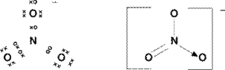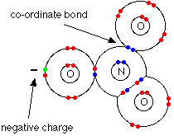 or

Potassium dichromate(VI), K2Cr2O7, can be used to accurately determine the

concentration of other chemicals, such as sodium thiosulfate, Na2S2O3.

The dichromate(VI) ion has two chromium atoms sharing one oxygen to give two tetrahedral units. Each chromium atom uses six electrons in bonding and expands its outer shell to accommodate a total of 12 electrons. Complete the dot and cross diagram for this ion below. Only show outer shell electrons.

Use **x** for chromium electrons and ∙ for oxygen electrons. Use the symbol **\*** to represent the extra electrons which give the ion its charge.

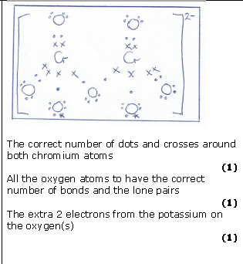

**MOLECULAR LATTICES**

Most covalent structure are molecules which are held together with strong bonds within the molecule but weak forces between the molecules examples include CO2, CH­4, H2O, at room temperature most of these are liquids or gases

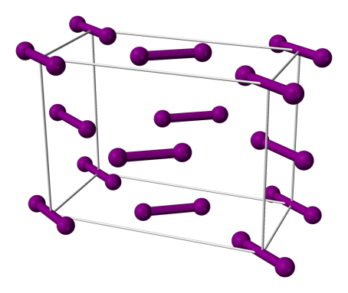However compounds can also form molecular solids, especially if the temperature is low enough . The two examples are ice and iodine

**Iodine**

Iodine is a diatomic molecule held together by weak

Intermolecular forces. In the solid form the molecules

are held in a regular lattice. What happens to the structure

as it is heated?

As the temperature increases the molecules gain

kinetic energy and vibrate more, enough to overcome the weak intermolecular forces between the molecules (the strong covalent bonds remain unchanged).

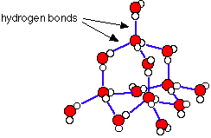

**Ice**

Another example of a molecular solid is ice,  
again held together by weak intermolecular forces.  
(you will study these in a later topic).   
Other molecular solids are Sulphur (S8), phosphorus (P4) C60 etc.  
Note that they have a specified number of atoms in the molecule.  
This differentiates them from Giant covalent lattices.

When melting a molecular lattice it is the weak intermolecular forces that are overcome NOT the strong covalent bonds within the molecule.

**GIANT COVALENT LATTICES**

**DIAMOND,** - AN ALLOTROPE OF CARBON

Allotropes – two or more forms of the same element in which the atoms or molecules are arranged in different ways

Class video

Video clip e-stream [317 network molecular substances](http://estream.godalming.ac.uk/View.aspx?ID=317) 16.00 – 19.42

[1772 giant covalent structures](http://estream.godalming.ac.uk/View.aspx?ID=1772)  12.11-14.44

DIAMOND - a giant, covalently bonded structure.

MCj04247820000[1]In a diamond, each carbon atom is bonded to four other carbon atoms oriented around it in a tetrahedral manner to form a giant molecule. The bonds are covalent and because the bonding electrons are localised close to the nucleus, they are exceptionally strong. Diamond is the hardest natural substance known.



New exerciseDraw a diagram of diamond

In terms of structure and bonding, explain the differences between diamond and iodine.

|  |  |  |
| --- | --- | --- |
|  | **Diamond (Giant covalent lattice)** | **Iodine (Simple molecular)** |
| Appearance | Extremely hard, transparent, colourless, crystals with a high refractive index | Grey Solid |
| Bonding | Each C atom makes 4 covalent single bonds. | Covalent bond between iodine atoms and weak attractions between molecules |
| Structure  (describe) | Each C atom is tetrahedrally bonded to four others in a giant 3D lattice. | Simple molecule I2 packed into a regular lattice |
| M.Pt. / B.Pt. | Very high = 3550oC | low = 114oC |

Why is there such a difference in the M.Pt. of iodine and diamond?

Diamond : giant covalent structure need to **break many covalent bonds** in 3D

Covalent bonds need to be broken

I2 molecule: only has weak attractions (London forces) between molecules

Little energy is needed to **overcome these weak forces** of attraction.

Silicon is also in group 4 and the element shows the same structure as diamond. Why does silicon have a very high melting point?

Si has a giant covalent structure and a lot of heat energy is needed to break the 4 covalent bonds between each Si atom

It has a lower M.Pt. than diamond as the atoms have a larger radius and so the covalent bonds will be longer and weaker

**Silicon dioxide (sand)**

If silicon forms four covalent bonds and oxygen forms two bonds how can a giant structure be formed?

Each Si atom makes single covalent bonds to four O atoms

Each O atom makes a single covalent bond to two Si atoms

Use this site to see a diagram <http://www.chemguide.co.uk/atoms/structures/giantcov.html>

Draw the structure then predict its properties in the table below:

|  |  |
| --- | --- |
| Diagram of SiO2 structure | Physical properties |
| http://www.chemguide.co.uk/atoms/structures/sio2.GIF | * hard * High M Pt. * Does not conduct electricity * Insoluble |

**Giant covalent and simple covalent structures- similarities and differences**

As we have seen covalent compounds can be described as either simple molecular or giant atomic/giant covalent.

Examples of simple covalent are water, ammonia, methane, carbon dioxide etc.

Examples of giant atomic (or giant covalent) are sand (SiO2), graphite and diamond

They have some quite different physical properties but one similarity.

Fill in the table below to illustrate the differences and similarities between giant atomic and simple

covalent structures using **carbon dioxide** and **silicon dioxide** as typical examples.

|  |  |  |
| --- | --- | --- |
| **Property** | **Giant atomic-SiO2** | **Simple covalent-CO2** |
| High/low melting point | High M Pt.  A lot of heat energy needed to break the covalent bonds. | Low M Pt. Little heat energy needed to overcome the weak attractions between molecules and separate them. |
| State & appearance at 25oC | Solid crystalline | Gas colourless |
| Electrical conductivity | Do not conduct.  All electrons localised in bonds | Do not conduct electricity.  All electrons localised in bonds. |
| Solubility in water | Insoluble in water.  Insoluble in organic solvents. | Soluble and able to react with water:-  CO2 + H2O  H2CO3  H+ + HCO3-  Soluble in organic solvents. |
| Hardness & strength of solid | Very hard but brittle. | Not very hard. |

Worksheet‘Giant covalent substances’ worksheet

Other Allotropes of carbon are  **GRAPHITE, GRAPHENE and C60**

Class videoNew Reference**GRAPHITE**

[Chemguide description of graphite](http://www.chemguide.co.uk/atoms/structures/giantcov.html) (and other giant structures)

Video: ‘Bonding in atoms’ 1770 5.15 – 7.00

CONSULT: Facer AS Chemistry p170

Graphite is one of three crystalline forms (allotropes) of carbon. It is an unusual non-metal as it is able to conduct both heat and electricity. The reason lies in its structure. It is composed of carbon atoms in rings of six, bonded together and formed into sheets. (The sheets are then stacked in a layer structure).

Strong covalent bonds

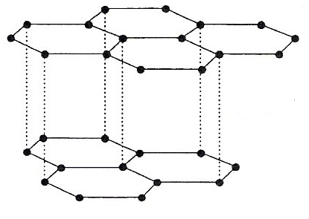

Weak London forces

Strong covalent

A carbon atom has four electrons in its outer shell.

Looking at the diagram, to how many other carbon atoms is each carbon atom bonded? 3 others

Each of these bonds is a strong covalent bond.

This means that each carbon atom has a valence. electron free which is not localised. These electrons are mobile and move freely across the plane of the sheet. They are said to be delocalised as they form a **delocalised  molecular orbital.**

Weak London forces

Between each layer are weak **intermolecular forces.**

(called London forces)

Show delocalised electrons as circles within the hexagons

* New exercise**Add labels** to the diagram as indicated by the arrows.
* Explain why graphite can conduct heat and electricity.
* Delocalised electrons are free to move ALONG a layer (not between layers)
* When a p.d.is applied they move to the +ve terminal conducting electicity.
* In a hot region they move faster colliding with other electrons so transferring KE
* In which direction can graphite conduct and why?
* Graphite only conducts ALONG sheets, electrons are only moving within sheets,
* adjacent sheets/ individual planes are too far apart.
* Explain why graphite is a good lubricant or useful in lead pencils?

Weak London forces allow layers to slip leaving a thin layer of graphite on the paper.

**GRAPHENE**

The 2010 Nobel prize for physics was awarded for the discovery of graphene another allotrope of carbon, similar in structure to graphite it can be thought of as a single sheet, one atom thick of graphite.

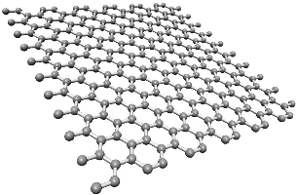

It can then be rolled into a ball to form a

Fullerene or into a cylinder to form a carbon

Nanotubes. Like graphite it forms 3 covalent

bonds with the last electron delocalised over the

surface. Hence it can conduct electricity.

Like graphite and diamond graphene is

considered as giant covalent lattice, whereas C60

(buckminsterfullerene) is considered as a

molecule

Why is Graphene a giant covalent lattice and C60 a molecular solid.

C60 has a fixed number of atoms in the molecule, whereas graphene (as well as graphite and diamond) have a variable number of atoms determined by the size of the crystal. Similar to giant ionic structures e.g.NaCl in ionic bonding.

**Comparison of Diamond and graphite**

****Class videoVideo clip e-stream 317 network molecular substances 16.00 – 19.42

**New Reference**Facer AS Chemistry p170

[Chemguide - How to draw diamond](http://www.chemguide.co.uk/atoms/structures/giantcov.html) and its properties.

**Diamond** - a giant, covalently bonded structure.

**New exercise**In a diamond, each carbon atom is bonded to four other carbon atoms oriented around it in a tetrahedral manner to form a giant structure. The bonds are covalent and because the bonding electrons are localised close to the nucleus, they are exceptionally strong. Diamond is the hardest natural substance known.

Without looking back, draw labelled 3 dimensional diagrams of:

|  |  |
| --- | --- |
| **i) Diamond** | **ii) Graphite** |
|  |  |

In terms of structure and bonding, explain the differences between diamond and graphite.

|  |  |  |
| --- | --- | --- |
|  | **Diamond** | **Graphite** |
| Appearance | Shiny transparent crystal | Dull grey / black solid |
| Ability to conduct heat | Yes but no delocalised e- , it is a quantum effect – you do not need to know about this | C atoms covalently bonded to three others forming sheets of hexagons, fourth electron is delocalised within the sheet.  **Electrical conductivity** – good along layers, delocalised e- free to move with applied p.d., current = flow of electrons.  **Heat energy** transferred by e- gaining KE and transferring it along layers. |
| Ability to conduct electricity | No – all electrons are localised within covalent bonds. |
| Density | 3.53 g cm-1  High, tetrahedrally bonded C atoms held close together so a large number of atoms per unit volume | 2.25 g cm-1  Low, due to large spaces between hexagonally bonded sheets |
| Solubility | Insoluble in polar and non-polar solvents as it is a giant structure | Insoluble in polar and non-polar solvents as it is a giant structure |
| Hardness | Hardest natural substance known. Tetrahedrally bonded C atoms form a strong rigid structure | Soft, layers rub off. Sheets weakly held to adjacent ones by weak dispersion forces |
| Uses | On surfaces of cutting/drilling tips | Good lubricant. |

New exerciseMETALLIC BONDING

New Reference<http://www.chemguide.co.uk/atoms/bonding/metallic.html>

Ref: Facer AS Chemistry p101 - 102

<http://www.drkstreet.com/resources/metallic-bonding-animation.swf>

Because metals have large atoms the electrons are far from the nucleus. Metals have **low ionisation energies.** This means that metal atoms have a **high tendency to lose electrons and form positive ions.**

The properties of metals depend on the way the atoms are packed (structure) and the bonding of the atoms making up the metal structure.

Most metals have fairly high melting points suggesting that the attractive forces between cations and delocalised electrons are strong. Metallic atoms readily lose their outer shell electrons which move randomly throughout the crystal structure, are shared by all the neighbouring positive ions and are said to be **delocalised**.

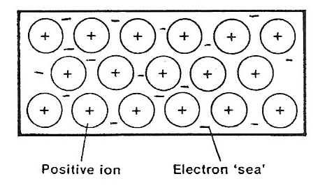

Metals of group 1 lose one electron.

Metals of group 2 lose two electrons

Metals of group 3 lose three electrons

Transition metals - the situation is more complex.

metal cations in ordered lattice

‘sea’ of delocalised electrons

**DEFINITION**: Metallic bonding is the electrostatic attractions between positive metal cations and the delocalised electrons.

The strength of the metallic bond depends on:

* the number of electrons which can become delocalised
* the size of the ions

The … greater the number of electrons delocalised the stronger the bonding.

The … smaller . the size of the ions the stronger the bonding.

State and explain which of the following will have the strongest metallic bonding.

Sodium or potassium? Na – smaller ionic radius, same no of delocalised electrons therefore greater electrostatic attraction and more energy required

Sodium or magnesium? Magnesium ion/ Mg2+ is smaller (than sodium ions) **(1)**

The magnesium ion contributes two electrons (to the sea of electrons)   
compared to sodium’s one**. (1)**

More **energy/heat** required to overcome (attractive) forces/bonds (between cations and “sea” of electrons) in magnesium (compared to sodium) **(1)**

Magnesium or aluminium Al – smaller ion, 3e- delocalised.

## Class videoPhysical properties of metals

Video ‘Bonding’ 328 11.31 [Metallic bonding](http://estream.godalming.ac.uk/View.aspx?ID=328)

Video ‘[Bonding in Metals](http://estream.godalming.ac.uk/View.aspx?ID=1765)’ 1765 7.15 – 20.19

New exercise

Explain why the delocalised electrons in metals make them:-

Good **electrical conductors**:

delocalised electrons are free to move in any direction

when a potential difference is applied the electrons move to the positive terminal

a flow of electrons is an electric current.

Good **conductors of heat**:

delocalised electrons are free to move in any direction

in hot areas electrons have more K.E., move faster

electrons collide more, passing on K E to other electrons.

Explain why the electrical conductivity increases Na → Mg →Al

More electrons are delocalised Na(1) 🡪 Mg(2) 🡪 Al(3) are free to move in any direction.

when a p.d. is applied the electrons move to the positive terminal

larger flow of electrons results in a larger current and so greater conductivity.

Explain why the thermal conductivity increases Na → Mg →Al

More electrons are delocalised Na(1) 🡪 Mg(2) 🡪 Al(3)

in hot areas electrons have more K.E.

more electrons collide more passing on K E to other electrons more efficiently.

The stronger the metallic bond the higher the **melting point**. Most metals are solids.

**Demonstration**Which one is liquid at room temperature? mercury

Which other two have the lowest melting points? Caesium, francium

**Teacher demonstration – Physical properties of Caesium**

Describe the appearance of Caesium Shiny silver solid

What is its state at room temperature? solid When warmed slightly? Melts to a liquid

Why is it kept in a sealed ampoule? Prevent any reaction with air or moisture

Two other key properties of metals is their malleability (made into different shapes) and their ductility(made into a wire)

Sort the following into metallic, covalent or ionic

Sodium chloride, Magnesium, Magnesium oxide, Methane, Silicon dioxide, Bromine, Aluminium, Oxygen, Graphite, Barium iodide, Water, Ammonia, (now add some of your own)

IONIC (giant ionic lattices)

Sodium chloride - conducts electricity when molten or (aq)

Magnesium oxide - conducts electricity when molten or (aq)

Barium Iodide - conducts electricity when molten or (aq)

METALLIC (giant metallic lattices)

Magnesium – conducts when molten or solid

Aluminium - conducts when molten or solid

COVALENT

Giant Covalent

Silicon Dioxide - does not conduct

Graphite - conducts due to delocalised electrons in layers between hexagonal sheets

Simple Covalent (molecular)

Methane

Bromine

Oxygen

Water

Ammonia

Note:

None of the simple covalent compounds are said to conduct electricity. Pure water will not conduct electricity, however most water contains dissolved salts which make it highly conductive.

Ammonium chloride: Simple covalent within the Ammonium ion (NH4+) ionic between the chloride and ammonium

Potassium dichromate: Simple covalent within the dichromate ion, ionic between the potassium and the dichromate

Revision Notes

AQA GCSE HF QA05DH1.15

AQA GCSE QCJ97 15 10

**AS Multiple choice and structured questions**

**1.** Covalent bonding results from the strong electrostatic attraction between

**A** instantaneous dipoles

**B** electron clouds

**C** electrons in the bonding pair

**D** bonding pairs of electrons and nuclei

**Total 1 mark**

**2.** Which is the strongest covalent bond?

**A** N–H

**B** P–H

**C** O–H

**D** S–H

**Total 1 mark**

**3.** Which does **not** contain a dative covalent bond?

**A** PCl4+

**B** NH4+

**C** PCl6-

**D** Al2Cl6

**Total 3 marks**

**4.** Which of the following does **not** have exactly 10 electrons?

**A** An ion of fluorine, F–

**B** A molecule of methane, CH4

**C** A molecule of nitrogen, N2

**D** An ion of sodium, Na+

(Total 1 mark)

**5.** Which of the following covalent bonds is the shortest?

**A** H―F

**B** H―Cl

**C** H―Br

**D** H―I

(Total 1 mark)

Do not write in the margin

June 2011.Q12

Facer Ch6 summary questions

Multiple choice p34 Q10

**Structured Questions**

June 2009.Q9

S09.1.19

**1.** (a) (i) Complete the electronic configuration of the magnesium atom.

**1s2 2s2 2p63s2 ­**

(1)

(ii) Complete the electronic configuration of the chlorine atom.

**1s2 2s2 2p6 3s2 3p5**

(1)

(b) (i) Write the equation, including state symbols, for the reaction of magnesium with chlorine.

Mg(s) + Cl2(g) MgCl2(s)

(2)

(ii) Name the type of bonding present in magnesium chloride

Ionic

(1)

(d) Explain fully why the melting temperature of magnesium is higher than that of sodium.

Magnesium ion/ Mg2+ smaller (than sodium ions) **(1)**

Also the magnesium ion contributes two electrons/more electrons (to the sea of electrons) than sodium**.(1)**

More **energy/heat** required to overcome (attractive) forces/bonds  
(between cations and “sea” of electrons) in magnesium (compared  
to sodium) **(1)**

Mark each point independently 3

Any references to the bonding being ionic scores **(0)** overall

Any references to “molecules”/intermolecular forces scores  
**(0)** overall

**JUST** “stronger bonds in Mg”

**JUST** “stronger bonds in Mg”

(3)

1. Draw dot cross diagrams for (show outer shell electrons only)

a) Carbon tetrachloride (tetrachloromethane)







**2)**

b) Carbon dioxide







c) Xenon tetrafluoride

(Hint-Xe can have more than 8 outer electrons, F cannot)





**(2)**

d) Sulfate(VI) ion

(Hint-S can have more than 8 electrons in outer shell, O cannot.

Also there will be two electrons added to form this ion)





**(2)**

**Total 8 marks**

**3.** (a) Define the term **covalent bond.**

(Electrostatic attraction between two nuclei and the) **shared pair (1)**

of electrons (between them) **(1)**

(2)Do not write in the margin

W09.1.22

(b) Nitrogen forms an oxide called nitrous oxide, N2O. The bonding in nitrous oxide can be represented as:

NN → O

Complete the diagram below for the N2O molecule using dots or crosses to represent electrons. Just show all of the outer shell electrons.

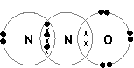

(Dative) pair of e- between N and O **(1)**  
Three bond pairs between N and N **(1)**  
Lone pair on left-hand N **and** three lone pairs on O atom **(1)**

(3)

(Total 5 marks)

**4.** (a) Explain why carbon dioxide is a gas at room temperature and pressure, whereas silicon dioxide is a solid with a very high melting temperature.

CO2 is molecular **(1)**

with weak inter-molecular / vdW / dispersion forces/dipole dipole **(1)**

SiO2 is giant covalent **(1)** *ACCEPT* giant molecular *OR* macromolecular

*NOT* giant lattice

SiO2 melting needs Si-O bonds/covalent bonds to be broken **(1)**

(4)

(b) Magnesium forms a hydrated ion [Mg(H2O)6]2+.

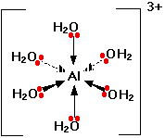

2++

**Mg**

Mg

(i) Name the type of bond between an oxygen atom and a hydrogen atom in this hydrated ion.

Covalent

(1)

Total 5 marks

Do not write in the margin

Jan 05 Unit 1 Q 3 & 5

**5.** (a) State the type of bonding in the following substances and draw diagrams to illustrate their 3-dimensional structures.

(i) Diamond

Bonding (giant) covalent (1)

Diagram

Diag. shows at least 5 carbon atoms correctly joined (1)

plus a hexagonal ring (1)

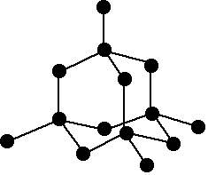Must NOT be graphite

(3)

(ii) Sodium chloride

Bonding ionic (1)

Diagram

shows alternating Na+ and Cl- ions OR a key (1)

More than one layer (1)

ALLOW correct unit cube for NaCl (2)

ALLOW 1 mark for single layer with at least 6 ions

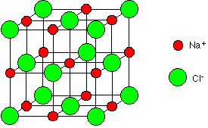

**(3)**

(b) Explain why both diamond and sodium chloride have high melting temperatures.

NaCl giant ionic lattice with strong attraction between oppositely charged ions in 3 D each Na+ surrounded by 6Cl- and vice versa

Diamond giant macromolecular lattice with each C forming 4 strong covalent bonds in 3D

Require a lot of heat energy to overcome

(3)

Total 9 marks

Do not write in the margin

June 04 Unit 1 Q3

W07C 1 Q4 mod

**6.** Explain each of the following.

(a) Silicon and phosphorus are both covalent substances, but silicon has a much higher melting temperature than phosphorus.

Si: giant atomic/ structure  
*OR* macro molecular/ atomic/ structure  
*OR* Lattice  
*OR* network  
*OR* diagram with a minimum of 5 atoms shown with continuation **(1)**



P: **molecular** *OR* exists as P4 **(1)**

Si: covalent Si-Si bonds to break **(1)**

P: intermolecular forces/ van der Waals’ forces between molecules to overcome **(1)**

Therefore more energy to separate silicon atoms (1)

– *dependent on a reasonable explanation for Si and P*

**(5)**

Do not write in the margin

Jan 04 Unit 1 Q7

.....

Worksheet

Additional practice, Gifted and talented ‘Covalent bonding’ worksheet

For practice on all types of bonding ‘Bonding 1’ worksheet**2015**

**NAME ...........................……... HOMEWORK DEADLINE .....................**

**Student Number ………… Chemistry Class ………**

Student targets from **previous pack**

Bonding II Covalent & Metallic

|  |  |
| --- | --- |
| **Task** | Mark |
| Notes | /10 |
| Revision Notes | /10 |
| Exam questions – | /45 % |
| Overall Grade for this work | A B C D E U |

Student comments

Tutor comments

Tutor signature Date

Student targets for **next pack**