NAME ............................................ Chemistry Class .........................
Student Number ……….
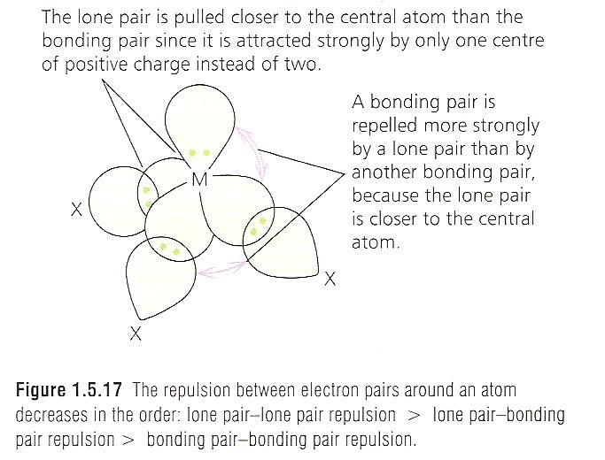
Shapes
The repulsion between electron pairs around an atom decreases in the order: lone pair-lone pair repulsion > lone pair bonding pair repulsion > bonding pair-bonding pair repulsion
answers
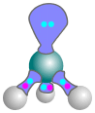

2A Bonding
Shapes of molecules and ions
Students will be assessed on their ability to:

10. understand that the shape of a simple molecule or ion is determined by the
repulsion between the electron pairs that surround a central atom

11. understand reasons for the shapes of, and bond angles in, simple molecules and
ions with up to six outer pairs of electrons (any combination of bonding pairs and
lone pairs) Examples should include BeCl2, BCl3, CH4, NH3, NH4+, H2O, CO2, PCl5(g) and
SF6(g) and related molecules and ions; as well as simple organic molecules in this specification.

12. be able to predict the shapes of, and bond angles in, simple molecules and ions
analogous to those specified above using electron-pair repulsion theory
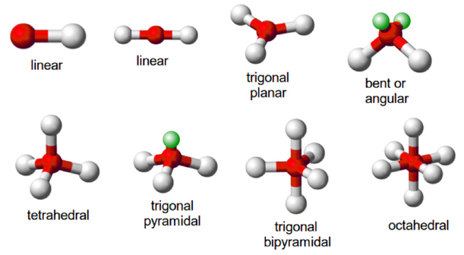


Textbook
Facer AS Chemistry p153 – 160

Department Website Factsheets

04 | Shapes of Molecules and Ions

Websites
http://www.ausetute.com.au/shapemol.html
This site gives an explanation of molecular shapes, diagrams and some worked examples

http://www.examstutor.com/chemistry/resources/studyroom/bonding/shapes_of_molecules/pictures/table_of_shapes.gif
Table of molecular shapes with bonding pairs, lone pairs and bond angles

http://www.mhhe.com/physsci/chemistry/carey/student/olc/ch01shapes.html
This site contains a shapes animation table and takes your understanding further. Perhaps useful for revision when you have covered the next topic as well.

http://webpages.dcu.ie/~pratta/jmgallery/
A molecular viewing gallery which allows you to view any named molecule in 3D and rotate it.

http://www-teach.ch.cam.ac.uk/links/3Dindex.html
3D diagrams of graphite and buckminsterfullerene

http://www.chemistryrules.me.uk/found/found3.htm#title
A site giving basic information about covalent bonding with animated structures

SHAPES OF COVALENT MOLECULES

CONSULT Facer AS Chemistry p153 - 160
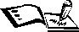
Video clips e-stream 317 Shapes of molecules 19.42 – 21.46
e-stream 1772 Molecular shapes with orbitals 3.20 – 7.50
Power point ’Shapes’ in Godalming online/Chemistry AS/ Unit 2 Shapes/ Resources

Knowledge of the shapes of molecules helps to understand their properties and reactions both in the test tube and in the human body. We can predict the shape of simple molecules using the

ELECTRON PAIR REPULSION THEORY, (also known as valence shell electron pair repulsion theory or VSEPR) which firstly states that:-
Bonding pairs of electrons around a central atom repel each other
and arrange themselves as far apart around the central atom to minimise repulsion

The method for predicting the shape is:-
- draw a dot and cross diagram and identify the central atom.
- count the number of σ-bond electron pairs round the central atom
- count the number of lone (outer shell) electron pairs round the central atom
- add the two together; this gives the total number of pairs around the central atom
- the electron pairs repel so arrange themselves as far apart as possible.
- the name of the shape depends on the position of atoms around the central atom
Formula  and dot and cross diagram | Apply VSEPR | 3D shape of molecule,  name and bond angles
CH₄ | σ-bond pairs = 4  lone pairs = 0  Total = 4  electron pair arrangement is  tetrahedral  Position of atoms | Shape = tetrahedral
A bond angle is the angle between two covalent bonds in a molecule or giant covalent structure

N.B. Atoms of elements in Period 3 and beyond (i.e. after Ne) can have more than 8 electrons in their outer shell. In the dot and cross diagram use all the outer shell electrons of the central atom to form bonds if necessary.
Also some atoms can be electron deficient (less than 8 electrons) if there are no more outer shell electrons available in the outer shell of the central atom.
Using the method on the previous page, complete this:-

Table of basic shapes
Formula  and dot and cross diagram | Apply VSEPR | 3D shape of molecule,  name and bond angles
BeCl₂ | σ-bond pairs = 2  lone pairs = 0  Total = 2  electron pair arrangement is  linear  Position of atoms | Shape = linear
BCl₃ | σ-bond pairs = 3  lone pairs = 0  Total = 3  electron pair arrangement is  trigonal planar  Position of atoms | Shape = trigonal planar
CCl₄ | σ-bond pairs = 4  lone pairs = 0  Total = 4  electron pair arrangement is  tetrahedral  Position of atoms | Shape = tetrahedral
PCl₅ | σ-bond pairs = 5  lone pairs = 0  Total = 5  electron pair arrangement is  trigonal bipyramidal  Position of atoms | Shape = trigonal bipyramidal
SF₆ | σ-bond pairs = 6  lone pairs = 0  Total = 6  electron pair arrangement is  octahedral  Position of atoms | Shape = octahedral
It is important that your diagram conveys a 3D shape, = bond coming towards you and away
MOLECULES WITH LONE PAIRS OF ELECTRONS AND/OR DOUBLE BONDS
VSEPR Valence Shell Electron Pair Repulsion theory, secondly states that:-
lone pairs of electrons are held more closely to the central atom and so exert a greater repelling effect than bonding pairs. This reduces the bond angle by approx 2º per lone pair.

Formula | Apply VSEPR | Bond angles | 3D shape of molecule,  name and bond angles
SO₂ | σ-bond pairs = 2  lone pairs = 1  Total = 3  electron pair arrangement is  trigonal planar | 118 | Shape = bent
NH₃ | σ-bond pairs = 3  lone pairs = 1  Total = 4  electron pair arrangement is  tetrahedral | 107 | Shape = trigonal pyramidal
H₂O | σ-bond pairs = 2  lone pairs = 2  Total = 4  electron pair arrangement is  tetrahedral | 104.5 | Shape = bent
SF₄ | σ-bond pairs = 4  lone pairs = 1  Total = 5  electron pair arrangement is  trigonal bipyramidal | Complex | Shape = seesaw
ICl₃ | σ-bond pairs = 3  lone pairs = 2  Total = 5  electron pair arrangement is  trigonal bipyramidal | 120 or 90 | Shape = trigonal planar or T-shape
IF₅ | σ-bond pairs = 5  lone pairs = 1  Total = 6  electron pair arrangement is  octahedral | 90 | Shape = square pyramidal
XeF₄ | σ-bond pairs = 4  lone pairs = 2  Total = 6  electron pair arrangement is  octahedral | 90 | Shape = square planar

For molecules with double bonds just count the σ bond electrons. π electrons do not affect the shape of the molecule so ignore them (i.e. treat double bonds like single bonds).
CO₂ | lone pairs = 0  σ-bond pairs = 2  π bond pairs = 2 have no effect on shape so,  Total = (σ-bond+lone pairs) = 2  electron pair arrangement is  linear  Position of atoms | Shape = linear
SO₃ | σ-bond pairs = …….  lone pairs = ……..  Total =  (σ-bond+lone pairs) = ……..  electron pair arrangement is  ……………………………  Position of atoms | Shape = …………………
Follow the link to help you answer:-
Why do the bond angles for NH₃, H₂O differ from CH₄ ? CH₄ has 4 bonding pairs → tetrahedral, 109.5º. In NH₃ 3 bonding pairs + one lone pair, lone pair held closer to central atom so repels bonding pairs reducing bond angle to 106.7º. H₂O has 2 bonding and 2 lone pairs, the latter reduce bond angle further to 104.5º.

SHAPES OF IONS
Ions are atoms or groups of atoms that have gained or lost electrons.
In the following dot and cross diagrams, for negative ions add an electron to O atoms, for positive ions remove an electron from H atoms. Remember to show the charges.
Formula and dot and cross | Apply VSEPR | 3D shape of molecule,  name and bond angles
NH₄⁺ | σ-bond pairs = 4  lone pairs = 0  Total = 4  electron pair arrangement is  tetrahedral  Position of atoms | Shape = tetrahedral
H₃O⁺ | σ-bond pairs = 3.  lone pairs = 1  Total = 4  electron pair arrangement is  tetrahedral  Position of atoms | Shape = trigonal pyramidal

SO₃²⁻ (S can have more than 8 outer electrons. O cannot) | σ-bond pairs = 3  lone pairs = 1  Total = 4  electron pair arrangement is  tetrahedral  Position of atoms | Shape = trigonal pyramidal

NOTE: To gain an accurate idea of the shapes of molecules you also need to be aware that different bonds have different lengths.
You do NOT need to memorise the values – data would always be given in a question
Bond length is the distance between the nuclei of two atoms linked by one or more covalent bonds.

Some lengths of carbon bonds are given below together with their bond enthalpies
Bond | Bond length  / nm | Bond enthalpy  / kJ mol⁻¹
C−C | 0.154 | 347
C=C | 0.134 | 612
C≡C | 0.120 | 838

What do you notice about the length and strength of the carbon bonds?
Bond strength inversely proportional to bond length
Shapes of simple organic molecules
You could use models or http://webpages.dcu.ie/~pratta/jmgallery/
Add bond angles and draw 3D stereo diagram next to each of the following displayed diagrams.
Alkanes
3D diagram to show shape

- All bond angles are .109.5º
- Shape around each C atom is tetrahedral
Alkenes
3D diagram to show shape

- Add in bond angles around the C atom on the diagram
- Length of the C=C bond in ethene compared to the C-C bond in ethane is shorter

Alcohols

- Mark the size of the bond angle around the O atom and show any lone pairs of electrons.
3D diagram to show shape
Halogenoalkanes

Name bromomethane Shape tetrahedral

- For the following add the values of bond angles marked * and any lone pairs of electrons
Carboxylic acids

*
*

methanoic acid ethanoic acid
Aldehydes and Ketones
*
*
*

Propanal propanone
Make sure you know the difference between state and explain. Answer the following question and underline any statements in one colour and explanations in a different colour.
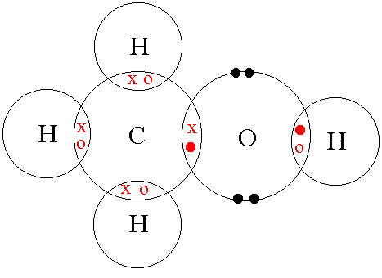
1) This question is about methanol, CH₃OH

(ii) Give the approximate values for the HCH and COH bond angles in methanol.
Explain (justify) your answers.
HCH angle = 109 / 109.5
The four bonding pairs of electrons separate out to minimise repulsion / to maximum separation leading to a tetrahedral shape

COH angle = 104-105
The 2 bonding pairs and 2 lone pairs separate out to maximise separation however the two lone pairs repel more than the bonding pairs, therefore the bond angle is reduced to 104.5.
2) Suggest a dot and cross diagram for the hydrogen peroxide molecule (H₂O₂) in which each oxygen atom is covalently bonded to one hydrogen atom (only outer electrons should be shown).
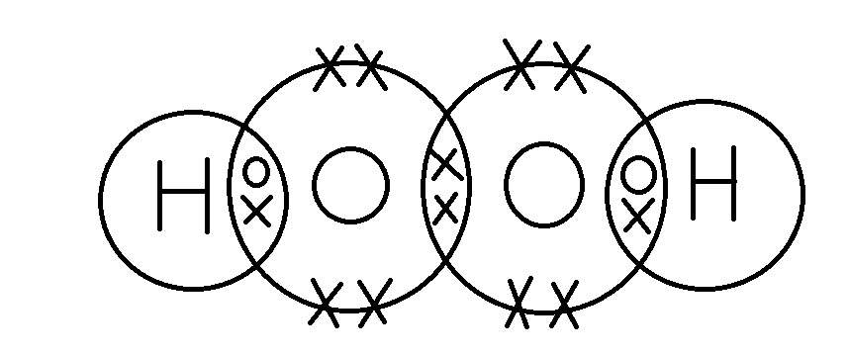
*(d) The bond angles in hydrogen peroxide are similar to those in a water molecule. Suggest a bond angle for hydrogen peroxide and reasons for your value. (3)
Bond Angle 104.5
Reasons
The 2 bonding pairs and 2 lone pairs separate out to maximise separation however the two lone pairs repel more than the bonding pairs, therefore the bond angle is reduced to 104.5

More Shapes

1)In iodine pentoxide, each iodine atom is bonded to three oxygen atoms and one of these oxygen atoms is bonded to both iodine atoms as shown in the layout below. Complete the dot and cross diagram for the molecule, using dots for the oxygen electrons and crosses for the iodine electrons.

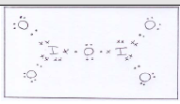
In this molecule, each iodine atom has twelve electrons in its outer shell. Show outer shell electrons only.
(2)

The shape around the iodine is similar to that around the nitrogen in ammonia, NH3. Suggest a value for the O – I – O bond angle and the name of the shape around the iodine atom.
(2)
O – I – O bond angle 105-107

Shape Pyramidal

2) Potassium bromate(V), KBrO3, is a primary standard, meaning that it can be obtained as a pure substance and used to accurately determine the concentrations of solutions of other chemicals, such as sodium thiosulfate, Na₂S₂O₈

(a) (i) Complete the dot and cross diagram for the bromate(V) ion. Show only the outer shell electrons.
In this ion, the bromine expands its outer shell to accommodate 12 electrons.
Use crosses for bromine electrons and dots for oxygen electrons. The symbol * on the diagram represents the extra electron which gives the ion its charge.
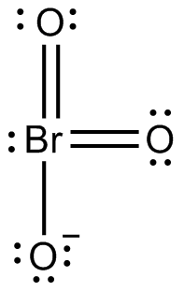
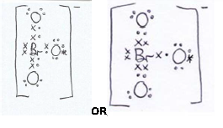

(2)

Revision page
Revision page – use the next page to make revision notes to include:-
VSEPR Theory statements 1
2

How to calculate angles and shape of molecules

Table of shapes of molecules

Bond angles and lengths of organic molecules

Carbon allotropes graphite,
diamond
Structures and uses of these
fullerenes
nanotubes

Revision Notes

Multiple Choice Exam Questions
Questions 1-6 are concerned with the following three dimensional shapes:
Multiple choice p19-20
A | tetrahedral
B | trigonal pyramidal
C | linear
D | trigonal planar
E | non-linear

1 Which of A-E is the shape of CH₄ molecules?
A | √ |  | B |  |  | C |  |  | D |  |  | E

What is the internal angle in a molecule of methane? 109.5º.
(2)
2 Which of A-E is the shape of BF₃ molecules?
A |  |  | B |  |  | C |  |  | D | √ |  | E

(1)

3 Which of A-E is the shape of NH₃ molecules?
A |  |  | B | √ |  | C |  |  | D |  |  | E

What is the internal angle in an ammonia molecule? 106.7º
(2)
4 Which of A-E is the shape of HCN molecules?
A |  |  | B |  |  | C | √ |  | D |  |  | E

(1)

5 Which of A-E is the shape of the CO₃²⁻ ion?
A |  |  | B |  |  | C |  |  | D | √ |  | E

(1)
6 Which of A-E is the shape of the NO₃⁻ ion?
A |  |  | B |  |  | C |  |  | D | √ |  | E

What is the expected shape of the nitrate(III) ion, NO₂⁻? Non – linear or bent due to the lone pair of electrons on the N atom (do a dot and cross to prove it!)
(2)

Do not write in the margin

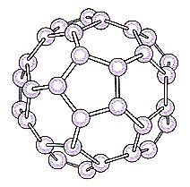
7 This molecule is called buckminsterfullerene and it has the formula C₆₀. Correct statements about this molecule include:
Multiple choice p21
(tick all correct statements)
√ | it consists of 60 atoms bonded together covalently
√ | each carbon atom is bonded to three others
√ | the molecule is likely to be soluble in non-polar solvents
√ | the substance is likely to be soluble in water

What type of structure is C₆₀ expected to possess? Simple molecular
(2)

8 Which of the following is a pure form of carbon that has both hexagonal and pentagonal rings in its structure and can conduct electricity?

A Charcoal
B Buckminsterfullerene
C Diamond
D Graphite

Structured Exam Questions
1. Consider the following shapes
Jan 01 Unit 1 Q1

Indicate by a letter (A, B, C or D) the shape of the following ions or molecules:
(i) H₂O C (ii) NH₃ . A
(iii) CO₂ D (iv) CO B
(4)
(a) Draw a dot and cross diagram to show the bonding in chloromethane. You need only draw the outer electrons of the atoms.
4 bond pairs around 1 carbon (1)
all electrons shown around chlorine (1)
(2)

Do not write in the margin

2. Deduce and draw the shapes of the following molecules or ions. Suggest a value for the bond angle in each case. Give a brief explanation of why each has the shape you give.
(a) SF₆
June 01 Unit 1 Q5

For diagrams there must be some attempt at 3D
- Octahedral diagram
- Angle = 90°
Repulsion between 6 bonding pairs / bonding pairs as far apart as possible
(3)
(b) PH₃

Trigonal pyramidal diagram
• Angle = 106o – 108o
• 3 bonding pairs and 1 lone pair (or shown by dot and cross diagram) / lone pair repels more than bonding pair
(3)
(c) PF

Tetrahedral diagram
• Angle = 109o – 110o
• Repulsion between 4 bonding pairs / 4 bonding pairs as far apart as possible
(3)
(Total 9 marks)

Do not write in the margin

3. (a) Boron forms the chloride BCl₃. Draw a dot-and-cross diagram for BCl₃.
Jan 02 Unit 1 Q5

Must show all the outer electrons around the chlorine
(1)
(b) (i) Draw the shape of the BCl₃ molecule.

(1)
(ii) Explain why BCl₃ has this shape.
The (three) bonding (electron) pairs (1)
repel as far apart as possible / position of minimum repulsion (1)
not stand alone, not just equal repulsion
(2)
(c) (i) State the shape of a methane, CH₄, molecule, and explain why it has this shape.
Jan 05 Unit 1 Q5
Shape: Methane is tetrahedral (1) – stated or drawn 3D
Explanation:
It has 4 pairs of electrons (1)
Which repel to a position of maximum separation / minimum repulsion
could be awarded from (ii) (1) – can score even if first two are wrong
Do not allow atoms or bonds repelling.
(3)
(ii) State the shape of a carbon dioxide, CO₂, molecule, and explain why it has this shape.
Shape: Shape of CO2 is linear (1) – can be a diagram
1st mark is stand alone
Explanation:
because there are 2 pairs of σ electrons / 2 sets of bonding electrons / 2 areas of negative charge/2 double bonds (1)
(2)
Total 9 marks
Do not write in the margin

4. (a) Draw the ammonia molecule, NH₃, making its three-dimensional shape clear. Mark in the bond angle on your diagram. Explain why ammonia has this shape and this bond angle.
Diagram
Jan 06 Unit 1 Q2

must be some attempt at 3D i.e. must NOT look planar
106 – 108º marked on diagram OR stated
Explanation
4 pairs (of electrons) / 3 bond pairs and 1 lone pair repel to maximum separation / minimum repulsion
lone pair (–bond pair) repulsion > bond pair (–bond pair) repulsion
(4)
(b) (i) Explain, in terms of electrons, how ammonia can react with hydrogen ions to form ammonium ions, NH₄⁺.
lone pair on N forms dative / co-ordinate bond with H+
(2)
(c) (i) Explain why a water molecule does not have a linear shape.
4 pairs of electrons /2 lone pairs and 2 bond pairs (1)
so electron pairs arranged tetrahedrally
OR
Arranged to give maximum separation / minimum repulsion (1).
(2)
(ii) State the HOH bond angle in water and explain why it has this value.
103 – 105 (°) (1)
lone pair repulsion> bond pair repulsion (1).
(2)
Total 10 marks
Do not write in the margin

5. (a) A diagram of the structure of solid graphite is shown below.
On the diagram name and label the types of bonding that exist in solid graphite.
Jan 07 Unit 1 Q4
Covalent
(2)

induced dipole/ dispersion/ London forces/temporary dipoles Van der Waals’ between planes of carbon atoms

Names not linked to bonds (max 1)
Reject giant covalent delocalised e–
(b) A diagram of the structure of solid diamond is shown below.
On the diagram name and label the type of bond that exists in solid diamond.

Covalent

(1)
Do not write in the margin

(d) The densities of diamond and graphite are
 | Density / g cm⁻³
Diamond | 3.53
Graphite | 2.25
Suggest, using information from (a) and (b), why diamond is more dense than graphite.
Covalent bonds in diamond are shorter than the distance between layers in graphite (1)
The atoms in diamond are packed closer together (1)
Accept layers in graphite are far apart (1)

(2)
(Total 5 marks)
NOTES:
Do not write in the margin

2015
NAME ...........................……... HOMEWORK DEADLINE .....................
Student Number ………… Chemistry Class ………
Student targets from previous pack

Shapes
Task | Mark
Notes | /10

Revision page
Multiple choice exam questions (GOL QUIZ) | /11
Exam questions | /51 = %
Overall Grade for this work | A B C D E U
Student comments

Tutor comments

Tutor signature Date

Student targets for next pack

