Name …………………………… Chemistry Class ………….

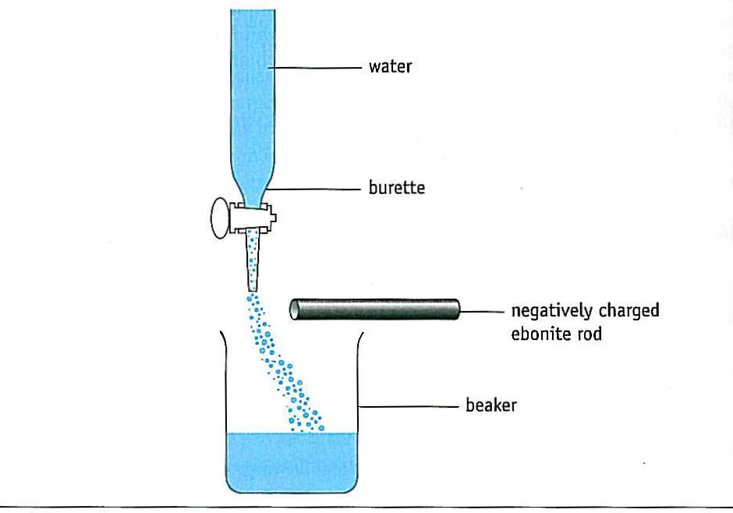
Bond Polarity
answers
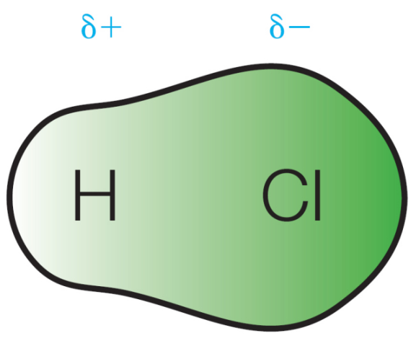

H Cl
Polarity of a bond is sometimes shown like this with the + at one end of the bond. The arrow points to the δ⁻ end.

Topic 2A: Bonding
13. know that electronegativity is the ability of an atom to attract the bonding electrons in a covalent bond

14. know that ionic and covalent bonding are the extremes of a continuum of bonding type and that electronegativity differences lead to bond polarity in bonds and molecules

15. understand that molecules with polar bonds may not be polar molecules and be able to predict whether or not a given molecule is likely to be polar

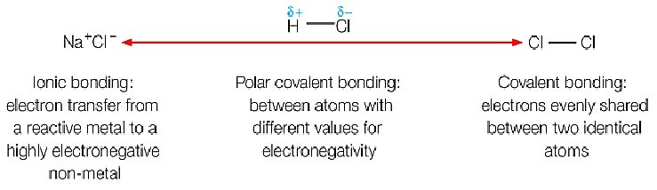


Bond polarity

Facer p159 – 163

Dept Website Factsheets

04 | Shapes of Molecules and Ions
05 | Bonding
71 | Revision Summary: Electronegativity, Ionisation Energies & Electron Affinities
107 | Intramolecular bonds
136 | Why students lose marks: Bonding


http://www.chemguide.co.uk/atoms/bonding/electroneg.html
A good site to support your AS and A level studies – here there is an explanation of electronegativity.

http://chemsite.lsrhs.net/ChemicalBonds/images/custom_dipole2.swf
An animation to explore the effects of differing electronegativity values

http://jchemed.chem.wisc.edu/journal/issues/2000/Nov/abs1520.html
Deflected jets, a more accurate explanation!

Contents

Non-polar covalent bonds
Electronegativity
Polar covalent bonds
Covalent or ionic bonding?
Polar covalent bonds and molecules
Polar and non-polar molecules experiment
NON-POLAR COVALENT BONDS

In molecules such as H₂, O₂, N₂ and Cl₂, where two atoms are identical, the electrons in the covalent bond are attracted equally to the nucleus of each atom. The electron density is evenly distributed and the electron cloud is symmetrical. The bond is described as non-polar.
Draw a diagram of a non-polar H₂ molecule to show the symmetrical electron cloud.

POLAR COVALENT BONDS
In most molecules the bonding is not purely covalent as the shared pair of electrons is attracted more strongly to one nucleus.
For example, consider H-Cl (gaseous molecule), will the bonding pair of electrons be attracted more to the H nucleus or the Cl nucleus? More attraction towards the Cl nucleus
Suggest why. because Cl has 17p⁺, even allowing for inner shielding there will still be an attraction of 7p⁺ whereas H has only 1p⁺.
The result is a polar covalent bond. This is a covalent bond where the bonding pair of electrons are not shared equally by the two atoms in the bond.

One end of the bond has a slight excess of negative charge and is marked δ⁻, the other end has a slight deficit of negative charge where the charge cloud of electrons does not cancel out the positive charge on the nucleus marked δ⁺.
The uneven electron distribution is depicted:-
H Cl
(as shown by the shading).
Polarity of a bond is sometimes shown like this with the + at one end of the bond. The arrow points to the δ⁻ end.

Polar molecules have a positive electric pole and a negative electric pole
H-Cl
Mark the slight negative charge and slight positive charge on


ELECTRONEGATIVITY
Video 317 electronegativity and polar bonds 8.40 – 10.30
Animation of differences in electronegativity on bond polarity
Facer AS Chemistry p159 – 161

Chemists have developed a measure of how unevenly the electrons will be attracted.
The electronegativity of an atom is a measure of its ability to attract the shared pair of electrons in a covalent bond. It is a comparative scale based on Fluorine = 4.0

Examine your coloured periodic table electronegativity values. Show the trends of electronegativity down a group and along a period on the table below

H
Li | Be | B | C | N | O | F
Na | Mg | Al | Si | P | S | Cl
K | Ca |  |  |  |  | Br

How does electronegativity change i) across a period L→R? increases.
Explain your answer Proton number increases but completed inner shells / shielding remains constant. Atomic radius decreases and attraction for shared pair of electrons increases.
ii) down a group? decreases.
Explain your answer There is an extra completed inner shell which results in increased shielding, this and the increase in atomic radius outweigh the increase in proton number

Learn the following ORDER of electronegativities F > O > N > Cl > Br > C similar to H
most commonly found in covalent molecules.

- Worksheet ‘Interpreting electronegativity.values’
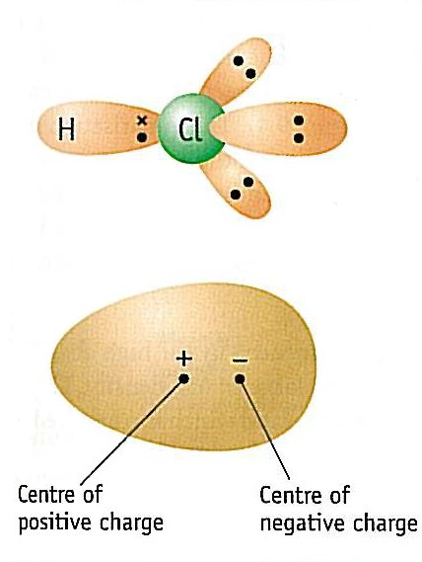
Returning to the HCl molecule:-

Shared pair of electrons
held closer to chlorine nucleus
because chlorine is more electronegative.

The negative charge is due to electrons
and will be at the centre of the electron cloud.
The positive charge is due to protons
and will be between the H and Cl nuclei.

Polar covalent bonds are bonds between different elements. The shared electrons are attracted towards the atom with the stronger pull from the nucleus which is described as more electronegative The bonds have a slightly positive pole δ⁺ at one end and a negative one δ⁻at the other.

This separation of charge is called a dipole (literally two poles)
The theoretical dipole moment can be calculated from the amount of charge separation multiplied by the distance between the centres of charge.

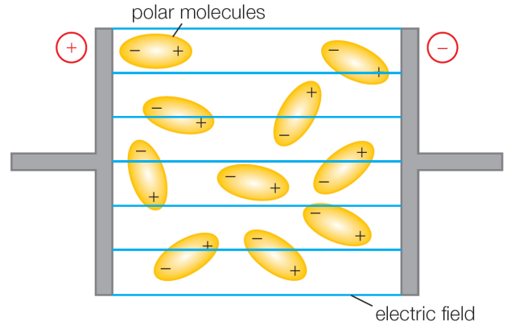
Dipoles tend to line up in an electric field:-

It is therefore possible to measure the dipole moment (in debye units). A comparison with the predicted value confirms the theory of bonding.
COVALENT OR IONIC BONDING?
In the table below:
- Use your coloured Periodic Table to give examples for the different types of bonding.
- Write the electronegativity values above the atoms concerned.
- Show the trend of increasing electronegativity and bond polarity in the last column.

Confirm your choice by checking on:-
http://chemsite.lsrhs.net/ChemicalBonds/images/custom_dipole2.swf

Type of bond | Diagram | Example | Trend of increasing electronegativity difference and bond polarity
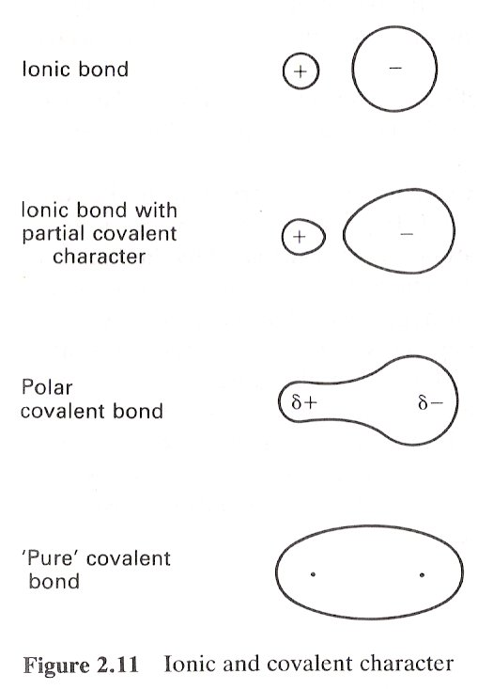  Start with Ions: Small highly charged cations polarise anions → ionic with covalent character  Start with molecule: Atoms in molecule have an electronegativity difference → polar covalent bond |  | Fr⁺ F⁻
 |  | AgI
 |  | HF
 |  | F₂

Show the trend of increasing electronegativity and bond polarity.

Is it possible to have a purely covalent bond? Yes
Explain why. Identical atoms will have identical electronegativities so the electron pair will be shared evenly
Is it possible to have a purely ionic bond? Explain. No, even FrF is only 98% ionic.
The process of electrostatic attraction distorts the electron cloud.
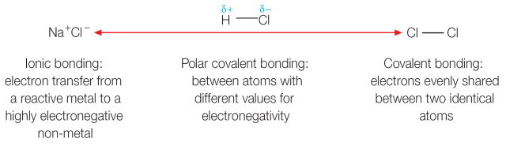

POLAR AND NON POLAR MOLECULES

If a molecule is composed of just two atoms of different electronegativity then the MOLECULE AS A WHOLE IS POLAR.
Describe why the electron cloud is distorted in these molecules
Two atoms with different electronegativities, the more electronegative one attracts the shared pair of electrons more. This results in a distorted electron cloud, and the molecule now has a δ⁺ and δ⁻ side so the bond and molecule are polar.
Draw diagrams of two named examples of diatomic polar molecules to show their distorted electron clouds:

Check out your diagrams at:- http://chemsite.lsrhs.net/ChemicalBonds/images/custom_dipole2.swf

For molecules composed of more than two atoms you need to consider the shape of the molecule in order to decide if the molecule as a whole is polar or non polar.

NON POLAR MOLECULES:-
e.g.BF₃
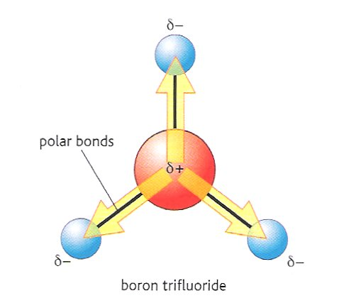
- Write the electronegativity values beside the atoms

- The electron clouds in the bonds will be distorted

            - The B-F bonds are highly polar, (mark in δ+ and δ-)

            - The molecule is trigonal planar.

            - It is symmetrical so the bond polarities cancel out.

            - Therefore there is no overall dipole

Draw out the following molecules showing their 3D shape and marking the polarity of their bonds

Carbon dioxide
Tetrachloromethane
Other examples of non polar molecules are: SF₆ and BeCl₂.
What feature do they have in common? They are symmetrical
In molecules with more than one covalent bond, if the molecule is symmetrical (state the shape as well in an answer) the bond polarities may cancel to leave a molecule with no dipole moment. The molecule will have a symmetrical electron cloud and be non-polar.

POLAR MOLECULES:-
They contain polar bonds but the bond polarities do NOT cancel out so there is an overall dipole.
- The molecule must contain two or more different atoms
- The bonds must be polar

- The shape of the molecule must be asymmetrical so polarities do not cancel
Polar molecules contain polar covalent bonds but are non symmetrical so the bond polarities do NOT cancel out so there is an overall dipole.

Examples of unsymmetrical polar molecules:
i) WATER
If molecules such as water are placed in an electrical field they will all arrange themselves so that they lie with their negative ends towards the positive electrode and their positive ends towards the negative electrode. They have a dipole moment.
- Draw a dot and cross diagram of a water molecule.

- Draw the displayed formula, labelling the polarity of the H^{δ+}-O^{δ-} bonds.

- Draw a diagram of the shape of the water molecule.

ii) TRICHLOROMETHANE
- Draw a dot and cross diagram of a CHCl₃ molecule.

- Draw a displayed diagram of CHCl₃ to show the electron distribution in the C^{δ+}-Cl^{δ-} bonds.
Is the C-H bond polar? .................... Therefore H in this molecule can also be shown as H^{δ+}

- Draw a diagram of the shape of the CHCl₃ molecule.
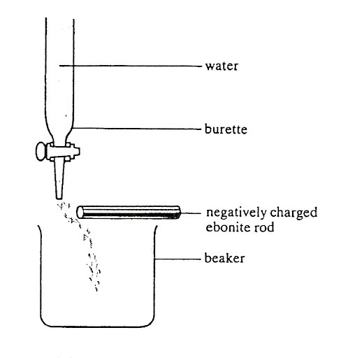
TESTING POLAR AND NON-POLAR MOLECULES
Charged rod
CONSULT: Facer AS Chemistry p162

- Charge up a ruler, plastic rod or ballpoint pen case, by rubbing it on a piece of wool or synthetic material.
- Bring the charged rod close to a stream of water emerging from a burette jet. Do not let the rod become wetted.
What happens? Jet is attracted

- Repeat with the other liquids in the table.

If the jet is deflected what can be implied about the molecule?
Molecule must be polar having an uneven electron distribution

Results

Liquid | Deflection  Yes/No | Polar /  non-polar molecule? | Formula showing 3D shape and polarity of bonds
water | Yes | Polar
propanone | Yes | Polar
ethanol | Yes | Polar
hexane | No | Non-polar
propan–1 ol | Yes | Polar
cyclohexene | No but would have expected it to | Polar
Explanation
If the jet is deflected this implies that the molecule has an electric charge. What does this tell you about the charge distribution within the molecule?
Uneven charge distribution and electron cloud so molecule is polar
Questions
- Decide if the following molecules are polar or non polar:
NH_{3,} CH₂F_{2,} SO_{2,} C₂H₄ C₂H₆ SO₃
Place them in the appropriate column in the table below:

POLAR MOLECULES | NON POLAR MOLECULES

- Label the molecules below as either NON POLAR (having a symmetrical electron cloud),
or POLAR (having a distorted electron cloud)
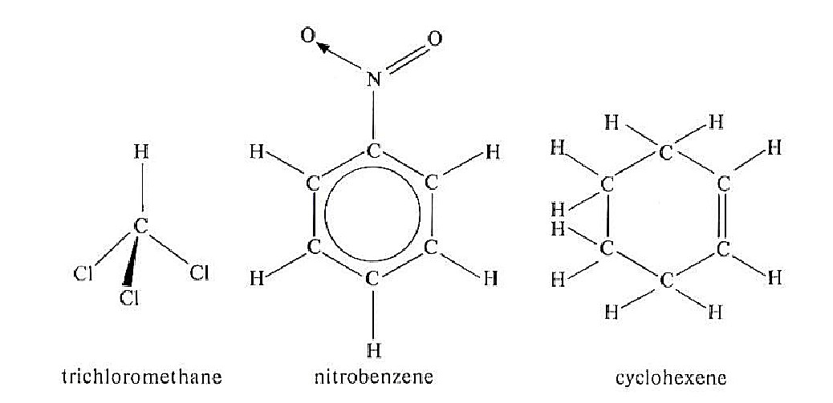

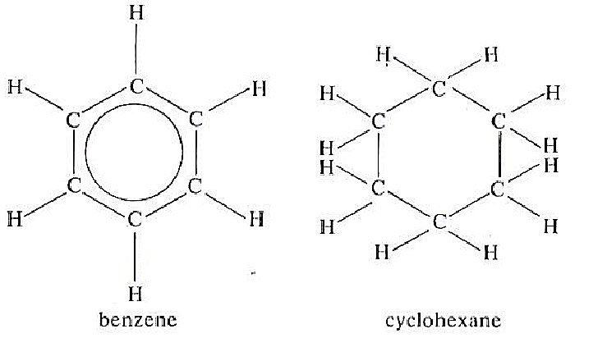

polar polar polar non- polar non- polar

4) Indicate the polarity of the following molecules by drawing δ+ and δ- on the appropriate atoms.

4) Which two will have no overall dipole moment? Explain your answer fully.

…………………………………………………………………………………………………….

……………………………………………………………………………………………………...


More practice:
- Facer pg 177 Question 4
- Worksheet on ‘Test yourself on polar bonds and molecules’

Revision page In the space below.. Include:-
Non-polar covalent bonds
Electronegativity
Polar covalent bonds
Covalent or ionic bonding?
Polar covalent bonds and molecules
Polar and non-polar molecules experiment

ELECTRONEGATIVITY
More p⁺, shielding const.
radius dec.

fewer p⁺,
shielding dec.
radius dec.
F = 4.0

Electronegativity difference
Consider
No electronegativity difference
Large electronegativity difference
ATOMS

ELECTRON
No distortion
e⁻ cloud attracted more to electronegative atom = Distorted
CLOUD

Polar bond - label δ⁺ and δ⁻

Non-polar bond
Ionic

BOND

MOLECULE
SHAPE
Asymmetrical molecule
have lone pairs

Symmetrical molecule

State shape and bond polarities cancel
VSEPR statements

MOLECULE
POLARITY
Non-polar molecule
Polar molecule

No jet deflection
Jet deflection

Non polar
Permanent dipole

Leads to:-
INTERMOLECULAR FORCES
Next pack! London permanent dipole/ hydration
permanent dipole lattice enthalpy

Questions
1. Which of the following species is polar?
A NH₃
B BF₃
C SO₃
D CO₂
(Total 1 mark)
2. Polar liquids are affected by electric fields. For which of the following liquids would a jet of the liquid be affected by an electric field?
A hexane
B cyclohexane
C cyclohexene
D cyclohexanol
(Total 1 mark)
3. Beryllium chloride, BeCl₂, is covalent.
(i) Use ideas of ion polarisation or electronegativity to suggest why beryllium chloride, a compound of a metal and a non-metal, is covalent rather than ionic.
The beryllium ion would be (very) small (1)
Allow Be2+ has a large charge to size ratio/large charge density
Accept answers that refer to polarisation of atoms score zero
and would polarise chloride ions (producing sharing of electrons / covalency) (1)
Accept distort for polarise
Accept anion for chloride ion
OR
Difference in electronegativity small /similar (1)
Therefore share (pair of) electrons / no electron transfer (1)
Reject answers that refer to electronegativity of ions score zero
If both routes given. Mark both out of 2 and then score higher hark.
(2)
(ii) Draw a ‘dot and cross’ diagram to show the bonding in a beryllium chloride molecule, BeCl₂. In your diagram show all the outer shell electrons in the atoms of beryllium and chlorine.

(1)
(Total 3 marks)
Do not write in the margin
Spec Unit 2 Q2

Spec Unit 2 Q3

Jan 08 Unit 1 Q2

4. (a) Boron forms the chloride BCl₃. Draw a dot-and-cross diagram for BCl₃.

(1)
(b) (i) Draw the shape of the BCl₃ molecule.

(1)
(ii) Explain why BCl₃ has this shape.
The (three) bonding (electron) pairs (1)
repel as far apart as possible / position of minimum repulsion(1)
not stand alone not just equal repulsion (2)
(c) (i) The B⎯Cl bond is polar due to the different electronegativity of the atoms. Explain what is meant by the term electronegativity.
Power (of an atom) to attract (the pair of) electrons (1)
in a covalent bond / bonding pair (1)
(2)
(ii) The B⎯Cl bond is polar. Explain why BCl₃ is not a polar molecule.
Bonds arranged symmetrically /molecule symmetrical /bond
polarities directional/ are vectors (1)
Bond polarities cancel (1)
Could be shown as a diagram
(2)
(Total 8 marks)
Do not write in the margin
Jan 02 Unit 1 Q5

5. Indicate whether each of the following molecules has an overall polarity.
Yes
Yes
Yes
No
No
No
½ each – round up

(3)

6. Silicon tetrachloride, SiC1₄, is a colourless liquid; its bonds are polar, but the molecule is not. Explain.
tetrahedral (1)
so polarities (NOT charges) cancel / balance (1)

(2)
7.(i) Define the term electronegativity
......... The ability (of an atom) to attract/to pull/to draw the electrons (1) in/of a covalent bond Allow ‘shared electron pair’ (1)
Allow species/element for atom.
(2)
7. (ii) Some Pauling electronegativity values for selected elements are given below.

H
2.1
Li  1.0 | Be  1.5 | B  2.0 | C  2.5 | N  3.0 | O  3.5 | F  4.0
Na  0.9 | Mg  1.2 | Al  1.5 | Si  1.8 | P  2.1 | S  2.5 | Cl  3.0

Using the values in the table above, compare the polarity of the bonds in a molecule of methane
with that found in a molecule of silane.

Comment on the significance of any difference
Point 1
In methane difference is 0.4 and silane difference is
0.3/Methane has a difference of 0.1 more than silane
(1)
Marking Point 2
Hydrogen is more electronegative than silicon but less
electronegative than carbon
OR
In methane, hydrogen will have a δ+ charge but in
silane hydrogen will have a δ- charge
OR
The C-H bonds in methane are more polar (than the
Si-H bonds in silane) (1)
Marking Point 3
The difference is small and so not significant, or has a
minor effect (1)
Ignore references to bond strength
( iii) Using the table in 7 (ii), choose an element which, when covalently bonded to hydrogen, forms a molecule containing bonds that are more polar than those in silane of methane. Give the formula of the hydride of your chosen element and state the electronegativity difference.
Any suitable example and electronegativity difference
scores 2 marks
NH3/H2O/HF/HCl (1)
0.9/1.4/1.9/0.9 (1)
Second mark consequential on the first, but if the
formula is incorrect, e.g. HF2, but the difference is
correct of 1.9, then allow second mark.
Allow one mark for an ionically-bonded hydride with a
correct electronegativity difference greater than 0.4,
e.g. NaH and 1.2 (1) Allow H2S and the difference of 0.4 for 1 mark.

REJECT BH3 / B2H6 / PH3 scores 0

(iv) Explain why it is possible for the bonds within a molecule to be polar, but for the molecule itself to be non-polar. Give an example of such a molecule.
Bond polarities cancel in a symmetrical molecule/
centres of charge coincide in a symmetrical molecule
OR
Linking bond polarities cancelling due to the
molecular shape which needs to be stated/drawn
(1) Allow polar bonds for bond polarities
Any suitable example, e.g. CCl4/CO2 / BF3 / SF6 (1)
Allow
CH4 / SiH4
Standalone marks (2)

2016
NAME ...........................……... HOMEWORK DEADLINE .....................
Student Number ………… Chemistry Class ………
Student targets from previous pack

Bond polarity

Task | Mark
Notes | /10
Exam questions | /27  = %
Revision Notes /Summary page | /10
Overall Grade for this work | A B C D E U

Student comments

Tutor comments

Tutor signature Date

Student targets for next pack

