Name …………………………… Chemistry Class ………….

Intermolecular forces

1. An instantaneous dipole in one atom gives rise to an induced dipole in a nearby atom, this causing a net attractive force between the two atoms.
2. The instantaneous dipole varies over time, sometimes having a value of zero. As a result, the attractive force between the atoms fluctuates, and is sometimes zero.

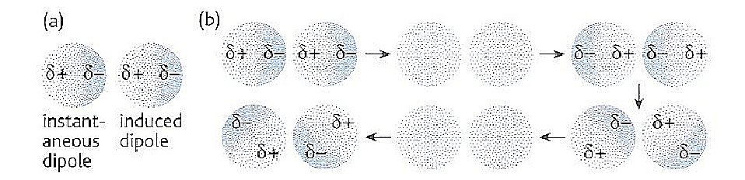

answers

**Intermolecular forces**

**Students will be assessed on their ability to:**

16. understand the nature of intermolecular forces resulting from the following

interactions:

i London forces (instantaneous dipole – induced dipole)

ii permanent dipoles

iii hydrogen bonds

17. understand the interactions in molecules, such as H2O, liquid NH3 and liquid HF,

which give rise to hydrogen bonding

18. understand the following anomalous properties of water resulting from hydrogen

bonding:

i its relatively high melting temperature and boiling temperature

ii the density of ice compared to that of water

19. be able to predict the presence of hydrogen bonding in molecules analogous to

those mentioned above

20. understand, in terms of intermolecular forces, physical properties shown by

materials, including:

i the trends in boiling temperatures of alkanes with increasing chain length

ii the effect of branching in the carbon chain on the boiling temperatures of

alkanes

iii the relatively low volatility (higher boiling temperatures) of alcohols compared

to alkanes with a similar number of electrons

iv the trends in boiling temperatures of the hydrogen halides, HF to HI

21. understand factors that influence the choice of solvents, including:

i water, to dissolve some ionic compounds, in terms of the hydration of the ions

ii water, to dissolve simple alcohols, in terms of hydrogen bonding

iii water, as a poor solvent for compounds (to include polar molecules such as

halogenoalkanes), in terms of inability to form hydrogen bonds

iv non-aqueous solvents, for compounds that have similar intermolecular forces

to those in the solvent

27. be able to predict the physical properties of a substance, including melting and

boiling temperature, electrical conductivity and solubility in water, in terms of:

i the types of particle present (atoms, molecules, ions, electrons)

ii the structure of the substance

iii the type of bonding and the presence of intermolecular forces, where relevant

In addition to the references given in the text, the following are helpful.

**New Reference**Facer AS p163 - 178

Department website

**Factsheets**

|  |  |
| --- | --- |
| 77 | Importance of Hydrogen Bonding |
| 106 | Intermolecular ‘bonds’ |

****

**Websites** for Intermolecular forces

General coverage

<http://www.webchem.net/notes/chemical_bonding/intermolecular_forces.htm>

<http://www.ausetute.com.au/intermof.html>

Hydrogen Bonding

<http://www.chemguide.co.uk/atoms/bonding/hbond.html>

<http://www.northland.cc.mn.us/biology/Biology1111/animations/hydrogenbonds.html>

London Forces (also called Van der Waals forces)

<http://www.chemguide.co.uk/atoms/bonding/vdw.html>

<http://antoine.frostburg.edu/chem/senese/101/liquids/faq/h-bonding-vs-london-forces.shtml>

**Contents**

London forces

Permanent dipole/permanent dipole

Hydrogen bonding

Solutions and solubility

New ReferenceINTERMOLECULAR FORCES

Facer AS Chemistry p163 - 168

The bonding within a molecule is **intramolecular**,

the forces between molecules are **intermolecular**.

It is important to distinguish between them as the bonding is **not** the same inside and between the molecules.

Class video

Videos 328 Bonding – useful for recap

1777 Bonding between molecules 9.32 – 11.48 - Introduction

There are **three types** of intermolecular forces:

* **London forces** or dispersion forces also called Instantaneous dipole – induced dipole forces or Van der Waals forces
* **Permanent dipole – permanent dipole forces**
* **Hydrogen bonds** (which are intermolecular forces NOT bonds!)
* Why would the melting points and boiling points of a substance give a measure of the strength of these intermolecular forces?
* Forces of attraction between molecules need to be overcome for a substance to melt / boil
* Intermolecular forces are overcome by supplying heat energy
* Stronger intermolecular forces require more heat energy, hence M.Pt. higher

|  |  |  |  |  |
| --- | --- | --- | --- | --- |
|  | Melting Point  /K | Molar enthalpy of melting  /kJ mol-1 | Boiling Point  /K | Molar enthalpy of vaporisation  /kJ mol-1 |
| Xe | 161 | 2.30 | 165 | 12.6 |
| CH4 | 90.7 | 0.94 | 111.7 | 8.2 |
| NH3 | 196 | 5.65 | 240 | 23.4 |
| C2H5OH | 156 | 4.60 | 352 | 43.5 |
| H2S | 188 | 2.38 | 212 | 18.7 |

* Which of the above substances has the strongest intermolecular forces?
* Give a reason for your choice
* NH3 requires most energy to melt one mole and consequentially has the highest melting point.
* Which of the above substances has the weakest intermolecular forces?
* Give a reason for your choice
* CH4 has the lowest M.Pt. and B.Pt. and requires the least energy to melt or vaporise.

**LONDON FORCES** – ‘dispersion forces’ ‘instantaneous dipole / induced dipole’ ‘van der Waals’

Refer to Facer AS Chemistry p164 - 165

 Video e-stream 1770 Bonding between molecules 11.43 – 17.00 min.

[Animation and explanation of London or transitory forces](http://antoine.frostburg.edu/chem/senese/101/liquids/faq/h-bonding-vs-london-forces.shtml)

This type of force is **always present** and varies in strength depending on the **number of electrons** and **shape of the molecule**. The electrons in a molecule or atom are always in constant motion. Although on average the electron charge is symmetrically distributed in a neutral molecule, at any given instant it may not be. At such an instant there may be more negative charge in one area of a molecule than another and more positive charge in another area. This creates an **instantaneous dipole.**

fluctuate1Complete the diagram to show a molecule at such an instant to show charge distribution.

Instantaneous dipole

The **instantaneous charge distribution** in one such molecule influences the charge distribution in nearby molecules. An **induced charge distribution** then results. A negative area produces a positive area in the neighbouring section of the next molecule as it repels the electrons, whilst a positive area induces a negative charge as it attracts the electrons. An **electrostatic attractive** force results.

Complete the diagram to show the effect on the neighbouring molecules.

Instantaneous dipole

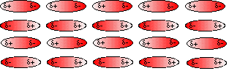

Force of attraction

Induced dipole

* The dipoles are not permanent, they arise and disappear all the time. The molecule remains neutral. The forces however are always attractive ones.
* The **more electrons** an atom/molecule possesses the stronger these forces will be. This is because the dipoles created can be greater.
* The **shape** of the molecule also affects the strength of attraction. Long thin molecules have larger instantaneous dipoles and can approach closer.



Referring back to Alkanes p11

You drew a graph:-

Explain why the boiling point increases with increasing chain length.

Increased chain length means more electrons and longer molecule so there will be a larger instantaneous dipole which induces the opposite charge distribution in a neighbouring molecule, these then attract Draw out the displayed formulae in the table below:-

|  |  |  |  |
| --- | --- | --- | --- |
|  | pentane | 2-methylbutane | 2,2-dimethylpropane |
| Boiling Point | 36oC | 27oC | 9 oC |
| Displayed formula |  |  |  |

Do these molecules have the same number of carbon and hydrogen atoms? Yes, they are isomers. So what can you say about the number of electrons of both? They have the same number of electrons.

Explain why their boiling points are so different.

Although they have the same number of electrons the shapes of the molecules influence the strength of these attractions.

Pentane has a higher boiling point because the London forces are greater.

The molecules are longer (and so set up bigger temporary dipoles) and they can lie closer together than the shorter, fatter 2,2-dimethylpropane molecules.

Look at and complete the following table

|  |  |  |  |  |
| --- | --- | --- | --- | --- |
| Halogen | fluorine | chlorine | bromine | iodine |
| B.Pt. /oC | -188 | -34.7 | +58.8 | +184 |
| State at 25oC | g | g | l | s |

Explain the different boiling points and change in state at room temp down the halogen group. The number of electrons increases and radius of the molecule increases so the instantaneous dipole is larger.

This in turn induces larger dipoles in neighbouring molecules.

This results in stronger London forces which require more heat E to overcome.

So B.Pt increases down the group and halogens become solid.

**PERMANENT DIPOLE - PERMANENT DIPOLE FORCES**

In the previous pack you learned that a polar molecule, which is said to have a permanent dipole moment, has a distorted electron cloud.

**Underline** the molecule(s) which are polar: CC14 CHC13 CH2C12 CH3Cl



* In the space below, draw out the displayed structural formula for CHCl3, giving the distribution of charge on each bond as δ+ and δ- whereappropriate.
* Now draw a second molecule next to the first, oriented to show how a δ+ region in one molecule is attracted to a δ- region in the second.
* Show the resulting attractive force between the molecules as a dotted line ----------



+

+

-

-

These attractive forces formed are described as **permanent dipole - permanent dipole** forces. They act in addition to the London forces already described.

**Questions**

**1**. Account for the difference in boiling temperatures between the following pairs of molecules by considering both London forces and permanent dipole- permanent dipole interactions.

1. ethene which boils at -88oC and fluoromethane which boils at -78oC.

Ethene, CH2CH2 has 16 electrons and is a longer, non-polar molecule with weak London forces between molecules.

Fluoromethane, CH3F has 18 electrons but is a more spherical molecule which is polar so in addition to the London forces it also has permanent dipole / permanent dipole forces of attraction so more heat energy is required to overcome these resulting in a higher BPt.

1. butane which boils at -0.5oC and propanone, CH3COCH3, which boils at 56oC.

Butane with 34 electrons is a longer non-polar molecule with London forces of attraction between molecules.

Propanone has 32 electons and is a shorter molecule so one would expect the London forces to be weaker. However it contains an electronegative -O atom resulting in a polar +C = -O bond which makes to molecule polar. This results in a permanent dipole / permanent dipole attraction so more heat energy is required to overcome these resulting in a higher BPt.

**2.** Why do the boiling points of the hydrogen halides, H-Cl to H-I, increase even though the strength of the permanent dipole-permanent dipole forces decrease?

HCl (18 electrons) has fewer electrons than HI (54 electrons) and is smaller so the instantanous dipole is smaller. Stronger London forces between HI require more heat energy to be overcome and hence a higher BPt.

Note although the electronegativity difference between H and Cl would result in a more polar molecule than H and I the permanent dipole attraction is only minor and London forces are the major factor.

**HYDROGEN BONDING**

New ReferenceFacer AS Chemistry p165 - 167



Draw arrows to show the trends in the increase in C N O F

electronegativity in the following series of elements: Cl

Br

Nitrogen, oxygen and fluorine are the three most electronegative elements in the periodic table. Give the formula of the hydrides formed when they are bonded to hydrogen.

Nitrogen…NH3… Oxygen…H2O….. Fluorine……HF……

These have **abnormally high boiling points** compared to other hydrides in the same group. (See graphs on page 173 Facer)

Draw out the displayed formulae of these molecules showing all bonds, bond polarity and lone pairs.

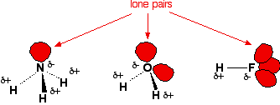

As the molecules are polar, what kind of forces do you already know exist between the molecules?

Permanent dipole-permanent dipole (as well as instantaneous dipole –induced dipole)

However, these molecules are not just ordinary polar molecules, there are two other factors to consider.

* The O, N and F atoms have **lone pairs**
* The O, N and F atoms attract electron(s) from the small hydrogen atom(s) so strongly that they leave **exposed protons.** These protons have a high charge density and strongly attract lone pairs from neighbouring O, N and F atoms.

An intermolecular force is formed which is considerably stronger than the normal permanent dipole-permanent dipole attraction and it is given a special name – a hydrogen bond or H-bond

**A hydrogen bond** is a particularly strong permanent dipole-permanent dipole attraction

between the lone pair of electrons on a very electronegative atom (N, O or F)

and a δ+ hydrogen atom **directly** covalently bonded to another very electronegative N, O or F atom.

H - bond

Mark the lone pairs, bond polarity and label the H-bonds and covalent bonds between:-

|  |  |  |
| --- | --- | --- |
| HF | H2O | NH3 |
| EDXChemAS_004870 | EDXChemAS_004860 |  |

Draw out H-bonded ammonia molecules in the space above.

Look at an [animation of H-bonding in water](http://www.northland.cc.mn.us/biology/biology1111/animations/hydrogenbonds.html)**Properties of substances which are due to hydrogen bonding**

Demonstration**Demonstration.** What happens when 50 cm3 ethanol is added to 50 cm3 water?

* 50 cm3 ethanol is pipetted into a 100 cm3 volumetric flask and the temperature recorded.
* 50 cm3 water is pipetted into the flask the meniscus level is recorded.Volume decreased to 95cm3
* The temperature is recorded. Temperature increased by 7o C

Explain the findings:-More H-bonds are formed between ethanol and water allowing more efficient packing.



[Animation and explanation](http://www.mpcfaculty.net/mark_bishop/ethanol_solution.htm). Draw a diagram to illustrate your answer.



**Density of water and ice**

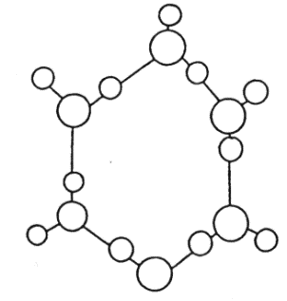Ice is less dense than liquid water and therefore floats. This is unusual as most solids are more dense than the liquid from which they are formed. The low density of ice is due to the fact that there are more [extensive and permanent hydrogen bonds in ice than in water](http://www.edinformatics.com/interactive_molecules/ice.htm) . The hydrogen bonds in ice **hold the molecules apart** in the crystal structure. When it melts, **some** of the hydrogen bonds break and the structure collapses in on itself, increasing the density. As the water continues to heat up, more and more hydrogen bonds break until they are all broken and the water boils.



Draw a diagram of ice to show the hydrogen bonding arrangement in the crystal.



**The hydrogen halides**

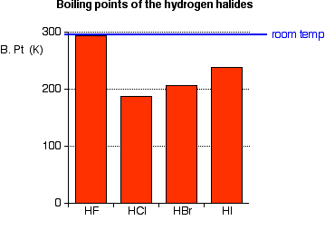The hydrogen halides are colourless gases at room temperature, producing steamy fumes in moist air. Hydrogen fluoride has an abnormally high boiling point for the size of the molecule (293 K or 20°C), and could condense to a liquid on a cool day.

Why is the B.Pt. of HF so much higher than the other hydrogen halides?

F is very electronegative, it has less shielding and smaller radius, and so the H-F bond is polar. H atom will be an exposed proton and form relatively strong H bonds with lone pairs of electrons from an F atom in an adjacent molecule.H-F**:** IIII H-F**:** . Strong H-bonds require more heat energy to be overcome.

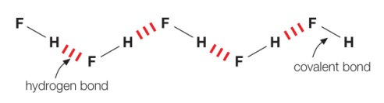Draw a diagram to show the intermolecular forces between H-F molecules (with polarities labelled and the correct geometry)

Bearing in mind that London forces are more significant than permanent dipole forces for the rest of the hydrogen halides, explain the trend in boiling points from HCl to HI

As HCl 🡪 HI, more electrons, so stronger London forces.

More heat energy is needed overcome them so the B.pt. increases

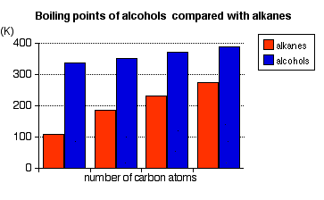**Boiling points of alkanes and alcohols**



Explain:-

Why is there a general increase in B.Pts. of both alkanes and alcohols as the number of carbon atoms increases? An increase in C atoms is accompanied by an increase in the number of electrons and length of the molecule resulting in stronger London forces of attraction which require more heat energy to be overcome

Why is the B. Pt. of an alcohol higher than the corresponding alkane? Due to the electronegative O atom causing the attached H atom to become +. This +H is attracted to the lone pair of electrons on O of an adjacent molecule resulting in relatively strong H-bonding. This requires more heat energy to be overcome then the weak London forces in alkanes.

**Specific Heat Capacity of water**

What is meant by the specific heat capacity of a liquid? The amount of energy to raise the temperature of 1g by 1oC

Water’s specific heat capacity is much greater than that of most other liquids. Explain why:

Relatively strong H-bonding in 3D which requires more heat energy to be overcome..

**Unusually high boiling points of HF, H2O and NH3 compared to other hydrides**

Worksheets ‘Boiling points of hydrides of groups 4, 5 and 6’ - easy

Worksheet‘Boiling points of hydrides of Groups IV to VII’ harder

**Relative strength of forces between particles**

Facer p163 - 164 Use this reference to complete the table

|  |  |  |  |
| --- | --- | --- | --- |
| Force / bond | Between which species | Typical strength  kJ mol-1 | Factors affecting the force. |
| **Bonds** | | | |
| Metallic | Metal cations and delocalised ‘sea’ of electrons | variable | Number of delocalised electrons and radius of cation |
| Ionic | Cations and anions | 250 | Charge on ion  Radius of ion  (any covalent character) |
| Covalent (Intramolecular) | Atoms in a molecule or giant structure | 200 - 500 | Bond enthalpy (affected by atomic radius and whether single, double or triple) |
| Hydration | Ions and water molecules | 100 | Charge on ion and ionic radius |
| **Intermolecular forces** | | | |
| H-Bonds | +H attached to N,O or F and lone pair on N O F | 5 - 40 | Electronegativity difference between +H and N O or F.  Strongest if in a straight line with bond |
| London force | All molecules and atoms | 10 | Number of electrons.  Shape of molecule/ radius of atom  Distance apart |
| Permanent.dipole – permanent. dipole | Polar molecules | 1.5 | Electronegativity difference of atoms in molecule. Geometry of molecule and distance apart. |

Using your understanding of intermolecular forces, underline the compound with the highest boiling point and justify you answer.

1. CH3F (-78oC) and CH3I (42- 43oC)

Both have London, stronger for CHI3 because more electrons and larger.

C-F electronegativity difference 🡪 bond polar molecule not symmetrical 🡪 molecule polar 🡪 pd/pd forces stronger BUT proportionally a lesser effect.

1. CH3Cl (a polar molecule) (-24.2oC)and CCl4 (a non polar molecule) (76.7oC)

Both have London, much stronger for CCl4 because more electrons.

C-Cl electronegativity difference 🡪 bond polar. CCl4 molecule is symmetrical so molecule is non-polar. CH3Cl molecule not symmetrical 🡪 molecule polar 🡪 pd/pd forces; they do not outweigh the stronger London in CCl4

1. CH3CH2F (-37.7 oC) and CH3CH2OH (78 oC)

Both have London, same number of electrons.

C-F electronegativity difference 🡪 bond polar molecule not symmetrical 🡪 molecule polar 🡪 pd/pd forces stronger.

O-H electronegativity difference 🡪 Hd+ and lone pair on O so forms H-bonds 🡪 forces stronger so higher B.Pt.

1. CH3CH2OH (78 oC) and CH3CH2NH2 (16.6 oC)

Both have similar London forces

Both make H-bonds but O-H electronegativity difference 🡪 Hd+ and lone pair on O so forms H-bonds. N-H electronegativity difference not as great so weaker H-bonds.

1. Br2 (58.8 oC) and HBr (-66.8 oC)

Both have London, much stronger for Br2 because more electrons and larger.

HBr is polar so will have pd/pd as well.

**Energy changes when an ionic compound dissolves in water**

When an ionic solid dissolves the ions become hydrated (electrostatic attractions form between the ions and polar water molecules) this is an exothermic process. The energy released is enough to overcome the lattice energy binding the ions together in the solid.

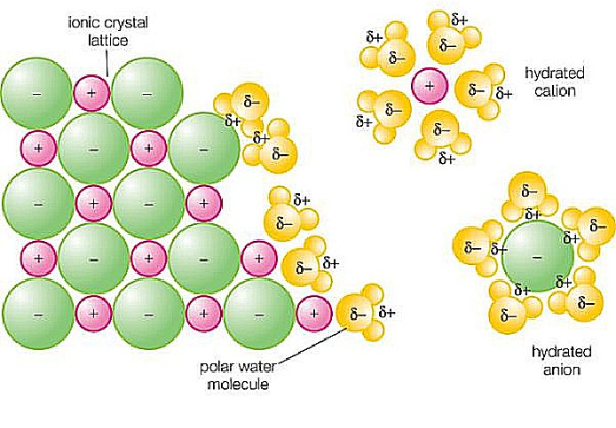[Animation of NaCl dissolving](http://preparatorychemistry.com/Bishop_NaCl_frames.htm)

Sodium ions and chloride ions leaving a crystal lattice and becoming hydrated as they dissolve in water. Here there are electrostatic attractions between the ions and the polar water molecules which compensate for the attractions between oppositely charged ions in the solid.

**Solubility of covalent molecules and energy**

Let us consider the old adage ‘**Like dissolves like**’. This means that polar molecules generally dissolve in polar solvents and non-polar molecules usually dissolve in non-polar solvents.

For a substance to dissolve the forces of attraction between the solute molecules and those between the solvent molecules must be overcome.

Name the 3 types of force between covalent molecules that may have to be overcome:-

1. London forces 2) permanent dipole.

3) H-bonds.

New attractive forces will arise between the solvent and solute. Why will these be exothermic?

Bond formation is exothermic

If the total energy required to separate the solute particles and to separate the solvent molecules is less than the energy released when new forces between the solute and solvent are formed, then the substance will dissolve

**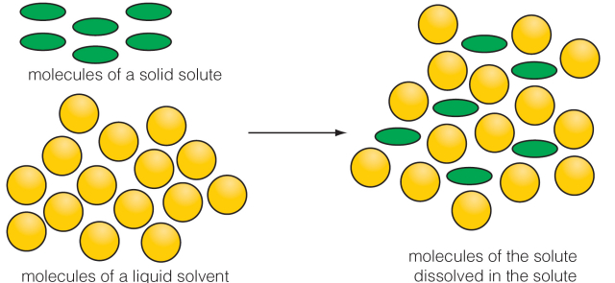**

Solubility can be described as: **Very soluble** or **Soluble** or **Sparingly soluble** or **Insoluble**.

The degree of solubility is largely determined by the **overall energy** of these processes

**Polar substances** contain permanent dipole / permanent dipole or H-bonds as well as

London intermolecular forces. When a **polar solvent** dissolves a **polar solute** the new intermolecular forces between solute and solvent molecules that could be formed would be

hydration enthalpy, permanent dipole/permanent dipole or H-bonds as well as

London forces. Therefore, the solute would probably dissolve because

energy required to overcome forces < energy released when new bonds are made

**Non-polar substances** contain London. intermolecular forces **only**. When a

**non-polar solvent** dissolves a **non polar solute** the new intermolecular forces between solute and solvent molecules that could be formed would be London. Therefore, the solute

would probably dissolve because energy required to overcome London forces = energy released when new London force form.

Why are **polar** solutes less soluble in **non-polar** solvents and vice versa?

Energy required to overcome pd/pd or H-bonds and London forces > energy released when weak London forces are made.**Experiment to test the solubility of simple molecules in different solvents**

**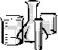Method**

* Put a small crystal of iodine in each of three test tubes.
* To the first, add 5 cm3 water, stopper and shake.
* Repeat by adding ethanol to the second test tube and cyclohexane to the third.
* Try to judge how much solute dissolves in each case.
* Record your observations in the table, recording it as soluble / slightly soluble / insoluble.
* Repeat with sucrose in each of the three solvents.
* Repeat for calcium chloride but to judge solubility decant off the solution and add 1 cm3 of silver nitrate. From the amount of chloride precipitated judge the solubility.

**Results**

|  |  |  |  |
| --- | --- | --- | --- |
| **Solvent**  **Solute** | Water | Ethanol | Cyclohexane |
| Iodine | V slight colour change  **Insoluble** | Deep brown colour + solid  **Sparingly soluble** | Purple solution  **Very soluble** |
| Sucrose | **Very soluble** | **Sparingly soluble** | **Insoluble** |
| Calcium chloride | Thick ppt. of AgCl  **Soluble** | Slight ppt.  **Sparingly soluble** | No ppt.  **Insoluble** |

**1**. Name the **intermolecular** forces or bonds within the separate solutes and solvents in the table:

|  |  |
| --- | --- |
| **Substance** | **Strongest intermolecular forces or bonds (if not simple covalent)** |
| Iodine | London (weak) |
| Sucrose | H-bonds (strong) |
| Calcium chloride | Ionic electrostatic attraction (strong) |
| Water | H-bonds (strong) |
| Ethanol | H-bonds (strong) |
| Cyclohexane | London (weak) |

**2**. Explain the relative solubility of each of the following solutes in each of the three solvents.

Iodine is most soluble in cylclohexane because overcoming London between iodine molecules and cyclohexane molecules is compensated by making new London forces between the iodine and cyclohexane molecules.

In water and ethanol the new London forces do not compensate for overcoming the H-bonds in the solvent.

Sucrose is most soluble in water because overcoming the H bonds between sucrose molecules and water molecules are compensated by formation of new H-bonds between the sucrose and water molecules.

Partially soluble in ethanol because fewer H-bonds are made.

Insoluble in cyclohexane because the London forces made do not compensate….

Calcium chloride is most soluble in water because in water the energy released as the ions are hydrated compensates for the energy needed to overcome the H-bonds in water and the lattice enthalpy between ions in the solid.

In ethanol only weak p.d. can form which partially compensates for the lattice enthalpy and in cyclohexane London forces do not compensate for overcoming the lattice.**ON-LINE REVISION**

MCj04247820000[1]Go to [www.bestchoice.net.nz](http://www.bestchoice.net.nz)

* Enter Institution ‘UK Schools’
* Enter user name: your user name
* Enter password: your password
* Choose ‘EDEXCEL AS’ course
* Choose topic ‘2.5 intermolecular forces’
* Work through all the topics identified below and record your scores.

We can see how well you are getting on!

**SCORES:** 2.5 Intermolecular forces /54

WorksheetWorksheet ‘Test yourself on Intermolecular forces’

**Revision page**

London forces

Permanent dipole/permanent dipole

Hydrogen bonding

Solutions and solubility

|  |  |  |  |  |
| --- | --- | --- | --- | --- |
| **Name of force** | **London, Dispersion,**  **Van der Waals,**  **Instantaneous dipole/induced dipole**  AND | **Permanent dipole-permanent dipole**  OR | **H-bonding**  OR | **Hydration** |
| Between | Non-polar groups | Polar molecules | Molecules with δ+H and N O or F atom with lone pairs | Ions surrounded by water |
| Diagrams | fluctuate1  London  +  +  -  - |  |  | Fe  3+ |
| Depends on | Number of electrons  Shape  Distance apart | Electronegativity difference  Shape of molecule  Distance apart | Alignment – strongest if 180o | Charge on ion  Ionic radius |
| Approx strength | 10 kJ mol-1 | 1.5 kJ mol-1 | 5 - 40 kJ mol-1 | 100 kJ mol-1 |

For solubility consider forces between solvent/solvent and solute/solute.

If energy to overcome these forces < energy released when new solvent/solute attractions are formed



Ice and water

– identify atoms, covalent bonds, H-bonds, shape and polarity

**Multiple Choice Questions**

**1.** Consider the following compounds, **P**, **Q**, **R** and **S**.

CH3CH2CH2CH3

**Compound P** **Compound Q**

CH3CH2CH2CH2Br

**Compound R Compound S**

The boiling temperatures of compounds P, Q, R and S **increase** in the order

**A** P Q R S

**B** R S P Q

**C** Q S P R

**D** Q P S R

(Total 1 mark)

**2.** Which of the following compounds shows hydrogen bonding in the liquid state?

**A** Hydrogen bromide, HBr

**B** Hydrogen sulfide, H2S

**C** Silane, SiH4

**D** Ammonia, NH3

(Total 1 mark)

**3.** Which of the following has dipole-dipole interactions between its molecules, but no hydrogen bonding?

**A** Methane, CH4

**B** Methanol, CH3OH

**C** Ammonia, NH3

**D** Hydrogen iodide, HI

(Total 1 mark)

Do not write in the margin

S10.2.02

S10.2.07

W10.2.04

**4.** Which list below shows the compounds in order of **increasing** boiling temperature?

**A** CH4, HCl, HF

**B** HF, CH4, HCl

**C** HCl, HF, CH4

**D** HF, HCl, CH4

(Total 1 mark)

**5.** Which of the following has the highest boiling temperature?

**A** Pentane, CH3CH2CH2CH2CH3

**B** Hexane, CH3CH2CH2CH2CH2CH3

**C** 2-methylbutane, CH3CH(CH3)CH2CH3

**D** 2-methylpentane, CH3CH(CH3)CH2CH2CH3

(Total 1 mark)

**6.** Which intermolecular forces exist between molecules of ethoxyethane?

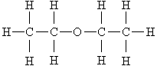

**A** Instantaneous dipole – induced dipole only

**B** Permanent dipole – permanent dipole only

**C** Instantaneous dipole – induced dipole and hydrogen bonds

**D** Instantaneous dipole – induced dipole and permanent dipole – permanent dipole

(Total 1 mark)

**7.** The following liquids all have the same number of electrons in each molecule. Which one is likely to have the lowest boiling point?

**A** CH3CH2CH2CH2OH

**B** CH3CH2CH2CH2CH3

**C** CH3C(CH3)2CH3

**D** CH3CH(CH3)CH2CH3

(Total 1 mark)

Do not write in the margin

W10.2.05

W10.2.06

W09.2.08

W09.2.09

**8.** Which of these is likely to be the best solvent for cyclohexanol?

**A** H2O(l)

**B** CH3COCH3(l)

**C** NaCl(aq)

**D** CH3CH2CH2CH2CH2CH3(l)

(Total 1 mark)

**9.** The ability of a liquid to flow is linked to the strength of its intermolecular forces. Suggest which of these liquids flows the slowest when poured.

**A** Propane-1,2,3-triol

**B** Propane-1,2-diol

**C** Pentane

**D** Butane

(Total 1 mark)

**10.** What are the intermolecular forces in methanal, HCHO?

**A** London forces only

**B** hydrogen bonds and London forces

**C** permanent dipole – permanent dipole only

**D** permanent dipole – permanent dipole and London forces

(Total 1 mark)

**Structured questions**

**1.** The graph below shows the boiling temperatures of the hydrides of Group 7.

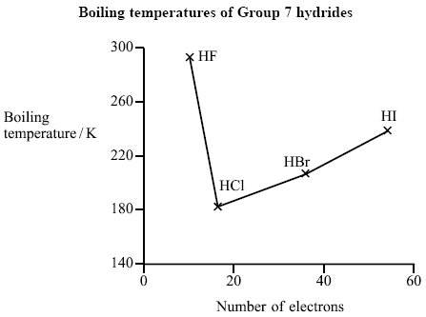Do not write in the margin

W09.2.10

W09.2.11

SP.2.04

S09.2.21

(a) (i) Identify the type of intermolecular force that gives rise to the unusually high boiling temperature of hydrogen fluoride.

Hydrogen bonding.

(1)

(ii) State and explain whether the electronegativity of fluorine is greater than, similar to or less than, that of bromine.

Hence explain why hydrogen fluoride can form the type of intermolecular force named in (a)(i) but hydrogen bromide cannot.

(Fluorine atom) is more electronegative **(1)**

Because it has less shielding / (bonding) electrons closer to the nucleus/ smaller /has less shells (so greater pull from nucleus on bonding electrons) **(1)**

so HF has a (greater) dipole moment/Hδ+ on HF (greater than on HBr)/HF is (more) polar **(1)**.

(3)

(iii) Use the graph to predict what the boiling temperature of hydrogen fluoride would be without the presence of the type of intermolecular force named in (a)(i).

Between 150 – 180 (K)

(1)

(b) Propanone, CH3COCH3, is a useful solvent for cleaning glassware in laboratories.

(i) Why is propanone able to dissolve a wide range of substances?

Because propanone has both polar and non polar characteristics/can  
form both London forces and H bonds/can form London forces and  
dipole-dipole forces OWTTE **(1)**

London forces can be described as Van der Waals VDW Temporary dipole-dipole Instantaneous dipole-induced dipole

(1)

(ii) Propanone can be used to remove both water and octane from glassware. For each of these substances, identify the strongest intermolecular force formed with propanone and the feature of the propanone molecule involved.

**Water** Hydrogen bonds with the (oxygen of the) carbonyl group/H bonds to the oxygen. **(1)**.

**Octane** London forces with methyl groups/carbon chain/CH groups/ H atoms **(1)**.

(2)

(Total 8 marks)

**Q2.**

The boiling temperatures of some hydrides are given below.

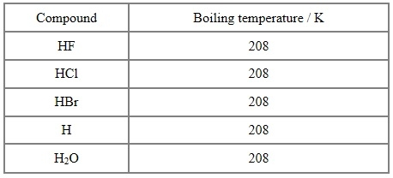

\*(a) Explain, by comparing the forces involved, why HI has a higher boiling temperature than HBr.

**(3)**

London foreces greater in HI compared to HBr because HI has more electrons than HBr therefore more energy is needed to break the London forces between the molecules.

\*(b) Explain, by comparing the types of forces involved, why HF has a higher boiling temperature than HCl.

HF has hydrogen bonding, HCl only has London and dipole-dipole forces. Hydrogen bonding between HF molecules is much stronger than the London and dipole dipole forces between HCl molecules. So more energy is needed to separate the molecules of HF compared to HCl.

**(3)**

(c) Suggest why H2O has a higher boiling temperature than HF.

Water forms up to two hydrogen bonds per molecule HF can only form one hydrogen bond per molecule

**(1)**

**(Total for question = 7 marks)**

**Q3.**The boiling temperatures of fluorine and two of its compounds are given below.

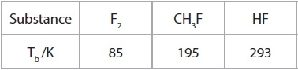

(a)  A molecule of F2 has 18 electrons.

Which intermolecular force depends to a large extent on the number of electrons in the molecule?

**(1)**

London forces  
(b)  Calculate the number of electrons in a molecule of CH3F.

18

**(1)**

(c)  Explain why the boiling temperature of CH3F is greater than that of F2, referring to the intermolecular forces present.

**(1)**

CH3F has permaent dipole – dipole attractions as well as London forces. As both molecules contain the same no of electrons the Londond forces are similar

(d)  Explain why the boiling temperature of HF is the highest in the series.

Hydrogen bondspresent, which are the strongest type of IMF and thus require more energy to break.

**(2)**

(e)  Explain why the values of the boiling temperatures for Cl2, CH3Cl and HCl do not follow the same trend as F2, CH3F and HF.

HCl does not show hydrogen bonding between molecules

**(1)**

**(Total for Question = 6 marks)**

**Q4.**

This question is about ethanethiol, CH3CH2SH. Thiols are like alcohols, but the oxygen atom has been replaced by a sulfur atom. They react in a similar way to alcohols.

(a) (i)   Draw a dot and cross diagram for ethanethiol, showing outer electrons only.

**(2)**

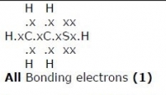

(ii)  Give the value for the CSH bond angle in ethanethiol. Justify your answer.

**(3)**

CSH angle 104.5

Justification

Two bonding pairs and two lone pairs minimise repulsion/maximise separation. The lone pairs repel more than the bonding pairs hence the bond angle

(b) There are hydrogen bonds between ethanol molecules but not between ethanethiol molecules.

      (i)   Explain why the bond angle around the hydrogen atom involved in a hydrogen bond is 180°.

**(2)**

Two pairs of electrons around the H atom, one bonding pair and one from the H bond these pairs repel to maximise separation/minimise repulsion hence linear shape

      (ii)  Explain why there are no hydrogen bonds between ethanethiol molecules.

**(1)**

Hydrogen bonds can only occur between H and either N, O or F due to the large difference in electronegativity. Sulfur is not electronegative enough to form Hydrogen bonds

(c) (i)   Describe the formation of London forces.

**(2)**

A temporary dipole due to the randon arrangement of electrons is produced. This induces a temporary dipole in an adjacent molecule, resulting in an attraction.

      (ii)  Explain why the London forces in ethanethiol are stronger than those in ethanol.

Ethanethiol has more electrons therefore stronger London forces

**(1)**

**2016**

**NAME ...........................……... HOMEWORK DEADLINE .....................**

**Student Number ………… Chemistry Class ………**

Student targets from **previous pack**

Intermolecular forces

|  |  |
| --- | --- |
| **Task** | Mark |
| Notes | /10 |
| Exam questions | /42  = % |
| Revision Notes /Summary page | /10 |
| Overall Grade for this work | A B C D E U |

Student comments

Tutor comments

Tutor signature Date

Student targets for **next pack**