NAME ............................................ Chemistry Class ...........................

Student Number ……….

ATOMIC STRUCTURE answers

[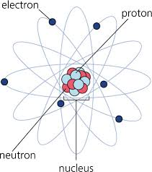](http://www.google.co.uk/imgres?imgurl=http://www.pfscience.com/wp-content/uploads/2010/11/atom.jpg&imgrefurl=http://www.pfscience.com/2010/11/structure-of-an-atom/&usg=__WSSUkUABBxU7A0FQJbMkfKlHpDc=&h=475&w=421&sz=46&hl=en&start=6&zoom=1&tbnid=wU0LQQNOsLR49M:&tbnh=129&tbnw=114&ei=wJcJTriVJtK28QPJp9iZAQ&prev=/search?q%3Datomic%2Bstructure%2Bimages%26hl%3Den%26sa%3DX%26rls%3Dcom.microsoft:en-gb:IE-SearchBox%26rlz%3D1I7GGLJ%26biw%3D1280%26bih%3D827%26tbm%3Disch&itbs=1)

**Topic 1: Atomic Structure and the Periodic Table**

1. know the structure of an atom in terms of electrons, protons and neutrons

2. know the relative mass and relative charge of protons, neutrons and electrons

3. know what is meant by the terms ‘atomic (proton) number’ and ‘mass number’

4. be able to determine the number of each type of sub-atomic particle in an atom, molecule or ion from the atomic (proton) number and mass number

5. understand the term ‘isotopes’

6. be able to define the terms ‘relative isotopic mass’ and ‘relative atomic mass’, based on the 12C scale

7. understand the terms ‘relative molecular mass’ and ‘relative formula mass’, including calculating these values from relative atomic masses *Definitions of these terms will not be expected. The term ‘relative formula mass’ should be used for compounds with giant structures.*

8. be able to analyse and interpret data from mass spectrometry to calculate relative atomic mass from relative abundance of isotopes and vice versa

9. be able to predict the mass spectra, including relative peak heights, for diatomic molecules, including chlorine

10. understand how mass spectrometry can be used to determine the relative molecular mass of a molecule *Limited to the m/z value for the molecular ion, M+, giving the relative molecular mass of the molecule.*

**References** Facer AS Chemistry p15-20

New Reference

**Department Website Factsheets**

|  |  |
| --- | --- |
| 01 | Atomic Structure |
| 55 | Organic Analysis II: Mass Spectrometry |

**Websites**

<http://www.chemguide.co.uk/atoms/properties/gcse.html>

This page revises the simple ideas about atomic structure

<http://www.chemguide.co.uk/analysis/masspecmenu.html>

Mass spectrometry explained

<http://www.a-levelchemistry.co.uk/AQA%20AS%20Chemistry/10.1%20Atomic%20Structure/10.1%20home.htm>

This site is geared towards AQA but contains useful notes, exercises and answers.

<http://www.chem.ox.ac.uk/vrchemistry/AMM/HTML/page01.htm>

An online text book. The first 13 pages may help to clarify your ideas

<http://scaleofuniverse.com/>

Showing how big things are compared to other things!

**Video:**

<https://www.youtube.com/watch?v=FSyAehMdpyI&list=PL8dPuuaLjXtPHzzYuWy6fYEaX9mQQ8oGr>

Crash Course Chemistry: The Nucleus

QuestionsAdditional questions:-

Facer AS Chemistry p39 You should be able to do questions 1 – 8.

**Contents**

Definitions

Isotopes

Relative atomic mass, molecular mass and formula mass

Mass Spectrometer basic principles

calculations Atoms

Molecules

Refer to: Facer p15-17

MCj04247820000[1]New Reference<http://www.chemguide.co.uk/atoms/properties/gcse.html>

**Introduction to Atoms and Elements**.

Everything we see around us, benches, computers and you! are made of atoms. At one time these atoms were part of something else. Some may have been in the soil, the air or even part of someone else. In other words one of the atoms that make up you could have been in your neighbour’s great grandad.

There are 92 naturally occurring types of atoms, we call these Elements.

Define:-

**ELEMENT** is a substance which cannot be broken down by any chemical process. All the atoms within it have the same atomic number (one type of atom).

You will need to be familiar with the symbols for the first 36 elements. For the moment check that you know symbols for the first 30.

The simplest model of the **atom** is shown in the diagram below:

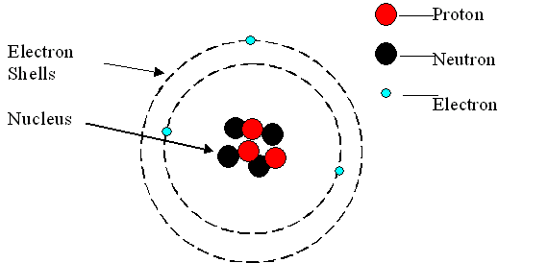

Atoms have a tiny central NUCLEUS containing:- PROTONS (positively charged)

and NEUTRONS (neutral)

The nucleus is surrounded by a cloud of ELECTRONS (negatively charged)

These are arranged in shells having different energy levels

The diagram above is of a Lithium atom. How do we know this?

Told it is an atom so number of electrons = Number of protons

3 protons so it is LithiumIt is the number of protons in the nucleus which determines which element we are looking at. An atom with 6 protons would be the element carbon; the number of protons determines the element. This number is called the ATOMIC NUMBER of the element, the number of protons also determines its position in the Periodic Table

Changing the number of neutrons, or electrons does not change the element.

Find the element:-

|  |  |
| --- | --- |
| No of Protons | Name |
| 77 | Iridium |
| 53 | Iodine |
| 47 | Silver |
| 6 | Carbon |
| 10 | Neon |
| 92 | Uranium |

If the number of electrons surrounding the nucleus is equal to the number of protons inside it, the atom is neutral. If the number of **electrons does not equal the number of protons** it is no longer an atom it is now an ion

Define:-

**ION** is an electrically charged particle formed from an atom or group of atoms which have lost or gained electrons.

Identify the following ions or atoms, giving the correct symbol

|  |  |  |
| --- | --- | --- |
| No protons | No electrons | Symbol |
| 17 | 18 | Cl- |
| 55 | 54 | Cs+ |
| 13 | 10 | Al3+ |
| 23 | 21 | V2+ |
| 7 | 10 | N3- |
| 7 | 4 | N3+ |
| 35 | 36 | Br- |
| 9 | 9 | F |
| 29 | 28 | Cu+ |
| 25 | 23 | Mn2+ |

Almost all the **mass** of an atom is in the nucleus. Almost all the **volume** is in the electron cloud.

The mass of one proton approximately equals the mass of one neutron i.e. 1 u (atomic mass unit), but an electron is much lighter. ( ~ 1/2000 u).

New exerciseComplete the following table:

|  |  |  |  |
| --- | --- | --- | --- |
|  | proton | neutron | electron |
| Approximate mass /u | 1 | 1 | 1/1836 |
| Charge | +1 | 0 | -1 |

Refer to; Facer p17

New Reference

Define:-

**MASS NUMBER** **(A)** of an isotope is

the number of protons + the number of neutrons in the nucleus.

**ATOMIC NUMBER** (proton number) **(Z)** is the number of protons in an atom

This information is expressed:

##### Li

Mass Number

Atomic number

7

3

Elements are arranged on the periodic table according to:

* + - New exerciseIncreasing atomic number
    - The arrangement of electrons in shells.

Complete the following table:

|  |  |  |  |  |  |
| --- | --- | --- | --- | --- | --- |
| Atom | Atomic  number | Mass  number | Number of  protons | Number of neutrons | Number of electrons |
| 12C  6 | 6 | 12 | 6 | 6 | 6 |
| 23Na  11 | 11 | 23 | 11 | 12 | 11 |
| F | 9 | 19 | 9 | 10 | 9 |
| Ar | 18 | 40 | 18 | 22 | 18 |
| K | 19 | 39 | 19 | 20 | 19 |
| Al | 13 | 27 | 13 | 14 | 13 |
| 197Au  79 | 79 | 197 | 79 | 118 | 79 |
| Br | 35 | 79 | 35 | 44 | 35 |
| U | 92 | 238 | 92 | 146 | 92 |

MCj04247820000[1]

For more practice go to:-

[Website practice](http://www.a-levelchemistry.co.uk/AQA%20AS%20Chemistry/10.1%20Atomic%20Structure/10.1%20exercise%201%20-%20atomic%20symbols.doc) follow link

WorksheetSee worksheets [Structure of atoms 1](http://moodle.godalming.ac.uk/learning/file.php/685/Unit%201/Atomic%20structure/Atomic%20structure%20resources/GCSEAtom01.doc)/ [structure of atoms 2](http://moodle.godalming.ac.uk/learning/file.php/685/Unit%201/Atomic%20structure/Atomic%20structure%20resources/GCSEAtom02.doc)[/ structure of atoms and ions 1](http://moodle.godalming.ac.uk/learning/file.php/685/Unit%201/Atomic%20structure/Atomic%20structure%20resources/GCSEAtom03.doc)

# ISOTOPES

New Reference

Reference: Facer p17-18

It is the proton number that determines the element, not the number of electrons OR the number of neutrons. Atoms which have the same number of protons but a different number of neutrons are called ISOTOPES.

Define:-

**ISOTOPES** of an element are atoms which have the same number of protons

but different numbers of neutrons.

They have the same atomic number but different neutron numbers.

In Chemistry we are interested in the electrons and their arrangement, as this is what determines   
the reactions they undergo. This means that all isotopes react in exactly the same way. The key difference between isotopes is their MASS.

Define:

**RELATIVE ISOTOPIC MASS**: is the mass of an atom of a particular isotope of an element relative to 1/12 of the mass of carbon–12 atom, defined as 12 exactly.

Compare this definition with that of mass number on page 3.

These are numerically almost identical for a given isotope, however, never mix them up.

New exerciseAlthough relative isotopic masses are close to whole numbers, by definition, Mass Number must be exactly a whole number (integer).

Complete the following table:

|  |  |  |  |  |
| --- | --- | --- | --- | --- |
|  | Cl  17  35 | Cl  17  37 | Ne  10  20 | Ne  10  22 |
| Number of protons | 17 | 17 | 10 | 10 |
| Number of electrons | 17 | 17 | 10 | 10 |
| Atomic number | 17 | 17 | 10 | 10 |
| Number of neutrons | 18 | 20 | 10 | 12 |

Worksheet

See worksheet [Basic atomic model](http://moodle.godalming.ac.uk/learning/file.php/685/Unit%201/Atomic%20structure/Atomic%20structure%20resources/GCSEAtom05.doc)

#### Class videoVideos:

[Atom](http://estream/View.aspx?ID=3223) (e-stream 3223) 11.30 – 23.02 The structure of the atom

[Discovery of the atom](http://estream/View.aspx?ID=306) (e-stream 306) 26 min

[Bohr’s model of the atom](http://estream/View.aspx?ID=2880) (e-stream 2880) 1.00 – 7.36

**New ReferenceTHE RELATIVE ATOMIC MASS**

Reference: Facer p17-18

Atoms are very small, very, very small - so small in fact that there are more atoms in this full stop “.” than there are people on the planet.

Weighing them is therefore difficult. To get round this problem scientist use a concept called relative atomic mass. This is the mass of the atom relative (i.e. compared to) something else. Originally they were compared to Hydrogen; however, it was difficult to produce pure samples of hydrogen without any isotopes

New exerciseTo avoid this problem the standard in use since 1961 consists of a single isotope:

What is it? . Carbon 12 12C

Define:-

**RELATIVE ATOMIC MASS (Ar)** of an element is the weighted average mass of atoms of an element

in their natural relative isotopic abundance

compared to the carbon 12 isotope taking the mass of 12C = 12.0000.

Questions

Try: Facer Page 39 Questions 1, 2 and 3

Worksheet Worksheet ‘structure of atoms 2’

### RELATIVE MOLECULAR MASS

This is the mass for substances which exist as **molecules,** a molecule is something which exists as a fixed number of atoms with covalent bonds. To find the RMM it is all of the atomic masses of a molecule added together

E.g.: RMM of CH3Cl = 1C +3H +1Cl = 12 + 3x1 + 1x35.5 = 50.5

|  |  |  |
| --- | --- | --- |
| **Formula** | **Working** | **RMM** |
| C6H12 | **6 x 12 + 12 x 1** | **84** |
| CH2F2 | **12 + 2 x 1 + 2 x 19** | **52** |
| H2SO4 | **2 x 1 + 32.1 +4 x 16** | **98.1** |

### RELATIVE FORMULA MASS

### This is very similar to the RMM, however it is for substances which form giant structures, eg ionic solids, where the cations and anions arrangement continues indefinitely.

### For example for NaCl, there is not one sodium ion and one chloride ion in a lattice – there are far far more!

### However to find the RFM we simply add up the masses in the formula given:

e.g. K2SO4 = 2K + S + 4O = 2x39.1 + 32.1 + 4x16 = 174.3

|  |  |  |
| --- | --- | --- |
| Formula | Working | RMM |
| Ca(OH)2 | 40.1 + 2 x 16 + 2 x 1 | 74.1 |
| MgCl2 | 24.3 + 2 x 35.5 | 95.3 |
| NaNO3 | 23 + 14 + 3 x 16 | 85 |

### MASS SPECTROMETER

MCj04247820000[1]Class video

<http://www.chemguide.co.uk/analysis/masspecmenu.html>

Video: [Mass spectrometer](http://estream/View.aspx?ID=303) (e-stream 303) 19.34 – 23.50 Modern Chemical Techniques

<http://www.chemsoc.org/networks/LearnNet/spectra/index2.htm>

Video [Atom 2](http://estream/View.aspx?ID=3224) (e-stream 3224) 07.35 -18.53. 1st mass spec, discovery of the proton and neutron

The existence of isotopes was suspected for quite a long time due to the fact that some relative atomic masses e.g. chlorine, were so far off being whole numbers.

The first absolute proof that isotopes existed was given by an instrument called a MASS SPECTROMETER.

There are now several different types of mass spectrometer that are used to investigate different aspects of atoms and molecules.

New ReferenceFor our syllabus we only need to know the basic points of the original design of mass spectrometer, and not in elaborate detail.

Refer to: Facer p18-19

Give an equation to show ionisation of an element E to form a 1+ positive ion by bombardment of a fast moving electron in the mass spectrometer:

E(g) + e- 🡪 E+(g) + e- + e-

New exerciseDraw a clear simplified diagram of a mass spectrometer to illustrate a written summary of the 5 / 6 stages in the identification of the relative atomic masses of atoms (or molecules).

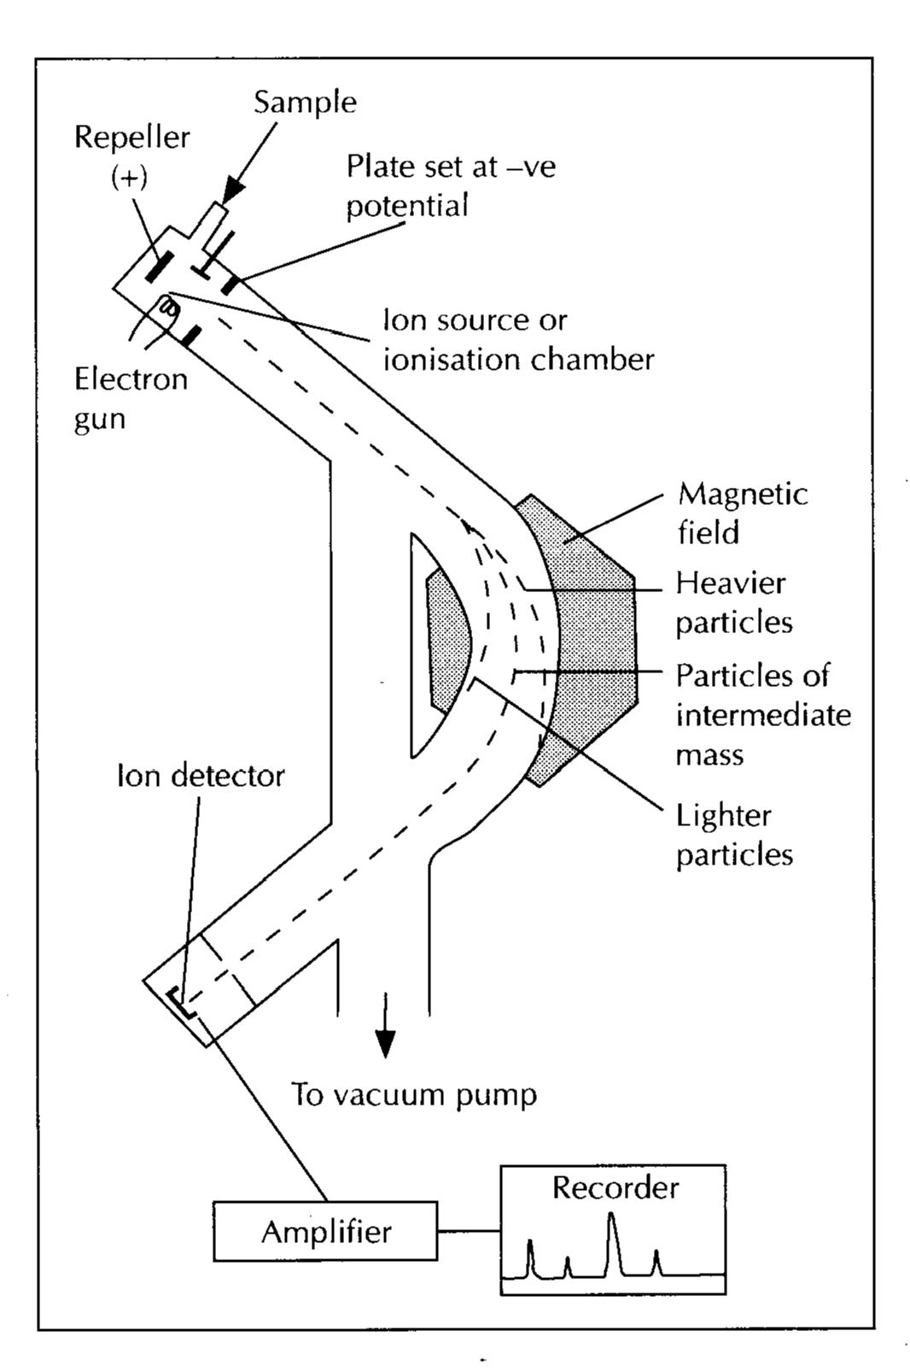

DETECTION

Ions detected, signal amplified, recorded.

DEFLECTION

Ions enter a uniform magnetic field.

Deflection depends on mass and charge

Lighter ions deflected more

ACCELERATION

Positive ions accelerated by electric field.

INJECTION

Sample (dissolved in methanol) injected into machine

VAPOURISATION

sample vapourised by high temperature

IONISATION

Electron beam produces high energy electron **e-**

**e-** + X(g) 🡪 X+(g) + e- + e-

positive ions attracted to –ve plate passing through hole to:-

### Mass Spectra of Elements

MCj04247820000[1]<http://www.chemguide.co.uk/analysis/masspec/elements.html#top>

* Mass spectra of elements usually show more than one ion present (more than one peak)
* Elements for which this occurs contain **isotopes**.
* The **heights of the peaks** show the **abundances** of these isotopes.
* From this information the **relative atomic mass** of the element can be calculated.

**New exerciseThe mass spectrum of boron** is given below.

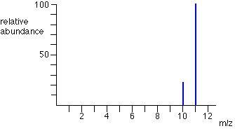

Scaled so most abundant peak is 100%

mass/charge

For our purposes only ions of +1 charge are considered

* How many isotopes does boron have? two
* What are their mass numbers? .10 and 11
* What is the ratio of abundance of these? 23 ; 100
* The relative atomic mass of boron = 23 x 10 100 x 11

123 + 123

= **10.8 (3 sig figs)**

$$Relative atomic mass:$$

$$=\frac{\left(abundance of peak1×mass of peak1\right)+ \left(abundance of peak2×mass of peak2\right)+…}{total abundance}$$

Calculate the average relative atomic mass of each of the following elements (to an appropriate number of significant figures)

1. Zirconium (51.5% Zr-90, 11.2% Zr-91, 17.1% Zr-92, 17.4% Zr-94, 2.8% Zr-96)

51.5 x 90) + (11.2 x 91) + (17.1 x 92) + (17.4 x 94) + (2.8 x 96)

100

= 46.35 + 10.92 + 15.73 + 16.35 + 2.69

= 91.3118 = 91.3 (3sf)

1. Silver (51.3% Ag-107, 48.7% Ag-109)

51.3 x 107) + (48.7 x 109)

100

= 107.974 = 108 (3sf)

1. Chromium (4.3% Cr-50, 83.8 % Cr-52, 9.6% Cr-53, 2.3% Cr-54.)

(4.3 x 50) + (83.8 x 52) + (9.6 x 53) + (2.3 x 54)

100 100 100 100

= 2.15 + 43.576 + 5.088 + 1.242

= 52.056 = 52.1 (3sf)

1. Magnesium has three isotopes. The mass spectrum of magnesium shows peaks at *m/e* 24 (78.60%), 25 (10.11%), and 26 (11.29%). Calculate the relative atomic mass of magnesium to 4 significant figures.

(78.6 x 24) + (10.11 x 25) + (11.29 x 26)

100 100 100

= 18.864 + 2.5275 + 2.9354

= 24.3268

= 24.33 (4sf)

QuestionsFor more practice:-

* MCj04247820000[1]Facer Page 39 Questions 4 and 5.
* Follow link to [An exercise on ram, rmm and mass spectra](http://moodle.godalming.ac.uk/learning/file.php/685/Unit%201/Atomic%20structure/•%09http:/www.a-levelchemistry.co.uk/AQA%20AS%20Chemistry/10.1%20Atomic%20Structure/10.1%20Exercise%202%20-%20ram,%20rmm%20and%20mass%20spectra.doc)
* WorksheetWorksheet ‘[Isotopes and Relative Atomic Mass](http://moodle.godalming.ac.uk/learning/file.php/685/Unit%201/Atomic%20structure/Resources/Isotopes%20and%20RAM.doc)’

**Mass Spectra of Molecules**

Chlorine has two isotopes 35Cl and 37Cl in the ratio of 3:1. You might, therefore expect the mass spectrum would look like:

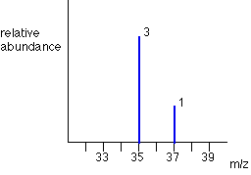

However, Chlorine **atoms** form diatomic (two-atom) **molecules**, Cl2 , (or Cl ─ Cl where ─ represents a covalent bond). These molecules will have an electron knocked off in the ionisation chamber of the mass spectrometer to form a **molecular ion.**

Give an equation to show how chlorine molecules ionise in a mass spectrometer:

Cl-Cl(g) + e- 🡪 Cl-Cl+(g) + e- + e-

Given that the ratio of chlorine atoms, = 75% 35Cl : 25 % 37Cl

= 3 : 1

New exerciseIt is possible to work out the % abundances of each of the chlorine molecules by filling in the relative molecular masses of the chlorine molecules in the table below.

(The relative molecular mass of a compound is the sum of the relative atomic masses)

|  |  |  |  |  |
| --- | --- | --- | --- | --- |
| RATIO 3:1 | 35Cl | 35Cl | 35Cl | 37Cl |
| 35Cl | 35 + 35 = 70 | 70 | 70 | 72 |
| 35Cl | 70 | 70 | 70 | 72 |
| 35Cl | 70 | 70 | 70 | 72 |
| 37Cl | 72 | 72 | 72 | 74 |

The emerging species will be :- 35Cl ─ 35Cl+ : 35Cl ─ 37Cl+ : 37Cl ─ 37Cl+

And the ratio is therefore: ..…9 .. : ……6 …… : ..… 1 ……

**The Mass Spectrum of Chlorine Molecules, Cl2**

New exerciseFrom the ratio you have calculated construct a mass spectrum for the molecular ions of the possible chlorine molecules on the axes given below:-

* The heights of the peaks must represent the abundances.
* Calculate the % abundance of each to give the height of each peak as shown below:

|  |  |  |  |
| --- | --- | --- | --- |
|  | 35Cl ─ 35Cl+ | 35Cl ─ 37Cl+ | 37Cl ─ 37Cl+ |
| Ratio | 9 | 6 | 1 |
| % abundance | 9/16 x 100 = 56.25 | 6/16 x 100 = 37.5 | 1/16 x 100 = 6.25 |

Add an appropriate scale to each axis and draw in the mass spectrum peaks label the peaks

50

40

30

20

10

60

0

10

20

30

40

50

80

60

70

35Cl ─ 35Cl+

35Cl ─ 37Cl+

37Cl ─ 37Cl+

37Cl+

35Cl+

% abundance

Mass/charge (m/e)

**Note:** The Cl2 molecules can break up into atoms in the mass spectrometer so there are also peaks due to these at m/e values 35 and 37. You will learn more about this fragmentation of molecules in the mass spectrometer later in the course.

**New exercise**

**Predicting the mass spectra of bromine, Br2:**

|  |  |
| --- | --- |
| **Isotope** | **Abundance** |
| 79Br | 50.7% |
| 81Br | 49.3% |

|  |  |  |
| --- | --- | --- |
| RATIO **1 : 1** | 79Br | 81Br |
| 79Br | **158** | **160** |
| 81Br | **160** | **162** |

% abundance

**79 81**

**158 160 162**

Mass/charge (m/z)

**Finding the relative molecular mass of a molecule**

The relative molecular mass of a molecule is easily found as it is the peak with the highest mass. The peak represents the molecular ion – the whole molecule with an electron missing (M+).

Circle the peak which represents the molecular ion in the following spectra and write the formula of the molecular ion in the table:

|  |  |  |
| --- | --- | --- |
| **Mass spectra example** | **Mass of molecular ion peak** | **Molecular ion** |
| http://panomics.pnnl.gov/images/waterspectrum.jpg | **18** | **H2O+** |
| [http://www.chemguide.co.uk/analysis/masspec/p3onemspec.GIF](http://www.google.co.uk/url?sa=i&rct=j&q=&esrc=s&source=images&cd=&cad=rja&uact=8&ved=0CAcQjRw&url=http://www.chemguide.co.uk/analysis/masspec/fragment.html&ei=ZgZaVfqGNe7e7AbZ7ICICw&bvm=bv.93564037,d.ZGU&psig=AFQjCNFbqR2nbmhN_SvthS8wUiAJpmZDFQ&ust=1432049568810135) | **86** | **C5H10O+** |
| [http://www.chemguide.co.uk/analysis/masspec/pentanemspec.GIF](http://www.google.co.uk/url?sa=i&rct=j&q=&esrc=s&source=images&cd=&cad=rja&uact=8&ved=0CAcQjRw&url=http://www.chemguide.co.uk/analysis/masspec/fragment.html&ei=IgZaVe_jMoGE7gaBzIDgDw&bvm=bv.93564037,d.ZGU&psig=AFQjCNFbqR2nbmhN_SvthS8wUiAJpmZDFQ&ust=1432049568810135) | **72** | **C5H12+** |

**Revision Notes**

Include:

* Definition of:
  + Atomic/proton number
  + Mass number
  + Isotope
  + Relative isotopic mass
  + Relative atomic mass
* Mass Spectrometer - Basics of how it works
* How to predict mass spectra
* How to calculate relative atomic mass from a mass spectra
* How to find the relative molecular mass of a molecule from a mass spectra

Outline only – make your own!

Mass Number =

Atomic Number =

Isotope is

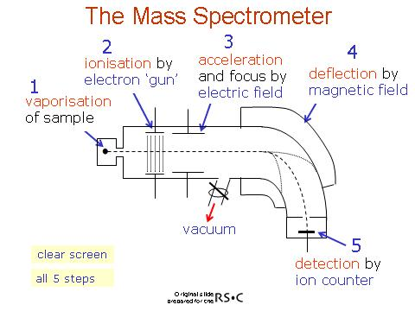

To remove air particles which would interfere with the spectrum

Relative isotopic mass is

Relative Atomic mass is

E(g) + e- 🡪 E+(g) + 2e-



Calculation of RAM



How to draw spectrum of Cl2



**Multiple Choice Questions**

**1.** Which of the following contains the greatest number of hydrogen atoms?

**A** 2 moles of water, H2O

**B** 1.5 moles of ammonia, NH3

**C** 1 mole of hydrogen gas, H2

**D** 0.5 moles of methane, CH4

(Total 1 mark)

**2.** The mass spectrum for a sample of a metal is shown below.

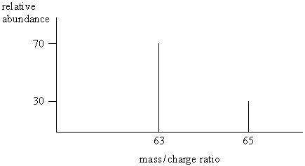

The relative atomic mass of the metal is

**A** 63.2

**B** 63.4

**C** 63.6

**D** 64.0

(Total 1 mark)

**3.** The nucleus of a  atom contains

**A** 11 protons and 12 neutrons.

**B** 11 protons and 12 electrons.

**C** 23 protons and 11 neutrons.

**D** 23 protons and 11 electrons

(Total 1 mark)

**Structured Questions**

S09.1.01

S09.1.02

W09.1.09

This question is about the structure of atoms.

**1.** (a) Choose words from the list to complete the sentences below.

**electrons ions neutrons protons**

In an atom, the particles with a negative charge are called electrons

Particles in the nucleus with no charge are called neutrons

An atom has no overall charge because is has the same number of electrons and

protons

(3)

(b) Two isotopes of the element carbon are:

12 14

C and C

6 6

Complete the table of information for these two isotopes.

|  |  |  |  |  |
| --- | --- | --- | --- | --- |
|  | ATOMIC NUMBER | MASS NUMBER | NUMBER OF PROTONS | NUMBER OF NEUTRONS |
| 12  Isotope       C  6 | 6 | 12 | 6 | 6 |
| 14  Isotope       C  6 | 6 | 14 | 6 | 8 |

(2)

(Total 5 marks)

**2**. Atoms of calcium, phosphorus and fluorine are represented below, each with its mass number and proton number.

QM991F.07

1. Use this information to complete the table.

|  |  |  |  |
| --- | --- | --- | --- |
|  | CALCIUM | PHOSPHOROUS | FLUORINE |
| Number of protons in the nucleus | 20 | 15 | 9 |
| Number of neutrons in the nucleus | 20 | 16 | 10 |
| Number of electrons | 20 | 15 | 9 |

(3)

**3.** You will find it helpful to use the periodic table when answering this question.

In the nucleus of an aluminium atom are:

          13 protons

and    14 neutrons.

(a)Complete these sentences.

(i)The mass number of the aluminium atom is .27 . In an atom of aluminium there are 13 electrons. **(2)**

(b)Why is an aluminium atom electrically neutral?

each proton has a/1 positive charge and each electron has a/1 negative  
charge ORelectrons and protons have (equal but) opposite charges

there are equal numbers of protons and electrons in the atom/  
so charges cancel or balance (each other)

(2)

(c)Complete the table for the element fluorine.

|  |  |  |  |
| --- | --- | --- | --- |
| PARTICLE | NUMBER OF PROTONS | NUMBER OF NEUTRONS | NUMBER OF ELECTRONS |
| Fluorine atom | 9 | 10 | 9 |
| Fluoride ion | 9 | 10 | 10 |

(3)

(Total 7 marks)

4. (a) When a sample of copper is analysed using a mass spectrometer, its atoms are ionised and then accelerated.

QM9713.15

QM9603.17

(i) Explain how the atoms of the sample are ionised.

S01C.1.03

Fast/high energy/fired/bombard/electrons (electron gun) strike sample atoms (1)

knocking out/ remove electron from sample atom (1)

(2)

(ii) State how the resulting ions are then accelerated.

Electric field/charged plates/negative plates

......................................................................................................................

(1)

(b) For a particular sample of copper two peaks were obtained in the mass spectrum.

|  |  |
| --- | --- |
| Peak at *m/e* | Relative abundance |
| 63 | 69.1 |
| 65 | 30.9 |

(i) Give the formula of the species responsible for the peak at *m/e* = *65*.

65Cu+.

(1)

(ii) State why **two** peaks, at *m/e* values of 63 and 65,were obtained in the mass spectrum.

(2)(different) isotopes

(1)

(iii) Calculate the relative atomic mass of this sample of copper, using the table of results above.

(63 × 69.1) + (65 × 30.9) divided by (69.1 + 30.9) **(1)**

= 63.6/63.62/63.618 (1)

(2)

(Total 7 marks)

**5.** A sample of titanium (atomic number 22) is made up of five isotopes. The sample has the following percentage composition:

S01C.1.03

W03N.1.06

|  |  |
| --- | --- |
| Mass number  46  47  48  49  50 | % composition  8.0  7.3  74.0  5.5  5.2 |

(a) (i) What is the average relative atomic mass of titanium?   
Give your answer to **three** significant figures.

(46 × 8 + 47 × 7.3 + 48 × 74 + 49 × 5.5 + 50 × 5.2) ÷ 100

= 47.926 (1)

= 47.9 (1)

(2)

(ii) What instrument would have been used to find this percentage composition?

mass spectrometer.

(1)

**6.** (a) State the number of protons, neutrons and electrons in a  ion.

protons: 3 neutrons: 4 electrons: 2

W03C.1. 3B

(3)

(b) The mass spectrum of lithium shows two peaks. Their mass/charge ratios and percentage abundance are shown below.

|  |  |
| --- | --- |
| Mass/charge | % Abundance |
| 6.02 | 7.39 |
| 7.02 | 92.61 |

Calculate the relative atomic mass of lithium, giving your answer to three significant figures.

=  **(1)**

= 6.95 (must be three s.f.) **(1)**

(2)

W03N.1.06

W03C.1.3B

2015

NAME ...........................……... HOMEWORK DEADLINE .....................

Student Number ………… Chemistry Class ………

Student targets

ATOMIC STRUCTURE

|  |  |
| --- | --- |
| **Task** | Mark |
| Notes | /10 |
| Revision Notes | /10 |
| Exam questions | /33 |
| Overall Grade for this work | A B C D E U |

Student comments

Tutor comments

Tutor signature Date

Student targets for **next pack**

Student targets for **next pack**