NAME ............................................ Chemistry Class ...........................
Student Number ……….
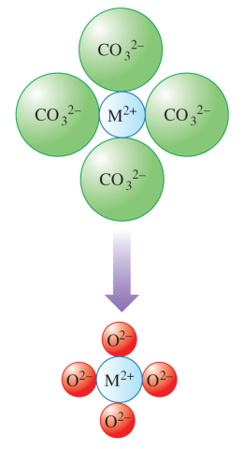

Groups I and II
Decomposition of a metal carbonate to form an oxide
Answers
Topic 4A: The elements of Groups 1 and 2

- understand reasons for the trend in ionisation energy down Group 2

- understand reasons for the trend in reactivity of the Group 2 elements down the group

- know the reactions of the elements Mg to Ba in Group 2 with oxygen, chlorine and water

- know the reactions of the oxides of Group 2 elements with water and dilute acid, and their hydroxides with dilute acids

- know the trends in solubility of the hydroxides and sulfates of Group 2 elements

- understand reasons for the trends in thermal stability of the nitrates and the carbonates of the elements in Groups 1 and 2 in terms of the size and charge of the cations involved

- understand the formation of characteristic flame colours by Group 1 and 2 compounds in terms of electron transitions
Students will be expected to know the flame colours for Groups 1 and 2 compounds

- understand experimental procedures to show:
- patterns in thermal decomposition of Group 1 and 2 nitrates and carbonates
- flame colours in compounds of Group 1 and 2 elements
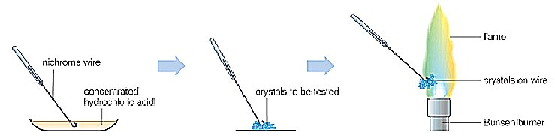
Flame tests can identify a group I or II cation
NAME ............................................
Group I and II Metals
Groups I and II exhibit some typical metallic properties however there is a trend in their properties

Refer to:- Facer AS Chemistry p197 – 214

Factsheets – on Dept website
13 |   Groups 1 and 2
69 | Revision Summary: Trends in the Periodic Table 1

Websites

http://www.chemistryrules.me.uk/found/periodictable.htm#groupII ??

http://www.docbrown.info/page07/sblock.htm
A section looking at the periodic patterns and further on some data graph pages which show graphs of the various properties.

http://www.chemguide.co.uk/inorganic/group1menu.html#top
This page describes and explains the trends in atomic and physical properties of the Group I elements and their chemical reactions.
http://www.chemguide.co.uk/inorganic/group1menu.html#top
Group II structure properties and reactions.

http://www.chemistryrules.me.uk/found/periodictable.htm#title
Another website covering Group II properties and reactions

http://www.rod.beavon.clara.net/incat2.htm
A list of the reactions you need to know from our chief examiner.

http://www.drbateman.net/asa2sums/sum1.6/sum1.6.htm
A good coverage of the topic with associated questions

http://www.a-levelchemistry.co.uk/AQA%20AS%20Chemistry/10.4%20Periodicity/10.4%20Exercise%202%20-%20trend%20in%20group%20II.doc
Questions on group II
http://www.mp-docker.demon.co.uk/as_a2/topics/group_2/index.html
Quizzes on group II

http://www.rsc.org/education/chemistryteachers/Index_Results.asp?Page=1&ID=11539&Search=&Age=4
Video of reactions

Group I and II Metals


UNIT 1 REVISION - PAGES 1-3
Group I and group II elements are metals.
Together groups I and II make up the s-block. Why are they referred to as the s block?
Highest energy, (outermost) electron is in s orbital
What kind of bonding is present in the elements of groups I and II?
Metallic bonding

Draw and label a diagram to illustrate the bonding.
Positively charged metal cations

Delocalised electrons

Reactivity of s-block elements
As a reminder look at the physical properties of Group I
And the reactions of Groups I metals

Group I and II behave in similar ways when they react with water, oxygen or halogens. When they react they lose electron(s) to form positive. ions.
Describe the trend in reactivity of group I and II on descending the group and relate it to ΔH_{I.E.}:
They become more reactive
The ionisation energies become less endothermic
There are two reasons for this trend in ionisation energy and therefore reactivity:
- More complete inner shells of electrons shield the outer electrons from the nuclear charge
- Larger atomic radius means outer electrons are more easily removed
Which elements are more reactive, group I or group II? Group I is more reactive than Group II
Explain why:
Group I atoms have one fewer protons than the corresponding group II atoms so the electrons are not attracted so strongly to the nucleus, resulting in a larger atomic radius.
The larger radius means the outer electron is more easily removed (lower first ionisation energy). The atom reacts more easily losing its outer electron forming an ion of +1.
Ionisation Energies of Group II
The relatively low ionisation energies of group 2 metals can be used to explain their reactivity and why the reactivity increases down the group. Can you remember the definitions?
First Ionisation energy ΔH_{i(1)}
The first ionisation energy is defined as the energy required to remove one mole of electrons from one mole of gaseous neutral atoms to form one mole of gaseous ions with a charge of +1.

What is the definition of second ionisation energy?
The energy required to remove one mole of electrons from one mole of gaseous ions of a +1 charge to form one mole of gaseous ions of +2 charge.

In the space below sketch 2 separate graphs (on the same axes) showing the trends of:
a) first ionisation energies and b) second ionisation energies for the elements in Group II. Distinguish clearly between the two graphs by labelling them clearly.

Element | Be | Mg | Ca | Sr | Ba
ΔH_{i(1)}./kJmol⁻¹ | 900 | 736 | 590 | 548 | 502
ΔH_{i(2)}./kJmol⁻¹ | 1760 | 1450 | 1150 | 1060 | 966

Energy / kJ mol⁻¹

1st Ionisation energy
2nd Ionisation energy

Atomic Number

Write an equation (with state symbols) for the first ionisation energy of magnesium

Mg_{(g)} → Mg⁺_{(g)} + e⁻ ΔH = +736 kJ/mol

Write an equation (with state symbols) for the second ionisation energy of magnesium

Mg⁺_{(g)} → Mg²⁺_{(g)} + e⁻ ΔH = +1450 kJ/mol

Write an equation (with state symbols) for the third ionisation energy of magnesium

Mg²⁺_{(g)} → Mg³⁺_{(g)} + e⁻ ΔH = +7740 kJ/mol
Use your understanding of electron structure to explain why there is a particularly large increase between the 2nd and 3rd ionisation energies of magnesium:
Second ionisation energy is the removal of the remaining 3s electron.
The third ionisation energy is the removal of a 2p electron from a principal quantum shell of lower energy

Use your understanding of ionisation energies to explain why beryllium chloride is a covalent compound but barium chloride is ionic.

The ionisation energies for beryllium are high so it is difficult to form Be²⁺ ions (which are small and very polarising) so beryllium tends to form covalent rather than ionic bonds and BeCl₂ is covalent. The ionisation energies for barium are lower so Ba²⁺ is easier to form and BaCl₂ is ionic (ΔH₁₊₂ Be = 2660 kJ mol⁻¹, ΔH₁₊₂ Ba = 1469 kJ mol⁻¹
- the greater energy required to form Be²⁺ is not compensated for by lattice formation)

State and explain the trend in 1st ionisation energies from magnesium to barium.

First ionisation energies become less endothermic as the group is descended. Each element on descending has one additional complete inner shell of electrons so there is more shielding and the electron is further from the nucleus at a higher energy level so requiring less additional energy to remove it.

Which is more reactive Mg or Ba? Explain your answer.

Ba is more reactive as the combined first and second ionisation energies are 1469 kJ mol⁻¹ whereas for Mg they are 2186 kJ mol⁻¹. The latter is not compensated so readily by formation of a lattice (which releases energy).

From your understanding of metallic bonding state, with an explanation, which group II element from magnesium to barium has the highest melting point.

One would expect magnesium to have the highest melting point. Both ions have a +2 charge, however the Mg²⁺ cation has a smaller radius than Ba²⁺. Expect a larger force of electrostatic attraction between Mg²⁺ cations and the delocalised sea of electrons.

What happens to the ionic radii of the 2⁺ ions on descending group II? Explain the trend.

The ionic radii increase. Each ion on descending has one additional complete inner shell of electrons and there is more shielding so the outer electrons are attracted to the nucleus less strongly
The reactions of the group II elements
In this section we will investigate the reactions of the group 2 elements with chlorine, water and oxygen.
Refer back to GroupI reactions on page 1
http://www.webelements.com/ provides information about the elements and their reactions.

Reactions with oxygen
Your tutor will demonstrate the reaction between magnesium and oxygen. A strip of magnesium is held in a non-luminous (blue/colourless) flame.

Safety precautions: wear goggles, do not look directly at the flame, view through cobalt glass
Reason: to avoid damage to the retina
Observation (from not really looking!) burns with an intense white flame
Equation: Mg_{(s)} + ½O_{2(g)} → MgO_{(s)}
What happens when the product is placed in water? Some of the solid dissolves. Process is slow
What colour does universal indicator turn? Turns blue-green after some time
What does this show? MgO is not very soluble but an alkaline solution (pH 9) is formed
Equation for the reaction of the combustion product with water:
MgO(s) + H₂O(l) → Mg(OH)₂(s)
The other group 2 elements follow the same pattern, write the equations for the reactions of:-
Barium with oxygen
Ba_{(s)} + ½O_{2(g)} → BaO_{(s)}
Calcium with oxygen
Ca_{(s)} + ½O_{2(g)} → CaO_{(s)}
Remember do not learn individual equations, remember the trend.
Reactions with Chlorine
Group II metals will react with chlorine to produce the chlorides.
Write the equation for the following reactions including state symbols:-
Magnesium and chlorine
Mg(s) + Cl₂(g) → MgCl₂(s)
Calcium and chlorine
Ca(s) + Cl₂(g) → CaCl₂(s)
Strontium and chlorine
Sr(s) + Cl₂(g) → SrCl₂(s)
Reactions with water of groups I and II Demonstration
Your teacher will demonstrate the reactions of Group I metals with water. The reactions can be quite violent but in every case the reaction is:-
Metal + water → hydroxide + hydrogen
Write an equation for the reaction of sodium with water:-
Na(s) + H₂O(l) → NaOH(aq) + ½ H₂(g)
All group I compounds are soluble → pH 13
The reaction of magnesium with steam.- demonstration
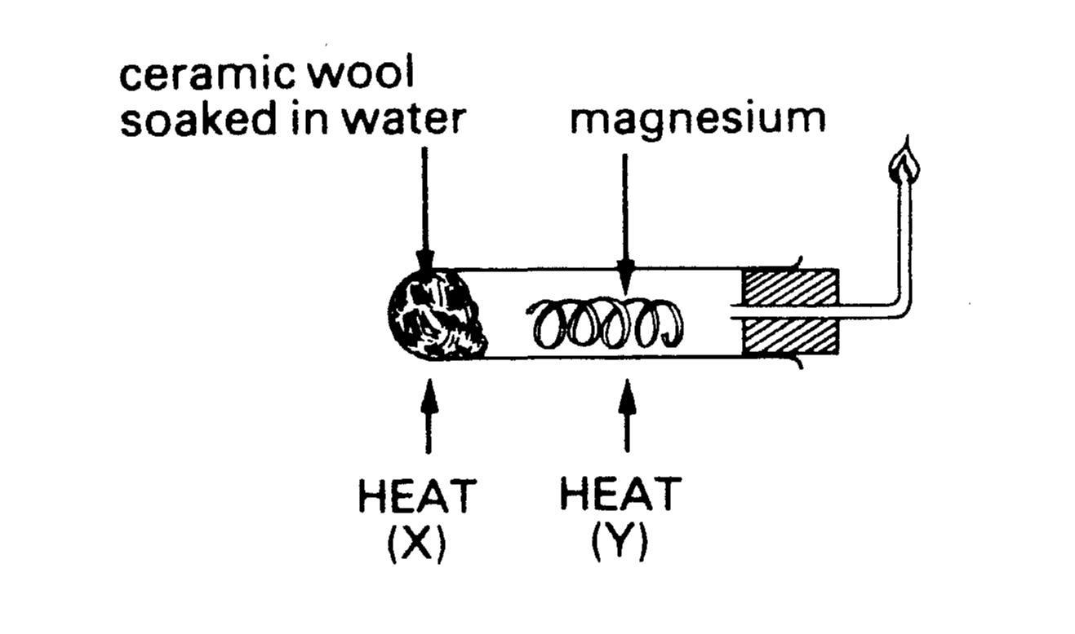
Magnesium towards the top of Group II will react very slowly with cold water to form a suspension of magnesium hydroxide and hydrogen. With hot water (i.e. steam) magnesium will react to form the oxide and hydrogen.

Heat cautiously with a hot flame until the magnesium nearly glows at Y, then heat the damp ceramic wool at X. When the reaction occurs move the flame to ignite the gas issuing from the jet.

Write the equation for the reaction of magnesium with steam
Mg(s) + H₂O(l) → MgO(s) + H₂(g) note that H₂O at 298K is a liquid
Would you expect calcium to react with cold water?
Prediction Yes, reactivity increases down the group
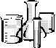
Explanation Larger atomic radius, more shielding results in lower H_{i} and so electron lost more easily → reaction.
Calcium and water | Observations
Add a small piece of calcium to water in a test- tube.  Test the pH of the solution formed. | - Effervescence.  - Test tube became hot.  - Gas burned with squeaky ‘pop’  - A cloudy white suspension is left  - Universal indicator → blue (pH 9).
Calcium, strontium and barium all react with cold water to produce the hydroxide and hydrogen.
Calcium and water equation
Ca(s) + 2H₂O(l) → Ca(OH)₂(s) + H₂(g) Ca(OH)₂ is sparingly soluble
Calcium oxide with water
CaO(s) + H₂O(l) → Ca(OH)₂(s)
What is a solution of calcium hydroxide also known as? Lime water
When carbon dioxide is bubbled through this solution what is observed? Solution → white ppt.
Give an equation (with state symbols) to explain this observation:
Ca(OH)₂(aq) + CO₂(g) → CaCO₃(s) + H₂O(l
Reactions of group II oxides and hydroxides
In this section we will investigate the reactions of the oxides with water and acid and the reactions of the hydroxides with acid.
Hydroxides with acids
These reactions should be familiar to you both from your work on Energetics and Titrations. Again, remember to learn trends not individual equations.
Acid + Base (hydroxide) Salt + Water
Write balanced equations for the following with state symbols.
Magnesium hydroxide and nitric acid
Mg(OH)₂(s) + 2HNO₃(aq) → Mg(NO₃)₂(aq) + 2H₂O(l)
Strontium hydroxide and sulfuric acid
Sr(OH)₂(s) + H₂SO₄(aq) → SrSO₄(s) + 2H₂O(l)
Barium hydroxide and hydrochloric acid
Ba(OH)₂(s) + 2HCl(aq) → BaCl₂(aq) + 2H₂O(l)
Reactions of the Oxides. The oxides are also basic, so they may react with water to form the hydroxide, and with acids to form the salt and water.
Equation for the reaction of magnesium oxide and water
MgO(s) + H₂O(l) → Mg(OH)₂(s) almost insoluble
Equation for the reaction of strontium oxide and water
SrO(s) + H₂O(l) → Sr(OH)₂(aq)
Equation for the reaction of barium oxide and water
BaO(s) + H₂O(l) → Ba(OH)₂(aq)
With acids
Equation for the reaction of magnesium oxide and nitric acid
MgO(s) + 2HNO₃(aq) → Mg(NO₃)₂(aq) + H₂O(l)
Equation for the reaction of strontium oxide and sulphuric acid
SrO(s) + H₂SO₄(aq) → SrSO₄(s) + H₂O(l)
Equation for the reaction of barium oxide and hydrochloric acid
BaO(s) + 2HCl(aq) → BaCl₂(aq) + H₂O(l)

Questions:
Facer page 213 questions 1-5
Solubility of Group II compounds
In this experiment you will be looking to see whether insoluble precipitates form when you add drops of solutions of sulphates, carbonates or hydroxide ions to solutions of group II metal ions.
Instructions
Cover the page with a clear plastic sheet.
Put two drops of the metal ion solution in each box of the appropriate row.
Add two drops of each of the anion solutions to each box of the appropriate column.
Observe whether a precipitate forms or not.
If a precipitate forms put ✓ for a light precipitate, ✓✓ for more and ✓✓✓ for a heavy precipitate.

Group II | Solution of sulphate ions SO₄²⁻ | Solution of hydroxide ions  OH⁻
Solution of magnesium ions  Mg²⁺ | O | ✓✓✓
Solution of calcium ions  Ca²⁺ | O | ✓✓
Solution of strontium ions  Sr²⁺ | ✓✓ | ✓
Solution of barium ions  Ba²⁺ | ✓✓✓  Less soluble | ✓  More soluble

State the pattern of solubility of the sulphates
Group II get less soluble on descending the group
State the pattern of solubility of the hydroxides
Group II get more soluble on descending the group

It is possible to remember the pattern of solubility:-
If the anion and cation sizes are similar, the lattice enthalpy is relatively high and the salt will not be soluble.

Sulphate ions are large so which of the Group II cations would be a better size match having a higher lattice enthalpy?
Barium ions so barium sulphate is insoluble
Draw diagrams to illustrate this

SO₄²⁻
Ba²⁺

Mg²⁺
OH⁻
OH⁻

Which cation would be a better size match for the small hydroxide ion and thus be relatively insoluble? Magnesium ions so magnesium hydroxide is insoluble
Ionic equation for formation of Mg(OH)₂(s): Mg²⁺(aq) + 2OH⁻(aq) → Mg(OH)₂(s)
Thermal stability of Group I and II nitrates (NO₃⁻) and carbonates (CO₃²⁻)

The stability of these salts depends on two factors:
- The charge on the cation
- The size of the cation
The higher the charge density on the cation, the more it will tend to polarise the large carbonate ion. This will tend to make the salt less stable to heat. So the bigger the cation gets the less polarising it will be and the less it will destabilise the anion.
So, the thermal stability of both Group I and II increases down the group.

The table below shows the relative sizes of the ions in groups I and II.
Label them with the element symbols, starting with lithium and beryllium respectively.

Group I ion | Symbol | Trend in stability of carbonate | Group II ion | Symbol | Trend in stability of carbonate
0.060 nm | Lithium  Li⁺ |  | 0.031 nm | Beryllium Be²⁺
0.095 nm | Sodium  Na⁺ |  | 0.065 nm | Magnesium Mg²⁺
0.133 nm | Potassium K⁺ |  | 0.099 nm | Calcium  Ca²⁺
0.148 nm | Rubidium  Rb⁺ |  | 0.113 nm | Strontium  Sr²⁺
0.169 nm | Caesium  Cs⁺ | More Stable | 0.135 nm | Barium  Ba²⁺ | More Stable

What do you notice about the size of the group II ions when compared with the size of the group I ion in the same period? Explain your observation.
They are smaller because the increased pull of the nucleus on the electrons pulls them further in and reduces the size (same number of electrons to more protons).
The carbonate ion, CO₃²⁻, is a large anion compared to the oxide, O²⁻, or hydroxide, OH⁻ anions. It can be polarised by a cation with a high charge density. For example, consider magnesium carbonate:-
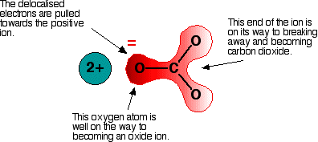

The polarising magnesium cation ‘pulls’ the oxygen away from the carbonate anion to leave MgO and CO₂.

Which ions are most polarising, group I or group II cations? Group II.
Why? Group II ions have a smaller ionic radius and a charge of +2 rather than +1.
Which group would you therefore expect to form the more stable carbonates? Group I.
Explain They have a larger ionic radius and a charge of +1 giving them a lower charge density so are less polarising.
How would you expect the stability to change on descending a group?
Would expect it to increase as the cation and anion become closer in size and the cation can polarise the anion less. The charge density on the cation decreases.
Put an arrow in the table to show the direction of increasing stability.

If a group I or II carbonate can be decomposed by heating it will react to form carbon dioxide and leave behind the oxide. How could we show that the carbonate has decomposed?
CO₂ is produced which turns limewater cloudy. The speed with which this is produced reflects the ease of decomposition
Write an equation to show the thermal decomposition of lithium carbonate

Li₂CO₃(s) → Li₂O(s) + CO₂(g)

Write an equation to show the thermal decomposition of magnesium carbonate

MgCO₃(s) → MgO(s) + CO₂(g)

Which carbonate would you expect to decompose the easier of these two? Explain your answer.

Magnesium carbonate, although Mg²⁺ has slightly larger ionic radius it has a higher charge than Li⁺ and so has higher charge density. The Mg²⁺ ion is therefore more polarising resulting in decomposition of the carbonate.
Experiment: The Effect of Heat on Some Carbonates of Group 1 and 2
Safety precautions: Do not heat the test tube holder or clamp.
Remove tube from the limewater before discontinuing heating.
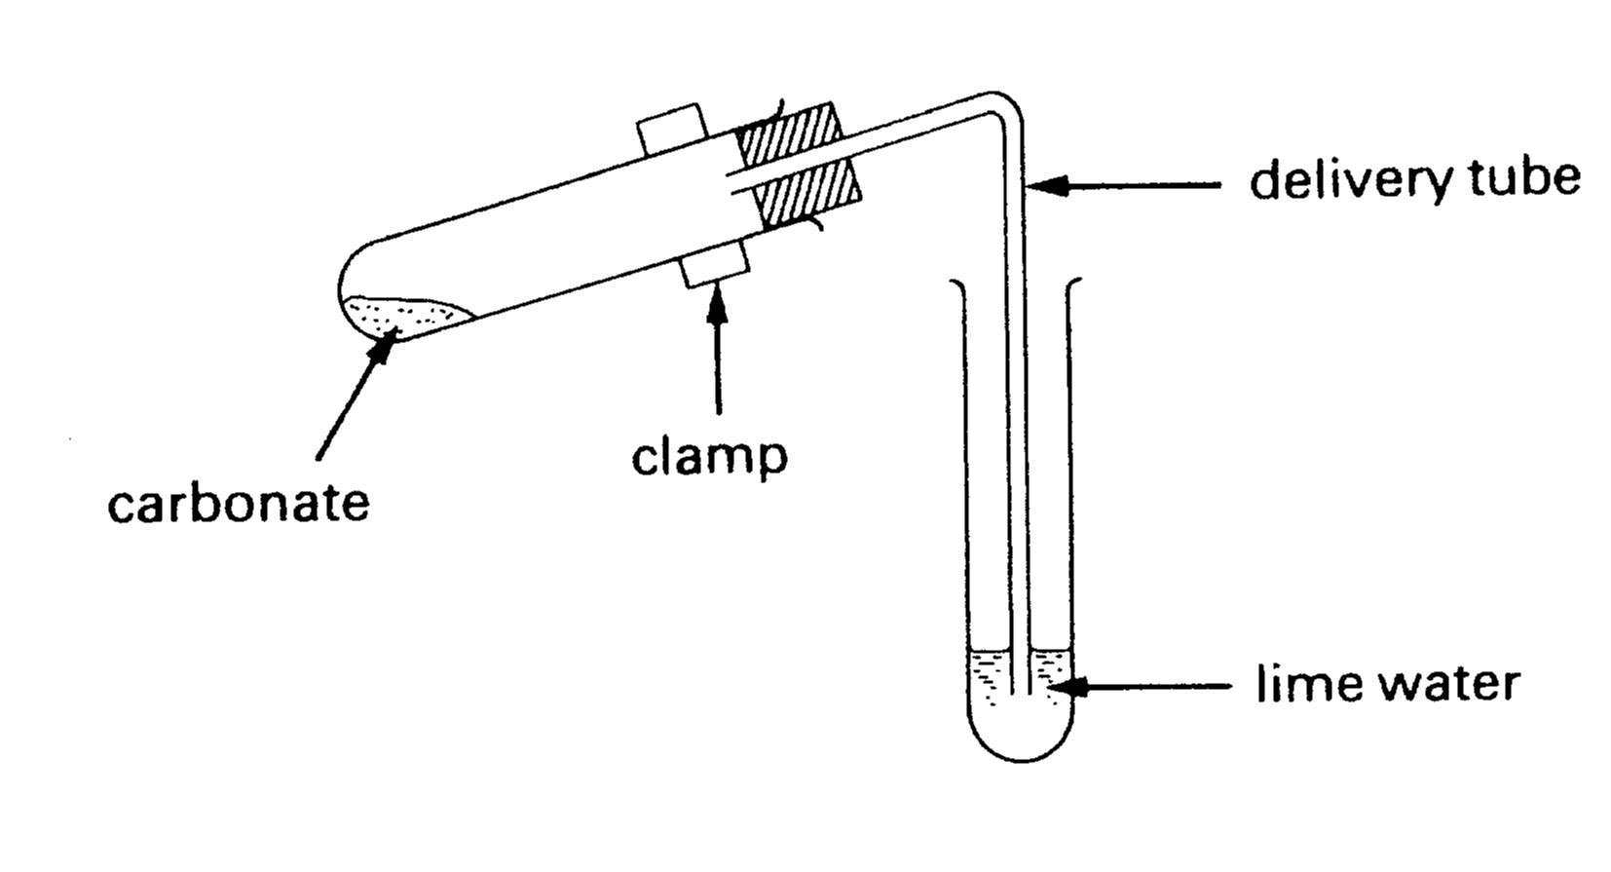
Clamp or test tube holder

- Take a spatula full of the carbonate and put it into a dry heating test tube.
- Heat with a blue flame, gently at first, and then more strongly.
- Do not melt the test tube and do not heat strongly for more than two minutes.
- Test any gas given off with limewater.
- Time how long it takes for the limewater to go cloudy (if it does)
- Note the appearance of the solid before and after heating, the time taken to decompose (if it does), whether CO₂ is evolved and the degree of cloudiness of the lime water.
- Repeat with each carbonate, using a fresh sample of lime water of equal volume each time.

Group 1  carbonate | Observations | Time for CO₂ to be produced? | Relative ease of decomposition
Lithium carbonate | Solid is white. The gas given off turns limewater milky. | About 1 min | Fairly easy  (723ºC)
Sodium carbonate | Solid is white. Solid melted. | About 2 min  (see note) | Not possible in a Bunsen flame  (851ºC)
Potassium carbonate | Solid is white. Melted | Not cloudy  (see note) | Not possible in a Bunsen flame.  (891ºC)

Group II carbonate | Observations | Time for CO₂ to be produced? | Relative ease of decomposition
Magnesium carbonate | Solid is white. The gas given off turns limewater milky. | Immediately | Fairly easy  (350ºC)
Calcium carbonate | Solid is white. | 5 min none | Difficult  (900ºC)
Barium carbonate  or  Strontium carbonate | Solid is white. No change observed on heating. | 5 min slightly cloudy | Not possible in a Bunsen flame.  (Ba 850ºC)

What do you notice about the stability of the carbonates as you descend a group?
The stability increases
What do you notice about the stability of group I carbonates compared to group II?
They are more stable
Write a general equation for the decomposition of a group I carbonate
M₂CO_{3(s)} → M₂O_{(s)} + CO_{2(g)} (may have absorbed H₂O from the atmosphere so forming the hydrogencarbonate which will decompose)
Write a general equation for the decomposition of a group II carbonate
MCO_{3(s)} → MO_{(s)} + CO_{2(g)}

CO₂
Decomposition of a group II carbonate to a group II oxide.

A smaller cation is more polarising and distorts the electron cloud of the carbonate anion.

CO₂ is given off leaving the oxide.

The smaller the metal ion, the less stable the carbonate.

Thermal decomposition of group I and II nitrates
The nitrate (V) ion (NO₃⁻) can be ‘pulled apart’ in the same way as a carbonate ion. This time it is complicated by the fact that you can get:-
- partial decomposition → nitrate(III) ion (NO₂⁻ ion) + oxygen gas O₂
- or complete decomposition → oxide ion (O²⁻) + O₂ + nitrogen dioxide gas NO₂.

Group II nitrates decompose fully to the oxide + nitrogen dioxide + oxygen
Group I nitrates decompose partially to the nitrate(III)salt (old name nitrite) + oxygen
Lithium nitrate (group I) is an exception and decomposes to the oxide + NO₂ + O₂ like group II.

Sodium nitrate partially decomposes, write the equation (with state symbols):-
2NaNO_{3(s)} → 2NaNO_{2(s)} + O_{2(g)}
Barium nitrate decomposes totally, write the equation (with state symbols):-
Ba(NO₃)₂(s) → BaO(s) + 2NO₂(g) + ½O₂(g)
Which ions are most polarising, group I or group II cations? Group II
Which group would you therefore expect to form the more stable nitrates? Group I
How would you expect the stability to change on descending a group?
Become more stable on descending the group
Exception: Lithium nitrate decomposes totally, write the equation (with state symbols):-
2LiNO₃(s) → Li₂O(s) + 2NO₂(g) + ½O₂(g)
Why do you think lithium nitrate is different to the other group I nitrates?
The ion has a very small ionic radius therefore a high charge density and so will polarise the anion leading to its decomposition when heated.
Experiment: The Effect of Heat on some Nitrates of the s-block Elements

Safety: use small quantities of nitrates, take test tube to fume cupboard if a lot of brown gas is produced
- Put a ½ small spatula of each nitrate in a heating test tube.
- Heat with a blue flame, gently at first, and then more strongly.
- Do not melt the test tube and do not heat strongly for more than two minutes.
- Note the appearance of the solid before and after heating, the time taken to decompose (if it does) and test whether NO₂ and/or O₂ is evolved. Write your results in the table (next page)

N.B. When a nitrate is heated, two gases may be evolved, oxygen and nitrogen dioxide.
- Nitrogen dioxide is brown and can be identified by its colour. It is toxic in high concentrations. If any brown gas is evolved the test tube should be put in a rack in the fume cupboard.
- Oxygen can be tested for by putting a glowing splint in the test-tube and seeing if it relights (or glows more brightly)

Group II nitrate | Observations and test results | Gases produced? | Relative ease of decomposition
Magnesium nitrate | White solid evolves a brown gas when heated. A glowing splint gets brighter and relights. | Brown gas = NO₂  Relit splint = O₂ | Gets easier
Calcium nitrate | White solid melted and evolves a brown gas when heated. A glowing splint gets brighter and relights. | Brown gas = NO₂  Relit splint = O₂
Barium nitrate | White solid melted forming a yellow liquid, evolves a brown gas when heated. A glowing splint gets brighter and relights. | Brown gas = NO₂  Relit splint = O₂

Group I nitrate | Observations and test results | Gases produced? | Relative ease of decomposition
Lithium nitrate | White solid evolves a brown gas when heated. A glowing splint gets brighter and relights. | Brown gas = NO₂  Relit splint = O₂ | Gets easier
Sodium nitrate | White solid melts and becomes a yellowy liquid. A glowing splint gets brighter (and relights). Cream solid left. | Relit splint = O₂
Potassium nitrate | White solid melts and becomes a yellowy liquid. A glowing splint gets brighter and relights. Cream solid left. | Relit splint = O₂

Only one Group 1 metal nitrate totally decomposes, write the equation:-
2LiNO_{3(s)} → Li₂O_{(s)} + 2NO_{2(g)} + ½O_{2(g)}
Other Group 1 metal nitrates partially decompose, write an example
KNO₃(s) → KNO₂(s) + ½O₂(g)
Group II nitrates totally decompose, write the equation
Ca(NO₃)₂(s) → CaO(s) + 2NO₂(g) + ½O₂(g)
Identification of s-block elements
http://www.chemguide.co.uk/inorganic/group1/flametests.html
Most ions of s-block metals produce characteristic colours in a flame. You have already seen the characteristic colour of sodium in street lamps and other metals in fireworks.

Chlorides evaporate more easily and so colour flames more strongly than less volatile compounds. Concentrated HCl converts involatile compounds such as carbonates to chlorides.
Safety precautions: conc HCl is corrosive and the rods/wires will be very hot
Method
- Clean a nichrome wire (or platinum wire) by dipping it in dilute HCl and holding it in a hot blue/colourless Bunsen flame.
- Repeat until no colour is seen other than that of the Bunsen flame.
- Moisten the rod by dipping just the tip into the acid and then into the solid to be examined.
- Put the tip of the wire with the sample on into the hottest part of the Bunsen flame (just above the blue cone) and note the first colour of the flame (after a while it will often go yellow)
- Record your results in the table. Need to know bold colours (* Further tests would be needed to distinguish these ions.)
Group I element | Flame colour | Group II element | Flame colour
Lithium | Red* | Beryllium | None
Sodium | Yellow/orange | Magnesium | None
Potassium | Lilac | Calcium | Yellow-red*
Rubidium | Violet | Strontium | Red*
Caesium | Violet | Barium | Pale green
Emission Spectra
At the end of 19th century, physicists knew there were electrons inside atoms, and that these electrons could give off light and other electromagnetic radiation.
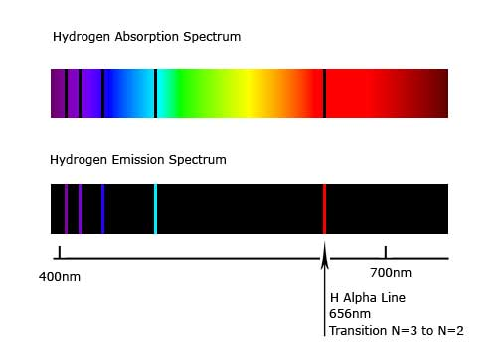
For an explanation of absorption and emission spectra and the origin of spectral lines.follow links.
Brian Cox Video http://www.youtube.com/watch?v=n_KyYFYNvpI

If elements are heated up, they absorb specific wavelengths electromagnetic radiation giving a characteristic absorption spectrum.

The element then emits the same specific wavelengths giving an emission spectrum. If these wavelengths are in the visible region they can be viewed through a diffraction grating or prism as coloured lines.


Neils Bohr used these emission lines as evidence for the existence of electron shells.
See Atom video 3223 22.24 – 30.04 Spectra and the work of Bohr
See Bohr model 2880 17.16-21.13 Bohr model in detail II
Look at some flame tests or discharge tubes through a prism or diffraction grating.
What do you see? – go to http://webmineral.com/help/FlameTest.shtml

Element | Number and colour of emission spectral lines
sodium | Bright line in yellow region
barium | Number of lines in green and yellow region
lithium | Lines in red region
These lines arise from the excitation of electrons in atoms:-
- When electrons get exactly the right amount of energy they can be promoted to a higher energy level shell.
- When they return to their normal level (ground state) they give out the excess energy as light of a specific frequency.
- The spectrum of any element consists of a series of discrete lines seen as colour in the visible region (which can be used to identify it or to determine the amount present).

Follow this link to see an animation of the process
Highest energy shell
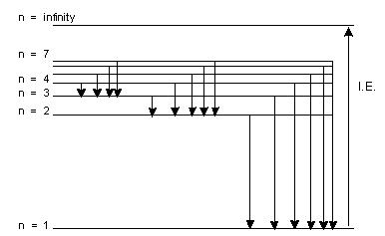
Electron transitions in the emission spectra of hydrogen:-
↓ = electron movement from high to lower energy shell.

Lowest energy shell

http://www.colorado.edu/physics/2000/applets/a2.html
shows the emission spectra of other elements

A Flame photometer is used to analyse the concentrations of Group I or II ions.
Revision page

Before attempting the questions make yourself a revision page or summary of this topic.
Use the statements on the front page to guide you.
A possible outline:-

Physical properties
Melting point. Smaller cations → stronger metallic bonding → higher M.Pt.
ΔH_{i}. Larger atoms, larger radius, more shielding → outer e⁻ more easily removed → lower ΔH_{i}.
Reactivity. Larger atoms →lower ΔH_{i} → more reactive

Chemical reactivity
Metal with oxygen
with chlorine

Oxide with water
with acids

Hydroxide with acid

Solubility of group II hydroxides and sulphates

Thermal stability of Group I and Group II carbonates
Nitrates

Flame colours and reasons
When ions are heated electrons move from the ground (lowest energy) state to a higher energy level.
The electrons drop back down and release quanta (precise amounts) of energy.
This energy is converted to light energy of precise wavelengths.
It is seen as a series of discrete lines through a spectroscope within the visible region of the spectrum.

Multiple choice questions
1. Which concentrated acid should be used to dissolve a carbonate of a Group 2 metal to carry out a flame test?
Spec Unit 2
A ethanoic acid
B hydrochloric acid
C nitric acid
D sulfuric acid
(Total 1 mark)
2. What colour does a barium salt give in a flame test?
A colourless
B green
C red
D yellow-red
(Total 1 mark)
3. Separate flame tests are carried out with lithium, sodium, potassium, magnesium, calcium and strontium salts. How many of these metal ions would colour the flame red?
A 1
B 2
C 3
D 4
(Total 1 mark)
4. A Group 2 element reacts vigorously with water to produce a soluble hydroxide, which forms a white precipitate when neutralised by sulfuric acid and forms a carbonate which is very stable to heat. The element could be
A magnesium
B calcium
C strontium
D barium
(Total 1 mark)
5. The Group 2 metals, considered in order of increasing atomic number, show a decrease in
A first ionisation energy
B nuclear charge
C chemical reactivity
D ionic radius
(Total 1 mark)
6. When a Group 1 metal nitrate is heated, brown fumes are observed. The metal could be
A lithium
B sodium
C rubidium
D caesium
(Total 1 mark)
Do not write in the margin

Structured Questions
1. (a) (i) Describe what would be seen if dilute sodium hydroxide solution was added, until in excess, to aqueous solutions of magnesium nitrate and barium nitrate.
Magnesium nitrate → White ppt / solid (1)
See p7
Barium nitrate → No change / colourless solution / then slight precipitate must imply much less than with Mg²⁺
(2)
(ii) Account for the observations given in (i) and write any relevant ionic equations.
Mg²⁺(aq) + 2OH⁻(aq) → Mg(OH)₂(s) (1)
State symbols not necessary but precipitate mark can be awarded for (s) in the equation.(1)
Barium hydroxide (more) soluble no ppt formed / solubility of hydroxides increases down group. (1)
See Ionic Bonding pack
(3)
(b) (i) State, and explain, the trend in the thermal stability of Group 2 carbonates.
Thermal stability increases down the group/it gets more difficult to break the carbonates down as atomic number increases (1)
See p9 and p11
Reference to change in cation size (1)
Reference to how this affects polarising power (1) eg Large cation low surface charge density polarises (the carbonate ion) electron cloud less, making it more stable
(3)
(c) Complete and balance the following equations:
(i) Ca + ½ O₂ → CaO(s)
(1)
(ii) MgO + H₂O → Mg(OH)₂(s)
(1)
(iii) MgO + 2HCl → MgCl₂(aq) + H₂O(l)
(2)
Total 12 marks
Do not write in the margin
Jan 99 CH3 Q1

2. (a) The compounds lithium chloride, sodium bromide and potassium iodide can be distinguished from one another by the use of flame tests.
(i) Complete the following table.
Compound | Flame colour
Lithium chloride | (carmine) red
Sodium bromide | Yellow/orange
Potassium iodide | lilac
(3)
(ii) Explain the origin of the colours in flame tests.
Heat energy excites electrons from ground state to higher energy orbital(1)
See p15
Electron moves down energy levels releasing energy which is converted to light of specific wavelengths appears as coloured lines(1)
(2)
(iii) Write an equation, including the state symbols, for the reaction between solid lithium and sulphuric acid.
. 2Li(s) + H₂SO₄(aq) → Li₂SO₄(aq) + H₂(g)
See p6
(2)
Total 7 marks
3. (a) Calcium and magnesium react vigorously with dilute hydrochloric acid but with dilute sulphuric acid the calcium stops reacting even though the magnesium continues.
(i) Write a balanced equation for the reaction between magnesium metal and dilute hydrochloric acid. Include all state symbols.
Mg(s) + 2HCl(aq) → MgCl₂(aq) + H₂(g)
See p6
(2)
(ii) Calcium reacts slightly more vigorously than magnesium with dilute hydrochloric acid. Suggest, in terms of atomic structure, why this is so.
In Ca the valence electrons are further away from the nucleus, there is more shielding from the nucleus by inner electron shells
See p3
Outer electrons are lost more easily, the ionisation energy is lower
(2)
(iii) Suggest why calcium stops reacting with dilute sulphuric acid after a few seconds even though it did react initially.
See p7
Calcium sulphate
Forms an outer, insoluble protective layer
(2)
Total 6 marks
Do not write in the margin
June 01 Unit 1 Q6

June 03 Unit 1 Q6

4. Barium and magnesium are both in Group 2 of the Periodic Table. Several bottles on the Group 2 shelf of the chemicals store had damaged labels.
(a) Two bottles are clearly labelled ‘sulphate’. The solid in bottle A dissolves easily in water but none of the solid in bottle B appears to dissolve when added to water.
See p7
Which of these two bottles contains barium sulfate? Bottle B
(1)
(b) Bottle C, labelled ‘magnesium carbonate’, contains a white powder. When heated this powder produces a colourless gas that turns limewater cloudy.
State whether this label is correct and explain your answer.
Gas that turns limewater cloudy is CO₂ produced from decomposition of a carbonate (or hydrogencarbonate)
See p11
The higher Group II carbonates decompose more readily on heating compared to those from lower down the group.
(2)
(c) Describe a test to show that the solid in bottle D is barium hydroxide and not magnesium hydroxide.
See p14
Clean a flame test rod in HCl until there is no colour produced in a luminous flame.
Dip the rod in HCl then the solid (converts the salt to a more volatile chloride) then hold in the luminous flame
Pale green colour indicates barium, no flame colour indicates magnesium
(3)
(d) Bottle E is clearly labelled ‘magnesium nitrate’. When a sample of the chemical is heated it gives off a brown gas and a gas that relights a glowing splint.
Give the name of each of the gases formed and write an equation for this chemical reaction.
See p13
Brown gas is nitrogen dioxide
Gas that relights a glowing splint is oxygen
Mg(NO₃)₂ → MgO(s) + 2NO₂(g) + ½O₂(g)
(4)
(Total 10 marks)

Do not write in the margin
June 01 CH1 Q4

5. (a) State the flame colours of
(i) barium . apple green / yellow(y) green
(1)
See p14
(ii) strontium (Crimson) red
(1)
(b) When barium is burnt in excess oxygen a compound containing 81.1% barium and 18.9% of oxygen is formed.
See Moles pack
Calculate the empirical formula of this compound.
Ba O
(1)
= 0.592 = 1.18
1 2 BaO₂(1)
(2)
(c) (i) Write the equation for the reaction of barium with water. Do not include any state symbols.
See p6
Ba + 2H2O → Ba(OH)2 + H2
(1)
(ii) When a small piece of barium is added to water, the barium gets smaller and eventually disappears.
State TWO other observations you could make (without any other tests).
• Gets warm
See p5
Accept heat produced
• Effervescence/fizzing/ bubbles/mist
Accept bubbles of hydrogen
• Ba sinks/moves up and down /Does not float
(2)
(iii) What would be the effect of adding a piece of blue litmus paper and a piece of red litmus paper to the aqueous product of the reaction in (ii)?
Red litmus Red litmus (goes) blue/ “(→) blue”
and
blue litmus unchanged/stays blue/no effect/nothing
(1)
(Total 8 marks)
Do not write in the margin
June 08 C Unit 1 Q6

June 08 C Unit 1 Q6

2015
NAME ...........................……... HOMEWORK DEADLINE .....................
Student Number ………… Chemistry Class ………
Student targets from previous pack

Group II

Task | Mark
Notes | /10
Revision Notes /Summary page | /10
Structured Exam Questions | /49 %
Overall Grade for this work | A B C D E U
Student comments

Tutor comments

Tutor signature Date

Student targets for next pack

