NAME ............................................ Chemistry Class ...........................
Student Number ……….
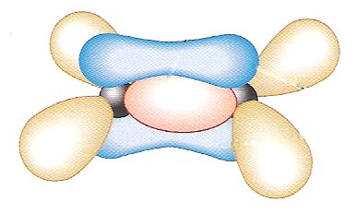
Alkenes and Polymers answers
σ bond
π bond
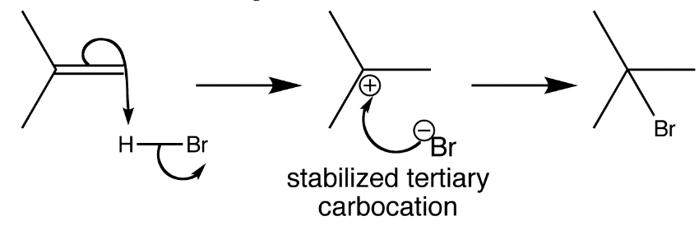

Topic 6A: Introduction to organic chemistry
5. be able to classify reactions as addition, elimination, substitution, oxidation, reduction, hydrolysis or polymerisation
Topic 6C: Alkenes
18. know the general formula for alkenes
19. know that alkenes and cycloalkenes are unsaturated hydrocarbons
20. understand the bonding in alkenes in terms of σ- and π bonds
21. know what is meant by the term ‘electrophile’
22. understand the addition reactions of alkenes with:
i hydrogen, in the presence of a nickel catalyst, to form an alkane (Knowledge of the application of this reaction to the manufacture of margarine by catalytic hydrogenation of unsaturated vegetable oils is expected.)
ii halogens to produce dihalogenoalkanes
iii hydrogen halides to produce halogenoalkanes
iv steam, in the presence of an acid catalyst, to produce alcohols
v potassium manganate(VII), in acid conditions, to oxidise the double bond and produce a diol
23. understand that heterolytic bond fission of a covalent bond results in the formation of ions
24. understand the mechanism of the electrophilic addition reactions between alkenes and:
i halogens
ii hydrogen halides, including addition to unsymmetrical alkenes
iii other given binary compounds Use of the curly arrow notation is expected − curly arrows should start from either a bond or from a lone pair of electrons. Knowledge of the relative stability of primary, secondary and tertiary carbocation intermediates is expected.
25. know the qualitative test for a C=C double bond using bromine or bromine water
26. know that alkenes form polymers through addition polymerisation Be able to identify the repeat unit of an addition polymer given the monomer,and vice versa.
27. know that waste polymers can be separated into specific types of polymer for:
i recycling
ii incineration to release energy
iii use as a feedstock for cracking
28. understand, in terms of the use of energy and resources over the life cycle of polymer products, that chemists can contribute to the more sustainable use of materials
29. understand how chemists limit the problems caused by polymer disposal by:
i developing biodegradable polymers
ii removing toxic waste gases caused by incineration of plastics
ALKENES and POLYMERS


REFERENCES
Facer AS Chemistry p141 - 150
Factsheets on Godalming online
15 | Organic Chemistry I - Nomenclature
16 | Organic Chemistry II – Reactions I
91 | Naming of Organic Compounds
18 | Applied Chemistry
76 | Polymers
84 | Free Radical substitution and Polymerisation mechanism

Websites:-

http://www.chemguide.co.uk/organicprops/alkenemenu.html
A good coverage of the topic for AS level with clear notes.

http://www.drbateman.net/asa2sums/sum2.2/sum2.2.htm
Useful notes and questions on organic chemistry including fuels, plastics, herbicides and pesticides.

http://winter.group.shef.ac.uk/orbitron/MOs/N2/2px2px-pi/index.html
Shows atomic and molecular orbitals animation

Useful background for polymers
http://www.bpf.co.uk/bpfindustry/History_of_Plastics.cfm
A short history of the development of plastics prepared by the British Plastics Federation.

Information on recycling and degradable plastics
http://www.wasteonline.org.uk/resources/InformationSheets/Plastics.htm#_Types_of_plastic

Very useful for AS
http://www.elecuter.co.uk/Scinet/chemistry/index.php?s=pr#pr
An introduction to the concepts of polymers, alkenes and intermolecular forces, focusing mainly on polymer science.

Levels 2-3 probably most useful for AS
http://www.pslc.ws/mactest/maindir.htm
A very informative site comprising:-
Level 1 (use of polymers in everyday life)
Level 2 (specific information on more than 30 polymers)
Level 3 (more detailed information about polymer properties and behaviour);

Finally some quizzes on hydrocarbons:-
These are all suitable
http://www.mp-docker.demon.co.uk/as_a2/topics/hydrocarbons/index.html

Try quizzes 1-3 only for AS – Quizzes 4-5 are for unit 5 A2
http://www.mp-docker.demon.co.uk/as_a2/topics/more_on_hydrocarbons/index.html

http://www.mpcfaculty.net/mark_bishop/addition_polymers.htm
This site details the chemistry behind addition polymerisation.
THE ALKENES
Power-point ‘ethene’

General formula: C_{n}H_{2n}
The alkenes are a family of aliphatic hydrocarbons.
Unlike the alkanes, they do not contain the maximum number of C - H bonds so they are said to be Unsaturated
Simple alkenes contain one double bond: >C = C<.
The first member of the alkene family is ethene.
From the prefix eth- how many carbon atoms does ethene have? two
The suffix -ene places it in the alkene family.
The general formula above enables you to write the molecular formula as: C₂H₄

The double bond in alkenes
In the electron structure pack you described the shapes of the s and p atomic orbitals, these are
S orbital is spherical and the p orbitals are dumb bell shaped along the x,y,and z axes..
When atomic orbitals containing a single electron overlap a new molecular orbital is formed which contains the shared pair of electrons. As before the molecular orbital show the region of space where there is a high probability of finding electrons.
Show how two s orbitals overlap to form a molecular orbital – called a sigma, σ orbital
Animation at http://winter.group.shef.ac.uk/orbitron/MOs/N2/2px2px-pi/index.html (dihydrogen σ)
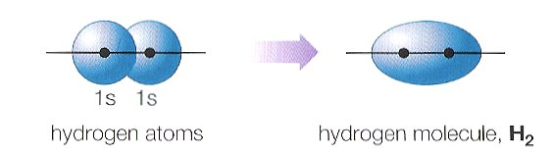
Eg H₂
Single sigma, σ bonds are formed from overlap of two s orbitals
an s and a p_{x} orbital or
two p_{x} orbitals.
The shared electron density is along the bond axis (straight line between the nuclei).

Sigma orbitals are also formed from overlap of an s and a p orbital
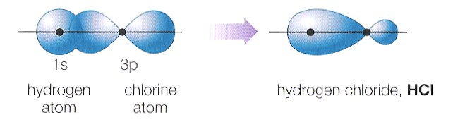
Eg HCl

And from overlap of two p orbitals (draw diagram below)
Eg F₂
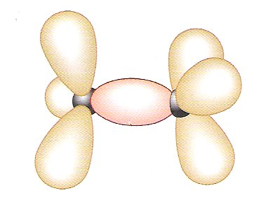

These are the molecular orbitals found in alkanes eg ethane:-
Label the sigma molecular orbital between the two C atoms

However, in alkenes, carbon forms three bonds and one electron remains in a p orbital, sideways overlap of two p orbitals forms a π orbital
Double or π bonds are formed from overlap of perfectly parallel p_{y} orbitals above and below the bond axis.
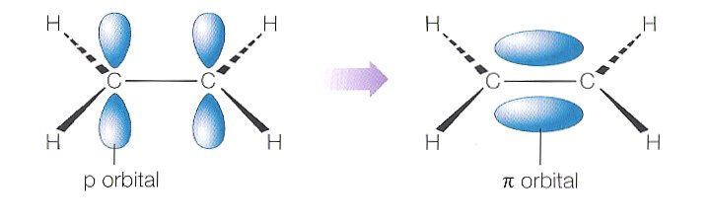

Label the sigma σ and pi π bonds in the ethene molecule:-
This double bond prevents free rotation.

Additional Worksheet ‘Bonding in akanes and alkenes’
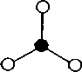
MOLECULAR MODELLING
Complete the following table:
Use model kits and/or the internet
Note the angles around the C=C atoms, try to draw them correctly.

No of  C atoms | Displayed formulae | Skeletal formulae | Name | Structural formula
2 |  |  | ethene | CH₂=CH₂
3 |  |  | propene | CH₂=CHCH₃

STRUCTURAL ISOMERISM
Alkenes of 4 carbon atoms can have structural isomers which differ by the position of the double bond as well as by the position of branches.
The position of the double bond is shown by the lower of the numbers of the 2 carbon atoms involved in the double bond. (Number from the end of the chain nearest the double bond)

Make models and draw the displayed formulae of the 4 structural isomers of butene (C₄ H₈) given below:
But-1-ene | But-2-ene | Methyl propene | Cyclobutane

GEOMETRIC ISOMERISM Facer AS Chemistry p134 - 136
Geometric isomerism is due to the fact that:-
- there is no free rotation about a >C = C< double bond (or in a ring structure)
- there are 2 different groups on each of the double bonded carbon atoms

Consider the model of but-2-ene. This lack of free rotation means that two isomers of the molecule are possible; they are called geometric isomers. Look at models of the 2 isomers
- The trans form will have the CH₃- groups on opposite sides of the double bond;
one on C2, and the other on C3. (Think transatlantic). Draw this structure below making sure that the bond angles round the double bonded carbon atoms = 120º
- The cis form will have both CH₃- groups on the same side,
one on C2 and the other on C3.(Cis – same side). Draw this structure below
Trans but-2-ene | Cis but-2-ene

Cis and trans isomers will have differing physical properties (M.Pt and B.Pt. and densities) but generally the same chemical properties. Because the same bonds are present, they are not structural isomers. They are stereoisomers (isomers with the same bonds but different arrangement of atoms in space.)
Biological organisms can distinguish them. (See Article ‘Cis-trans isomerism and tomatoes’)
Identify the molecules below as cis or trans and name them

Cis trans cis
Is there a molecule you have difficulty with? (circle it). Why is there a problem?
You do not know which groups to compare if there are different groups on the C atoms
The E - Z naming system
- Look at the atoms bonded to the first carbon atom in the C=C bond. The atom with the highest atomic number takes priority.
- If two atoms with the same atomic number, but in different groups, are attached to the first carbon atom, then the next bonded atom is taken into account. Thus, CH₃CH₂- has priority over CH₃-.
- This consideration is then repeated with the second carbon atom in the C=C bond.
What is the order of priority among Br, C in CH₃, Cl and H? Br > Cl > CH₃ > H
What is the priority among CH₃-, CH₃CH₂-, CH₃O- and HOCH₂- ? CH₃O- > HOCH₂-> CH₃CH₂- > CH₃

Look again at 2-bromo-1-chloroprop-1-ene:-
What is the priority between H- and Cl- attached to the first carbon atom in the double bond? Cl
What is the priority between Br- and CH₃- attached to the second carbon atom in the double bond? Br

- If the two groups of highest priority are on the same side of the double bond, the isomer is designated Z- (German 'zusammen' meaning 'together'),
- and if the two groups of highest priority are on opposite sides of the double bond, the isomer is designated E- (German 'entgegen' meaning 'opposite').
Therefore, the structure drawn above is called Z-1-chloro-2-bromopropene
Use the E-Z system to draw and name the geometric isomers of:
but-2-ene |  | 2 chloro pent-2-ene.
Z but-2 ene | E but-2 ene | Z-2-chloro pent-2-ene | E-2-chloro pent-2-ene

CHEMICAL REACTIONS OF THE ALKENES
- REDUCTION
Reference Facer AS Chemistry p143
Consider the reaction of ethene with hydrogen:-
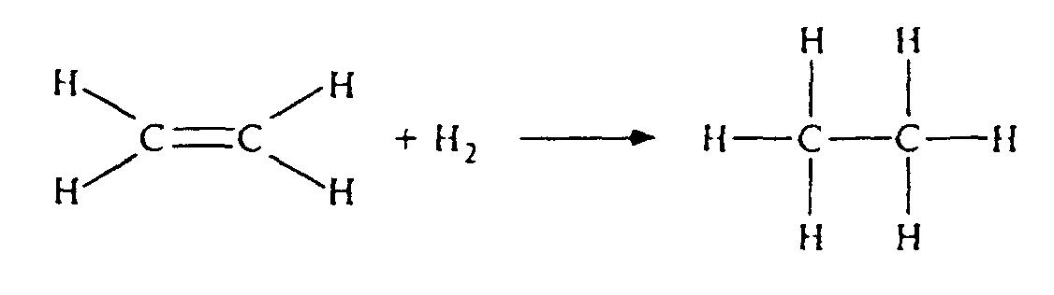
Reduction is:-
a gain of electrons
a gain of H atoms
a loss of O atoms

- Why is this classified as a reduction reaction?
C atom has gained electrons. Addition of H is reduction
- What conditions are needed for this reaction to occur?
Finely divided nickel catalyst 150ºC or Platinum/palladium catalyst at room temp.
- What is this useful for in food manufacturing?
It is used to hydrogenate (add hydrogens to) fatty acids to make them have a lower melting point, this is useful in the production of margarine.

2) ELECTROPHILIC ADDITION REACTIONS OF ALKENES
Facer p142 – 147
Addition reaction
Where one or more groups are added onto a molecule to give a single product
(It usually converts an unsaturated compound into a saturated compound.)

Why do alkenes undergo addition reactions?
π bond is weaker than σ bond, and is exposed to attack, when it breaks two atoms can be added.
What type of reagent would be most likely to be attracted to the double bond in an alkene?
electrophile
Electrophile (electron loving)
An electron deficient species with a vacant orbital
They are often positively charged.
They react by accepting a pair of electrons forming a new covalent bond.
Examples:-

Electrophiles can only be produced by:- http://www.avogadro.co.uk/chemist.htm
Heterolytic bond fission
This results in the production of two different (hetero) species.
A: B → A:⁻ + B⁺ or A :B → A⁺ + :B⁻
The covalent bond breaks so that both the bonding electrons go to either A or B.
It results in the formation of oppositely charged ions. Complete the example below using the correct curly arrows:
H : Cl → H⁺ + :Cl⁻

see animation at http://www.avogadro.co.uk/chemist.htm
ELECTROPHILIC ADDITION REACTIONS WITH HYDROGEN HALIDES
Reference Facer p144-145
Power-point ‘Orgmechs’

Ethene with hydrogen bromide
Reagent:- HBr(g) (made from NaBr and conc. H₂SO₄)
Conditions:- room temp
Equation:- + H-Br →
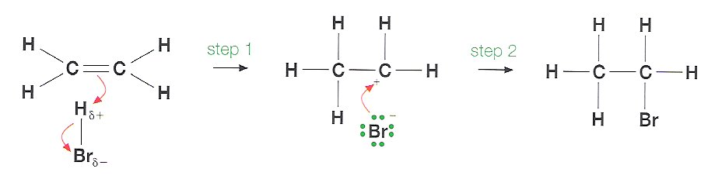
Mechanism:-

Product:- bromoethane
ELECTROPHILIC ADDITION REACTIONS WITH HALOGENS

Reference Facer AS Chemistry p143 and 146
Power-point ‘Electrophilic addition’
In general these reactions take place at room temperature.
Give an equation of heterolytic fission of a halogen and underline the electrophile formed
X—X(g) → X⁺(g) + X⁻(g)
Ethene with bromine
Reagents:- Bromine in an inert solvent (such as hexane)
Conditions:- Ethene bubbled through bromine solution at room temperature.
Equation (displayed):
+ Br—Br(l) →

Product name 1,2-dibromoethane
Mechanism:-

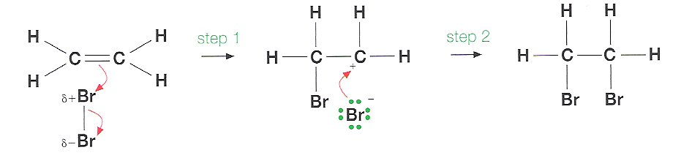
A perfectly acceptable simpler version:-

Product:- 1.2-dibromoethane
SYMMETRICAL AND UNSYMMETRICAL ALKENES
Ethene is an example of a symmetrical alkene (same number of C atoms on either side of the double bond). Depending on the position of the double bond, some alkenes will not have this line of symmetry and are described as unsymmetrical.
Circle the unsymmetrical molecules from the following examples and name them:-

propene but-1-ene
Reaction of an unsymmetrical alkene - propene with hydrogen bromide
Reagents:- HBr(g) (made from NaBr and conc. H₂SO₄) Conditions:- room temp
Equation (note the HBr can add onto the double bond either way round)
+ HBr -→ name: 2-bromopropane

OR → name: 1-bromopropane

Mechanism for addition reaction to form 2 bromopropane (This is the major product)

Mechanism for addition reaction to form 1 bromopropane (This is the minor product)

Explanation - Stability of the carbocation intermediate.
- Methyl groups are weakly electron donating compared to hydrogen, they have a positive inductive effect as shown by the arrow H₃C→C , mark these on the carbocations below
- Carbocations carrying a positive charge are highly unstable. Stability can be increased as the number of methyl groups attached to the C⁺ centre increases because they reduce the density of the positive charge.

Primary – least stable intermediate Tertiary – most stable
- In the above case the secondary carbocation is more stable, suggesting a lower activation energy and so it will be formed faster. The formation of the product is thus kinetically controlled
Extension ‘Addition reactions of Alkenes’
COMPARISON OF REACTIONS OF ALKENES AND ALKANES
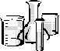
Identify the hazards for each chemical involved – write their names beside each symbol
FLAMMABLE  cyclohexane  cyclohexene | CORROSIVE  conc.sulfuric acid | HARMFUL  cyclohexene  cyclohexane  dil.sulfuric acid  KMnO₄(aq) | DANGEROUS TO ENVIRONMENT  cyclohexane  KMnO₄(aq)

Method | Alkane cyclohexane | Alkene cyclohexene
Combustion.  Burn one drop of cyclohexane on a tuft of mineral wool on a heatproof mat.  Repeat for cyclohexene. | burns with yellow flame | burns with yellow sooty flame  Incomplete combustion → C and CO
Bromine water.  Put 1cm³ of bromine water in a test tube and add 3 drops of cyclohexane and mix.  Repeat for cyclohexene. | Orange bromine water and alkane formed two layers.  Upper layer red/ brown, lower layer colourless.  Br₂ dissolves preferentially in the upper organic layer.  No reaction | Orange bromine water decolourised.  Br₂(aq) reacted with alkene.  upper layer of bromoalcohol
Potassium manganate(VII) and dil H₂SO₄.  Put 2 drops of KMnO₄ into a test tube add 1 cm³ dil.H₂SO₄ and a few drops of cyclohexane, shake.  Repeat for cyclohexene. | Purple KMnO₄ solution did not change.  Alkene floated on surface | Purple KMnO₄ and dil acid solution turned brown then decolourised.  Alkane floated on surface
Solubility in water  (Physical property)  Put approx 1 cm³ of distilled water in a test tube and a few drops of cyclohexane and shake.  Repeat for cyclohexene. | Two layers formed after shaking, organic layer on the surface. | Two layers formed after shaking, organic layer on the surface.
ELECTROPHILIC ADDITION REACTION WITH BROMINE WATER
Facer p 147
NOTE: This is a test for unsaturation (>C=C<)
Reagents: Bromine water (Bromine dissolved in water)
Conditions: Shake together / bubble gas through at room temperature.
Observations: Orange bromine water is decolourised

Bromine water and ethene
As well as simply dissolving, Br₂(l) also reacts with water:
Br₂(l) + H₂O(l) HO-Br(aq) + HBr(aq)
This means that there are two possible reactions as 2 negative ions can add onto the carbocation intermediate:
- Identify the electrophile in the HO-Br molecule and mark it with a δ⁺ in the equation below
Equation:
+ HO-Br

Name . 2-bromoethanol
2.

+ Br-Br →

Name:. 1,2-dibromoethane

Bromine water and propene: Draw structural formulae of 3 possible products and name them.
1-bromopropan-2-ol | 2-bromopropan-1-ol | 1,2-dibromopropane

Which one is the major product of the addition of HO-Br? Why?
1-bromoprop-2-ol, ^{δ+}Br can attack C₁ or C₂ in propene.
If it attaches to C₁ this results in a 2ry carbocation which is more stable:-
Followed by attack by OH⁻ results in 1-bromoprop-2-ol
ELECTROPHILIC ADDITION REACTION WITH STEAM AND AN ACID CATALYST

Steam and an alkene in the presence of an acid catalyst produces an alcohol.

This reaction could be classified as an addition reaction or…hydrolysis

3) OXIDATION REACTION WITH POTASSIUM MANGANATE(VII)
Facer p 147
Reagents: Potassium manganate(VII) solution with dilute H₂SO₄ (or dilute NaOH)
Conditions: Shake together at room temperature.
Observations: Purple solution is decolourised on shaking.
Purple MnO₄⁻ ions are reduced to very pale pink Mn²⁺ ions.
Equation
+ [O] + H₂O

[O] represents the oxidising agent, name the organic product ethane-1,2-diol

This reaction could be classified as an oxidation reaction, or addition
CRACKING PRODUCES ALKENES demonstration
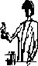
Alkenes can be prepared by cracking of longer chain alkanes.
Medicinal paraffin contains a mixture of alkanes, typically 12C.
Complete the following equation:
C₁₂H₂₆(l) → C₁₀H₂₂(l) CH₂=CH₂(g)
long chain alkane → shorter alkane + alkene
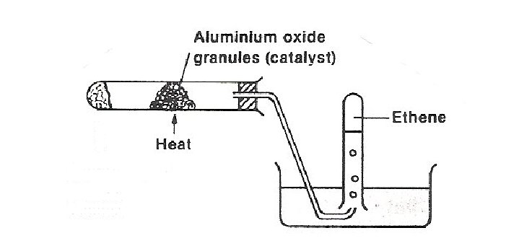
Mineral wool soaked in medicinal paraffin

Mineral wool soaked in medicinal paraffin
Cracked products – short chain alkanes and alkenes

Method
- Pour 2-3 cm³ of medicinal paraffin onto the mineral wool in a boiling tube
- Set up the apparatus as shown in the diagram.
- The alumina, (Al₂O₃,) is a catalyst (or porous pot or a zeolite can be used)
- Heat the catalyst (not the mineral wool) continuously until bubbles appear.
Discard the first test tube of gas, then collect several test tubes of gas.
- Remove the delivery tube from the water before cooling.
- Test samples of the gas:-
Combustion
Holding the test tube upside down with test tube holder, hold a flame to the mouth of the test tube.
Observations:-
burned with a yellow sooty flame
With bromine water
Add 1 cm³ bromine water to the second test tube, cork and shake.
Observations:-
Orange bromine water decolourised on shaking
Why was the first sample of gas discarded? Contained air from the apparatus
Why was the delivery tube removed from the water? To avoid cold water being sucked back into the hot reaction tube.
4) POLYMERISATION (Polymer animation ‘polyanim’ and Power-point ‘Polymers’)
Reagent: any short chain alkene (e.g. ethene, propene, chloroethene)
Conditions: High Pressure and Peroxide INITIATOR that produces free radicals
R-O-O-R → 2 R-O∙
Mechanism for the polymerisation of ethane:
A free radical causes the ethene π bond to break and attach, this in turn produces a free radical.
R-O∙ + H₂C=CH₂ → R-O-CH₂CH₂∙
This radical causes another ethene π bond to break and attach.
R-O-CH₂CH₂∙ + H₂C=CH₂ → R-O-CH₂CH₂CH₂CH₂∙
The process repeats thousands of times resulting in a polymer.
Equation for polymerisation of ethane This polymerisation can be represented:-
n

nH₂C=CH₂

MODEL-MAKING
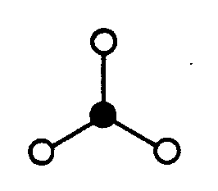
Work in groups of four or five to carry out this activity
1) POLY(ETHENE)
Construct a number of ethene molecules using flexible bonds for the double bonds. These ethene molecules represent the monomer units.
Now open up the double bonds in the monomer units and pool your resources to construct a polymer unit. This is poly(ethene) or polythene.

Three repeating units
n

One repeat unit
n

2) POLY(PROPYLENE)

Draw out one repeat unit
n
n

Addition Polymers – a summary
Refer to Facer p147-149
http://www.chemguide.co.uk/organicprops/alkenes/polymerisation.html

Monomer  name | Monomer formula | Polymer name  and formula | Properties | Uses
Ethene |  | Poly(ethene)  n | Light ,flexible  Easily moulded  Transparent  Good insulator  Resistant to water, acids and alkalis | LDPE - plastic bags  HDPE – water pipes, bowls, buckets
Chloroethene |  | Poly(chloroethane)  PVC  n | Tough, Rigid  (with plasticisers → flexible)  Very resistant to water, acids, alkalis resists fire and water | Guttering and window frames  Insulation for cables  Waterproof clothing  Flooring
Propene |  | Poly(propene)  n | Tough  Easily moulded  Easily coloured  Very resistant to water, acids, alkalis | Fibre for ropes  Crates  Toys
Phenylethene |  | Polystyrene  n | Brittle, inexpensive and hard  Expanded foam | Packaging boxes  When expanded -thermal insulation, packaging
Tetrafluro-ethene |  | PTFE  n | High M Pt  Low friction  Good insulator  Inert to chemicals | Non-stick coatings, low-friction bearings, burette taps, plumbers tape, electrical insulation
Propenenitrile |  | Acrilan  n | Can be drawn into fibres.  Elasitcity | Fibres for clothing  Tennis racquet strings
Ethenol |  | Polyethanol  PVA  n | Water soluble | Soluble laundry fasteners / bags, liquitab capsules

Demo - Polyethenol – a dissolving plastic
Describe the appearance of the polyethenol sheet .transparent sheet
What happens when it is put in hot water?. Sheet dissolves → viscous solution
Can you think of some uses of this polymer?. Soluble laundry fasteners / bags, liquitab capsules
Making Slime
Requirements
CARE Gloves must be worn
Slime may damage fabrics

- polystyrene drinking cup
- sodium borate solution, 4% (4 cm³)
- poly(ethenol) solution, 4% (20 cm³) (PVA solution)
IRRITANT
- disposable gloves
- colouring or dye e.g. fluorescein

Method
- Put about 20 cm³ of poly(ethenol) solution into the polystyrene cup. Stir the solution and note its appearance. (A few drops of dye may be added at this stage.)
Appearance:-
Viscous colourless liquid

- Add 4 cm³ of sodium borate solution and stir the mixture vigorously. Keep on stirring while the mixture is setting. When the mixture has set to a gel, remove it from the cup and continue to shape it with your hands (wear gloves).
Note changes
Turns jelly-like
3) Investigate the properties of the 'slime' you have produced and compare it with the poly(ethenol) solution you started with. 'Slime' is not dangerous, but as a precaution you should wear gloves and wash your hands at the end of the experiment as some skins are sensitive to the sodium borate used.
Differences in properties:-
Becomes semi-solid, elastic(bounces) yet plastic(stretches)
Can be slowly stretched into a film, when pulled sharply it snaps, it self siphons, when squeezed though a small hole it expands the other side (die swell)
Explanation
Borate ions in the sodium borate form cross-links between the poly(ethenol) chains:

poly(ethenol) chain

borate borate

poly(ethenol) chain

The forces produced by these cross-links are of a different kind to the intermolecular forces between poly(ethene) chains. They are also stronger, which allows you to see more clearly the effects of introducing forces between polymer molecules.
Power point ‘Slime’
Degradable Plastics
http://www.wasteonline.org.uk/resources/InformationSheets/Plastics.htm#_Types_of_plastic

Most plastics are not degradable because bacteria do not have the enzymes needed to break them down. As a result these have contributed to environmental pollution.
There are several types of degradable plastics: -

Biopolymers
Poly(hydroxybutanoate) or PHB is a natural polyester made by certain bacteria and used by them as source of energy. Microorganisms found in the soil and in natural water sources, such as streams and the sea, are able to break the polymer down again. PHB degradation in the environment is usually complete within 9 months, but of course there is a price to pay. PHB is about 15 times more expensive than polythene.

Photodegradable polymers
Carbonyl groups (>C=O) absorb radiation in the wavelength range 270-360 nm. This corresponds to light in the near ultra-violet region of the spectrum. These groups can be incorporated into polymer chains to act as energy trappers. The trapped energy causes fission of bonds in the neighbourhood of the carbonyl group, and the polymer chain breaks down into short fragments which can then be biodegraded.

Synthetic biodegradable plastics
Some plastic bags are made of polythene which has starch granules encapsulated in it. The starch is digested by micro-organisms in the soil when the plastic bag is buried. The very small pieces of left over polythene have a large surface area which greatly speeds up their biodegradation.

Dissolving plastics
Poly(ethenol) is a water soluble polymer manufactured from poly(ethenyl ethanoate). The manufacturing process can control the degree of solubility of the resulting polymer.
A soluble form of this polymer is used to make ‘slime’.
Questions
1) Suggest some suitable uses for photodegradable polymers.
Short life containers eg milk bottles
2) Suggest some situations where their use would be unsuitable.
Drainpipes, window frames – any permanent structures
3) What happens to a photodegradable polymer if it is disposed of by landfill?
No exposure to light when buried so no photo-degradation and consequently very slow rate of bio-degradation

Additional resources in Godalming online/AS chemistry/Alkenes/resources
‘Polymer problems and solutions’
‘A more sustainable future’
‘The polymer predicament’ Chemistry Reviews article
Management of plastic waste

More and more plastics are being used for packaging, especially with food. What could you as an individual do to reduce plastic waste?

Try to buy products which have less packaging. Use of renewable shopping bags.

What could be done to reduce the amount of plastic waste which goes to landfill, outline the 3 main ways.

Way to reduce waste | Main stages of how it works | Example(s)
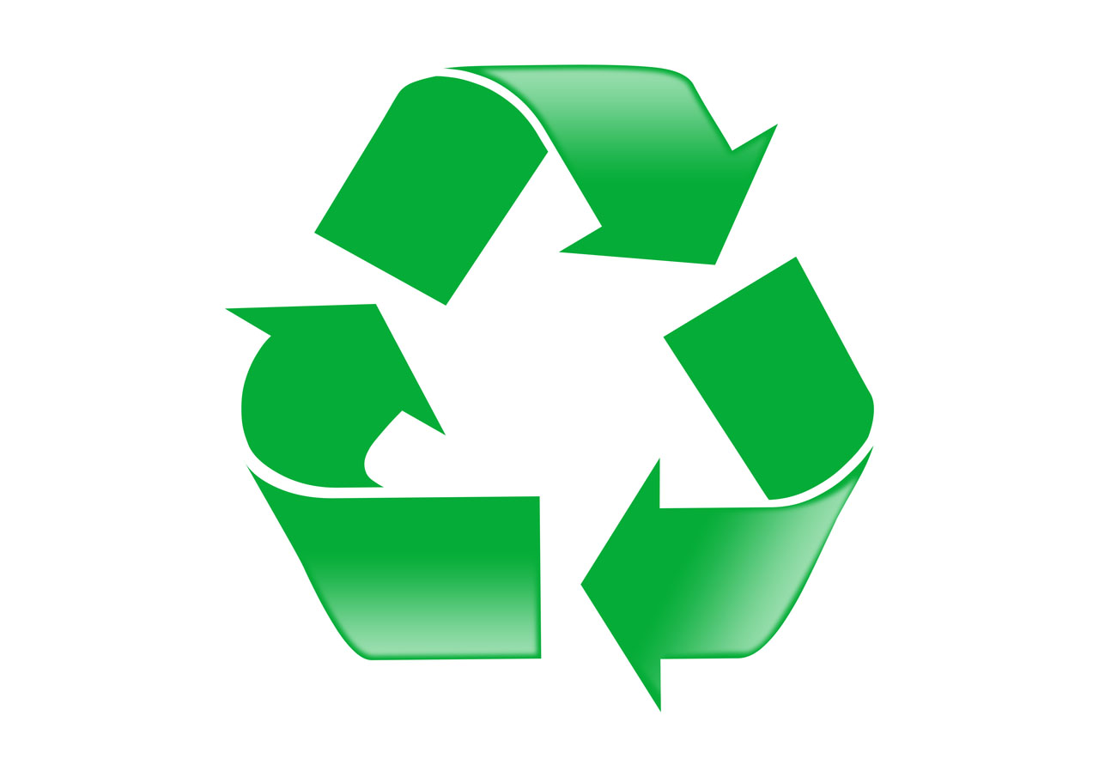  Recycle  (converting into other materials) | Plastics need to be sorted (ideally in an automated process rather than by hand), can sort polymers using the code on the product.  Then waste is chopping into small pieces and washed. Then melted, moulded or drawn into fibre depending on the final use of it. | PET (polyethylene terephthalate) is used in plastic bottles, which can be recycled to make carpets
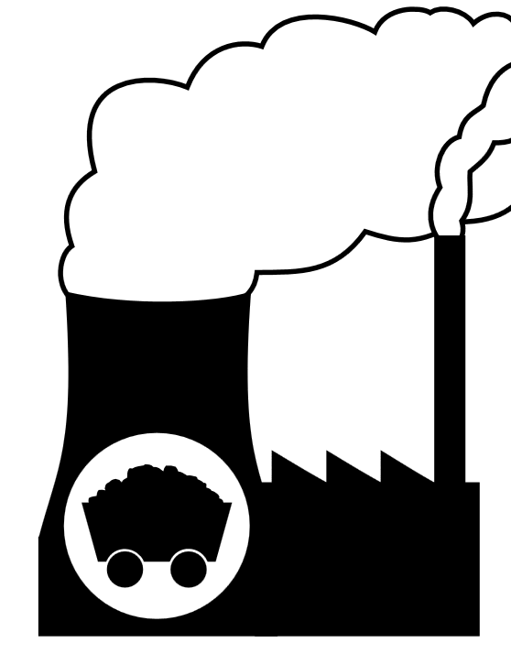  Incineration to produce energy | Majority of elements in polymers are carbon and hydrogen so they can be combusted to produce CO2 and H2O.  There may be a small amount of toxic waste from pigmants, and halogens which are in the plastics which can be difficult to remove before they are let into the atmosphere. | Incinerators burn the plastic to produce heat energy which can be used to heat up homes.
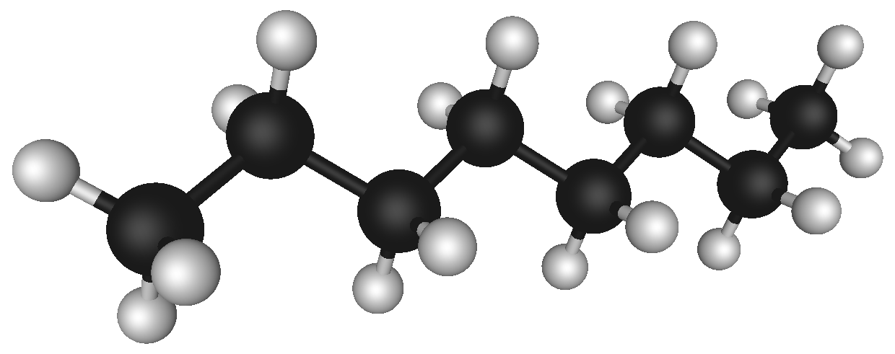  Use for chemical feedstocks (reagents) | Polymer can be broken down into gases (similar to cracking). These gases can then be used to make new chemicals/polymers

Chemist’s responsibilities
Scientists have a responsibility to limit the problems caused by polymer disposal by considering the following:

- Develop biodegradable polymers
Why?
So they can be broken down by microbes and therefore do not hang around in the environment. They can be used in medicine.
But the majority of them are made from plant material so might require a lot of land use.
When they are broken down the products are not reused.
- Remove toxic waste gases caused by incineration
Why?
So they do not go into the environment

The life of a polymer:
Outline the main ways which Chemists can improve the life cycle of polymer products

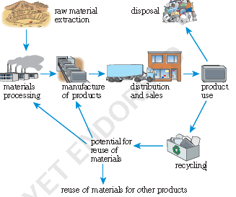

- Make products which are biodegradable
- Removal of gases from incineration to re-use elsewhere
- Make manufacturing more efficient with less waste
- Develop more ways to recycle polymers
- To develop polymers which are useful
- Try to reduce the need on raw materials

SUMMARY OF REACTIONS OF ALKENES
Using notes and references complete the spider diagram to show:-
- Reaction types
- Reagents and conditions
- Name the products

Crude oil fraction

n
Fractional distillation
cracking

Al₂O₃ or zeolite catalyst
High temp
polypropene
Catalyst
High pressure
1-bromopropan-2-ol
Br₂(aq)
Room temp.
Free Radical
Addition Polymerisation
H₂(g)
/Ni 150ºC
Pt/Pd room temp.
electrophilic
addition
reduction
Br₂(hexane)
Room temp.

propane
1,2 -dibromopropane
oxidation
KMnO₄/H₂SO₄
HBr(g)
Room temp.
hydrolysis/
addition
H₂O and a conc acid catalyst.

2-bromopropane
Propan-1,2-diol

Make a revision page summarising
Cis/trans isomerism and E/Z naming
Mechanism of electrophilic addition to propene
Polymers uses and problems

MULTIPLE CHOICE EXAM QUESTIONS
1. In a molecule of ethene, C2H4, how many π (pi) bonds are present?
A One
B Two
C Three
D Four
(Total 1 mark)
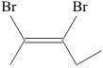
2. What is the correct name for the compound below?
A E-2,3-dibromopent-2-ene
B E-2,3-dibromopent-3-ene
C Z-2,3-dibromopent-3-ene
D Z-2,3-dibromopent-2-ene
(Total 1 mark)
3. The mechanism of the reaction represented by the equation
C2H4 + Br2 → CH2BrCH2Br
is an example of
A Free radical substitution
B Free radical addition
C Electrophilic substitution
D Electrophilic addition
(Total 1 mark)

Do not write in the margin
W09.1.15

S10.1.13

W09.1.16

4. This question is about the following organic compounds with skeletal formulae as shown:
A B C D
(a) Which compound could be made from one of the others in an addition reaction?
A
B
C
D
(1)
(b) Which compound has E–Z isomers?
A
B
C
D
(1)
(Total 2 marks)
5. Propene reacts with hydrogen chloride gas to give mainly
A 1-chloropropane (CH3CH2CH2Cl)
B 2-chloropropane (CH3CHClCH3)
C 3-chloroprop-1-ene (CH2==CHCH2Cl)
D 1,2-dichloropropane (CH3CHClCH2Cl)
(Total 1 mark)
6. Chemists investigating the mechanism of the reaction of ethene and bromine thought that the first step was the addition of Br+. To test this, they reacted bromine with ethene in the presence of sodium chloride.
If their theory about the first step of the reaction was correct, which product might form as well as 1,2-dibromoethane?
A CH2BrCH2Na
B CH2BrCH2Cl
C CH2ClCH2Cl
D CH2NaCH2Na
(Total 1 mark)

Do not write in the margin

SP.1.11

W09.1.18

SP.1.12

STRUCTURED EXAM QUESTION
7. This question is about ethene and related compounds.
(a) One way to manufacture ethene is by cracking hydrocarbon molecules such as liquid paraffin.
(i) Name a raw material from which liquid paraffin can be obtained.
Crude oil / petroleum / coal.
Reject; Oil on its own / Natural gas / fossil fuels / any named fraction of crude oil
(1)
(ii) Describe what is meant by cracking.
use of high temperatures / heat (in the absence of air) / thermal
decomposition / catalysts (1)
Either
to break large molecules / to form smaller molecules / to break
bonds in large molecules / to break carbon-carbon bonds (1)
OR
producing alkenes / producing carbon-carbon double bonds (1)
(2)
(iii) It was proposed to set up the apparatus below on a laboratory bench, in order to crack paraffin.
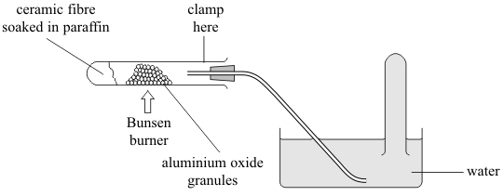

State TWO of the risks of using the apparatus in this way and suggest how you would amend the set-up to minimise each risk.
Risk | Amendment
exposure to harmful / toxic fumes | Set up in fume cupboard
Escape of flammable / harmful / toxic reactants or products from ill fitting bung | Correct fitting of bung
Escape of flammable / harmful /toxic reactants or products from poorly positioned delivery tube | Placement of delivery tube below mouth of test tube / use a longer delivery tube
suck back | Attach Bunsen valve / remove delivery tube from water before stopping heating etc
Risks (2) Amendments (2) Mark all 4 points independently (4)
Do not write in the margin
S10.1.18

(b) Study the reaction scheme below and then answer the questions that follow.
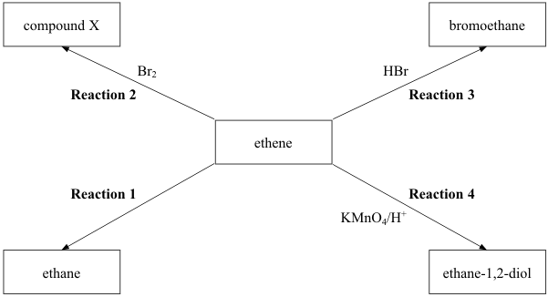

(i) Name the reagent and catalyst needed for Reaction 1.
Reagent. Hydrogen/H2
Catalyst.. Nickel/Ni/palladium/Pd/platinum/Pt.
(2)
(ii) Give the name and displayed formula of compound X.
Name. 1,2 – dibromoethane
Displayed formula
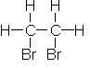

(2)
(iii) Describe what colour change you would see during Reaction 4 if a small amount of acidified KMnO4(aq) was shaken with ethene.
From. purple / pink. to.. colourless (reject clear).
(1)
Do not write in the margin

(c) (i) Use displayed formulae to show the mechanism for Reaction 3.
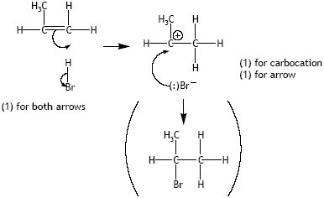

- For both arrows
arrow from bromide ion can start from any part of the bromide ion and can go towards the C or the + sign on the intermediate
bromide ion must show negative charge
allow 2 max for addition of Br2 and any other electrophilic additions
half headed arrows used throughout penalise once
Reject ∂- on bromide ion for third mark (3)
(ii) Explain why the alkene, propene, could form two products when it reacts with hydrogen bromide in a similar way.
Bromine / bromide / hydrogen could add to either carbon (in the double bond) / bromide / bromine could add to either primary or secondary carbocation / (propene is unsymmetrical) so could form 1-bromopropane and / or 2-bromopropane.
Allow correct structural or displayed formulae. 1
Reject bromine could add to any of the three carbons
(1)
(d) The formula of the alkene phenylethene, often called styrene, is shown below. It can be used to make the polymer poly(styrene).
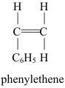
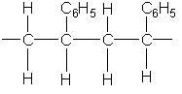
Draw a section of the poly(styrene) polymer chain formed from two monomer units.

position of hydrogen atoms and phenyl groups (1)
Allow phenyl groups on 2nd and 3rd carbon OR 1st and 4th OR 1st and 3rd
carbon carbon single bonds and continuation bonds (1)
second mark not awarded for incorrect monomer
(2)
Do not write in the margin

(e) The table below shows some data used in a life cycle analysis of polystyrene and paper drinking cups.
 | Paper Cup | Polystyrene Cup
Raw Materials (per cup)
Wood or bark | 26 g | 0 g
Petroleum fractions | 2.2 g | 3.4 g
Energy used (per tonne of  material made) | 980 kWh | 280 kWh
Water released into  environment (per tonne of  material made) | 120 m3 | 2.5 m3
Air emissions (per tonne
of material made)
Chlorine / chlorine dioxide | 0.4 kg | 0 kg
Sulfides / sulfur dioxide | 11 kg | 3.5 kg
Hydrocarbons | 0 kg | 40 kg
(i) Some people argue that using a polystyrene cup has less environmental impact than using a paper cup.
Choose TWO pieces of data to support this argument, explaining your choices.
Any two (raw material for) paper cup requires cutting down trees (1)
polystyrene cup uses less energy (280 kWh rather than 980 kWh) to produce so less CO2 released / less fossil fuels (1)
polystyrene cup releases less sulfur based compounds into air so less chance of forming acid rain / less chance of damaging buildings / acidifying lakes (produces 3.5 kg rather than 11 kg) (1)
polystyrene cup releases no chlorine compounds which damages ozone layer / poisonous (produce 0 kg rather than 0.4 kg) (1)
2 pieces of data chosen with no explanation allow 1 mark
Ignore comments regarding water (2)
(ii) Suggest TWO further pieces of information, not given in the table, regarding the life cycle of the cups that would make any assessment of the environmental impact more reliable.
e.g. ease of recyclability whether cup is easy to reuse space taken up in landfill type and amount of gases formed if incinerated useful heat obtained if incinerated biodegradeability / how long they take to decompose management of gases produced during decomposition durability / how long the cup lasts method of disposal
Ignore comments regarding atom economy
Ignore comments regarding acid rain / ozone layer / greenhouse gases unless linked to gases produced during disposal (2)
(Total 22 marks)
Do not write in the margin

NAME ...........................……... HOMEWORK DEADLINE .....................
Student Number ………… Chemistry Class ………
Student targets from previous pack

Alkenes and polymers
Task | Mark
Notes | /10
Bestchoice online tutorial | /223
Revision Notes /Summary page | /10
Structured exam questions | %
Overall Grade for this work | A B C D E U
Student comments

Tutor comments

Tutor signature Date

Student targets for next pack

