Name …………………………… Chemistry Class ………….
Alcohols answers

Topic 6E: Alcohols

37. know that alcohols can be classified as primary, secondary or tertiary

38. understand the reactions of alcohols with:
i oxygen in air (combustion)
ii halogenating agents:
PCl5 to produce chloroalkanes
50% concentrated sulfuric acid and potassium bromide to produce bromoalkanes
red phosphorus and iodine to produce iodoalkanes
iii potassium dichromate(VI) in dilute sulfuric acid to oxidise primary alcohols to aldehydes (including a test for the aldehyde using Benedict’s/Fehling’s solution) and carboxylic acids, and secondary alcohols to ketones In equations, the oxidising agent can be represented as [O].
iv concentrated phosphoric acid to form alkenes by elimination
Descriptions of the mechanisms of these reactions are not expected.

39. understand the following techniques used in the preparation and purification of a liquid organic compound:
i heating under reflux
ii extraction with a solvent in a separating funnel
iii distillation
iv drying with an anhydrous salt
v boiling temperature determination

CORE PRACTICAL 5: The oxidation of ethanol

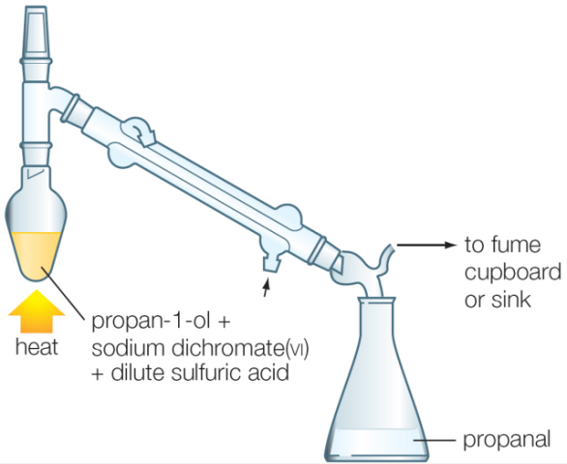


THE ALCOHOLS

REFERENCES
Facer AS Chemistry Ch14 p259 -265

Factsheets on Godalming online
15 | Organic Chemistry I - Nomenclature
16 | Organic Chemistry II – Reactions I
91 | Naming of Organic Compounds

Websites:-

http://www.chemguide.co.uk/organicprops/alcoholmenu.html#top
A good coverage of the topic for AS level

http://www.chem.ucalgary.ca/courses/351/Carey5th/Ch04/ch4-0.html
An outline of nomenclature and physical properties

Finally some quizzes on hydrocarbons:-
These are all suitable
http://www.mp-docker.demon.co.uk/as_a2/topics/hydrocarbons/index.html

Finally some quizzes on alcohols:-
These are all suitable
http://www.mp-docker.demon.co.uk/as_a2/topics/naming_and_classifying_alcohols/index.html

Ethanol based reaction schemes:-
http://www.mp-docker.demon.co.uk/as_a2/topics/reaction_schemes_ethanol/index.html

http://www.mp-docker.demon.co.uk/as_a2/topics/oxidation_of_alcohols/index.html

ALCOHOLS
General formula of alcohols: C_{n}H_{(2n+1)}OH Functional group: -O-H
Three types of alcohols can be identified: (Note: R = an alkyl group C_{n}H_{2n+1})

Primary (1º) Secondary(2º) Tertiary (3º)
Primary alcohol. The OH group is attached to a C atom attached to only ONE alkyl group.
Secondary – C atom attached to TWO alkyl groups.
Tertiary – C atom attached to THREE alkyl groups


Use the model kits to make models of the following molecules.
Draw out the full structural (displayed) formulae.
Primary alcohols | Secondary alcohols
Methanol
Ethanol
Propan-1-ol | Propan-2-ol
Butan-1-ol | Butan-2-ol
Pentan-1-ol | Pentan-2-ol  OH | Pentan-3-ol  OH
Alcohols with 4 carbon atoms or more exist also as tertiary isomers.
Draw full structural formulae and name the following:
Tertiary isomer of butanol  OH  Name: .2-methylpropan-2-ol  Structure: | Tertiary isomer of pentanol  OH  Name: 2-methylbutan-2-ol  Structure:
See quiz naming alcohols
PHYSICAL PROPERTIES OF ALCOHOL
Facer AS Chemistry p259 - 260
Although short chain alkanes and alkenes of similar molecular mass are gases at room temperature and pressure, alcohols are LIQUIDS

Draw the displayed structure of ethanol to show the lone pair of electrons on the oxygen atom.
The most electronegative atom present is oxygen
Show the distribution of charge on the O-H group using δ+ and δ-
Draw a second molecule orientated to show the type of intermolecular force which arises.
Identify the intermolecular forces between alcohol molecules

Examine the graph of boiling points of alkanes and alcohols:-

Why are alcohols less volatile than the corresponding alkane?

OH, hydroxyl group can make H-bonds between adjacent molecules.

These are stronger than the London forces between alkanes

So more heat energy is required to overcome them, leading to higher B Pts.

Draw a diagram to show the hydrogen bonding between a methanol molecule and a water molecule.

Explain why hydrogen bonding accounts for the fact that methanol, at room temperature, is a liquid that mixes freely with water, while ethane is a gas which is insoluble in water.

Both have similar number of electrons and London forces

Methanol can form H-bonds with water so mixing with it.

Ethane can only form weaker London forces so cannot disrupt the H-bonds between the water molecules.
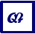
Facer p281 – 282 Questions 3 and 7
Reactions of the Alcohols Refer to: Facer p261 - 265
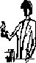
HIGHLY FLAMMABLE
1) Combustion.
Alcohols are fuels. They burn in excess oxygen to produce carbon dioxide and water
Balance the equation for the complete combustion of methanol:-

CH₃OH + 2 ½ O₂ → CO₂ + 2H₂O

Give the equation for the complete combustion of propan-1-ol:-

CH₃CH₂CH₂OH + 4½O₂ → 3CO₂ + 4H₂O

Put a small amount of alcohol (1 cm³) onto a watch glass. Light it with a taper. What do you notice about the flame compared to a hydrocarbon burning?
Colourless flame (yellow at top) not at all smokey.
Demonstration of burning £5 – Classic Chemistry 30. What happens - and why?
£5 had a surface flame only, pre-soaking in ethanol / water allowed more volatile ethanol to burn and the water soaked into the paper preventing it from igniting.

2) Elimination of alcohols to form alkenes

Elimination reaction is the removal of one or more groups or atoms from adjacent C atoms forming an unsaturated molecule.

Dehydration is the removal of a water molecule – water is the only inorganic product formed in the reaction

Alcohols react with concentrated phosphoric acid to form alkenes by an elimination reaction, forming water – this can also be classed as a dehydration reaction.

Write the equation for the elimination of a water molecule from propan-1-ol in the presence of phosphoric acid (the hydrogen and alcohol group need to be removed from adjacent carbons:

CH₃CH₂CH₂OH → CH₃CH=CH₂ + H₂O

Write an equation to show the 3 possible organic products for the reaction between butan-2-ol and phosphoric acid:

CH₃CH₂CH(OH)CH₃ → cisCH₃CH=CHCH₃ + H₂O
CH₃CH₂CH(OH)CH₃ → transCH₃CH=CHCH₃ + H₂O
CH₃CH₂CH(OH)CH₃ → CH₃CH₂CH=CH₂ + H₂O

3) The reactions of alcohols to form halogenoalkanes - Nucleophilic substitution
Alcohols react with phosphorous pentachloride PCl₅ or conc. HCl to form chloroalkanes.
This is an example of a nucleophilic substitution reaction.
Nucleophile
An electron rich species with an available lone pair of electrons
May be negatively charged
Reacts by donating a pair of electrons to form a new covalent bond to a carbon atom.

Substitution reaction
Where one group replaces another in a molecule e.g. when an alcohol forms a chloroalkane . OH group is replaced by Cl atom

Chlorination
PCl₅ or conc. HCl can be used to prepare a chloroalkane from the corresponding alcohol
Write the equation for the reaction of ethanol with HCl:
CH₃CH₂OH(l) + HCl(aq) → CH₃CH₂Cl(l) + H₂O(l)
See p6 for PCl₅ + alcohol reaction, observations and equations. Reaction with PCl₅ is important as a test for a covalently bonded -OH group in organic chemistry. (do not get this confused with the OH⁻⁻ ion)

Bromination

The alcohol is heated under reflux with KBr and 50% conc. sulfuric acid.
This produces HBr which reacts ‘in situ’. You will carry out this reaction later.
Write the equation for what happens between KBr and H₂SO₄:

KBr + H₂SO₄ → KHSO₄ + HBr

Write the equation between HBr and Propanol:

HBr + CH₃CH₂CH₂OH → CH₃CH₂CH₂Br + H₂O
………………………………………………………………………………………………..

Iodination

Heat alcohol with moist red phosphorus and iodine. This produces PI₃ ‘in situ’.
Write the equation between methanol and PI₃.

3 CH₃OH + PI₃ → 3 CH₃I + H₃PO₃

4) The oxidation of alcohols.
Alcohols are oxidised by heating with potassium or sodium dichromate in 50% sulphuric acid. Write a half ionic equation for the reduction of Cr₂O₇²⁻ ions to Cr³⁺ ions in acidic solution:- +6 +3
Cr₂O₇²⁻ + 14H⁺ + 6e⁻ → 2Cr³⁺ + 7H₂O
Orange green

The degree of oxidation of the alcohols depends on the type of alcohol (i.e. primary secondary tertiary).
Primary alcohols are oxidised to an aldehyde and then with excess oxidising agent to a carboxylic acid. (extension on aldehydes and ketone)
Note; for organic reactions we can represent the oxidising agent as [O]
Write a reaction for the oxidation of propan-1-ol to propanal then to propanoic acid using displayed formulae
[O] [O]

propan-1-ol propanal propanoic acid
Secondary alcohols
Secondary alcohols are oxidised to ketones and no further. E.g. Write the reaction for the oxidation of propan-2-ol to propanone using displayed formulae

[O]

Tertiary alcohols
Tertiary alcohols cannot be oxidised under normal conditions. Explain why not. The carbon atom to which the –OH group is attached must also have an H atom attached
Learn the functional groups for aldehydes, carboxylic acids and ketones show below.
Put a ring round the H atoms that are involved in the oxidation-
oxidation
oxidation

primary alcohol aldehyde carboxylic acid

oxidation

secondary alcohol ketone

tertiary alcohol
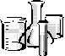
CHEMICAL REACTIONS OF THE ALCOHOLS - OXIDATION
OXIDISING
HIGHLY FLAMMABLE
CORROSIVE
Identify the hazards associated with each of the following symbols
ethanol
propan-1-ol
H₂SO₄
K₂Cr₂O₇

METHOD | OBSERVATIONS | INFERENCES
OXIDATION REACTION  (PRIMARY ALCOHOL)  Add 10 drops of dilute sulfuric acid and 5 drops of potassium dichromate(VI) solution to 5 drops ethanol.  Mix and warm in a water bath.  Write ionic half equations  Oxidation equation  Reduction equation  Identify the organic product | Orange dichromate solution turned blue rapidly  CH₃CH₂OH → CH₃CHO + 2H⁺ + 2e⁻  Ethanal  CH₃CHO + H₂O → CH₃COOH + 2H⁺ + 2e⁻  ethanoic acid  Cr₂O₇²⁻ + 14H⁺ + 6e⁻ → 2Cr³⁺ + 7H₂O | Orange Cr(VI) reduced to blue Cr(III) Redox reaction  Ethanol can be oxidised  Primary alcohols can be oxidised to ALDEHYDES  Or to further oxidised to form CARBOXYLIC ACIDS
(SECONDARY ALCOHOL)  Add 10 drops of dilute sulfuric acid and 5 drops of potassium dichromate(VI) solution to 5 drops propan-2-ol.  Mix and warm in a water bath.  Write ionic half equations  Oxidation equation  Reduction equation  Identify the organic product | Orange dichromate solution turned green then blue slowly  CH₃CH(OH)CH₃ → CH₃COCH₃ +2H⁺ +2e⁻  propanone  Cr₂O₇²⁻ + 14H⁺ + 6e⁻ → 2Cr³⁺ + 7H₂O | Orange Cr(VI) reduced to blue Cr(III) Redox reaction  Propan-2-ol can be oxidised  SECONDARY ALCOHOLS can be oxidised to KETONES
(TERTIARY ALCOHOL)  Repeat the test with 5 drops of  2-methylpropan-2-ol | Orange dichromate solution remains orange | No redox reaction  Tertiary alcohols not oxidised
CHEMICAL REACTIONS OF THE ALCOHOLS - TEST FOR THE –OH GROUP
HIGHLY FLAMMABLE
CORROSIVE
ethanol
propan-1-ol
PCl₅
HCl
Identify the hazards associated with the following symbols

METHOD | OBSERVATIONS | INFERENCES
TEST FOR THE –OH GROUP  Work in a fume cupboard  Add a little phosphorus pentachloride to 10 drops of ethanol in a dry test tube.  Collect some of the fumes in a test pipette and identify them by bubbling them through  silver nitrate solution.  Write:-  Equation for result with Ag⁺ solution.  Equation for the reaction with PCl₅  identify the organic product | PCl₅ pale yellow solid  Added to dry sample  Effervescence, became warm, steamy fumes evolved  Silver nitrate formed white ppt.  Ag⁺(aq) + Cl⁻(aq) → AgCl(s)  CH₃CH₂OH + PCl₅ → CH₃CH₂Cl +  HCl(g) + POCl₃  Chloroethane produced | Gas evolved  Possibly HCl(g)  Ppt of AgCl  So gas was HCl  So -OH group present  could be water, alcohol or carboxylic acid.

OXIDATION OF ETHANOL TO ETHANAL

(PRIMARY ALCOHOL OXIDISED TO AN ALDEHYDE)

Problem: Primary alcohols are oxidised in two steps, first to an aldehyde and then to a carboxylic acid. The conditions of this experiment are designed to stop the oxidation at the first step.
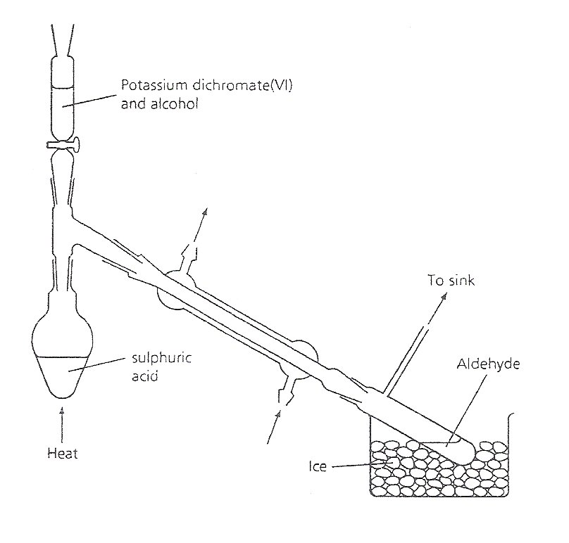
Oxidising agent: acidified potassium dichromate.
sulfuric acid
CORROSIVE
Conc.H₂SO₄
Water out (to sink)
Water in
(from tap)
Allow space for micro burner
Grease all joints
Clamp on condenser
Clamp on
neck of flask
Still head adaptor
Some practical hints and tips shown
HIGHLY FLAMMABLE

ethanol

OXIDISING
Sodium dichromate

X
X
X
TOXIC
X

Sodium dichromate

On the apparatus above:-
- label the pieces of quickfit glassware
- label water flow direction
- show the positions of the clamps with a X
- Write beneath each hazard symbol the name of the chemical(s) it applies to

1) First partner: Put 5 cm³ distilled water into a pear - shaped flask. Very cautiously add 2 cm³ concentrated sulfuric acid drop by drop to the water, swirling and cooling in an ice bath after each addition. Add a few anti - bumping granules to the flask.

2) Second partner: Weigh approximately 5g sodium dichromate(V1) into a small beaker and dissolve it in 5 cm³ distilled water. Add 4 cm³ ethanol and put this mixture into a dropping funnel.

3) Working together, set up the apparatus as shown in the diagram. Pass a stream of cold water through the condenser and surround the receiver vessel with a mixture of ice and water.

4) Using a micro-burner, heat the sulfuric acid gently at first, then more strongly until it is boiling. Remove the flame, and allow the ethanol/dichromate mixture to drip slowly into the contents of the pear -shaped flask. The reaction is exothermic so it should continue boiling, but it may be necessary to warm the mixture gently towards the end of the addition process.

5) When the addition is complete, a small volume of aqueous ethanal will have distilled over into the receiver. (Boiling point of ethanal is 21°C). Note the characteristic smell.

6) Transfer it to a stoppered bottle for confirmatory test.
Write half equations:-
Oxidation of ethanol to ethana1:
CH₃CH₂OH → CH₃CHO + 2H⁺ + 2e⁻
Reduction of acidified Cr(VI) to Cr(III):
Cr₂O₇²⁻ + 14H⁺ + 6e⁻ → 2Cr³⁺ + 7H₂O
Total redox reaction:
3CH₃CH₂OH + Cr₂O₇²⁻ + 8H⁺ → 3CH₃CHO + 2Cr³⁺ + 7H₂O
Why is ethanal distilled off as fast as it forms?
Reaction vessel is about 90º C which is considerably above the B Pt. of ethanal (21º C) so distills immediately
What happens when the alcohol / dichromate mixture is added to the hot sulfuric acid?
Exothermic reaction, orange Cr₂O₇²⁻(aq) is reduced to green Cr³⁺(aq)
Why is the distillate cooled in an ice bath?
B Pt of ethanal is below room temperature.
Name three impurities which contaminate the ethanal distillate and explain where they come from.
Ethanol (B.Pt 78º C) – unreacted reagent
Water – H-bonded to ethanal
Ethene (B.Pt -104º C) – dehydration of an alcohol with excess acid 170º C
(Ethoxyethane (B.Pt 34º C) – under acid conditions CH₃CH₂OH + H⁺→ CH₃CH₂⁺ + H₂O At 140º C with excess ethanol, CH₃CH₂⁺ + CH₃CH₂OH → CH₃CH₂O CH₂CH₃ DO NOT WORRY ABOUT THIS ONE)
Not Ethyl hydrogen sulphate(s) – reaction of ethanol with cold H₂SO₄
Ethanoic acid (B.Pt 114º C)
How would you obtain pure ethanal from the impure, aqueous solution?
Fractional distillation
Collect fraction B.Pt. 19 -23º C
Shake with drying agent e.g. anhydrous Na₂SO₄
In a test tube mix 1 cm³ Fehling’s A solution and 1 cm³ Fehling’s B solution. Add a few drops of your sample mix and warm in a water bath.
This is a test for an aldehyde.
NOTE
Fehlings warmed with a ketone = stays blue
Colour of Fehling’s A and B mixed before test dark blue solution
Observations solution gradually forms red ppt. so aldehyde present
Additional test: Addition of orange (2,4 DNP)2,4-dinotrophenylhydrazine forms a yellow/orange ppt.
This confirms that there is an aldehyde present

In many organic reactions, the materials are refluxed in order to increase the yield and improve the conversion of reactants to products. .Your teacher will show you the apparatus for boiling under reflux and explain this. Why is ethanol not refluxed with the oxidising agent in this case?
To avoid further oxidation of ethanal to ethanoic acid.

Oxidation quiz
Worksheets ‘Test yourself on alcohols’
‘Extension questions’
Facer AS Chemistry p282 questions 8, 9, 14, 15, and 16.
OXIDATION OF ETHANOL TO ETHANOIC ACID
(PRIMARY ALCOHOL OXIDISED TO A CARBOXYLIC ACID)
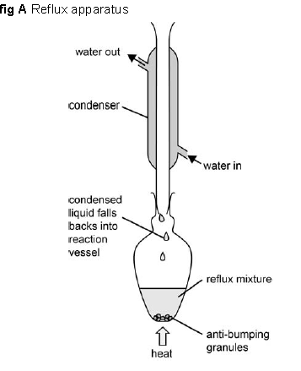
CORROSIVE

H₂SO₄

HIGHLY FLAMMABLE

CH₃CH₂OH

OXIDISING
K₂Cr₂O₇

TOXIC
K₂Cr₂O₇.

On the apparatus above:-
- label the pieces of quickfit glassware
- label water flow direction
- show the positions of the clamps with a X
- Write beneath each hazard symbol the name of the chemical(s) it applies to

Method
- Carefully add 10cm³ of the acidified dichromate solution to a 50 ml pear shaped flask. Cool the flask in a cold water bath.
- Set up the apparatus for reflus (see fig A)
- Mix 2cm³ of ethanol with 5 cm³ of water.
- Usig a pipette slowly add the ethanol solution down the reflux condenser
- Using a micro burner heat the solution so that it refluxs for approx. 15 min
- Allow the equipment to cool and collect your sample for distilling and testing next lesson

Next lesson

Purifying sample
Set up apparatus as in fig b
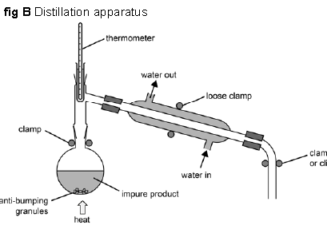

Distill your product using the apparatus above. Collect anything that boils between 114 C and 120 C

Split your distillate into 3 portions and test as follows

- Add a few drops of indicator
The solution turns pink/red indicating an acid is present (H⁺ ions)

- Add a spatula of calcium carbonate
The solution fizzes as the carboxylic acid reacts with the carbonate
CaCO₃ + 2CH₃COOH → CO₂ + H₂O + (CH₃COO⁻)₂Ca²⁺

- Add a small piece of magnesium ribbon
The solution fizzes as the reactive metal reacts with the acid
Mg + 2CH₃COOH → H₂ + (CH₃COO⁻)₂ Mg²⁺

Heating under reflux and simple distillation

In the box below draw the apparatus you would use for Heating under reflux.

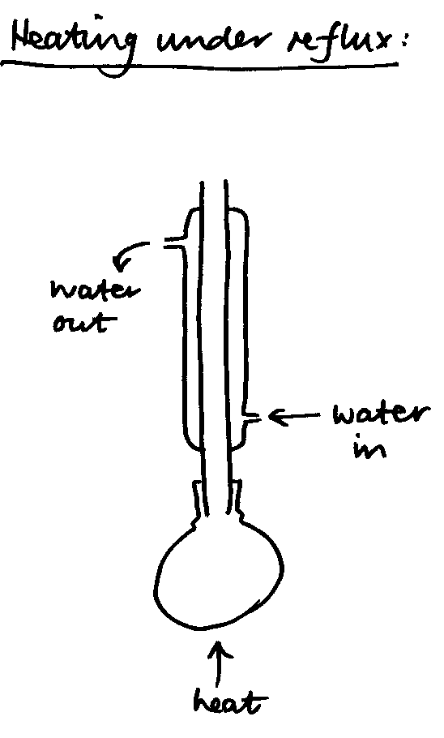

Heating under reflux enables a mixture including volatile materials to be heated for a long time without loss of solvent. The system is designed to keep materials in the flask - it follows, therefore, that any apparatus attached to the top of the condenser is redundant.
Notes:
- The water goes in at the bottom of the condenser
- There must not be a stopper in the top of the condenser - the apparatus must not be sealed.
- There must not be a thermometer in the top of the condenser, partly for the same reason as above but also because it wouldn't measure the temperature of anything that mattered. The vapour doesn't get that far.

In the box below draw the apparatus you would use for simple distillation
Notes:
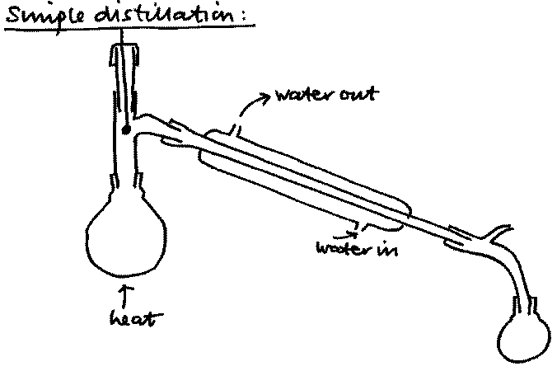
- The bulb of the thermometer is opposite the exit to the condenser. You want the temperature of the exit vapours since it is these that will condense.

- The delivery bend is vented so that when the apparatus is heated the joints aren't pushed apart by expanding gas. Never draw a closed apparatus.

- Water goes in at the bottom of the condenser jacket and out at the top.
Note the structure of the condenser - the water jacket is separate from the tube down the middle!
Which of the above methods would be suitable for oxidising Propan -1-ol to Propanal. Justify your answer
Simple distillation. The aldehyde must be distilled over as soon as it forms to prevent further oxidation to the carboxylic acid

Purifying an organic liquid.
Once the aldehyde/carboxylic acid/ketone has been made in the reaction vessel it needs to be separated from the rest of the solution – which may contain impurities such as unreacted reactants and side products.
There are several ways to do this, or all of them may be used:

- Solvent extraction
- A separating funnel is used, the reaction mixture is put into this and another solvent which is immiscible (insoluble) in the reaction mixture, so two layers are seen.

- The desired product must also be more soluble in the new solvent added

- The idea is that the product will move into the new solvent and any impurities will remain behind in the original reaction mixture.

- Then the two layers are ‘tapped off’ and the desired layer kept.

- Fractional distillation
Good to use when the difference between the boiling points of substances is small.
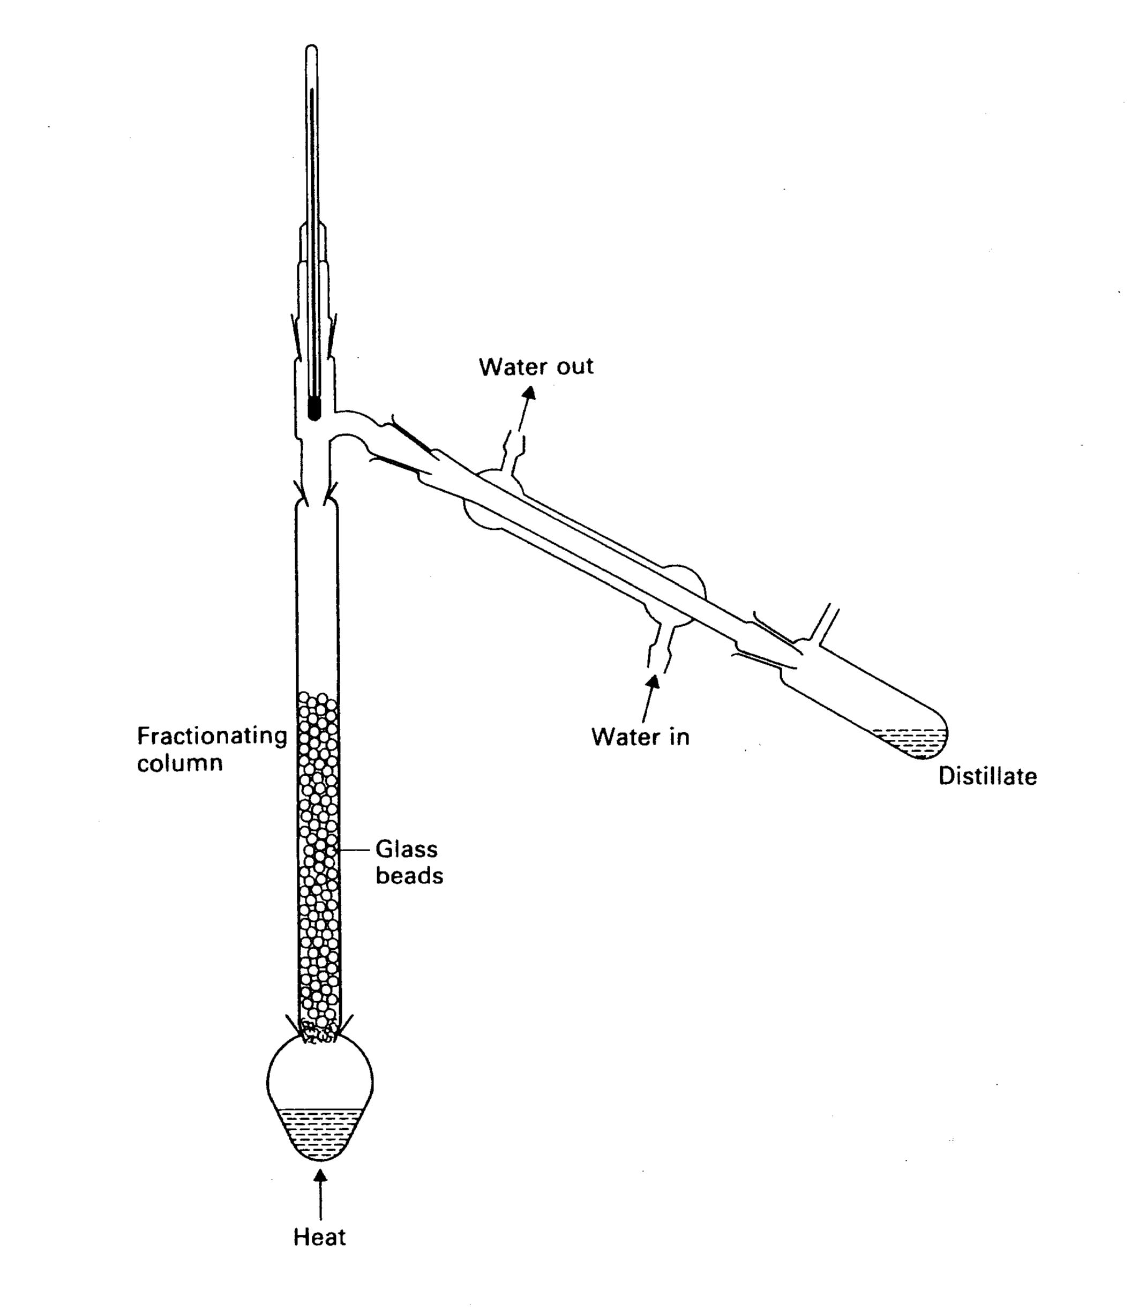

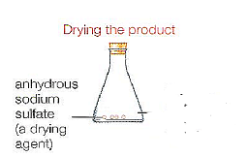
- Drying

Even after distillation and solvent extraction water can still be present in liquid products.
To remove water we use a ‘drying agent’ this can be silica, or an anhydrous salt such as anhydrous calcium/magnesium or sodium sulfate, - they absorb the water molecules in the liquid and the solid is easily removed by filtration.

Revision of Alcohols – make a summary:-
- Primary, secondary, tertiary and their identification
Look at C atom to which OH is attached, number of alkyl groups → 1ry, 2ry or 3ry.

- Intermolecular forces diagram

H-bonds from lone pair on O or ^{δ+}H attached to O
Alkyl groups → London forces

- Physical properties
Liquids with higher than expected BPts (H-bonding)
Miscible with water in all proportions (H-bonding)

- Test for OH group
Add PCl₅ to dry sample. Effervescence and gas → white smoke with NH₃
or white ppt with AgNO₃
- Reactions:-
(draw out appropriate structures, name them and put in reagents and conditions beside the arrows)

Oxidation
K₂Cr₂O₇/dil H₂SO₄
Heat + distil.
K₂Cr₂O₇/dil H₂SO₄
Heat + reflux.
ethanol

ethanal

ethanoic acid

oxidation
oxidation

primary alcohol aldehyde carboxylic acid

K₂Cr₂O₇/dil H₂SO₄
Heat + reflux.
propan-2-ol

propanone

oxidation

secondary alcohol ketone

2-methylpropan-2-ol

tertiary alcohol

Spider diagram of alcohols reactions

ethanal
PCl₅ room temp
Or HCl conc.
K₂Cr₂O₇/dil H₂SO₄
Heat + distil.
chloroethane
OXIDATION
SUBSTITUTION
ALDEHYDES
H A L O G E N O A L K A N E S
KBr + conc H₂SO₄
Heat under reflux
Ethanol
K₂Cr₂O₇/dil H₂SO₄
Heat under reflux.
ALCOHOLS

bromoethane
ethanoic acid

I₂ and red P →PI₃
Heat under reflux
CARBOXYLIC ACIDS
Concentrated phosphoric acid

Elimination / dehydration

iodoethane

ethene

On the diagram above using different colours
- State the homologous series of each product
- Write the displayed formulae
- Put the reagents and conditions beside the arrows
- Classify the reactions as oxidation or substitution

Multiple Choice Exam Questions
1. Which of these is a tertiary alcohol?
W09.2.04
A 3-methylpentan-2-ol
B Pentan-2-ol
C Pentan-3-ol
D 2-methylpentan-2-ol
(Total 1 mark)

2. The best method of converting ethanol, C2H5OH, into iodoethane, C2H5I, is to
A heat iodine and ethanol under reflux.
S10.2.14
B react ethanol and potassium iodide in the presence of dilute acid.
C heat potassium iodide and ethanol with concentrated sulfuric acid.
D heat red phosphorus, ethanol and iodine under reflux.
(Total 1 mark)

3. An organic compound is found to react with sodium metal and to react with acidified sodium dichromate(VI), but not to decolourise bromine water, nor to neutralise sodium carbonate solution. The liquid could be
SP.2.18
A ethanol
B ethane
C ethanoic acid
D ethene
(Total 1 mark)

Do not write in the margin

Structured Questions
1. Five formulae of alcohols with the same molecular formula, C4H10O, are shown below.
W05N.1.05 part
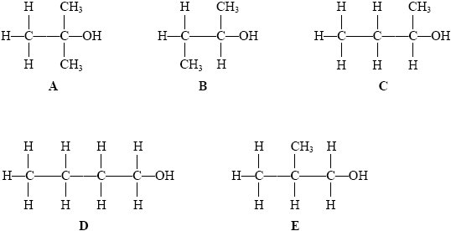
(a) What is the name given to organic compounds with the same molecular formula, but different structural formulae?
Isomer(s)
(1)
(b) Which TWO of the formulae, A to E, represent the same alcohol?
B and C
(1)
(c) Which formula represents a tertiary alcohol?
A
(1)
(d) Name alcohol A.
2-methylpropan-2-ol
(1)
(e) Which TWO of the alcohols, A to E, can be each readily oxidised to a carboxylic acid?
D and E
(2)
(Total 6 marks)
Do not write in the margin

For help with practical details of this refer to Facer p321 – 322

2. In an experiment to prepare iodoethane, solid moist red phosphorus is placed into a flask to which ethanol is added. The flask is then arranged as shown in Apparatus I.
S07C.3B.06
20.0 g of powdered iodine is then added to the flask in small portions. Before each addition the condenser is removed, the iodine is added and the condenser is immediately replaced. At least two minutes must be allowed between additions of iodine.
When all the iodine has been added, the flask is allowed to stand for about 10 minutes and is then heated for an hour in Apparatus I.
2P + 3I2 → 2PI3
3CH3CH2OH + PI3 → 3CH3CH2I + H3PO3
The iodoethane is then removed from the reaction mixture, purified and dried. A final purification is then carried out using Apparatus II. Iodoethane is collected over a narrow temperature range.
Apparatus I Apparatus II
Data
Ethanol: colourless liquid, flammable, boiling temperature 78 °C
Iodoethane: colourless liquid, flammable, boiling temperature 72 °C
(a) (i) Give the name of the practical technique carried out in each apparatus shown above.
Apparatus I . (heating under) reflux.
Apparatus II distillation not fractional distillation
(2)
(ii) Explain why it is important that a stopper should not be placed in the top of the condenser in Apparatus I.
(expansion of vapour will) build up pressure
(1)
Do not write in the margin

(b) (i) Suggest a reason why the iodine is added in small portions and over a period of time.
Reaction is vigorous
OR exothermic
OR (very) fast or violent.
(1)
(ii) Give ONE reason why water baths are used in both Apparatus I and Apparatus II, rather than heating the flasks directly with a Bunsen flame.
(One or both of) the liquids flammable
OR ethanol is flammable
OR iodoethane is flammable
OR ethanol and iodoethane are flammable
(1)
(iii) Why is the reaction mixture in Apparatus I heated for such a long time after all the iodine has been added?
To allow reaction to reach completion
OR reaction is slow
OR reaction has high activation energy
(1)
(iv) Suggest the readings on the thermometer in Apparatus II between which iodoethane should be collected.
From .......... 70 to 71............... to ............. 73 to 74............°C
(1)
(c) (i) Calculate the amount (moles) of iodine molecules, I2, in 20.0 g of iodine.
20.0= 0.0787 (moles)
254
(1)
(ii) Calculate the maximum mass of iodoethane that would be formed from 20.0 g of iodine.
[molar mass iodoethane = 156 g mol–1]
1 mol I2 → 2 mol C2H5I (1)
Answer to (i) × 2 × 156 = 24.6 / 24.55 / 24.57 (g) (1)
(2)
(iii) In such a preparation, the yield of iodoethane was 16.7 g. Calculate the percentage yield.
16.7× 100 = 67.9 / 67.98 / 68.0 (%)
24.6
(1)
(Total 11 marks)
Do not write in the margin

3. This question is about organic compounds with the molecular formula C3H8O.
(a) Draw the structural formulae of the two isomers with molecular formula C3H8O which are alcohols. Give the names of these alcohols.
SP.2.25
Alcohol 1 Alcohol 2
Structural
formula CH3CH2CH2OH (1) CH3CH(OH)CH3 (1)

Name Propan-1-ol (1) Propan-2-ol (1)
(4)
(b) Primary alcohols can be oxidised to carboxylic acids.
(i) Give the name and structural formula of the carboxylic acid formed when the primary alcohol C3H8O is fully oxidised.
Name Propanoic acid (1)
Structural formula

CH3CH2CO2H (1)

(2)
(ii) State the reagents used for this oxidation.
Reagent 1 . Either
sodium dichromate (VI)
or potassium manganate(VII) (1).
Reagent 2 (dil) Sulfuric acid (1)
(2)
(Total 8 marks)
Do not write in the margin

4. Butan-1-ol is a primary alcohol with the formula CH3CH2CH2CH2OH.
(a) Butan-1-ol can be converted into an aldehyde.
W06N.1.05
(i) What type of reaction is this?
Redox ALLOW oxidation / partial oxidation
(1)
(ii) Give the names or formulae of the TWO reagents you would mix with butan-1-ol to carry out this reaction.
Sodium or potassium dichromate ((VI)) / Na2Cr2O7 / K2Cr2O7 (1)
Sulphuric acid / H2SO4 dilute or concentrated (1).
(2)
(iii) What colour change would you see when the reaction occurs?
From Orange to green / blue / blue green
(1)
(iv) Draw a labelled diagram showing the apparatus you would use to carry out this reaction and collect the product.

Arrow is enough to show heat
Pear-shaped/round bottomed flask/tube with side arm +
reagents/reaction mixture + heat (1)
Side-arm from adaptor/delivery tube from side-arm
tube/condenser + collecting vessel (1)
–1 for poor drawing e.g. line not tube, sealed apparatus, open at top, collecting under water, large gaps in equipment, one-piece equipment (i.e. flask must be separate from rest)
IF condenser used ignore water direction
No marks if refluxed/apparatus would not work

(2)
Do not write in the margin

(v) Draw the displayed formula of the aldehyde that forms.

(1)
(vi) An isomer of butan-1-ol produces butanone if treated as in (ii).
How would you distinguish the aldehyde from butanone?
Name the reagent you would use and state your observation with each
compound.
Reagent Fehling’s solution (+ heat).
Observation with aldehyde Red/brick-red (precipitate).
Observation with butanone Stays blue (solution)
(3)
(b) Draw the displayed formula of another primary alcohol which is an isomer of
butan-1-ol, and name it.

Name (2-)methylpropan-1-ol.
(2)
(Total 12 marks)
Do not write in the margin

5. (a) A compound Q has the composition (by mass) of 68.2% C, 13.6% H and 18.2% O.
It has a relative molecular mass of 88.
(i) Find the empirical formula of Q.
W03C.2.03 part. (NB changed compound ID)
C H O
68.2/12 13.6/1 18.2/16 ÷ by A, (1)
5.68 13.6 1.14 ÷ by smaller (1)
5 12 1
formula C5H12O(1)

(3)
(ii) Deduce the molecular formula of Q.
Empirical formula mass = 88 = Molar mass (1)
Thus C5H12O (1)
(2)
(b) Compound Q is an alcohol, which can be tested for with phosphorus pentachloride, PCl5.
(i) Using the symbol ROH to represent compound Q, write an equation to show how it reacts with PCl5.
ROH + PCl5 → RCI + HCl + POCl3
(1) for HCl, (1) for the rest

(2)

(ii) What would you see as the test is performed?
(Effervescence and) steamy / misty / fumes (1)
(1)
(c) (i) Draw a full structural formula for Q that is a branched-chain primary alcohol.
Any of
2-methylbutan-1-ol,
3-methylbutan-1-ol,
2,2-dimethylpropan-l-ol. (2)

(2)
Do not write in the margin

(ii) Draw the full structural formula of the compound that would be obtained if the primary alcohol in (c) (i) were to be oxidised so that the product distils over as it is formed.
Structure of the aldehyde consequent on the alcohol in (i) (1)
Mark CQ on the structure of the compound in (i), so if a 2° alcohol 1
appears it must be a ketone, if a 3° alcohol no product or distils
over. Carboxylic acid scores zero
(1)
(iii) Suggest a suitable oxidising mixture for the reaction in (c) (ii).
Potassium (or sodium or ammonium) dichromate(VI) (1)
and sulphuric acid (1)
(2)
(iv) State what type of organic compound would be formed if the reaction in (c)(ii) were heated under reflux.
Carboxylic acid (1) Consequential
(1)
(Total 14 marks)
Do not write in the margin

6. This question is about the reactions of a compound Z, CH3CH(OH)CH3.
(a) Name compound Z.
S06N.1.4A part
Propan-2-ol
(1)
(b) Explain, in terms of its structure, why Z is classified as a secondary alcohol.
Contains or fully displayed
OR carbon carrying OH / hydroxyl / “hydroxide” group attached to two other carbons/ two other methyl groups/ one other hydrogen ALLOW contains CHOH/CH (OH)
(1)
(c) Write an equation for the complete combustion of Z using the molecular formula for Z. State symbols are not required.
C3H8O + 4½O2 → 3CO2 + 4H2O
(2)

(e) A few drops of Z were put in a boiling tube with a mixture of sodium dichromate(VI) solution and dilute sulphuric acid and the mixture was warmed gently until a reaction occurred.
(i) What colour change would be observed?
From . Orange. to ........ green/blue.........................
(1)
(ii) Draw the displayed formula of the organic product of this reaction and name it.

Name Propanone
(2)
(iii) A pure sample of the organic product was mixed with Benedict’s solution. State the colour of the mixture after it was warmed.
Blue / light blue
(1)
(Total 8 marks)
Do not write in the margin

2016
NAME ...........................……... HOMEWORK DEADLINE .....................
Student Number ………… Chemistry Class ………
Student targets from previous pack

Alcohols

Task | Mark
Notes | /10
Revision Notes /Summary page | /10
Structured Exam questions | /61 = %
Overall Grade for this work | A B C D E U

Student comments

Tutor comments

Tutor signature Date

Student targets for next pack

