**NAME ............................................ Chemistry Class ...........................**

**Student Number ………**

Energetics

In Thiemann’s fuel calorimeter, a supply of oxygen ensures complete combustion, and heat loss to the air is reduced

**answers**

**Topic 5: Formulae, Equations and Amounts of Substance**

12. be able to:

i calculate measurement uncertainties and measurement errors in experimental results

ii comment on sources of error in experimental procedures

13. understand how to minimise the percentage error and percentage uncertainty in experiments involving measurements

**Topic 8: Energetics I**

1. know that standard conditions are 100 kPa and a specified temperature, usually 298 K

2. know that the enthalpy change is the heat energy change measured at constant pressure

3. be able to construct and interpret enthalpy level diagrams showing an enthalpy change, including appropriate signs for exothermic and endothermic reactions

*Activation energy is not shown in enthalpy level diagrams but it is shown in reaction profile diagrams.*

4. be able to define standard enthalpy change of:

i reaction

ii formation

iii combustion

iv neutralisation

5. understand experiments to measure enthalpy changes in terms of:

i processing results using the expression:

energy transferred = mass x specific heat capacity × temperature change (Q=mcΔT)

ii evaluating sources of error and assumptions made in the experiments

*Students will need to consider experiments where*:

* *substances are mixed in an insulated container and the temperature change is measured*
* *enthalpy of combustion is measured, such as using a series of alcohols in a spirit burner*
* *the enthalpy change cannot be measured directly*.

6. be able to calculate enthalpy changes in kJ mol-1 from given experimental results

*Both a sign and units are expected in the final answer.*

7. be able to construct enthalpy cycles using Hess’s Law

8. be able to calculate enthalpy changes from data using Hess’s Law

***CORE PRACTICAL 8: To determine the enthalpy change of a reaction using***

***Hess’s Law***

9. know what is meant by the terms ‘bond enthalpy’ and ‘mean bond enthalpy’

10. be able to calculate an enthalpy change of reaction using mean bond enthalpies and explain the limitations of this method of calculation

11. be able to calculate mean bond enthalpies from enthalpy changes of reaction

**A + B**

**C + D**

**X + Y**

**P + Q**

H1

H2

H3

H4

*Route 2*

*Route 1*

CHEMICAL ENERGETICS

The study of energetics is an important area of not just chemistry, but also biology and physics. In this pack you will study a variation of the first law of thermodynamics called Hess’s Law. In the U6 you will take this topic much further and study the famous second law of thermodynamics, which underpins all reactions.

New Reference**References:** Facer AS Chemistry Chapter 5

**Godalming online**

**Factsheets**

|  |  |
| --- | --- |
| 08 | Energetics I – Hess’s Law |
| 65 | Calorimetry Experiments |
| 82 | Why students lose marks: AS Energetics |
| 98 | Improve your marks: AS energetics |

**Websites**

Basic definitions relating to energetics

<http://www.avogadro.co.uk/h_and_s/enthalpy.htm>

More questions and answers on energetics

<http://www.drbateman.net/asa2sums/sum2.1/sum2.1.htm>

Chemguide

<http://www.chemguide.co.uk/physical/energeticsmenu.html#top>

(Extension) The Oxford university pre-university chemistry course.

<http://www.chem.ox.ac.uk/vrchemistry/energy/default.htm>

Crash course chemistry YouTube – calorimetry

<https://www.youtube.com/watch?v=JuWtBR-rDQk&list=PL8dPuuaLjXtPHzzYuWy6fYEaX9mQQ8oGr&index=19>

An Energetic method! Works if you show working

1. Write the equation that is asked for across the top – balance it
2. Look at data or definitions – you may need to work out Joules = m . c . ΔT

and ΔH = kJoules

moles

1. Construct a Hess cycle and balance – three ways! (top, right and left)
2. Arrow directions go **in the direction of** data/definitions
3. Put in Hess cycle arrows (do not go against definition arrows)

Clockwise = anticlockwise

1. Label arrows in terms of ΔH, Write out Hess statements (clockwise = anticlockwise) ΔH = ΔH + ΔH then rearrange to give ΔH? as subject
2. Work out individual ΔH1, ΔH2 values using data (X number of moles, with signs)
3. Substitute in 6. Using brackets and consider s.f.

CHEMICAL ENERGETICS

* Energetics is the study of energy transfers between reacting chemicals and their surroundings
* Energy changes are a characteristic feature of chemical reactions.
* When a reaction takes place, bonds break and new bonds are formed.
* It takes energy to break bonds and energy is given out when bonds are formed.
* We measure the energy transferred to and from the surroundings as **enthalpy change**

**Enthalpy change for a reaction = the heat change when the reaction is carried out at constant pressure** (i.e. in an open vessel). It is given the symbol **ΔH**

* During an **exothermic** reaction energy is transferred **to** the surroundings (i.e. they get hot) and the energy level goes down i.e. a –ve energy change so **ΔH is negative**
* During an **endothermic** reaction energy is transferred **from** the surroundings (i.e. they get cold) and the energy level goes up i.e. a +ve energy change so **ΔH is positive**

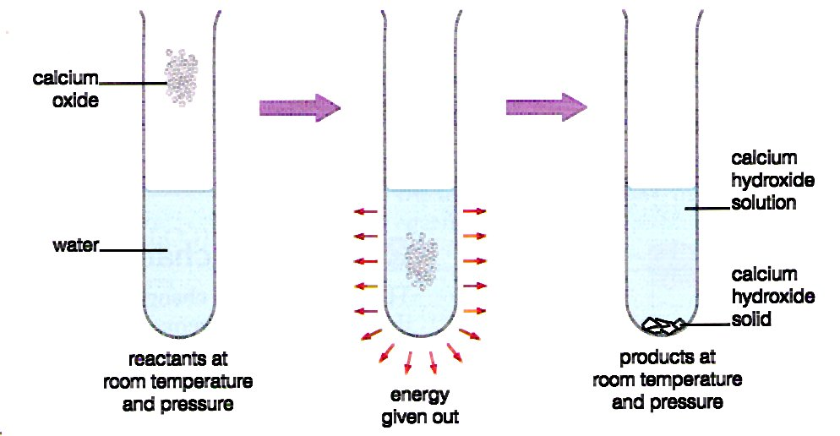

This shows what happens in the exothermic reaction between calcium oxide and water.

This reaction is used in **hot packs** such as the self warming can of coffee.

**Cold packs** are examples of endothermic reactions.

Complete the **enthalpy level diagrams** below with:

* labels for reactants and products
* a labelled arrow for H with the appropriate sign for an exothermic or endothermic reaction
* Activation energy is **not** shown in **enthalpy level diagrams** (it is shown in reaction profile diagrams)

|  |  |
| --- | --- |
| a) Enthalpy level diagram for an **exothermic** reaction  reactants  H = -ve  EXOTHERMIC  Enthalpy  kJ mol-1  products  Progress of reaction | b) Enthalpy level diagram for an **endothermic** reaction  products  H = +ve  ENDOTHERMIC  Enthalpy  kJ mol-1  reactants  Progress of reaction  En thalpy |

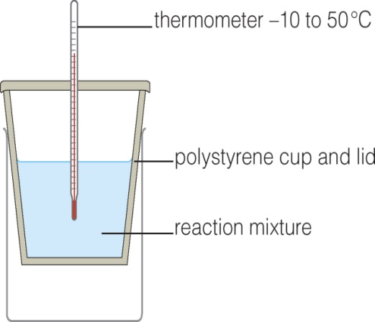**Enthalpy change experiments**

For reactions which take place in **solution.**

An insulated container such as an expanded

polystyrene cup can be used.

When carrying out these experiments we assume:-

* The cup absorbs no heat
* No heat is lost to the air/surroundings
* The solution behaves like water
* 4.18 Joules heat 1cm3 solution by 1oC

**Specific heat capacity** = the enthalpy in joules/KJ which heats 1g/Kg of the substance by 1oC/K

For **water** specific heat capacity = 4.18Jg-1K-1. Because 1cm3 water weighs 1g we can use cm3 as g.

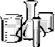

**Expt 1. Reaction of copper sulfate solution and zinc metal.**

Write the reaction for the displacement reaction

CuSO4(aq) + Zn(s) 🡪 ZnSO4(aq) + Cu(s)

**Method:**

1. Measure out 25cm3 0.2M of copper sulfate solution into a polystyrene cup held in a beaker.
2. Measure the temperature and record in table 1.
3. Add 1g of zinc powder and stir.
4. Measure the max/min temperature reached and record in table 1.

**Results:**

|  |  |
| --- | --- |
|  | **oC** |
| Initial temperature of CuSO4(aq) |  |
| Final temperature of mixture (when no longer changing) |  |
| Change in temperature | + 9.5 |

Table 1

Is the reaction exothermic or endothermic? exothermic.. So ΔH sign is - ve.

**Calculate:** Enthalpy in Joules = volume of solution x 4.18 x change of temperature

DH = m x 4.18 x DT = 25 x 4.18 x 9.5 = 668 Joules.

Using this information draw an enthalpy level diagram for this reaction.

H = Enthalpy

/ J

CuSO4(aq) + Zn(s)

ZnSO4(aq) + Cu(s)

Progress of reaction

H = -ve = -668 J

EXOTHERMIC

**Expt 2. Citric acid solution and solid sodium hydrogen carbonate**

****C6H8O7 + 3NaHCO3 C6H5O7Na3 + 3CO2 + 3H2O

1. Measure out 25cm3 of 1M citric acid into a polystyrene cup held in a beaker.
2. Measure the temperature and record in table 2.
3. Add 10g of NaHCO3 and stir.
4. Measure the max/min temperature reached and record in table 2.

|  |  |
| --- | --- |
|  | **oC** |
| Initial temperature of citric acid solution |  |
| Final temperature of mixture (when no longer changing) |  |
| Change in temperature | -19.0 |

Table 2

Use the information from Table 2 to:-

1. Calculate the enthalpy change in joules for this expt. (remember to include the sign!)

H = m x 4.18 x T = 25 x 4.18 x 19 = 1985.5 Joules.

b) draw an enthalpy level diagram for this reaction.

H = Enthalpy

/ J

C6H8O7 + 3NaHCO3

C6H5O7Na3 + 3CO2 + 3H2O

Progress of reaction

H = +ve = +1985.5 J

ENDOTHERMIC

**STANDARD CONDITIONS**

The heat energy or **enthalpy** for reactions varies according to conditions. In order to carry out fair tests we choose certain **standard conditions.** These allow us to compare different reactions.

* **Molar quantities of reactants:** 1.0 mol dm-3
* **Pressure:** 1 atmosphere. Or 100 kPa
* **Temperature:** 298K (25oC)

**Physical state of reactants/products** normal for these conditions – most stable allotrope for carbon this is graphite.

* **Concentration of solutions** 1.0 mol dm-3

**SYMBOL FOR STANDARD ENTHALPY CHANGE H~~O~~,298, 1 atm.1 mol dm-3**.

**The units of** H kJ

**Enthalpy changes**

Enthalpy changes are measured in kilojoules per mole. For example, for the reaction of methane with oxygen, we write

CH4(g) + 2O2(g) 🡪 CO2(g) + 2H2O(l) H~~O~~ = -890 kJ mol-1

This means that for every mole of methane that reacts in this way, 890 kJ of **energy** are **released** to heat the surroundings.

How much energy is released if two moles of methane are burned?

H= 2 x -890 = -1780 kJ for 2 moles, energy released is 1780kJ



When calcium carbonate is heated, it decomposes. **Energy is taken in –** it isan **endothermic** reaction. We write

CaCO3(s) 🡪 CaO(s) + CO2(g) H~~O~~ = + 572 kJ mol-1

For every mole of CaCO3 that is decomposed, 572 kJ of energy is taken in. How much energy is taken in when 0.1 mole of CaCO3 decomposes?

0.1 x +572 = +57.2 kJ for 0.1 mol

**STATES OF MATTER** matter and should always be included because the energy change depends on the state of the substance. Look at the example given below:

2H2(g) + O2(g) 🡪 2H2O(l) H~~O~~ = -572 kJ mol-1

H = Enthalpy

/ kJ mol-1

2H2(g) + O2(g)

2H2O(g)

Progress of reaction

H = -88 kJ

2H2O(l)

H = -484 kJ

H = -572 kJ

2H2(g) + O2(g) 🡪 2H2O(g) H~~O~~ = -484 kJ mol-1

Explain why the enthalpy changes have different values

The difference represents the energy released

as 2H2O(g) 🡪 2H2O(l) being 88 kJ for 2 moles steam.

**COMBUSTION EXPERIMENTS AND CALORIMETRY**

DEFINITION **– THE STANDARD ENTHALPY OF COMBUSTION H~~o~~C,298**

The heat energy released when one mole of a substance in its standard state is completely burned in excess oxygen under standard conditions (1atm. 298K)



Write the equations for the complete combustion of:-

1. CH4(g) + 2O2(g) 🡪 CO2(g) + 2H2O(l)

2) C2H4(g) + 3O2(g) 🡪 2CO2(g) + 2H2O(l)

1. C6H6(g) + 7.5O2(g) 🡪 6CO2(g) + 3H2O(l)

**EXPERIMENT TO FIND THE ENTHALPY OF COMBUSTION OF AN ALCOHOL**



**Calibration of apparatus to find its heat capacity**

Look at the diagram (below) of the apparatus that we can use to measure enthalpy of combustion.

Is just the water heated up by the fuel burning? No What else is heated up?

The calorimeter (tin can), thermometer, stand, nearby apparatus and air.

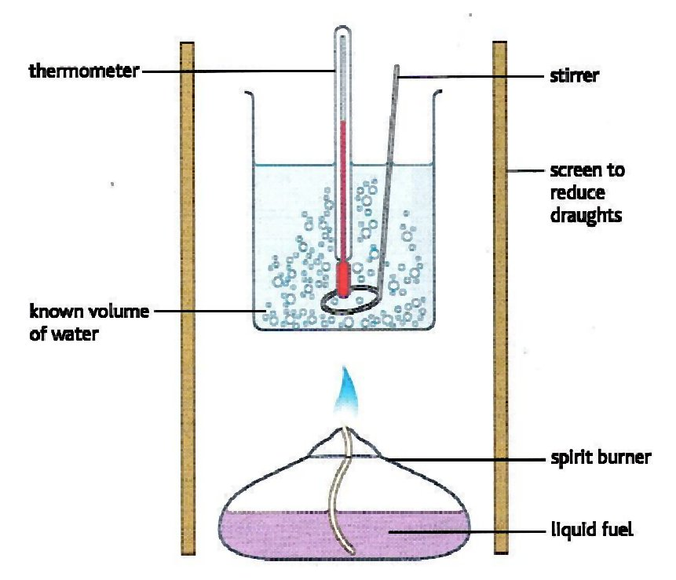**Method**

1. Make sure the outside of your calorimeter (tin can) is clean before half filling with water. 200 cm3
2. Measure the temperature and record in table 1.
3. Weigh the **propanol** spirit burner + lid and record the mass.
4. Quickly light the spirit burner.
5. Stir the water and wait until the temperature has risen by at least 5oC. Record the temperature.
6. Place the lid on the spirit burner to extinguish the flame and trap the alcohol vapour.
7. Re-weigh the spirit burner + lid.
8. Repeat the experiment using the same calorimeter and **same volume of water** with another alcohol from the series butan-1-ol to octane-1-ol. Aim to have the same temperature rise in each experiment.

**Results** specimen results used in calculations

Table 1

|  |  |  |
| --- | --- | --- |
|  | Propan-1-ol | Alcohol - |
| **Molecular formula** | C3H7OH | CH3CH2CH2CH2CH2OH |
| **Relative molar mass** | 60 | 88 |
| **Initial** mass of spirit burner + lid + alcohol /g | 201.91 | 196.60 |
| **Final** mass of spirit burner + lid + alcohol /g | 200.13 | 195.40 |
| Therefore **mass of alcohol burnt** | 1.78 | 1.20 |
| Initial Temp water / oC | 28.0 | 21.0 |
| Final Temp water / oC | 33.0 | 26.0 |
| Therefore **temperature rise /oC** | 5.0 | 5.0 |

**Calculations**

**Find the enthalpy change of combustion of propan-1-ol:**

1. Calculate the number of moles of propan-1ol burnt
$$moles=\frac{mass}{RMM}=\frac{1.78g}{60}=0.0297mol$$

2. Find the energy transferred
$$Energy transferred \left(Q\right)=mass of solution \left(m\right)×4.18\left(c\right)×change in temp \left(∆T\right) =200×4.18×5=4180J$$

3. Find the energy transfer**red in kJ**
$$=\frac{4180}{1000}=4.18kJ$$

4. Calculate the enthalpy change in kJ/mol (don’t forget to include a sign for exo/endo)

$$∆H=±\frac{Energy transferred (kJ)}{number of moles (mol)}$$

$$∆H=±\frac{4.18 (kJ)}{0.0297 (mol)}=-140.7 kJ/mol$$

**Find the enthalpy change of combustion of chosen alcohol……pentan-1-ol…..:**

1. Calculate the number of moles of ……pentan-1-ol…….. burnt
$$moles=\frac{mass}{RMM}=\frac{1.20g}{88}=0.0136mol$$

2. Find the energy transferred
$$Energy transferred \left(Q\right)=mass of solution \left(m\right)×4.18\left(c\right)×change in temp (∆T)$$

$$=200×4.18×5=4180J$$

3. Find the energy transferred in kJ
$$=\frac{4180}{1000}=4.18kJ$$

4. Calculate the enthalpy change in kJ/mol (don’t forget to include a sign for exo/endo)

$$∆H=±\frac{Energy transferred (kJ)}{number of moles (mol)}$$

$$∆H=±\frac{4.18 (kJ)}{0.0136 (mol)}=-307.4 kJ/mol$$

**Questions**

1. Can you be sure complete combustion has taken place? What might have been formed as well as carbon dioxide and water?

No, some soot deposited on the base of the calorimeter

1. List the main sources of heat loss.

* Draughts.
* Heat radiated from calorimeter.
* Heat absorbed by tripod, pipe clay triangle, clamp and stand and spirit burner.
* Incomplete combustion

1. Will heat loss and incomplete combustion make the standard enthalpy value more or less negative?

Less negative e.g. ethanol found to be -1080 should be -1367 kJ mol-1

**Compare your results with the rest of the class**

|  |  |  |  |
| --- | --- | --- | --- |
| Alcohol name | Structural formula | Enthalpy of combustion  / kJ mol-1 | |
|  |  | Class average | Data book |
| methanol | CH3OH | -667 | -726 |
| ethanol | CH3CH2OH | -1080 | -1367 |
| butan-1-ol | CH3CH2CH2CH2OH | -2931 | -2676 |
| pentan-1-ol | CH3CH2CH2CH2CH2OH | -2598 | -3329 |
| hexan–1-ol | CH3CH2CH2CH2CH2CH2OH | -4259 | -3984 |

1. How does the number of carbon atoms in the alcohol affect the enthalpy of combustion?

Longer molecules with more C result in a more exothermic Hc

1. Can you explain why this is?

More bonds formed as more CO2 and H2O is formed from each mole

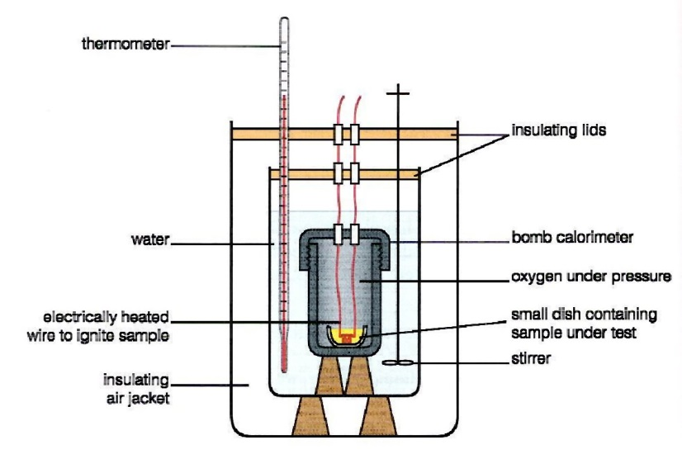7) A tin can is not a very effective calorimeter. To do more accurate experiments chemists use a bomb calorimeter:-

What are the advantages of using this calorimeter over a tin can?

* Insulation – prevents heat radiation.

compensates for convection

* Lid – prevents convection losses.
* No draughts.
* Stirrer results in even water temperature..
* Electric ignition, sealed system – all heat energy transferred to the water.

compensates for radiation

Partially compensates for radiation

**Calorimetry experiment calculations**

New exerciseFor these types of calculations we use the equation

**Energy transferred** /J **= Mass** /g **x Specific Heat Capacity** / J/g/oC **x Change in temp** / oC

1. 0.315 moles of hexane (C6H14) are burned in a calorimeter containing 5.65 litres of water. The maximum temperature rise was 55.4 oC.

What is the molar heat of combustion of hexane? i.e. the Hc in kJ mol-1

Ignore the specific capacity of the calorimeter. The specific heat capacity of water is 4.184 J/g/oC.

Hc= mass of liquid x Specific Heat capacityx T

= 5650 x 4.184 x 55.4

= 1309633 84 J = 1309.6 kJ

= 1309.6 kJ

0.315 mol

= 4157 kJ mol-1

= 4160 kJ mol-1 (3sf) Data book = 4194 kJ mol-1

2) 22.0 grams of propane (C3H8) are burned in a calorimeter containing 3.25 litres of water. The maximum temperature rise was 27.5 oC. What is the molar heat of combustion of propane?



Ignore the specific capacity of the calorimeter. The specific heat capacity of water is 4.184 J/g/oC.

Hc= mass of liquid x Specific Heat capacityx T

= 3250 x 4.184 x 27.5

= 373945 J = 373.945 kJ

RMM propane = 44

Moles propane = 22.0 = 0.5

44

Hc= 373.945 kJ

0.5 mol

= 747.89 kJ mol-1

= 748 kJ mol-1 (3sf)

3) As it turns out, the data from the two experiments described above would not give the correct molar heats of combustion for the compounds stated. Explain why this is, based on your knowledge of calorimetry experiments.

Heat capacity of calorimeter was not taken into account

Heat losses were not taken into account

Density of water depends on the temperature

Now do **Exam question 1** on page 30 – 31.

For extra practice Worksheets Thermodynamics 1, 2 and 3 also [worksheet for lesson 1](http://moodle.godalming.ac.uk/learning/file.php/1008/Unit%201/2009%20Packs/Energetics%20Worksheets/Worksheet%20for%20lesson%201.doc)

Questions**Facer p 97-98, questions 1, 2, 16, 17 & 18**

**IMPORTANT ENTHALPY CHANGE DEFINITIONS**

New ReferenceFacer Chapter 5 **LEARN THESE SO YOU ARE WORD PERFECT!**

There are five different kinds of energy changes that you need to be familiar with:-

* reaction
* neutralization
* formation
* New exercisecombustion
* atomisation.

**THE STANDARD ENTHALPY OF COMBUSTION H~~o~~C,298**

The heat energy released when one mole of a substance in its standard state is completely burned in excess oxygen under standard conditions (1atm. 298K).

E.g. Equation for complete combustion of butane (include state symbols – important here)

C4H10(g) + 6.5O2(g)🡪4CO2(g) + 5H2O(l) **H~~o~~C,298 = -2877 kJ mol-1**

E.g. Equation for complete combustion of ethanol (include state symbols – important here)

C2H5OH(l) + 3½ O2(g)🡪 2CO2(g)+ 3H2O(l) .**H~~o~~C,298 = -1367 kJ mol-1**

**THE STANDARD ENTHALPY CHANGE OF FORMATION H~~o~~f,298**

Enthalpy change when one mole of a substance in its standard state is formed from its elements in their standard states under standard conditions (1atm. 298K).

NOTE; **the enthalpy change of formation of a pure element in its standard state is zero**

E.g. Hydrogen and iodine reacting to form hydrogen iodide

½H2(g) + ½I2(s) 🡪 HI(g) H**~~o~~**f

Worksheet

E.g. Equation for hydrogen and nitrogen reacting to form ammonia (with state symbols)

1½H2(g) + ½N2(g) 🡪 NH3 (g) **H~~o~~f,298 = -46.1 kJmol-1**

For extra practice, worksheet Enthalpy of formation

**THE STANDARD ENTHALPY CHANGE FOR A REACTION, H~~o~~r,298**

The enthalpy change when molar quantities of reactants as stated in the equation react together under standard conditions (1atm, 298K, 1mol dm-3)

You must always give an equation when quoting an enthalpy of reaction – otherwise things can get very muddled

E.g. Hydrogen and oxygen forming water

Given 2H2(g) + O2(g) 🡪 2H2O(l) Hr = -572 kJ mol-1

Then H2(g) + ½O2(g) 🡪 H2O(l) Hr = -286 kJ mol-1

Can you see why the Hc of hydrogen is -286 kJ mol-1?

**THE STANDARD ENTHALPY CHANGE OF NEUTRALISATION**

**H~~o~~neut,298**

The standard enthalpy change of neutralisation is the enthalpy change

when **one mole of water** is formed by the neutralisation between an acid and an alkali under standard conditions, 298K, 1atm..

Write equations for the standard enthalpy of enthalpy of neutralization for:-

1. H2SO4 (sulfuric acid) by sodium hydroxide

½H2SO4(aq) + NaOH(aq) 🡪 ½Na2SO4(aq) + H2O(l)

1. HCl (hydrochloric acid) by potassium hydroxide

HCl(aq) + KOH(aq) 🡪 KCl(aq) + H2O(l)

1. HNO3( Nitric acid) by calcium carbonate

HNO3(aq) + ½CaCO3(aq) 🡪 ½Ca(NO3)2(aq) + H2O(l) + ½CO2(g)

**ENTHALPY CHANGES BY DIFFERENT ROUTES**

When we write a chemical equation, we usually show just the reactants and products, but there may be several different routes by which one can be converted to the other.

**HESS'S LAW states that:**

# **The total enthalpy change for a chemical reaction is independent of the route by which the reaction takes place.**

**A + B**

**C + D**

**X + Y**

**P + Q**

H1

H2

H3

H4

*Route 2*

*Route 1*

In the example above, Hess’s law tells us that the enthalpy change for route 1 is equal to the enthalpy change for route 2:-

H1 = H2 + H3 + H4

This is just another way of saying that energy cannot be created or destroyed, but may be converted from one form to another. (First Law of thermodynamics)

These **energy cycles** enable us to measure **indirectly** enthalpy changes which cannot be made **directly.**

For example, the reaction C(graphite) + 2H2(g) 🡪 CH4(g) does not occur under normal conditions.

How can the value of ΔH°f be measured? It has to be done indirectly using energy cycles.

This figure shows what we mean by an energy cycle. There is both a direct and an indirect way to turn graphite (C) and hydrogen (H2) to methane (CH4). We can't measure the enthalpy change for the *direct* route. The *indirect* route goes via CO2 and H2O, and involves two enthalpy changes, which we *can* measure.

C(graphite) + 2H2(g)

CH4(g)

CO2(g) + 2H2O(l)

*H going this way*

*…is the same as*

*H going this way*

*An energy cycle for finding the enthalpy change of formation of methane, CH.4*

If you know the enthalpy changes involved in two parts of the cycle you can work out the enthalpy change in the third.

What is the Enthalpy of formation of CH4(g)

C(graphite) + 2H2(g)

CH4(g)

CO2(g) + 2H2O(l)

H1

H2

H3

+2O2(g)

+2O2(g)

Cycle arrows direction results from definitions of data given

Hess arrows must follow definitions arrows

TO FIND AH°f [CH4(g)]

Given C(s) + O2(g) 🡪 CO2(g) H~~O~~C = - 393.5 kJ mol-1

H2(g) + 0.5O2(g) 🡪 H2O(l) H~~O~~C = - 285.8 kJ mol-1

CH4(g)+ 2O2(g) 🡪 CO2(g) + 2H2O(1) H~~O~~C = - 890.3 kJ mol-1

Apply **Hess's law.** (The energy changes represented by the arrows in the clockwise direction are equal to the energy changes represented by arrows in the anti-clockwise direction.)

H1 + H3 = H2 (1)

H1 = H°f[CH4(g)]

H2 = H°C [C(graphite)] x 1 + H°C [H2(g)] x …**2**…

= -393.5 + -285.8 x **2**

= -965.1 kJ mol-1 units?

H3 = H°C [CH4(g)] =-890.3 kJ mol-1

Insert these values into equation 1:-

H1 = H2 - H3

Hef[CH4(g)] =H2 - H3

= (-965.1) – (-890.3)

= -74.8 kJ mol-1 **exothermic – you must always put in the sign**

Using the energy cycle has enabled us to find a value for an enthalpy change, which we could not find directly..**TO FIND ΔH°f [CO(g)]**

Given: C(graphite) + O2(g) 🡪 CO2(g) H~~o~~ = -394 kJ mol-1

CO(g) + 0.5O2(g) 🡪 CO2(g) H~~o~~ = -283 kJ mol-1

Write an equation to represent the standard enthalpy change of formation of carbon monoxide,

including the states of matter:

New exercise

C(graphite) + 0.5 O2(g) 🡪 CO(g)

Complete the following energy triangle,

C(graphite) + O2(g)

CO2(g)

CO(g) + 0.5O2(g)

H1

H2

H3



Apply Hess’s Law:

H1 = H2 + H3 (1)

As in the previous example, identify the type of energy change and give numerical values for:-

H1 = H~~O~~f [CO2(g)] = H~~O~~c [C (graphite)] = -394 kJ mol-1

H2 = H~~O~~f [CO(g)] = ?

H3 = H~~O~~c [CO(g)] = -283 kJ mol-1.

Insert these values into equation (1)

H2 = H1 - H3

H~~O~~f[CO(g)] = (-394) – (-283)

= -111 kJ mol-1 units?

Explain why the enthalpy change of formation of carbon dioxide is comparatively easy to measure experimentally, but it is impossible to obtain an accurate experimental value for carbon monoxide.

H~~O~~f [CO2(g)] = H~~O~~c [C(graphite)], excess O2, standard conditions

H~~O~~f [CO(g)] represents incomplete combustion of carbon but this results in some CO2,

some CO and some C, as CO is thermodynamically unstable with respect to CO2.

Questions **For extra practice try Facer p 97 question 6**

**USING Hθf DATA TO CALCULATE Hθr**

formation reaction

TO FIND Hθr, for a reaction, using the data:-

NH3 H**θ**f = - 46 kJ mol-1

HBr H**θ**f = -36 kJ mol-1

NH4Br H**θ**f = - 271 kJ mol-1

Hθr

Hess cycle arrows must follow definition / data arrows 

* Write out the equation NH3(g) + HBr(g) 🡪 NH4Br(s)



(done for you in this case)

H1

H2

* Add elements in their standard states

½N2(g) + ½Br2(l) + 2H2(g)

in the correct molar quantities.

* Draw an arrow FROM the elements TO the reactants and label it H**1**.
* Draw an arrow FROM the elements TO the products and label it H2.
* Apply Hess's Law: H1 + H**θ**r. = H2
* Rearrange the equation so H**θ**r = H2 - H1 (1)
* H1 = H**θ**f [NH3(g)] + H**θ**f [HBr(g)]

= …(-46)…+ …(-36)…

= …-82 kJ mol-1…units?

* H2 = H**θ**f [NH4Br(s)]

= -271 kJ mol-1

* Insert values into the rearranged Hess equation:-

H**θ**r = (H2 value with sign) - (H1 value with sign)

= (-271) **-** (- 82)

= -189 kJ mol-1units?

* Draw an enthalpy level diagram (not to scale) to represent this enthalpy cycle.

H = Enthalpy

/ kJ mol-1

½N2(g) + ½Br2(l) + 2H2(g)

Progress of reaction

Hr = -189 kJ mol-1

NH3(g) + HBr(g)

NH4Br(s)

H2 = -271 kJ mol-1

H1 = -82 kJ mol-1



**CALCULATE** Hθrfor the following reactions, setting out the calculation using Hess cycles as shown in the previous example.

**New exercise**

**Make it crystal clear what you are doing in these calculations as marks are awarded for each step. (and you will never find your error otherwise!)**



1) SO2(g) + 2H2S(g) 🡪 3S(s) + 2H2O(l) H**θ**f (SO2(g)) = -297 kJ mol-1

H**θ**f (H2S (g)) = -20.2 kJ mol-1

H2

H1



H**θ**f (H2O (l)) = -286 kJ mol-1

3S(s) + O2(g) + 2H2(g)

H1 + Hr = H2 H2 = 2 x H**θ**f (H2O(l)) = 2(-286 )

Hr = H2 - H1 = -572 kJ mol-1

= (-572) – (-337.4) H1 = H**θ**f (SO2(g)) + 2H**θ**f (H2O(l))

= -297 + 2 x -20.2

= -234.6 kJ mol-1 = - 337.4 kJ mol-1

2) CO2(g) + 2Mg(s) 🡪 2MgO(s) + C(s) H**θ**f (CO2(g)) = -394 kJ mol-1

H**θ**f (MgO(s)) = -602 kJ mol-1

H2

H1

C(s) + O2(g) + 2Mg(s)

H1 + Hr = H2 H1 = H**θ**f (CO2(g)) = -394 kJ mol-1

Hr = H2 - H1 H2 = 2 x H**θ**f (MgO(s)) = -602 kJ mol-1

= (-1204) – (-394) = - 1204 kJ mol-1

= -810 kJ mol-1

H2

Hr

H1

N2(g) + ½O2(g) + Cu(s)

3) N2O(g) + Cu(s) 🡪 CuO(s) + N2(g) H**θ**f (N2O(g)) = +81.6 kJ mol-1

H**θ**f (CuO (s)) = -155 kJ mol-1

H1 + Hr = H2 H1 = H**θ**f (N2O(g)) = +81.6 kJ mol-1

Hr = H2 - H1 H2 = H**θ**f (CuO (s)) = -155 kJ mol-1

= (-155) – (+81.6)

= -236.6 kJ mol-1

These can also be calculated from

Hr = Hf products – Hf reactants

Questions

Now do **Exam question 2** on page 32

**Facer p 97 questions 4-9**

See worksheets energetics 1 / even more energetics questions / Even more energetics questions 2

Worksheet**ENTHALPY LEVEL DIAGRAMS** (Energy level diagrams)

The energy cycles can also be represented as an enthalpy level diagram. Drawn to scale on graph paper this provides an alternative method of calculating enthalpy values.

1. Draw an energy level diagram to summarise the information given. Start with the elements in their standard states and conditions at ΔH=0 kJ mol-1.

New exercise

H kJ mol-1

0

C(graphite) + O2(g)

2. The combustion of 1 mol of graphite produces CO2 and releases 394 kJ. Show this on the energy-level diagram (not necessarily to scale);

Enthalpy changes are represented by vertical lines with arrows:-

exothermic changes

endothermic changes

explain why exothermic gives out heat so system has a lower enthalpy

H kJ mol-1

0

C(graphite) + O2(g)

CO2(g)

-394 kJ mol-1

1. Now consider the combustion of CO, which gives the same product, 1 mol of CO2. The energy released is 283 kJ mol-1. Show this on the diagram:

H kJ mol-1

0

C(graphite) + O2(g)

CO2(g)

-394 kJ mol-1

-283 kJ mol-1

CO(g) + ½O2(g)

**4**. The gap between the two upper lines represents the heat of formation of carbon monoxide. Show this on the diagram:

H kJ mol-1

0

C(graphite) + O2(g)

CO2(g)

-394 kJ mol-1

-283 kJ mol-1

CO(g) + ½O2(g)

Hf(CO)

**EXPERIMENT TO FIND THE ENTHALPY OF NEUTRALISATION**

June 05 3A Group 2 Q2

You are provided with:

Solutions of 0.75 mol dm-3 phosphoric acid and 2.00 mol dm-3 sodium hydroxide.

You are to measure the enthalpy of reaction for the reaction of the acid with excess sodium hydroxide.

**Procedure – Read through this carefully before you start.**

1. Rinse out the pipette with phosphoric acid. Transfer 25.0 cm3 of phosphoric acid into the polystyrene cup. Stand the cup in the beaker provided to ensure that it is more stable. Place the thermometer into the liquid.
2. Fill the measuring cylinder up to the 50 cm3 mark with sodium hydroxide.
3. Record the temperature of the phosphoric acid to the nearest 0.5oC in the table below. Do not remove the thermometer from the solution.
4. Start the clock and record the temperature of the solution every minute for 2 mins.
5. **After exactly 3 mins** pour the sodium hydroxide, as quickly as possible, from the measuring cylinder into the phosphoric acid. Stir the mixture with the thermometer and then record the temperature of the mixture after 3 ½ mins from the start and again after 4 mins
6. Record the temperature of the mixture every minute for a further 6 mins.
7. **Results:**

|  |  |  |  |  |  |  |  |  |  |  |  |  |
| --- | --- | --- | --- | --- | --- | --- | --- | --- | --- | --- | --- | --- |
| Time / min | 0 | 1 | 2 | 3 | 3 | 4 | 5 | 6 | 7 | 8 | 9 | 10 |
| Temperature / °C | 18.5 | 18.5 | 18.5 | **mix** | 27.5 | 28.0 | 28.0 | 27.7 | 27.5 | 27.5 | 27.0 | 27.0 |

1. **Plot a graph of your results as shown below:**



**Calculations**

(c) (i) Use the graph to find the change in temperature, *T*, on mixing 25.0 cm3 of phosphoric acidwith 50 cm3 of sodium hydroxide. Show on the graph how you calculated the change.

*T* = 28.3 – 18.5 = 9.8 oC

(ii) Use the expression below to calculate the enthalpy change for the reaction.  
Give your answer to three significant figures.

*H* = – kJ mol-1

*H* = - 9.8 x 4.18 x 100 = - 163.85 = - 164 kJ mol-1

25

(d) (i) The neutralisation reaction can be represented as follows:

H+(aq) + OH-(aq) → H2O(l)

The heat change for this reaction is about –56 kJ per mol of hydrogen ions, H+(aq). Use this data plus the result from (c)(ii) to suggest whether 1, 2 or 3 mol of hydrogen ions, H+(aq), took part in the reaction.

Moles of H+ neutralised =164 = 2.9

56

H3PO4 + 3NaOH 🡪 Na3PO4 + 3H2O

(ii) Indicate, with a tick (), which salt is produced in this reaction.

|  |  |
| --- | --- |
| NaH2PO4 |  |
| Na2HPO4 |  |
| Na3PO4 | **√** |

(e) Which piece of **apparatus** is responsible for limiting the overall accuracy of this experiment?

Thermometer only reads ± 0.5 leading to 2 x 0.5 / 10.0 🡪**10% error**

Measuring cylinder only accurate to ±1.0 cm3 leading to 1.0/50 🡪 2% error but as NaOH is in excess this does not matter

Pipette error is accurate to 0.06/25 🡪0.24%

QuestionsNow do Exam question 3 on page 33 - 34.



Facer p 98 question 15.

**EXPERIMENT TO MEASURE AN INDIRECT ENTHALPY CHANGE**



The enthalpy change for the decomposition of sodium hydrogen carbonate

     Hr

2NaHCO3(s) 🡪 Na2CO3(s) + CO2(g) + H2O(1)

cannot be measured directly. However the enthalpy changes for the reactions of sodium hydrogen carbonate and sodium carbonate with hydrochloric acid

NaHCO3(s) + HCl(aq) 🡪 NaCl(aq) + CO2(g) + H2O(1)

Na2CO3(s) + 2HCl(aq) 🡪 2NaCI(aq) + CO2(g) + H2O(1)

can be measured readily. From these two enthalpy changes, the enthalpy change for the decomposition of sodium hydrogen carbonate can be calculated.

**Instructions**

1. Weigh out accurately about 4 g of NaHCO3(s).

2. Measure 40 cm3 of hydrochloric acid of concentration 2 mol dm-3 into a plastic cup and record its temperature.

3. Add the NaHCO3to the cup, stir, and record the final temperature.

4. Repeat parts (1) to (3) using about 2.5 g of Na2CO3(s).

5. Use the results of your experiments to calculate the enthalpy changes of the two reactions you have performed, in each case expressing your answer in kJ per mole of solid. Use the data given below, and state clearly any assumptions that you make.

6. Now construct a Hess cycle to allow you to calculate the enthalpy change for the decomposition of sodium hydrogen carbonate to sodium carbonate.

7. Suggest what the major errors are in this experiment, and explain why the enthalpy change that you have calculated cannot be measured directly.

**Data** Specific heat capacity of water = 4.2 J g-1 °C-1

Molar mass of NaHCO3 = 84 g mol-1

Molar mass of Na2CO3 = 106 g mol-1

The density of all the solutions is 1.0 g cm-3

|  |  |  |
| --- | --- | --- |
| **Results** | NaHCO3 | Na2CO3 |
| Mass of solid / g | 4.00 | 2.50 |
| Temperature,T, of acid initially / oC | 22.5 | 22.5 |
| Temperature of solution after mixing / oC |  |  |
| Temperature change during reaction / °C (T) | 7.3 | 4.5 |
| State whether exo- or endothermic | endothermic | exothermic |

**Calculations**

Calculate the enthalpy changes for the reactions of acid with:

**i) Sodium hydrogen carbonate, NaHCO3(s)**

No. moles of NaHCO3(s) = 4.00 = 0.04761

84

For 0.04761 moles, H = mass of water x specific heat capacity x T

= 40 x 4.2 x 7.3

= 1226.4 J

= 1.226 kJ

For 1 mole, H = 1.226

0.04761

= **+** 25.82 kJ mol-1 endothermic (appropriate sign?)

**ii) Sodium carbonate, Na2CO3(s)**

No. moles Na2CO3(s) = 2.50 = 0.02358

106

For 0.02358 moles, H = mass of water x specific heat capacity x T

= 40 x 4.2 x 4.5

= 756J

= 0.756 kJ

For 1 mole, H = 0.756

0.02358

= **-** 32.06 kJ mol-1‑ exothermic (appropriate sign?)

**Construct an energy cycle:**

2NaHCO3

+ 2HCl

Na2CO3 + CO2 + H2O

+ 2HCl

Hr



H1

H2

NB 2 moles

2NaCl + 2CO2 + 2H2O



Hr + H2 = H1



**Calculate** Hr (Show all working.)

Hr = H1 - H2

= 2(+ 25.82) – ( - 32.06)

= 51.64 + 32.06

= + 83.7 kJ mol-1

What assumptions have you made in this calculation?

* standard conditions, specific heat capacity of acid = 4.2 J g-1
* no heat losses, no loss of material and a total instant reaction
* density of acid assumed to be 1 g cm-1

Identify the size of the measurement/precision errors in the experiment and calculate the **percentage error** for:

* Volume of acid. Measuring cylinder is only accurate to ±1.0 cm3 leading to 1.0/40 x 100🡪 2.5% error but as acid is in excess this does not matter
* Mass of sodium hydrogen carbonate. 2 x 0.005 / 4.0 x 100 = 0.25%
* Temperature change on mixing. Thermometer only reads ± 0.5 leading to 2 x 0.5 / 10.0 🡪**10% error**

How could you reduce these errors? Use a more accurate thermometer. Record temperature for several minutes before adding NaHCO3 and then for 10 mins afterwards.

Draw a graph of temp vs time and extrapolate to calculate a more accurate T

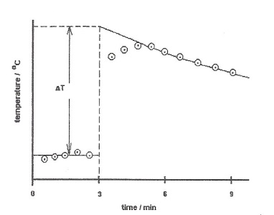Identify any procedural errors and explain any steps you could take to reduce these

* heat losses – lid and insulation, data log temperature, plot a temp / time graph, extrapolate to give corrected T overcoming effects of cooling
* Incomplete /slow reaction – magnetic stirrer 🡪 complete efficient mixing
* unreacted solid remaining in the weighing beaker

weigh beaker before and after transferring solid 🡪 solid used.

* fizzing and loss of liquid – use lid

Why is it not possible to measure Hr for this reaction directly?

Hr 2NaHCO3(s) 🡪 Na2CO3(s) + CO2(g) + H2O(l) is endothermic

It is not possible to measure the kJ absorbed if a sample is heated

QuestionsNow do **Exam question 4** on page 35 – 36.

**Facer p 97/98 questions 13 & 14.**

WorksheetSee also energetics dry labs for additional practice with analysis of practical experiments**BOND ENTHALPIES AND MEAN BOND ENTHALPIES**

**New Reference**

**Reference:** Facer p92 - 93

The overall enthalpy change for a reaction is the difference between the energy needed to break bonds in the reactants and the energy released as new bonds form in the products.

New exercise

* Bond breaking requires energy, it is endothermic
* Bond making releases energy, it is exothermic

**Definition of bond dissociation enthalpy (also called ‘bond enthalpy’):**

**HB Hd E(X-Y)**

The energy required to break one mole of bonds in a substance when it is the gaseous state

To break a covalent bond the attractive forces between the shared electrons and the nuclei of the two atoms involved need to be overcome. This can be illustrated by looking at the covalent bond in a hydrogen molecule

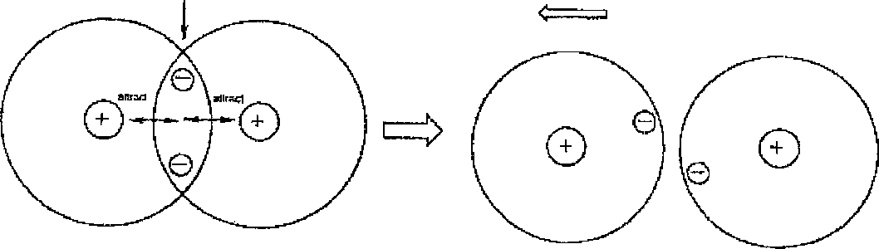

Shared electrons

Two H atoms bonded by a shared pair of electrons

Both nuclei are attracted to the same shared pair of electrons. This holds the nuclei together

Pull atoms apart against the force of attraction

The bond dissociation enthalpy of the single H—H covalent bond is +436 kJ mol-1. This can be written as

H2(g) 🡪 2H (g)H = +436 kJ mol-1

Note the sign of this enthalpy change. Since energy is needed to break covalent bonds, bond breaking is always endothermic, the sign is always positive.

When investigating bond breaking, chemists distinguish between:-

• **Bond dissociation enthalpies** - precise values for particular bonds

• **Mean bond enthalpies** - average values that are a useful approximate guide. In molecules with two or more bonds between similar atoms, the energies needed to break successive bonds are not the same. In water, for example, the energy needed to break the first OH bond in H-O-H (g) is 498 kJ mol-1 but the energy needed to break the second OH bond in O-H(g) is 428 kJ mol-1.

The mean values of bond enthalpies take into account the facts that:

* The successive bond dissociation enthalpies are not the same in compounds such as water or methane
* The bond dissociation enthalpy for a specific covalent bond varies slightly from one molecule to another,

For most of our calculations we will be using average bond enthalpies.

A selection of average bond enthalpies and bond lengths are given below.

The symbol E(X—Y) stands for the average bond energy of a covalent bond.

|  |  |  |
| --- | --- | --- |
| **Bond (X-Y)** | **E (X-Y)**  **Average bond energy / kJ mol-1** | **Bond length / nm** |
| C-C | + 347 | 0.154 |
| C=C | + 612 | 0.134 |
| C≡C | + 838 | 0.120 |
| C-H | + 413 | 0.108 |
| O-H | + 464 | 0.096 |
| C-O | + 336 | 0.143 |
| C=O | + 805 | 0.116 |
| O=O | +498 | 0.121 |
| N≡N | + 945 | 0.110 |

Make a comparative statement on the strengths of single, double and triple bonds.

Strength of bond single < double < triple

Ratio 1 1.7 2.4

bonds are composed of         

Comment of the correlation between bond length and bond strength

Length = 1/ strength but only for bonds between the same atoms

The nitrogen molecule is very unreactive. Why is this so?

N≡N bond is very strong, 945 kJmol-1, needs a lot of energy to overcome it.

**Calculating Enthalpy Changes of Reaction using Bond Enthalpies**

**Example**

The combustion of methane is written as:

CH4(g) + 2O2(g) 🡪 CO2(g) + 2H2O(l)

In order to calculate the enthalpy change of reaction using bond enthalpies it is useful to follow the following steps:

1. **Write the equation using displayed formulae**.

(This will make it easy for you to spot which bonds are broken and which are made).



1. **List the bonds broken and bonds made as shown.** Using bond enthalpies shown in the table on the previous page we can calculate how much energy is involved in each stage of the process that leads to the complete combustion.

|  |  |
| --- | --- |
| **• Bond breaking** | **• Bond making** |
| 4 x E(C - H) = 4 x 413 = 1652 kJ mol-1 | 2 x E(C=O) = 2 x 805 = 1610 kJ mol-1 |
| 2 x E(O=O) = 2 x 498 = 996 kJ mol-1 | 4 x E(O- H) = 4 x 464 = 1856 kJ mol-1 |
| Total = 2648 kJ mol-1 | Total = 3466 kJ mol-1 |

**iii)Calculate the enthalpy change of the reaction**

EITHER  Hr = Total energy to break bonds - total energy to make bonds



OR Add endothermic (+ve)bond breaking enthalpies to exothermic(-ve) bond making

enthalpies

= 2648 -3466

= -818 kJ mol-1

Since more energy is given out when the new bonds are formed than is needed to break the bonds to begin with, energy is given out overall. The reaction is ………………......

1. **Write the balanced equation + the associated enthalpy of reaction**

CH4(g) + 2O2(g) 🡪 CO2(g) + 2H2O(l) Hc = -818 kJ mol-1

1. Finally, draw the **energy level diagram** indicating **energy needed to break bonds, energy given out when bonds form** and **overall enthalpy of combustion**

C(g) + 4H(g) + 4O(g)

bond breaking

+2648kJ

Enthalpy

kJ mol-1

Progress of reaction

bonds forming

-3466kJ

CH4(g) + 2O2(g)

Hc = -818 kJ mol|-1

CO2(g) + 2H2O(l)

Questions

Now do **Exam questions 5 and 6** on page 37 – 38.

Worksheet**Facer p 97 questions 11 and 12.**

See worksheets Bond enthalpies 1/ energy changes / energy changes 2 / enthalpy 2 / enthalpy 3.

**Multiple choice questions**

* + - 1. 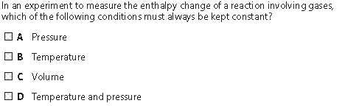

Answer D

(Total 1 mark)

**2.** Which equation represents the reaction for which the enthalpy change is the standard enthalpy change of formation, Δ*H*fө, of sodium nitrate, NaNO3?

**A** 2Na(s) + N2(g) + 3O2(g) → 2NaNO3(s)

**B** Na(s) + ½N2(g) + 1½O2(g) → NaNO3(s)

**C** Na(s) + N(g) + 3O(g) → NaNO3(s)

**D** Na(g) + ½N2(g) + 1½O2(g) → NaNO3(g)

(Total 1 mark)

**3.** Which equation represents the reaction for which the enthalpy change, Δ*H*, is the mean bond enthalpy of the C–H bond?

**A** ¼CH4(g) → ¼C(g) + H(g)

**B** CH4(g) → C(s) + 2H2(g)

**C** CH4(g) → C(g) + 4H(g)

**D** CH4(g) → C(g) + 2H2(g)

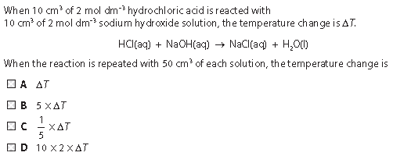(Total 1 mark)

4)

Answer ADo not write in the margin

S10 1 11

W10 1 04

W10 1 05

**5.**Some mean bond enthalpy values are given in the table below.

|  |  |
| --- | --- |
| Bond | Mean bond enthalpy / kJ mol-1 |
| H―H | +436 |
| I―I | +151 |
| H―I | +299 |

What is the enthalpy change for the reaction shown below in kJ mol-1?

H2(g) + I2(g) → 2HI(g)

**A** +436 + 151 – 299 = +288

**B** –436 – 151 + 299 = –288

**C** +436 +151 – (2 × 299) = –11

**D** –436 – 151 + (2 × 299) = +11

(Total 1 mark)

Structured Questions

**5.** In an experiment to find the enthalpy change when copper is displaced from a solution of copper ions excess zinc was added to 50.0 cm3 of 1.00 mol dm-3 aqueous copper(ii) sulphate in a plastic cup.

Zn(s) + Cu2+(aq)  Zn2+(aq) + Cu(s)

The temperature of the solution in the cup was measured every minute for 10 minutes with the zinc being added after 3.5minutes.

 The temperature readings are shown on the graph below.

T

Do not write in the margin

S09 1 03

S01 3B01

(a) Suggest two reasons why a series of temperature readings is taken rather than simply initial and final readings.

**Any 2**

First reason Any fluctuations in temperature smoothed out / minimizes reading error / allows line of best fit to be drawn **(1)**

Second reason Able to allow for cooling effect / able to calculate more accurate **temperature** change / need to find highest temperature **(1)**

**i.**e. extrapolation reasons

Third reason Reference to problem of how the experiment is carried out practically e.g. reaction slow / too much to do all at once **(1)**

**(2)**

(b) Use the graph to calculate the maximum temperature change, *T*, as the reaction takes place.

Extrapolation of lower and upper temperatures at 3.5 min **(1)**T correct to + 1.0°C according to candidate’s method **(1)**Consequential on sensible method of finding temp change between 3 and 4 minutes

*T* = ...................43..................°C

(2)

(c) Calculate the enthalpy change for the reaction using the formula below, giving your answer to an appropriate number of significant figures.

**H = –4**.**18 × T kJ mol-1**

H = - 4.18 × **candidate’s** T = -4.18 x 43  
H correctly calculated **(1)** = - 179.74  
with consequentially correct sign and to 3 or 4 SF **(1)** = -180 kJ mol-1  
*This is consequential on part (b)*

(2)

(Total 6 marks)

**6.**(a) (i) Define the term **standard enthalpy of formation**, *H*f

**Enthalpy/heat change** for formation of **1 mole** of a compound **(1)**  
from its **elements (1)**  
in their **standard states** / or stated temperature of 298K (25C) and 1 atm (or suitable unit) **(1)**

(3)

Do not write in the margin

W02 C206

(ii) The following table shows some values of standard enthalpy of formation.

|  |  |  |
| --- | --- | --- |
| Name | Formula | *H*f/kJ mol-1 |
| ethene | C2H4(g) | +52.3 |
| hydrogen bromide | HBr(g) | –36.2 |
| bromoethane | C2H5Br(g) | –60.4 |

Use the data in the table above to calculate the standard enthalpy change for the following reaction.

C2H4(g) + HBr(g)  C2H5Br(g)

= -60.4  (52.336.2) **(1)** = -60.4 – 16.1  
= -76.5 (kJ mol**1) (1)**

See notes p14-15

(2)

(iii) State the significance of the sign of the value obtained in part (a)(ii) above.

negative sign means reaction exothermic/gives out heat **(1)**  
if no answer given to part (ii) must give general explanation that negative means exothermic and positive means endothermic reaction

(1)

(b) Enthalpy changes can also be calculated usingaverage bond enthalpy data.

|  |  |
| --- | --- |
| Bond | Average bond enthalpy/kJ mol-1 |
| C == C | +612 |
| C  C | +348 |
| C  H | +412 |
| C  Br | +276 |
| H Br | +366 |

Use the data in the table above to recalculate the enthalpy change for the reaction in part (a)(ii).

C2H4(g)  HBr(g)  C2H5Br(g)

See notes p26

Best to draw out displayed formulae



+ 🡪



Using just **the bonds** **that change**:-

Energy in = breaking C=C and H-Br

= (612 + 366) = 978 **(1)**  
Energy out = making C-C,C-H and C-Br

= 348 + 412 + 276 = 1036 **(1)**  
Energy change = 978 – 1036 = -58 **(1)** consequential

Calculation using all bonds:-

Energy change = 2626 – 2684 = -58

**(3)**

Do not write in the margin

(c) Suggest why the value obtained in part (b) above is likely to be less accurate than that obtained in part (a)(ii).

**Average** values from many compounds used in bond enthalpies **(1)**  
**Actual values** for these compounds probably slightly different / or, calculation in (a) (ii) uses real / actual / experimental /standard/ values **(1)**  
*n.b. do not accept arguments based on error*

See notes p25

(2)

(Total 11 marks)

**7.** (a) Define the term **standard enthalpy** **of** **combustion**, making clear the meaning of **standard** in this context.

* + - Enthalpy or heat change or heat energy / released when 1 mol of substance / element or compound (need to say both) **(1)**
    - is burned in excess oxygen / completely / reacts completely **(1)**
    - at 1 atm pressure and specified temperature **(1)**

(3)

(b) Use the enthalpies of combustion given below to find the enthalpy change for the reaction:

2C(graphite) + 2H2(g) + O2(g)  CH3COOH(l)

|  |  |
| --- | --- |
|  | *H*combustion/kJ mol-1 |
| C(graphite) | –394 |
| H2(g) | –286 |
| CH3COOH(l) | –874 |

*H* = 2*H*c(C) + 2*H*c(H2)  *H*c(CH3COOH) **(1)** for this or equivalent cycle drawn;

*H* = (–394  2) + (286  2)–(–874) **(1)**

= (-1360) - (-874)

= 486 kJ mol–1 **(1)**

(3)

(c) With reference to ethanoic acid, CH3COOH, what is the enthalpy change obtained in (b) called?

(Enthalpy of) formation / Hf **(1)**

(1)

Do not write in the margin

W03C 25A.

(d) Draw an enthalpy level diagram to represent the enthalpy change for the combustion of graphite. Show both the enthalpy levels of the reactants and products and an energy profile which represents the activation energy for the reaction.



-394

correct orientation of energy levels / labelled (at least one) **(1)**

H shown - number allowed **(1)**

reaction profile showing *E*a **(1)**

[if based on (b) max 2] **(3)**

(Total 10 marks)

**8.** The reaction of an acid with a base to give a salt is an exothermic reaction. In an experiment to determine the enthalpy of neutralisation of hydrochloric acid with sodium hydroxide, 50.0cm3 of 1.00 mol dm-3 HCl was mixed with 50.0 cm3 of 1.10 mol dm-3 NaOH. The temperature rise obtained was 6.90 °C.

(a) Define the term **enthalpy of neutralisation**.

Enthalpy / heat (energy) change on the neutralisation / reaction of one mole of a **monobasic** acid / hydrogen ions (by an alkali)  
or  
Enthalpy / heat (energy) change on the formation of one mole of water when an acid is neutralised  
Or  
Enthalpy change per mole for reaction H+ + OH , H2O **(1)**

(1)

(b) Assuming that the density of the final solution is 1.00 g cm-3 and that its heat capacity is 4.18 J K-1 g-1, calculate the heat evolved during the reaction.

q = mcT **(1)** other unambiguous symbols/names  
= 100 × 4.18 × 6.90 **(1)**  
= 2884 J including units **(1)***Consequential on sensible chemistry in line 2 i.e. use of 50 for mass or temp in K or data for temperature, transposed(max2). Ignore sign of answer   
Allow 3 or 4 significant figures*

(3)

Do not write in the margin

S02 C 2 01

(c) 0.0500 mol of acid was neutralised in this reaction; calculate *H*neutralisation in  
kJ mol-1.

2884/0.05 **(1)**  
*answer from (b)  0.05/allow answer from (b) × 20*= – 57.7 kJ mol– 1 **(1)** accept – 57.6*If wrong sign (max 1)  
If wrong units (max 1)*

(2)

(d) Suggest why sodium hydroxide is used in slight excess in the experiment.

Ensures all acid reacts / neutralisation (of acid)completed / reaction (of acid) completed / all H+ reacted **(1)**

(1)

(Total 7 marks)

**9.** This question is about a self-heating can of coffee.

The bottom of the can has a compartment containing copper(II) nitrate solution. When a button on the bottom of the can is pressed, magnesium powder is released into the compartment where it reacts with the copper(II) nitrate solution.

(a) (i) Write an ionic equation for the reaction between magnesium powder and copper(II) ions. Include state symbols, but omit any spectator ions.

Mg(s) + Cu2+ (aq)  Mg2+ (aq) + Cu(s)  
entities **(1)**state symbols **(1)**

(2)

(ii) Show how the standard enthalpy change for this reaction could be calculated from the standard enthalpies of formation of copper(II) ions and magnesium ions. You should include a Hess cycle in your answer.



*H~~ο~~(r)* = *H~~ο~~f*[Mg 2+ (aq)] – *H~~ο~~f* [Cu2+ (aq)]

entities including state symbols **(1)**arrows **(1)**Hess applied **(1)**

(3)

Do not write in the margin

W04N 1 08

(b) The can contains 150 g of a solution of coffee in water.

The temperature of the solution needs to increase by 60 °C to produce a hot drink.

(i) Calculate the energy change needed to produce a temperature increase of 60 °C in the coffee, using the relationship

Energy change = 4.2 × mass of solution × temperature change.

Remember to include a unit in your answer.

4.2×150×60 **(1)**= 37800 / 38000 J **(1)***OR* 37.8 / 38 **kJ**

(2)

(ii) The standard enthalpy change for this reaction is –530 kJ mol-1.

Calculate the number of moles of reactants needed to produce the energy change in (i).

Moles = kJ . 37.8 x 1000

kJ mol-1 530

37800 / 530000  
= 0.07(13) (mol)

(1)

(iii) A solution of copper(II) nitrate of concentration 8.0 mol dm-3 is used.

Use your answer to (ii) to calculate the volume, in cm3, of copper(II) nitrate solution needed.

Your answer should be given to two significant figures.

Vol = moles x 1000

conc

1000 × 0.0713 / 8  
= 8.9(2) cm 3  
*ALLOW* TE from (i) and (ii)

(1)

(c) Suggest TWO reasons why the temperature of the coffee may **not** increase by as much as 60 °C.

Heat losses to **surroundings** /**container** / through container **(1)**Heat capacity of chemicals not considered **(1)**Incomplete reaction / mixing **(1)**Any two reasonable points

(2)

(Total 11 marks)

Do not write in the margin

10. The apparatus used and the recordings made by a student, carrying out an experiment to determine the enthalpy of combustion of methanol, are shown below.

 **Diagram**

|  |
| --- |
| Molar mass (methanol) = 32 g mol-1 Volume of water in beaker = 50 cm3 Mass of water in beaker = 50 g  Weighings Spirit lamp + methanol before combustion = 163.78 g Spirit lamp + methanol after combustion = 163.44 g  Temperatures Water before heating = 22.0 °C Water after heating = 43.5 °C  Specific heat capacity of water = 4.18 J g-1 °C-1 |

**Results**

**Observations**

• When the spirit lamp was being weighed its mass was continually falling.

• A black substance formed on the bottom of the beaker as the methanol burned.

(a) (i) Calculate the amount (moles) of methanol, CH3OH, burned.

In (a)(i), (ii) and (iii) penalise 1SF on the first occasion only. ACCEPT ≥ 2SF

Mass methanol burnt = 0.34 (g) **(1)**

 = 0.0106 **(1)**

Accept 0.011, 0.01063, 0.010625 CQ on incorrect calculation of mass

Correct answer with some working **(2) (2)**

(ii) Calculate the heat gained by the water. Give your answer in kJ.

Temperature rise = 43.5 – 22 (= 21.5) (°C) **(1)**

(Heat energy =)  = 4.49 (kJ) **(1)**

The temperature rise mark can be scored from the heat energy expression

Accept CQ on incorrect calculation of temp.

Correct answer with some working **(2)**

Reject answer in Joules

(2)

Do not write in the margin

S07 C 3B 05

(iii) Use your values from (i) and (ii) to calculate the enthalpy of combustion of methanol in kJ mol-1. Include a sign with your answer.

Accept CQ on (i) and ii)

= –422.9 (kJ mol–1) [calculator stored value]

Accept answers in the range –420 to –424

OR  
= –423.6 (kJ mol–1) [using rounded values] **(1) minus sign and value both required**

Correct answer with some working **(2)**

If the final answer is incorrect the 2nd mark is only accessible if energy is divided by moles in first part of calculation

∆*H* = ........................................ kJ mol-1 **(2)**

(b) (i) The thermometer used in the experiment can be read to an accuracy of ±0.5 °C.  
Calculate the percentage error in the temperature change.

× 100 = (±)4.65 %  
IGNORE SF **(1)**

(ii) Calculate the maximum temperature change that could have occurred during the experiment.

(21.5 + 1.0 =) 22.5 (°C)  
OR  
(44 – 21.5)=22.5 (°C)  
OR  
 = 22.5 (°C)

CQ on % error in b(i) if this is used to calculate the temperature

Reject all other values **(1)**

(c) (i) Give a reason why the mass of the spirit lamp fell as it was being weighed.

Evaporation (of methanol/alcohol)

Accept turns to vapour OR methanol volatile

Reject balance faulty or spills or Methanol reacts

(1)

(ii) Suggest the identity of the black substance that forms on the beaker. State the effect on the value of the enthalpy of combustion obtained.

Carbon **(1)**

Lower/less exothermic **(1)** ignore references to incomplete combustion

Accept soot

Reject any other substance

**(2)**

**(Total 11 marks)**

Do not write in the margin

.

**2016**

**NAME ...........................……... HOMEWORK DEADLINE .....................**

**Student Number ………… Chemistry Class ………**

Student targets from **previous pack**

Energetics

|  |  |
| --- | --- |
| **Task** | Mark |
| Notes | /10 |
| Multiple choice exam questions | /28 |
| Structured exam questions | /49…….% |
| Revision Notes | /10 |
| Overall Grade for this work | A B C D E U |

Student comments

Tutor comments

Student targets for **next pack**