NAME ............................................ Chemistry Class ..........................
Student Number ……….

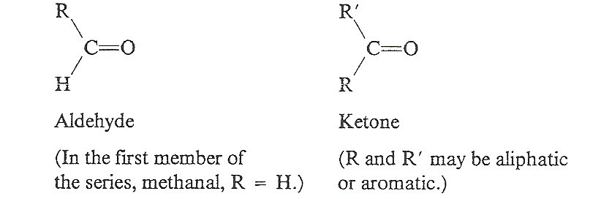
Carbonyl compounds

17B Organic chemistry II - Carbonyl compounds

6. Be able to identify the aldehyde and ketone functional groups.
7. Understand that aldehydes and ketones:
i do not form intermolecular hydrogen bonds and this affects their physical properties
ii can form hydrogen bonds with water and this affects their solubility
8. understand the reactions of carbonyl compounds with:
i Fehling’s or Benedict’s solution, Tollens’ reagent and acidified dichromate(VI) ions
In equations, the oxidising agent can be represented as [O]
ii lithium tetrahydridoaluminate (lithium aluminium hydride) in dry ether
In equations, the reducing agent can be represented as [H]
iii HCN, in the presence of KCN, as a nucleophilic addition reaction, using curly arrows, relevant lone pairs, dipoles and evidence of optical activity to show the mechanism
iv 2,4-dinitrophenylhydrazine (2,4-DNPH), as a qualitative test for the presence of a carbonyl group and to identify a carbonyl compound given data for the melting temperatures of derivatives
The equation for this reaction is not required
v iodine in the presence of alkali

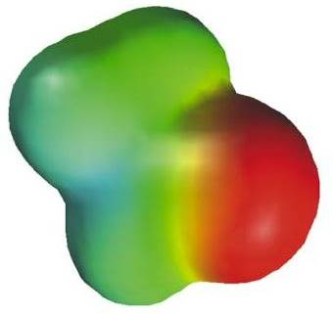


Ref:- Facer A2 Chemistry Chapter 7 p130 - 143
Cann and Hughes p526 -540

Department website Factsheets
33 | Organic Chemistry 4 – Carbonyl Compounds
35 | Answering Questions on Organic Pathways and Conversions
97 | Oxidation and Reduction in Organic Chemistry
101 | Organic functionality and structure – part 2(A2)

Websites

One of the best sites
http://www.chemguide.co.uk/organicprops/carbonyls/background.html
Carbonyl compounds, their physical properties and reactions

A rather older site but having some useful notes with exercises.
http://www.a-levelchemistry.co.uk/old%20AQA%20A2%20Chemistry/13.5%20Compounds%20Containing%20the%20Carbonyl%20Group/13.5%20Compounds%20Containing%20the%20Carbonyl%20Group.htm

Or if you prefer notes
http://www.knockhardy.org.uk/sci.htm

Finally
http://www.mp-docker.demon.co.uk/as_a2/topics/carbonyl_compounds/index.html
some quizzes to test your understanding

Contents

Nomenclature
Physical properties of carbonyl compounds
Reactions
- The reduction of the carbonyl group with LiAlH₄
H₂ and catalyst
- Nucleophilic addition reactions with HCN in KCN.
and mechanism
- The test to identify a carbonyl group using 2,4-dinitrophenylhydrazine.
- Tests to identify an aldehyde. Fehling’s reagent
Tollens’ solution
Oxidation with K₂Cr₂O₇ and dil H₂SO₄
- The iodoform test.
Carbonyl compounds.

Collectively aldehydes and ketones are known as carbonyl compounds. The carbonyl group, C=O is a subunit for many other functional groups but the term carbonyl compounds is reserved for those compounds where it appears on its own. Therefore carboxylic acids despite containing a C=O are not carbonyl compounds and will be dealt with separately.



ALDEHYDES | Displayed formulae | Structural formulae | Skeletal formula
Methanal
Ethanal
Propanal
KETONES
Propanone

Butanone
Pentan-2-one
Pentan-3-one
- With 2 different coloured asterisks * mark two sets of structural isomers in the table above

W/S ‘Nomenclature Aldehydes & Ketones’
Physical Properties.

Bonding between molecules.

Draw out the displayed structure of propanal and label the polar bond with δ+ and δ-.

Does propanal have Hydrogen bonding between its molecules? ...........................

Explain your answer. ………………………………………………………………………………….
…………………………………………………………………………………………………………
…………………………………………………………………………………………………………

Aldehydes and ketones have higher boiling points than the corresponding alkanes but lower boiling points than the alcohols.
(see graph)

Explain these differences.
…………………………………………………………………………………………………………
…………………………………………………………………………………………………………
…………………………………………………………………………………………………………
…………………………………………………………………………………………………………
…………………………………………………………………………………………………………
…………………………………………………………………………………………………………
Bonding between carbonyl compounds and water.
Draw out the displayed structures of propanone and a molecule of water. Label the dipoles with δ+ and δ- and include the lone pairs on the oxygen atoms of both molecules. Show the strongest intermolecular force that forms between the 2 molecules.

Will a Hydrogen bond form between the water and propanone molecule? ………………….
Explain your answer. …………………………………………………………………………………
…………………………………………………………………………………………………………
…………………………………………………………………………………………………………
The lower members of the series are all soluble in water. As the chain length increases the solubility in water decreases. Explain this trend.
…………………………………………………………………………………………………………
…………………………………………………………………………………………………………
…………………………………………………………………………………………………………

Other physical properties
Carbonyl compounds have distinctive smells. Ketones and aldehydes of higher molecular weight have important uses as flavouring and perfuming agents. For the following compounds circle the carbonyl group.

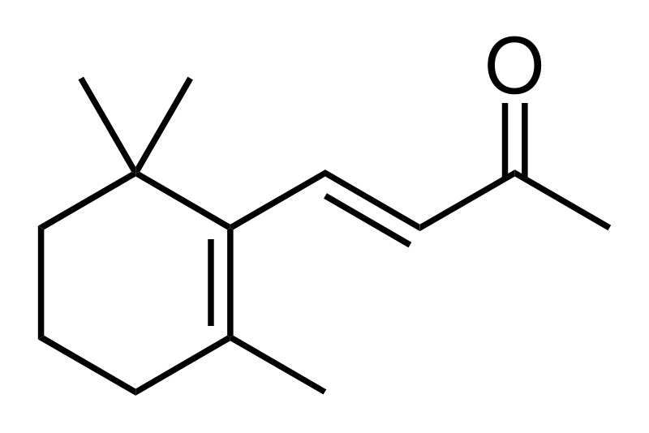
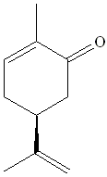

carvone (spearmint or caraway) ionone (violets) benzaldehyde (almonds)
Worksheets ‘Chemicals in perfumes’
‘Test yourself aldehydes and ketones Q1-9’
Reactions of carbonyl compounds.
You will need to know these reactions for the Unit 4 exam and for the organic practical assessments.
- The reduction of the carbonyl group
- Nucleophilic addition reactions with HCN in KCN.
- The test to identify a carbonyl group using 2,4-dinitrophenylhydrazine.
- Tests to identify an aldehyde (and distinguish it from a ketone)
- The iodoform test.

- Reduction of the carbonyl group.
From AS you will remember that a primary alcohol can be oxidised to an aldehyde then to a carboxylic acid, and a secondary alcohol can be oxidised to a ketone. These processes can be reversed by reacting the carboxylic acid, ketone or aldehyde with a strong reducing agent:-

The strong reducing agent we use in this case is Lithium tetrahydroaluminate (Lithium Aluminium Hydride), LiAlH₄ in dry ether

This compound acts as a source of hydride, H⁻ ions. This reagent must be used in a solution of dry ether (ethoxyethane), as it will hydrolyse in water. It is expensive and the reaction only results in low yields.

(EXTENSION) The reaction takes place in two stages:-
- AlH₄⁻ acts as a source of H⁻ ions which will act as a nucleophile, attacking the ^{δ+}C=O forming the alkoxide:-
→
H⁻
- This must be followed by warming with dilute HCl (hydrolysis) to protonate the O⁻ and release the alcohol
H⁺ →⁻

This reagent can reduce the C=O group in carboxylic acids and aldehydes to 1º alcohols and reduces ketones to 2º alcohols.

Note the H⁻ ions attacks the delta + carbon (the mechanism is very similar to the Nuleophilic addition reaction you will study later)

Complete the equation for the reduction of ethanoic acid using displayed formulae and balancing charges. The reducing agent can be represented as [H].

+ → +

ethanoic acid ethanol
Representing the reducing agent as [H], write similar equations for the reduction of:-
ethanal

propanone

The H⁻ ions from the LiAlH₄ are strong reducing agents, however they cannot reduce a C=C to a C-C. Why not?
………………………………………………………………………………………………………………………………………………………………………………………………………………………………………………………………………………………………………………………………

Draw the structure of the organic compound, when the following compounds are reduced using
- Hydrogen and a catalyst
- LiAlH₄ in dry ether
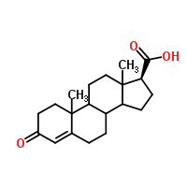
Compound |  | 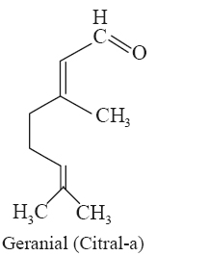
H₂ + Catalyst
LiAlH₄ in dry ether
2) Nucleophilic addition reactions with HCN with a little KCN (including the mechanism)

HCN is a weak acid and produces very few CN⁻ ions in solution, so a small amount of base is added to shift the equilibrium to the RHS, producing more CN⁻ ions. With KOH this makes KCN.
HC≡N + OH⁻ ⇌ :C≡N⁻ + H₂O

Draw a dot cross diagram for the CN⁻ ion

What feature does the C in the CN⁻ have that makes it a nucleophile?

……………………………………………………………………………………

The reaction of HCN (in KCN) with an aldehyde or ketone produces a compound called a hydroxynitrile.
Example: Ethanal reacting with HC≡N
Conditions: Room temperature and pressure, small amount of alkali
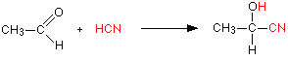

The product above is 2-hydroxypropanenitrile: The backbone of the compound is 3 carbons in length so it is a propan and the CN group is called a nitrile. As a member of the nitriles, the CN carbon atom is numbered C₁. The OH on C₂ is called a hydroxyl group.

With propanone (a ketone) the product is 2-hydroxy-2-methylpropanenitrile:
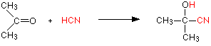

Notice that we have increased the number of carbon atoms in the molecule, this is one of the few ways of extending the carbon chain.

The conditions are very important for this reaction. If the pH is too low (acidic), there are not enough CN⁻ ions, if it is too high (alkaline) there are not enough H⁺ ions.

Write similar equations for:
- Methanal reacting with HC≡N

- Butanone reacting with HC≡N

Mechanism for the Nucleophilic addition of HC≡N

You need to be able write out the mechanism for this reaction
Mechanisms power point that you looked at in the mechanisms pack

Write the equation for the reaction of HC≡N with propanone.

Why is this classed as an addition reaction? ……………………………………………………….
Using this step by step guide through the mechanism
Draw the mechanism for the reaction between propanone and HC≡N.
Step 1

Step 2

Draw the mechanism for the reaction between propanal and HC≡N and asterisk the chiral C atom.

Step 1

Step 2

If the starting compound is symmetrical the product will …….………………………………………
If the starting compound is unsymmetrical the product will ………………………………………….
Refer to the ‘Isomerism ‘pack page 11 for the significance of any optical activity of the products.‘Test yourself aldehydes and ketones Q10 – 17’

The addition of HCN to a carbonyl can be used in organic synthesis in order to increase the length of a carbon chain. The nitrile group added can then by hydrolysed to a carboxylic acid group.

Addition of HCN to ethanal:

Hydrolysis of CN group
If the nitrile group is further reacted with HCl the nitrile group is hydrolysed into a carboxylic acid. The nucleophilic addition of HCN followed by a hydrolysis can be used to add a carbon onto a chain and then turn it into a carboxylic acid is a very useful tool in the synthesis of compounds

CH₃CH₂CN + HCl + 2H₂O → CH₃CH₂COOH + NH₄Cl

Draw this reaction showing the structural formulae:

Show a step by step route (synthesis) of turning propanal into 2-hydroxybutanoic acid, include all reagents and conditions:

You can find out more about this on Chem Guide
Test for the carbonyl (C=O) group.

This test involves the reagent 2,4-dinitrophenylhydrazine. This is sometimes abbreviated to 2,4-DNPH or 2,4-DNP and is also known as Brady’s reagent.

Method:
Add a few drops of aldehyde or ketone to a few cm³ of DNPH solution.
If a precipitate does not form immediately, add a few drops of dilute sulphuric acid and warm in a water bath. Then allow it to cool.

Result/observation:
Aldehydes and ketones all give a yellow/orange precipitate.

The reaction between 2,4-DNPH and the carbonyl group is classed as a condensation reaction.

Condensation reaction. Two molecules covalently bond together to form a bigger molecule, with the elimination of a molecule of water (or other small molecule)

+ → + H₂O

R₁ and R₂ = H, alkyl or aryl group

This is the general equation for this condensation reaction. Circle on the structures above the H atoms and O atom that are being removed to form the water. The rest of the molecule then joins at what was the carbonyl group.

You do not need to know the structure of DNPH or how it reacts. This exercise is included here as background knowledge.

Writing the formula:-
- Write the displayed formula for hydrazine H₂N–NH₂
- A phenyl group is C₆H₅– (a benzene ring as a side chain) Replace one of the hydrogen atoms in hydrazine with a phenyl group and write out the structural formula for phenylhydrazine.
- A nitro group is –NO₂. Number the carbon atoms in the benzene ring 1 - 6, where number 1 is the carbon atom bonded to the rest of the hydrazine molecule.
Draw out the structure of 2,4-dinitrophenylhydrazine, placing –NO₂ groups on carbon atoms 2 and 4.

Try this in the space below:

Draw out the displayed equation for the reaction between butanal and 2,4-dinitrophenylhydrazine.

Draw out the displayed equation for the reaction between butanone and 2,4-dinitrophenylhydrazine.

Identifying individual aldehydes and ketones from their DNPH derivatives

Aldehydes and ketones are mainly liquids but the DNPH product forms a crystalline precipitate; simple aldehydes form yellow precipitates, aromatic aldehydes or ketones form orange precipitates.

The identity of the carbonyl compound can be found by measuring the melting point of the DNPH derivative as this is more reliable than measuring the boiling point of the liquid alone.

Method
- Filter off the precipitate
- Dissolve in the minimum quantity of hot ethanol, filter, cool and allow it to recrystallise.
- Filter off the crystals, dry and measure their melting point.
- Compare the melting temperature with known 2,4-DNPH derivatives in a data book. (data sheet in online resources folder)

Recrystallisation of impure solids

When an organic solid is prepared it is not pure. This is because it contains traces of starting materials, co products and by products. These impurities have the effect of …………………
the melting point.

To obtain pure crystals the technique of recrystallisation is used. This involves:
- Find a solvent in which the solid dissolves when hot but is insoluble when cold.
- Dissolve the solid in the minimum possible amount of hot/boiling solvent.
- Allow to cool so the crystals come out of solution/recrystallise.
- Filter under reduced pressure, washing the crystals with a little cold solvent.
- Dry.

Note: The presence of a 2,4-DNPH precipitate will identify the presence of a carbonyl group but will not tell us the difference between an aldehyde and a ketone. To identify our unknown further we must be able to distinguish between an aldehyde and a ketone.
Worksheet ‘Identifying an unknown carbonyl compound’
Tests to distinguish aldehydes from ketones
We can identify the two series based on the fact that aldehydes are reducing agents. They can therefore be oxidised; from your work on alcohols, what are aldehydes oxidised to? .........................
The ability of aldehydes to act as reducing agents forms the basis for all the tests that distinguish between aldehydes and ketones. When writing oxidation equations of aldehydes the oxidising agent can be represented as [O]. The chemistry of the oxidising agents is included here as background.
Write the oxidation equation for ethanal using [O] to stand for the oxidising agent.

Test 1 - Fehling’s solution. (similar to Benedict’s solution)

Fehling’s solution is a solution of Cu²⁺ (blue) ions dissolved in an aqueous alkali and complexed with salts of tartaric acid. When an aldehyde is warmed with the solution it changes from blue and forms a red precipitate of Cu₂O, copper(I) oxide. As there are OH⁻ ions present the carboxylic acid formed reacts to produce the carboxylic acid salt.

CH₃CHO(aq) + 2Cu²⁺ + 5OH⁻ CH₃COO⁻ + Cu₂O + 3H₂O

This reaction is the same for all aldehydes, only the salt will change

Write out the equation for propanal with Fehling’s solution:-

Test 2 - Ammoniacal silver nitrate (Tollens’ reagent) (‘silver mirror’ test)

Tollens’ reagent contains the Ag⁺(aq) ion; this can be reduced by the aldehyde to produce Ag(s) (metallic silver). A silver mirror will form on the inside of the test tube.

CH₃CHO + 2Ag⁺(aq) + 3OH⁻ CH₃COO⁻ + 2Ag(s) + 2H₂O

Write out the equation for propanal with ammoniacal silver nitrate:-

Test 3 - Potassium dichromate(VI) and sulfuric (VI) acid

Acidified K₂Cr₂O₇ is a strong oxidising agent and is able to oxidise the aldehyde to a carboxylic acid.

CH₃CHO + [O] CH₃COOH

The reaction takes place on gentle heating and the solution changes colour as the orange dichromate(VI) ions are reduced to green Cr³⁺ ions:-

Write out the reduction half equation:-

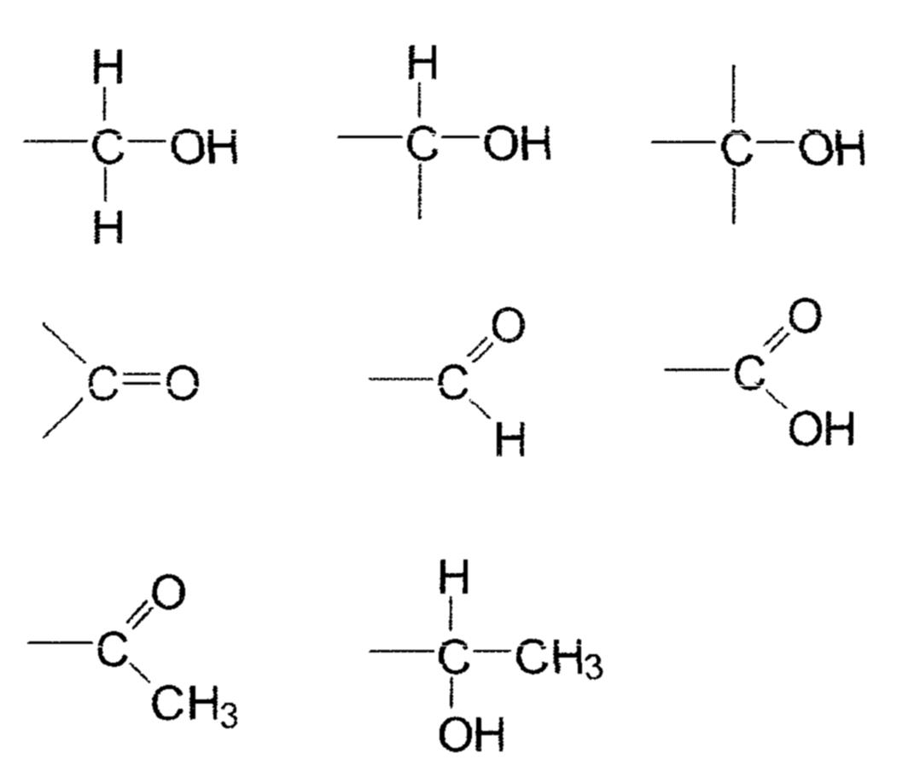
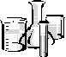
DNPH TEST FOR FUNCTIONAL GROUP
Consult Facer p137-139, Cann and Hughes p533
CORROSIVE
TOXIC
HIGHLY FLAMMABLE
2,4 DNP

Method | Observations | Deductions and Equations
IRRITANT

To 2 cm³ 2,4-dinitrophenylhydrazine solution (2,4-DNP) add 3 drops propanal.

If crystals do not form, add a few drops of 2M sulfuric acid, warm in a water bath and cool.

Describe the appearance of the crystals.
Repeat the test with a ketone e.g. propanone.

Write an equation for the condensation reaction.

CORROSIVE
HIGHLY FLAMMABLE
propanal
propanone
sulfuric
acid
TESTS FOR ALDEHYDES (OXIDATION)

Method | Observations | Deductions
TOLLENS’ REAGENT
(Ammoniacal silver nitrate
Into a CLEAN test tube put:-
- 2 cm³ silver nitrate solution.
CORROSIVE
- Add just enough sodium hydroxide to produce a ppt. Pour away the liquid above the ppt.
sodium
hydroxide
conc. ammonia
- Add conc. ammonia solution drop wise with shaking to the ppt. until it just dissolves.
HIGHLY FLAMMABLE
- Add 10 drops ethanal.
propanal
propanone
Heat in a water bath.
This solution contains diamminosilver(I) ions.
Oxidation half equation:
Reduction half equation

Repeat the test with 10 drops propanone.

What happens if this is left too long in the water bath?
Can you suggest why this happens?

Method | Observations | Deductions
FEHLING'S SOLUTION
Into a test tube put:-
- l cm³ Fehling's A (contains Cu²⁺(aq) ions)
- 1cm³ Fehling’s B (an alkaline solution of tartrate ions to complex with the copper and prevent precipitation of copper(II) hydroxide)
- 10 drops ethanal.
HIGHLY FLAMMABLE

ethanal
propanone
Heat in a water bath.
Consider Fehling’s as a solution of copper(II) ions
Oxidation half equation
Reduction half equation
.
Repeat test with 10 drops of propanone

TOXIC
potassium dichromate

POTASSIUM DICHROMATE +H₂SO₄  Method  IRRITANT | Observations | Deductions
Into a test tube put:-
sulfuric acid
- 10 drops dil.H₂SO₄(aq)
- 2 drops potassium dichromate(VI)
- 5 drops methanal.
Warm in a water bath
HIGHLY FLAMMABLE
Oxidation half equation:
Reduction half equation
methanal
ethanal
propanone

Into a test tube put:-
- 10 drops dil.H₂SO₄(aq)
- 2 drops potassium dichromate(VI)
- 5 drops ethanal.
Warm in a water bath
Oxidation half equation:
Reduction half equation

Into a test tube put:-
- 10 drops dil.H₂SO₄(aq)
- 2 drops potassium dichromate(VI)
- 5 drops propanone.
Warm in a water bath

The Iodoform test
We can now identify the carbonyl group and the difference between an aldehyde and a ketone. The iodoform test identifies a CH₃C=O group (and also CH₃CH(OH) groups).
Draw the displayed formulae molecules and circle the groups that would be identified.
ethanol | ethanal
a methyl ketone | a methyl 2º alcohol

The overall reaction for both the secondary methyl alcohol and the methyl ketone are very similar:-

Methyl ketone equation
+ 3I₂ + 4NaOH → + 3NaI + 3H₂O + CHI₃(s)

carboxylate salt iodoform

Write out the equation for the reaction with ethanal

Secondary methyl alcohol equation
Complete this using the general formula for a methyl 2º alcohol – in this case no water is formed

Write out the reaction for ethanol

IODOFORM REACTION; TEST FOR THE
Consult Facer p140
Method | Observations | Deductions
In a test tube place:-
CORROSIVE
- 1cm depth 1M NaOH
sodium hydroxide
- Add 5 drops propanone
HIGHLY FLAMMABLE
- Quickly add I₂/KI saturated solution dropwise until a faint brown colour remains
HARMFUL
propanone
ethanal
propanal

(If no ppt formed warm in a water bath and cool)
iodine
Name both organic products.
Repeat the test with ethanal.

(The yellow ppt forms slowly in this case)
Write an equation for the reaction.

Demonstration:
- 1cm depth 1M NaOH
- Add 5 drops propanal
- Quickly add I₂/KI saturated solution dropwise until a faint brown colour remains

Assessment practice.
We can use the previous tests to identify functional groups in unknown organic compounds.
The two organic compounds H and I contain the elements carbon, hydrogen and oxygen only. One of H and I can be converted into the other by oxidation.
June 05 6A2 Q2
Carry out the following tests on H and I, recording your observations and inferences in the spaces provided.
You are not expected to identify H and I in your inferences.
(a) To 2 cm³ of aqueous 2,4-dinitrophenylhydrazine add 6 drops of H and shake the test tube gently.
Observation | Inference
(2)
(b) To 4 drops of H add 2 cm³ of dilute sulphuric acid, followed by about 8 drops of aqueous potassium dichromate(VI). Stand the test tube in a beaker of warm water for about three minutes.
Observation | Inference
(2)
(c) Carry out the following test in a fume cupboard.
To 1 cm³ of I in a dry boiling tube, add about half a spatula measure of phosphorus pentachloride. Test any gas evolved with damp blue litmus paper.
Leave your boiling tube in the fume cupboard.
Observations | Inferences
(5)

(d) To about 4 cm³ of the aqueous sodium hydroxide in a test tube, add 5 drops of I. Then add aqueous iodine drop by drop until a faint brown colour remains.
Allow the test tube to stand for a few minutes.
Observation | Inference
(3)
(e) The mass spectrum of H is given below.
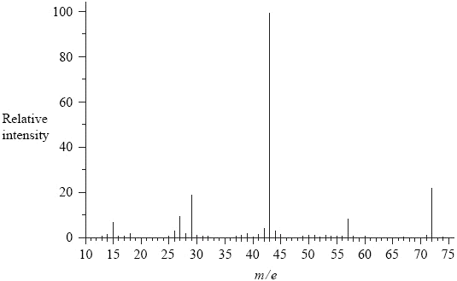
Use the information from the mass spectrum and the results of the tests in (a) and (b) to draw the structure of H.

(1)

(f) Use the information given at the beginning of the question, the results of the tests in (c) and (d) and your answer in (e) to draw the structure of I.

(1)
(Total 14 marks)

‘Test yourself aldehydes and ketones Q18 – 23’
Revision page(s)
- Look at the syllabus on the front cover and make sure you have notes on each section:-
Nomenclature
Physical properties of carbonyl compounds
Reactions:-
The reduction of the carbonyl group with LiAlH₄
H₂ and catalyst
Nucleophilic addition reactions with HCN in KCN.
and mechanism
The test to identify a carbonyl group using 2,4-dinitrophenylhydrazine.
Tests to identify an aldehyde. Fehling’s reagent
Tollens’ solution
Oxidation with K₂Cr₂O₇ and dil H₂SO₄
The iodoform test.

- Write out a spider diagram of the reactions of aldehydes and ketones.

- Draw out a decision tree for the identification of an unknown organic compound

- Use your decision tree to identify each chemical from a series of three unlabelled samples:-
- ethanol ethanal ethanoic acid
- 1-chlorobutane butanone butane
- ethanal propanone butanal

1. This question concerns the nucleophilic addition reaction between a carbonyl compound and hydrogen cyanide, HCN.
(a) Which one of the following carbonyl compounds would produce a racemic mixture?
Refer to ‘Isomerism’ pack page 6
A CH3COCH3
B C2H5CHO
C HCHO
D C2H5COC2H5
(1)
(b) Which of the following best represents the first step of the mechanism for this reaction with an aldehyde?
(1)
(Total 2 marks)
Do not write in the margin
SP4 14

2. (a) Name the homologous series to which the compound CH₃CH₂CHO belongs.
…................................................................................................................................
(1)
(b) Describe what you would see if a sample of CH₃CH₂CHO was warmed with Fehling’s solution.
…................................................................................................................................
…................................................................................................................................
…................................................................................................................................
…................................................................................................................................
(2)
(Total 3 marks)
  - Compound V, the structure of which is shown below, is found in human sweat.
Compound V

(b) Compound V can be converted into two carbonyl compounds W and X, shown below.
  - Which of the compounds W or X would react when warmed with Fehling’s solution to give a red precipitate? Justify your answer.
…......................................................................................................................
…......................................................................................................................
(1)
(ii) Compound W can be reduced in two steps to compound Y of molecular formula C₂H₆O₂.
Identify Y.
…......................................................................................................................
(1)
(iii) Compound W can be oxidised to compound Z of molecular formula C₂H₂O₄.
Identify Z.
…......................................................................................................................
(1)
Total 3 marks
Do not write in the margin
S08N.1.02

S08C.4.01 mod

4. (a) Draw the displayed formula of a branched chain ketone containing five carbon atoms.

(2)
(b) Give the systematic name for this ketone.
…................................................................................................................................
(1)
(c) What is the molecular formula of the alcohol this ketone could be made from?
…................................................................................................................................
(1)
(d) An alcohol can be converted into a ketone by oxidation with sodium dichromate(VI) and sulphuric acid.
Explain why refluxing the mixture first, rather than immediately distilling the product over from the beginning, results in a higher yield of the ketone.
…................................................................................................................................
…................................................................................................................................
…................................................................................................................................
…................................................................................................................................
(1)
(Total 5 marks)
Do not write in the margin
W08N.1.02

5. This question is about propanal, CH₃CH₂CHO, propanone, CH₃COCH₃, and propanoic acid, CH₃CH₂CO₂H.
(a) Explain why all three compounds are soluble in water.
…................................................................................................................................
…................................................................................................................................
(1)
(b) Propanal and propanone contain the carbonyl group.
State a chemical test for the presence of this group. Give the result of a positive test.
Test …........................................................................................................................
Result ….....................................................................................................................
(2)
(c) Propanal can be distinguished from propanone by its oxidation to propanoic acid.
(i) Name an oxidising agent you would use.
…......................................................................................................................
…......................................................................................................................
(1)
(ii) State the colour change you would observe during the oxidation.
From …................................................... to ….................................................
(1)
(iii) State how propanone can be distinguished from propanal using infra-red spectra.
Refer to Unit 2 ‘Mass spec.and IR pack

You are not expected to give actual absorption values, but you should indicate the bonds in the molecules which would give rise to the distinguishing absorptions.
…......................................................................................................................
…......................................................................................................................
(1)
Total 6 marks
Do not write in the margin
S03.N.4.03

2016
NAME …........................……… HOMEWORK DEADLINE …..................
Student Number ………… Chemistry Class ………
Student targets from previous pack

Carbonyl compounds
Task | Mark
Notes | /10
Assessment practice, identification of organic compounds | /14
Final questions | /19  = %
Revision Notes /Summary page | /10
Overall Grade for this work | A B C D E U

Student comments

Tutor comments

Tutor signature Date

Student targets for next pack

