Topic 7 Extension questions
1 a) A compound P has the formula C₄H₆O₂. P reacts with HCN to form a compound Q, C₆H₈O₂N₂. P is easily oxidised by potassium dichromate(vi) to an acidic compound R, C₄H₆O₄. When 1.0 g R is dissolved in water and titrated with 1.00 mol dm⁻³ sodium hydroxide, the mean titre is 16.90 cm³. Suggest structures for P, Q and R and explain the reactions.
b) A compound Z contains 64.3% carbon, 7.1% hydrogen and 28.6% oxygen by mass. The mass-to-charge ratio of the molecular ion in its mass spectrum is 56. Z reduces Fehling’s solution to give an orange precipitate. When Z reacts with hydrogen in the presence of a nickel catalyst, 0.1 g Z reacts with 85.4 cm³ hydrogen under conditions in which 1 mol gas occupies 24 dm³. Suggest a structure for Z and account for the observations.
2 An optically active compound X with the formula C₃H₆O₃. reacts with sodium carbonate giving off a colourless gas. Oxidation of X gives Y which reacts with 2,4-dinitrophenylhydrazine but not with Fehling’s solution.
Account for these observations and give the structures of X and Y.
3 Glucose is a carbohydrate. Glucose molecules usually exist in a ring form. In solution about 1% of the molecules exist in an open chain form.

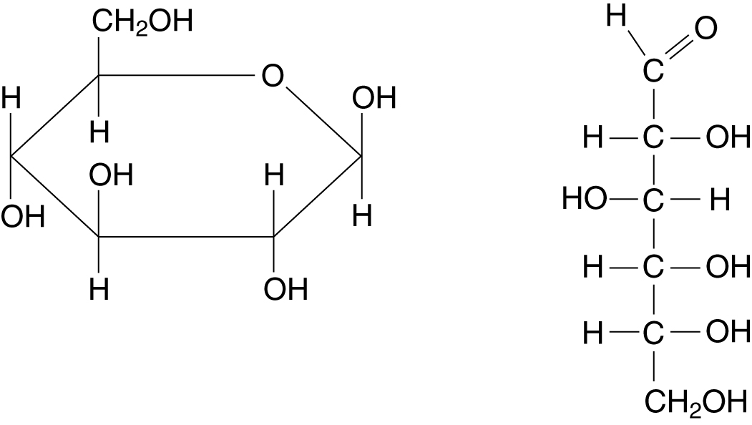

a) i) What is the molecular formula of glucose?
ii) By inspection of the formula suggest a reason why glucose and related compounds are called carbohydrates.
b) Explain why glucose is a solid at room temperature but also very soluble in water.
c) Sugars such as glucose are classified as aldoses or ketoses based on the type of carbonyl group present in the open chain forms of the molecules. Is glucose an aldose or a ketose?
d) i) What would you expect to observe on mixing a solution of glucose with a solution of
2,4-dinitrophenylhydrazine?
ii) This reaction is slower with glucose than with compounds such as propanal. Suggest a reason for this.
e) i) What would you expect to observe on warming a mixture of a solution of glucose and Tollens’ reagent?
ii) Why is glucose classified as a reducing sugar?

