Identifying an unknown carbonyl compound
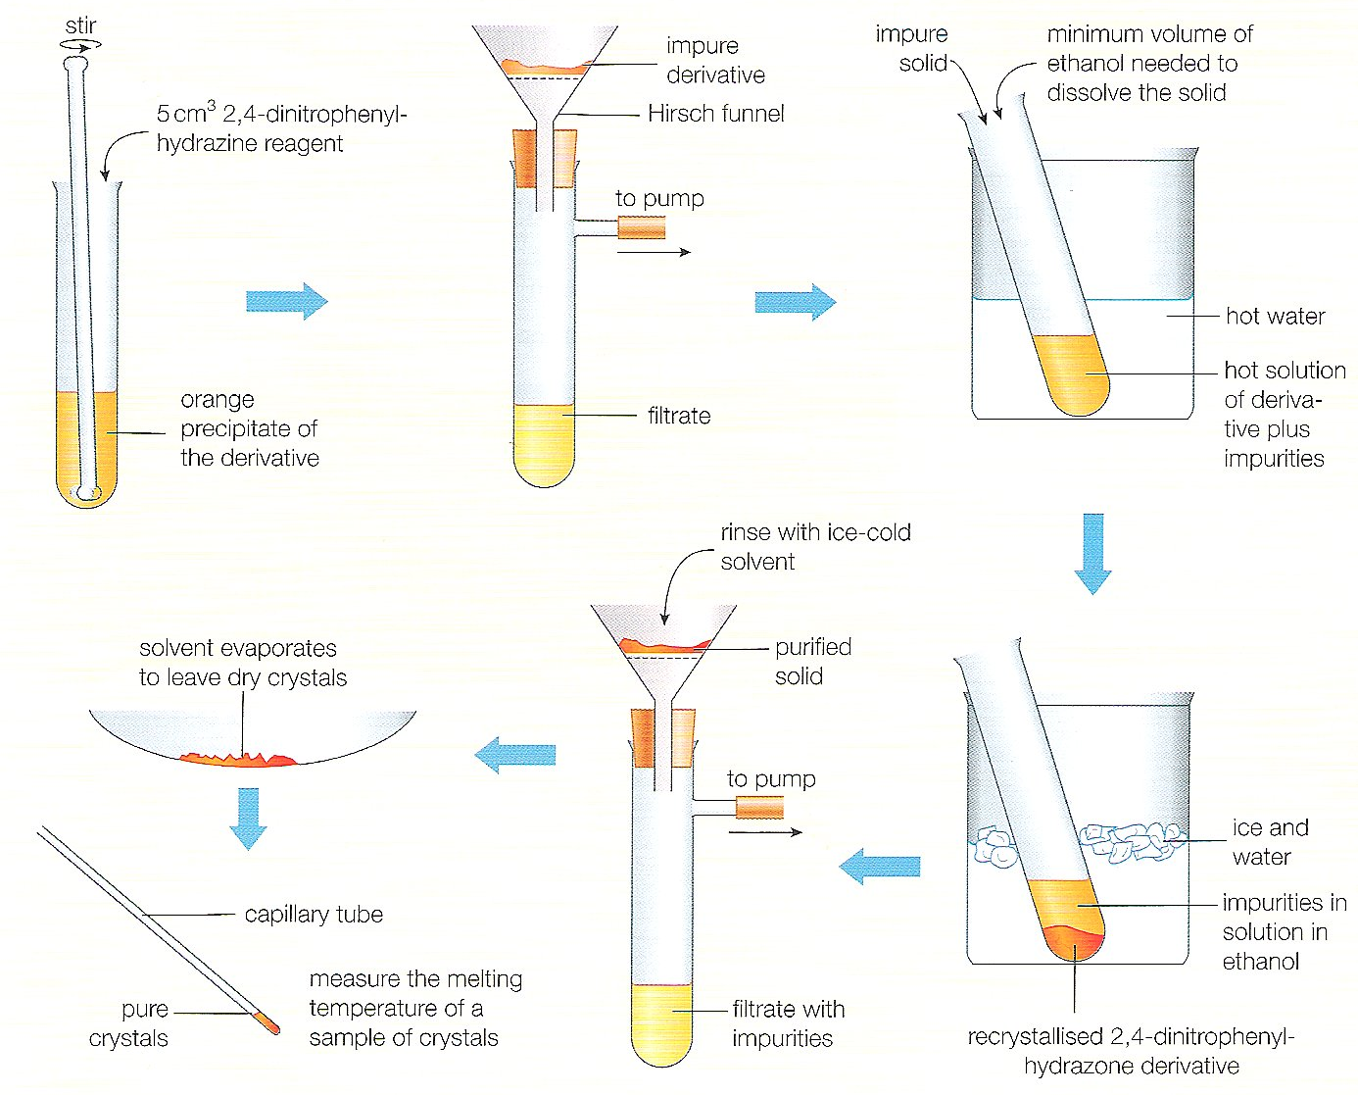
The stages in making, purifying and identifying a carbonyl compound are shown below are shown below

1 Why is it necessary to purify the derivative before measuring its melting temperature?
……………………………………………………………………………………………………..
2 Explain how the procedure illustrated removes impurities from the derivative.
……………………………………………………………………………………………………..
……………………………………………………………………………………………………...
3 In this instance, ethanol is the solvent used for recrystallising the derivative. What determines the choice of solvent?
……………………………………………………………………………………………………..
4 When measuring the melting temperature, what are the signs that the derivative is pure?
………………………………………………………………………………………………………..
5 Identify the carbonyl compound that forms a 2,4-dinitrophenylhydrazone that melts at 115°C. The carbonyl compound boils at 80°C. The compound does not give an orange precipitate with Fehling's solution.
……………………………………………………………………………………………………….

