AS.CHEM2.10.001 31-Jul-26 © Ripon Grammar School / RWGrime  NOMENCLATURE - Aldehydes and Ketones  Name ………………………………………….………………………………. Form …………………. | 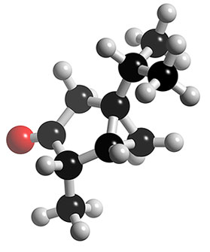

1) Naming aldehydes | Functional group: |  | Suffix = -al

 | Displayed and skeletal formulae | Name
CH₃CHO

CH₃CH₂CH₂CH₂CHO

(CH₃)₂CHCHO

CH₃CH=CHCHO

CH₂BrCH₂CHO

2) Naming ketones | Functional group: |  | Suffix = -one Prefix = oxo-

 | Displayed and skeletal formulae | Name
CH₃COCH₃

CH₃CH₂CH₂COCH₃

CH₃COCH₂CH₃

CH₃COCH(CH₃)₂

3) Some extra practice Complete the table.

Name | Structural formula | Displayed and skeletal formulae
butanal
butanone
 | CH₃COCH₃
 | CH₃COCH₂CH₂CH₃
 | (CH₃)₃CCH₂COCH₃
1-chlorobutan-2-one
but-3-enal
1-bromopentan-3-one
 | CH₃CH₂COCH(CH₃)₂
 | CH₃CH(OH)CH₂COCH₃

