Chemicals in perfumes

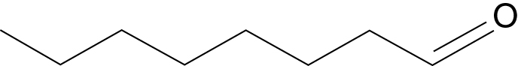
1

2 Advantages of synthetic perfume chemicals include:
- uniformity – the quality of oils from natural sources (plants or animals) can vary with the conditions for growth and the circumstances in which the material was collected or harvested and then stored.
- reliability of supply – weather conditions can cause a crop to fail or yield poorly, while political or economic conditions can restrict access to raw materials.
- stability of price – the cost of synthetic chemicals is more predictable than the cost of chemicals extracted from natural sources.
3 Compounds with an aldehyde group: undecanal, citral.
Compounds with a ketone group: hexamethyl tetralin musk, methyl dihydrojasmonate.
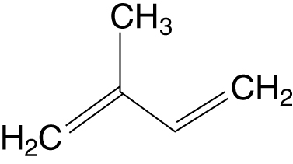
4 a)

b) The carbon skeleton of a geraniol molecule is based on two 2-methylbuta-1,3-diene molecules joined together.
5 a) London forces increase with increasing molecular size because the higher the number of electrons in a molecule the greater the fluctuating dipoles that lead to weak intermolecular forces.
Molecules with fewer than five carbon atoms are generally too volatile for use in perfumes: they are either gases at room temperature or liquids with such low boiling temperatures that they vaporise too easily. Molecules with more than seventeen carbon atoms are generally not volatile enough.
Intermolecular hydrogen bonding is possible between molecules of an alcohol, but not between aldehyde molecules. Alcohols therefore have higher boiling temperatures than aldehydes of similar molar mass.
b) Musks are near the upper limit of molecular size for perfume chemicals. They may act as fixatives by means of hydrogen bonding or dipole–dipole interactions with more volatile components.
c) Each –OH group in an alcohol can link to two or three water molecules by hydrogen bonding. As a result, alcohols are more soluble in water than other perfume ingredients such as carbonyl compounds.

