AS.CHEM2.10.001 31-Jul-26 © Ripon Grammar School / RWGrime  NOMENCLATURE - Aldehydes and Ketones  Name answers Form …………………. | 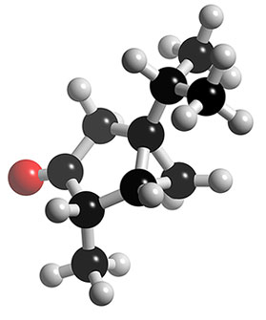

1) Naming aldehydes | Functional group: |  | Suffix = -al

 | Displayed and skeletal formulae | Name
CH₃CHO |  | ethanal
CH₃CH₂CH₂CH₂CHO |  | pentanal
(CH₃)₂CHCHO |  | 2-methylpropanal
CH₃CH=CHCHO |  | but 2-enal cis and trans
CH₂BrCH₂CHO |  | 3-bromopropanal

2) Naming ketones | Functional group: |  | Suffix = -one Prefix = oxo-

 | Displayed and skeletal formulae | Name
CH₃COCH₃ |  | propanone
CH₃CH₂CH₂COCH₃ |  | pentan-2-one
CH₃COCH₂CH₃ |  | butanone
CH₃COCH(CH₃)₂ |  | 3-methylbutanone

3) Some extra practice Complete the table.
Name | Structural formula | Displayed and skeletal formulae
butanal | CH₃CH₂CH₂CHO
butanone | CH₃COCH₂CH₃
propanone | CH₃COCH₃
pentan-2-one | CH₃COCH₂CH₂CH₃
4,4-dimethylpentan-2-one | (CH₃)₃CCH₂COCH₃
1-chlorobutan-2-one | CH₂ClCOCH₂CH₃
but-3-enal | CH₂=CHCH₂CHO
1-bromopentan-3-one | CH₂BrCH₂COCH₂CH₃
2-methylpentan-3-one | CH₃CH₂COCH(CH₃)₂
4-hydroxypentan-2-one | CH₃CH(OH)CH₂COCH₃

