Answers to Topic 7 Test yourself questions

1 CH₃CH₂CH(CH₃)CHO
2 a) CH₃CH₂CH₂OH(l) + [O]
→ CH₃CH₂CHO(l) + H₂O(l)
b) The reaction of propan-1-ol with the oxidising agent is vigorous. If the alcohol is added too quickly the mixture can get very hot. There is a danger of loss of volatile organic compounds before all the alcohol has been added if it is added too quickly.
c) The conditions are chosen to make the aldehyde and avoiding oxidising the aldehyde further to propanoic acid. The aldehyde distils off as soon as it forms.
3 (CH₃)₃CCH₂COCH₃
4 C₁₀H₁₈O
5 Both have the molecular formula C₃H₈O but one is a ketone and the other an aldehyde.
6 CH₃CH₂CHOHCH₃(l) + [O]
→ CH₃CH₂COCH₃(l) + H₂O(l)
7 a) Propanone and propanal are liquids at room temperature, boiling at 56 °C and 49 °C respectively. Butane, which has the same molar mass, is a gas boiling at –0.5 °C. Propan-1-ol with a very similar molar mass boils at 97 °C.
b) The C=O bond is polar and so aldehyde molecules have a permanent dipole. Molecules with permanent dipoles have stronger intermolecular forces than alkanes, which are non-polar. Hydrogen bonding, such as between the –OH groups of alcohols, is considerably stronger than other intermolecular forces.
8 The oxygen atom in the carbonyl group of propanone can take part in hydrogen bonding with the –OH groups in water molecules. This allows propanone molecules to break into the hydrogen-bonded network of molecules in water and mix freely.
9 In any aldehyde, solubility is a balance between the attraction water molecules have for the electronegative oxygen atom which can take part in hydrogen bonding, and the hydrophobic properties of the hydrocarbon part of the molecule. The benzene ring (C₆H₅) means that the hydrocarbon part of benzene carbaldehyde is the more significant.
10 Cr is reduced from +6 to +3
11 a) Mix with excess of an acidic solution of potassium dichromate(vi) and then heat under reflux.
b) i) A flask fitted with a reflux condenser
ii) Apparatus rearranged for distillation of the product from the reaction flask
12 Butanal is reduced to the primary alcohol,
butan-1-ol.
Butanone is reduced to the secondary alcohol, butan-2-ol.
13 C=O becomes CH−OH (in an aldehyde or a ketone).
14 a) The cyanide ion is negatively charged and has a lone pair of electrons.
b) Heterolytic bond breaking
c) The C−O bond which breaks was formed using one electron from C and one from O. When both electrons are transferred to O it gains one extra electron and so has a single negative charge.
d) HCN acts as an acid donating a proton to the intermediate.
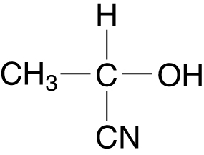
15 a) The product of the reaction has four different groups attatched to the central carbon atom. It is asymmetric.

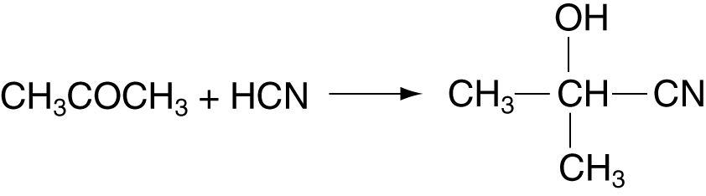
16

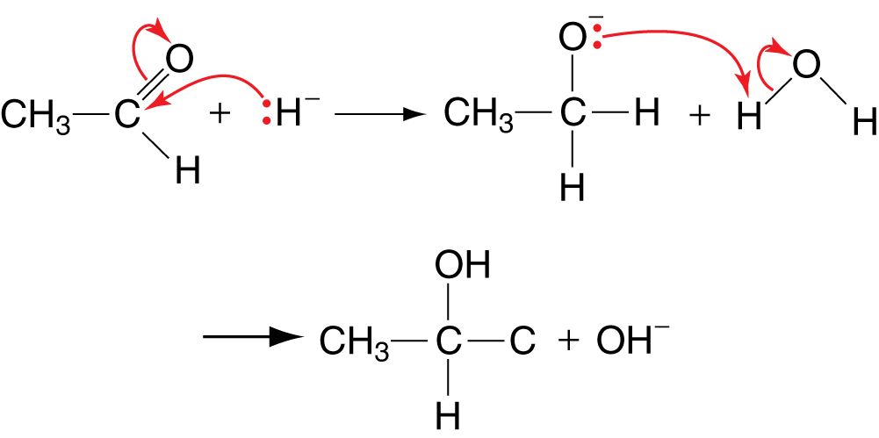
17 a)

b) Nucleophiles attack the carbonyl group. Double bonds in alkenes undergo electrophilic addition. Hydride ions are nucleophiles.
18 Cu²⁺(aq) + 2OH⁻(aq) → Cu(OH)₂(s)
19 a) CH₃CH₂CHO(l) + [O] → CH₃CH₂COOH(l)
b) Silver ions in solution (oxidation state +1) are reduced to silver metal (oxidation state 0).
20 A (1-chlorobutane) hydrolyses to B (the primary alcohol, butan-1-ol) which oxidises to C (the aldehyde, butanal).
21 a) The reagent first oxidises the alcohol to a carbonyl compound, which can then take part in the triiodomethane reaction.
b) Sodium chlorate(i) is a solution of chlorine in sodium hydroxide. The chlorate(i) ions oxidise iodide ions to iodine.
22 Pentan-2-one
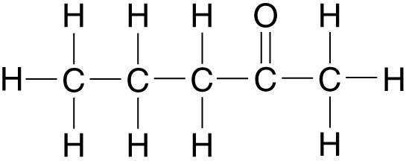

3-methylbutan-2-one
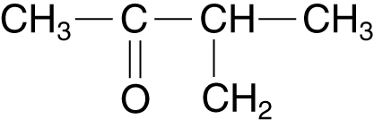

23 Ethanal

