**3.5.2 Respiration**

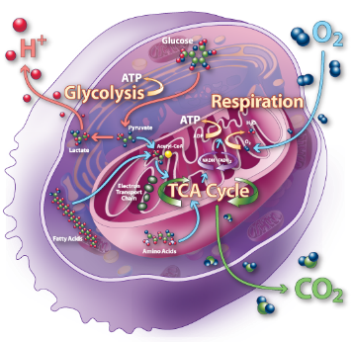

**Specification**

Respiration produces **ATP**.

**Glycolysis** is the first stage of anaerobic and aerobic respiration. It occurs in the cytoplasm and is an anaerobic process.

Glycolysis involves the following stages:

* + **phosphorylation** of glucose to glucose phosphate, using ATP
  + production of **triose phosphate**
  + oxidation of triose phosphate to **pyruvate** with a net gain of ATP and reduced NAD.

If respiration is only anaerobic, **pyruvate** can be converted to ethanol or **lactate** using reduced NAD. The oxidised NAD produced in this way can be used in further glycolysis.

If respiration is aerobic, pyruvate from glycolysis enters the mitochondrial matrix by active transport.

Aerobic respiration in such detail as to show that:

* + pyruvate is oxidised to **acetate**, producing reduced NAD in the process
  + acetate combines with **coenzyme A** in the link reaction to produce **acetyl coenzyme A**
  + acetyl coenzyme A reacts with a four-carbon molecule, releasing coenzyme A and producing a six-carbon molecule that enters the **Krebs cycle**
  + in a series of oxidation-reduction reactions, the Krebs cycle generates reduced coenzymes and ATP by **substrate-level phosphorylation**, and carbon dioxide is lost
  + synthesis of ATP by **oxidative phosphorylation** is associated with the transfer of electrons down the electron transfer chain and passage of protons across inner mitochondrial membranes and is catalysed by **ATP synthase** embedded in these membranes (**chemiosomotic theory**)
  + other respiratory substrates include the breakdown products of lipids and amino acids, which enter the Krebs cycle.

**Required practical 9**: Investigation into the effect of a named variable on the rate of respiration of cultures of single-celled organisms.

**Resources**

* AQA Biology, Toole & Toole: Pgs. 283 – 297
* Respiration PowerPoint on GOL

**Recall Activities**

These are activities to develop your recall of information you covered in the previous topics that are linked to respiration. You should do this before you start the work on respiration. Once you have done the recall activity quickly check your info/answers using your student booklets and notes from that topic.

**Topics covered**: Biological molecules, enzymes, transport across membrane

|  |  |  |  |
| --- | --- | --- | --- |
| **Topic** | **Recall activities** | **Understanding**  *Please write down any questions you have when completing this activity.* | **Completed** |
| **Biological molecules** | On the MWB/scrap paper, draw an alpha glucose and beta glucose molecule highlighting the difference between the 2 molecules |  |  |
| On the MWB/scrap paper, draw an ATP molecule to show its structure and write an equation to show the ATP/ADP cycle. |  |  |
| On the MWB/scrap paper, write down 5 energy-requiring processes within cells. |  |  |
| **Enzymes** | On a scrap piece of paper/MWB sketch the graphs to show the effects of substrate concentration, pH, temperature and enzyme concentration on the rate of reaction. Now explain the shape of the graphs |  |  |
| **Transport** | On the MWB/scrap paper define facilitated diffusion, active transport and co-transport. Draw simple diagrams to demonstrate each type of movement |  |  |
| **Cells** | On a MWB/scrap paper draw, label and annotate a mitochondria |  |  |
| **Digestion** | On a MWB/scrap write down the equations that release glucose in digestion and write a paragraph explaining how glucose is absorbed from the ileum into the bloodstream. |  |  |

**3.5.2 Respiration**

A series of enzyme controlled reactions which produce chemical energy in the form of ATP from organic molecules (mainly glucose). It can be done aerobically (with oxygen) or anaerobically (without oxygen)

**Mechanisms of ATP synthesis**

What is meant by the term phosphorylation?

……………………………………………………………………………………………………………………………………………………………………………………………………………………………………………………………………………………………………………………

Complete the table below showing the types of phosphorylation found in respiration.

|  |  |
| --- | --- |
| Type of phosphorylation | Description and where is takes place in the cell |
|  |  |
|  |  |

**Coenzymes**



**substrate**

**enzyme**

**coenzyme**

Coenzymes bind with a specific enzyme or substrate, helping to catalyze a reaction. Coenzymes transfer a chemical group (like hydrogen) from one molecule to another.

List the coenzymes used in respiration below and describe their function.

|  |  |
| --- | --- |
| Coenzyme | Function |
|  |  |
|  |  |
|  |  |

**Important processes in respiration**

Define the terms below:

|  |  |
| --- | --- |
| **Oxidation** |  |
| **Reduction** |  |
| **Dehydrogenation** |  |
| **Decarboxylation:** |  |

**Aerobic Respiration**

List the 4 stages of aerobic respiration below.

1. ……………………………………………………….

2. ………………………………………………………..

3. ………………………………………………………..

4. …………………………………………………………

**Glycolysis**

Glycolysis is the first stage of both aerobic and anaerobic respiration and takes place in the cytoplasm of the cell.

Complete the diagram below and then annotate the diagram to explain what happens in glycolysis.

**1.**

**2.**

ADP

Pi

ADP

Pi

4ATP

2 NAD

**2H+**

**4.**

**3.**

**5.**

**6.**

Extra Information

**Link reaction**

Pyruvate is actively transported into the matrix of the mitochondria from the cytoplasm where the link reaction takes place.

Complete the diagram below and then annotate the diagram to explain what happens in the link reaction.

**1.**

CO2

NAD

**2.**

**3.**

**4.**

Extra Information

**Krebs Cycle**

Krebs cycle involves a series of oxidation reduction reactions in the matrix of the mitochondria. Reduced coenzymes and ATP are produced.

Complete the diagram below and then annotate the diagram to explain what happens in the Krebs cycle.

**1.** Formation of citrate

**2.** Formation of a 5 carbon compound

CoA

**Krebs Cycle**

**NAD**

**NAD**

**ADP + Pi**

**NAD**

**FAD**

**3.** Regeneration of oxaloacetate

Extra information:

**Oxidative phosphorylation and the electron transport chain.**

Oxidative phosphorylation is where most of the ATP is made in respiration. Energy is carried by electrons to produce the ATP. The electrons come from the reduced NAD and reduced FAD (the coenzymes).

Oxidative phosphorylation involves two processes:

1. Electron Transport Chain
2. Chemiosmosis

**Inner mitochondrial membrane**

Carrier 1

ATP Synthase

ATP Synthase

Carrier 2

Carrier 3

**Outer mitochondrial membrane**

H+

H+

H+

H+

H+

H+

H+

H+

H+

H+

H+

H+

H+

**Intermembrane** **space**

**Matrix of mitochondria**

**High H+ Concentration**

**Low H+ Concentration**

**Reduced NAD**

**NAD**

**2H**

**2e-**

**2H+**

**2ADP + 2Pi**

**2ATP**

H+

**H2O**

**½ O2 + 2H+**

**2e-**



Compete the table below to explain the stages of oxidative respiration.

|  |  |
| --- | --- |
| **Step** | **Explanation** |
| **1** |  |
| **2** |  |
| **3** |  |
| **4** |  |
| **5** |  |
| **6** |  |
| **7** |  |
| **Extra**  **info** |  |

**Alternative respiratory substrates**

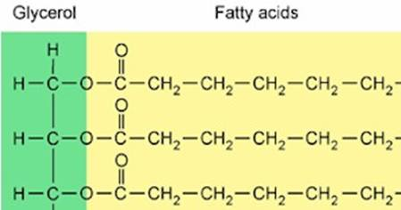**Fat as a respiratory substrate**

How can fats be used as a respiratory substrate?

…………………………………………………………………………………………………………..

…………………………………………………………………………………………………………..

……………………………………………………………………………………………………………………………………………………………………………………………………………………………………………………………………………………………………………………

Why do fats produce a large amount of ATP?

……………………………………………………………………………………………………………………………………………………………………………………………………………………………………………………………………………………………………………………

**Protein as a respiratory substrate**

How can protein be used as a respiratory substrate?

……………………………………………………………………………………………………………………………………………………………………………………………………………………………………………………………………………………………………………………

……………………………………………………………………………………………………………………………………………………………………………………………………………………………………………………………………………………………………………………

……………………………………………………………………………………………………………………………………………………………………………………………………………………………………………………………………………………………………………………

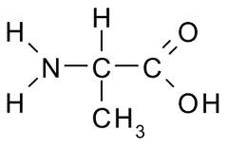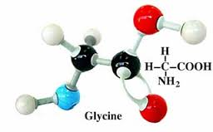

**Anaerobic Respiration**

Anaerobic respiration is the incomplete intracellular breakdown of glucose or other organic compounds in the **absence** of oxygen that releases energy. The process **stops** at glycolysis.

In eukaryotic cells only 2 types of anaerobic respiration occurs.

1. Alcoholic fermentation – in plants and microorganisms such as yeast.
2. Lactate fermentation – in animals

Complete the diagrams below and then annotate to explain what happens in alcoholic and lactate fermentation

**Alcoholic fermentation**

CO2 (1C)

NAD

**Lactate fermentation**

NAD

**Summary of Anaerobic respiration**

|  |  |  |
| --- | --- | --- |
|  | **Plant** | **Animal** |
| Decarboxylation |  |  |
| Number C atoms – end product |  |  |
| Dehydrogenation |  |  |
| NAD regenerated |  |  |
| Ethanal |  |  |
| Lactic acid? |  |  |
| Ethanol? |  |  |

What is the significance of anaerobic respiration?

……………………………………………………………………………………………………………………………………………………………………………………………………………………………………………………………………………………………………………………

……………………………………………………………………………………………………………………………………………………………………………………………………………………………………………………………………………………………………………………

……………………………………………………………………………………………………………………………………………………………………………………………………………………………………………………………………………………………………………………

**Energy budget of Respiration**

It is possible to compare the energy converted in aerobic and anaerobic respiration.

Work through the questions.

1. Which type of phosphorylation forms ATP in anaerobic respiration?

………………………………………………………………………………………………………………………………………………………

1. How many ATP molecules are needed to start glycolysis?

………………………………………………………………………………………………………………………………………………………

1. How many ATP molecules are formed during glycolysis?

………………………………………………………………………………………………………………………………………………………

1. What is the net gain of ATP during glycolysis?

………………………………………………………………………………………………………………………………………………………

1. Complete the table below to show how much ATP is produced in the different stages of respiration.

|  |  |  |
| --- | --- | --- |
| **Stage of respiration** | **Molecules produced** | **Number of ATP molecules** |
| Glycolysis | ……. ATP |  |
| Glycolysis | ……. reduced NAD |  |
| Link Reaction (x2) | ……. reduced NAD |  |
| Krebs cycle (x 2) | ……. ATP |  |
| Krebs Cycle (x2) | ……. reduced NAD |  |
| Krebs Cycle (x2) | ……. reduced FAD |  |
|  | | Total ATP = |

1. Is any ATP formed during the reduction of pyruvate to form Lactate or ethanol?

………………………………………………………………………………………………………………………………………………………

1. Aerobic respiration produces 32 ATP while anaerobic respiration produces only 2 ATP. How much more efficient is aerobic respiration than anaerobic respiration? Show your calculation.

………………………………………………………………………………………………………………………………………………………

………………………………………………………………………………………………………………………………………………………

………………………………………………………………………………………………………………………………………………………

1. If one mole of ATP yields 30kJ and aerobic respiration produces 32 ATP how much energy will one mole of glucose release. Show your working.

………………………………………………………………………………………………………………………………………………………

………………………………………………………………………………………………………………………………………………………

………………………………………………………………………………………………………………………………………………………

1. Glucose has the potential to release 2900kJ of energy. Calculate the efficiency of aerobic respiration.

………………………………………………………………………………………………………………………………………………………

………………………………………………………………………………………………………………………………………………………

………………………………………………………………………………………………………………………………………………………

………………………………………………………………………………………………………………………………………………………

………………………………………………………………………………………………………………………………………………………

1. What is the main cause of energy loss?

………………………………………………………………………………………………………………………………………………………

………………………………………………………………………………………………………………………………………………………

**Measuring the rate of respiration and respirometers**

The rate of cellular respiration can be measured by:

1.

2.

3.

A respirometer is a device used to measure the rate of respiration of a living organism by measuring its rate of exchange of oxygen and/or carbon dioxide.

Answer the questions below about this respirometer:

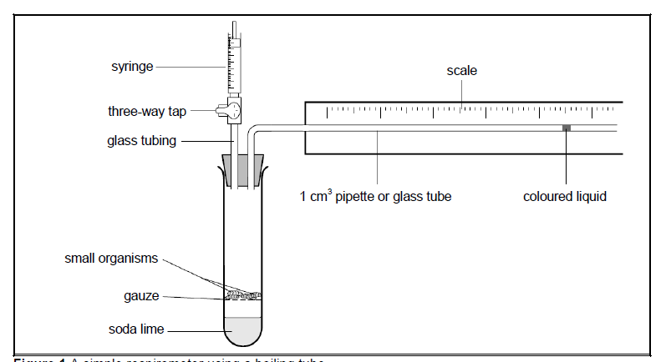

1. What is the purpose of the three way tap?

………………………………………………………………………………………………………………………………………………………

………………………………………………………………………………………………………………………………………………………

1. What is the purpose of the syringe?

………………………………………………………………………………………………………………………………………………………

……………………………………………………………………………………………………………………………………………………

1. What is the purpose of the gauze?

………………………………………………………………………………………………………………………………………………………

1. What is the purpose of the soda lime?

………………………………………………………………………………………………………………………………………………………

1. What is the dependent variable for an investigation using a respirometer?

………………………………………………………………………………………………………………………………………………………

1. How could you measure the exact volume of gas consumed?

………………………………………………………………………………………………………………………………………………………

………………………………………………………………………………………………………………………………………………………

………………………………………………………………………………………………………………………………………………………

1. List three possible independent variables

………………………………………………………………………………………………………………………………………………………

………………………………………………………………………………………………………………………………………………………

………………………………………………………………………………………………………………………………………………………

1. List three possible control variables.

………………………………………………………………………………………………………………………………………………………

………………………………………………………………………………………………………………………………………………………

………………………………………………………………………………………………………………………………………………………

1. The coloured liquid moves to the left. Explain in detail what happens to the oxygen molecules, the carbon dioxide molecules and the pressure in the tube.

………………………………………………………………………………………………………………………………………………………

………………………………………………………………………………………………………………………………………………………

………………………………………………………………………………………………………………………………………………………

………………………………………………………………………………………………………………………………………………………

1. How would you ensure that measurements were reliable?

………………………………………………………………………………………………………………………………………………………

………………………………………………………………………………………………………………………………………………………

1. Suggest how you could ensure the results were more precise and accurate?

………………………………………………………………………………………………………………………………………………………

………………………………………………………………………………………………………………………………………………………

………………………………………………………………………………………………………………………………………………………

………………………………………………………………………………………………………………………………………………………

Answer the question below about this respirometer

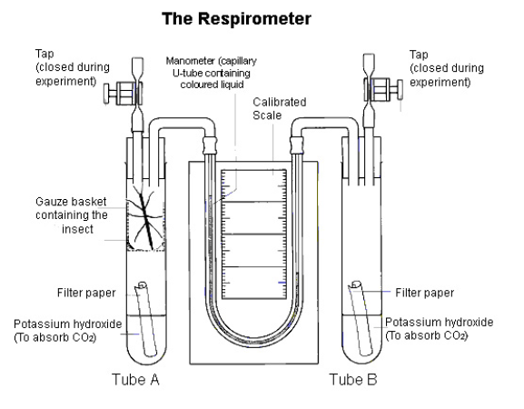

1. What is the purpose of having a second tube with no organisms in it?

………………………………………………………………………………………………………………………………………………………

………………………………………………………………………………………………………………………………………………………

1. If the experiment was carried out with water instead of potassium hydroxide what difference would you expect to see in the experiment?

………………………………………………………………………………………………………………………………………………………

………………………………………………………………………………………………………………………………………………………

………………………………………………………………………………………………………………………………………………………

1. What possible explanation could there be for this experiment being set up and no movement of the liquid in the U-tube?

………………………………………………………………………………………………………………………………………………………

………………………………………………………………………………………………………………………………………………………

**Required Practical 9**

**An investigation of the effect of temperature on respiration in yeast.**

The following information will help you to plan the required practical.

**How do yeast respire?**

* Yeast (single-celled fungus) can metabolise glucose under two different conditions. When oxygen is present aerobic respiration occurs yielding a large amount of energy for the organism and producing carbon dioxide & water as waste products.
* However when oxygen is in short supply (anaerobic conditions) the yeast will break down the carbohydrate into ethanol & carbon dioxide with a much reduced energy output (alcoholic fermentation).

**How can you measure the rate of respiration in yeast?**

* During respiration, dehydrogenase enzymes catalyse the removal of hydrogen atoms (a proton & an electron) from substrate molecules. This allows coenzymes to be reduced (in Krebs cycle) and use electrons to form ATP in oxidative phosphorylation.
* In experiments an artificial hydrogen/electron acceptors can be used that will change colour when they are reduced and therefore indicating that respiration is occurring.
* Methylene blue can accept electrons to be reduced and changes colour from blue to colourless.
* How quickly methylene blue decolourises will indicate the rate of respiration.

**Other factors to consider**

* Methylene blue can re-oxidise at the surface of the yeast solution in the test tube and a blue ring observed. Shaking/mixing the solution can cause this re-oxidising of the methylene blue and introduce errors to results.

**Summary Activity**

Produce a revision resource (flash cards, mind map, large annotated diagram) for the respiration topic to include a glossary of terms

Tips:

* Make questions that you can answer and test your knowledge
* Use the resources available on GOL to help you
* Watch the animations and videos from the presentation from GOL
* Ensure that you are not just copying information from one place to another
* Condense down any writing into note form using just key words
* Use diagrams

Once you have made your revision resource, have a go at the questions below.

**Aerobic respiration fact recall Anaerobic respiration fact recall**

