**3.5.3 Energy & Ecosystems**

**Section 1 – Recall**

**What does this section contain and why?** Activities to develop your recall of information you covered in the previous topics that are linked to inheritance. If you don’t have a mini whiteboard (MWB) please do invest in one, they are great for revision and recall. Once you have done the recall activity quickly check what you have done with the student booklets from that topic.

**Topics covered**: Energy and Ecosystems

|  |  |  |  |
| --- | --- | --- | --- |
| **Topic** | **Recall activities** | **Understanding**  *Please write down any questions you have when completing this activity.* | **Completed** |
| **Biological molecules** | Draw a molecule of alpha and beta glucose |  |  |
| Explain the structure to function of cellulose |  |  |
| Draw an ATP molecule to show its structure and write an equation to show the ATP/ADP cycle. |  |  |
| Write down 5 energy-requiring processes within cells. |  |  |

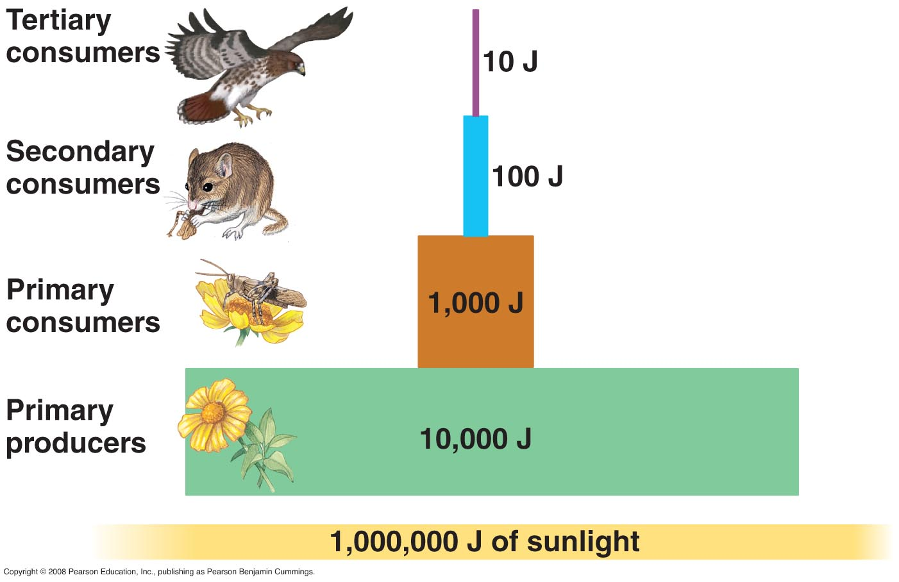

**Section 2 – Student booklet framework**

Once you have finished learning this topic ensure that you go through the table below to check your knowledge and highlight areas that you need to revisit

|  |  |  |  |  |
| --- | --- | --- | --- | --- |
| **Key info** | **Topic:** Energy and ecosystems  **Synoptic Link:** Biodiversity, photosynthesis, respiration  **Text book pages:** 298-305 | | | |
| **Step 1** | **Use the tutorial (GOL), presentation (GOL), video links and text book to complete the pack.** | | | |
| **Step 2** | **Learning outcome** | **I understand this** | **I can recall this** | **I need to revisit this** |
| Define an ecosystem and understand that plants synthesise organic compounds from atmospheric, or aquatic, carbon dioxide. |  |  |  |
| Understand that most of the sugars synthesised by plants are used by the plant as respiratory substrates. The rest are used to make other groups of biological molecules. These biological molecules form the biomass of the plants. |  |  |  |
| Know that biomass can be measured in terms of mass of carbon or dry mass of tissue per given area per given time. |  |  |  |
| Understand the chemical energy store in dry biomass can be estimated using calorimetry. |  |  |  |
| Understand that GPP is the chemical energy store in plant biomass, in a given area or volume, in a given time. |  |  |  |
| Understand that Net primary production (NPP) is the chemical energy store in plant biomass after respiratory losses to the environment have been taken into account and is represented by the equation NPP = GPP - R |  |  |  |
| Explain ways in which production is affected by farming practices designed to increase the efficiency of energy transfer by:  • simplifying food webs to reduce energy losses to non-human food chains  • reducing respiratory losses within a human food chain. |  |  |  |
| **Step 3** | **In lesson:** you will be undertaking activities to develop your understanding of the learning objectives and able to add to your notes. | | | |

**Energy Transfer and Productivity**

Complete the glossary of terms.

|  |  |
| --- | --- |
| **Term** | **Definition** |
| **Producer** |  |
| **Consumer** |  |
| **Saprobiont** |  |
| **Herbivore** |  |
| **Carnivore** |  |
| **Omnivore** |  |
| **Ecosystem** |  |
| **Community** |  |
| **Habitat** |  |
| **Food web** |  |
| **Food chain** |  |
| **Ecological niche** |  |
| **Biotic factor** |  |
| **Abiotic factor** |  |

**Biomass**

Biomass definition.

………………………………………………………………………………………….......................................................................

………………………………………………………………………………………………………………………………………………………………

What is the difference between fresh mass and dry mass?

………………………………………………………………………………………….......................................................................

………………………………………………………………………………………………………………………………………………………………

What are the advantages of calculating fresh mass over dry mass?

………………………………………………………………………………………….......................................................................

………………………………………………………………………………………………………………………………………………………………

What are the disadvantages of calculating dry mass over fresh mass?

………………………………………………………………………………………….......................................................................

………………………………………………………………………………………………………………………………………………………………

What are the units of biomass? Distinguish between areas that are sampled on land and volumes with aquatic ecosystems. ………………………………………………………………………………………….......................................................................

………………………………………………………………………………………………………………………………………………………………

………………………………………………………………………………………….......................................................................

………………………………………………………………………………………………………………………………………………………………

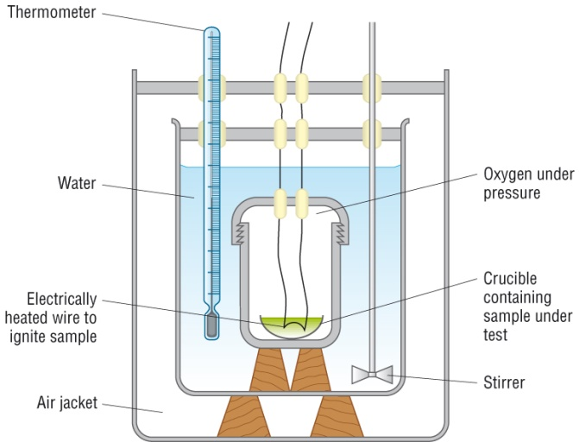**Chemical energy in biomass**

Describe how a bomb calorimeter can be used to calculate the energy found in biomass

**Questions**

1. Complete the questions below using the words available.

**community heterotrophs producers relationships saprobionts**

**transfer of energy energy trophic level**

Organisms can be divided into 3 groups depending on how they obtain their ____________.

* ........................... - photosynthetic organisms that manufacture organic substances using light energy, water and CO2
* ........................... - obtain their energy by consuming other organisms. Primary consumers feed directly off plants (producers). These are then consumed by secondary consumers and then tertiary consumers (usually predators)
* ........................... - feed off dead organic matter. The majority of them fungi and bacteria (decomposers) and to a lesser extent by animals such as earth worms (detritivores)

Food chains describe a feeding relationship by showing the .................................................. between producers and consumers. Each stage is referred to as a .......................... ............................ Arrows represent the direction of energy flow. However, most organisms in a...........................do not just feed upon one animal, and one animal can be fed upon by many other animals, a food web shows some of the feeding........................... within the community.

2. The diagram shows a simplified food web within an aquatic ecosystem.

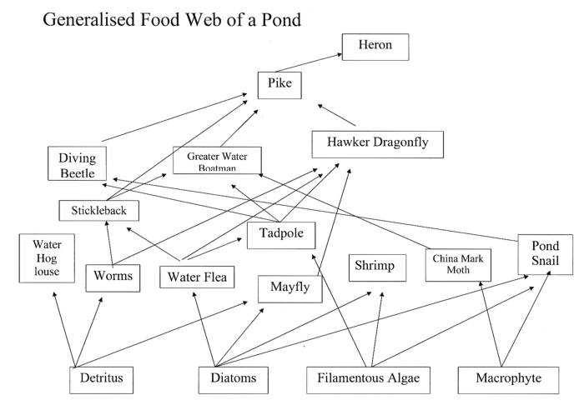

State which organisms are secondary consumers.

………………………………………………………………………………………….......................................................................

………………………………………………………………………………………………………………………………………………………………

State which organisms carry out photosynthesis.

………………………………………………………………………………………….......................................................................

………………………………………………………………………………………………………………………………………………………………

State which organisms are at the fourth trophic level.

………………………………………………………………………………………….......................................................................

………………………………………………………………………………………………………………………………………………………………

Explain what the arrows in the diagram show.

………………………………………………………………………………………….......................................................................

………………………………………………………………………………………………………………………………………………………………

When the organisms in this web die they will be broken down by bacteria and fungi. Name the general term used to describe these bacteria and fungi.

………………………………………………………………………………………….......................................................................

………………………………………………………………………………………………………………………………………………………………

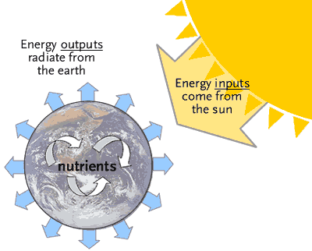

**Energy Transfer and Productivity**

The sun is the source of energy for ecosystems.

Plants are not very efficient at capturing light energy.

List the reasons why

1. ……………………………………………………………………………………………………………….

2. ……………………………………………………………………………………………………………….

3. ……………………………………………………………………………………………………………….

4. ……………………………………………………………………………………………………………….

5. ……………………………………………………………………………………………………………….

Complete the table of important definitions.

|  |  |
| --- | --- |
| **Term** | **Definition and equation if relevant** |
| Photosynthetic efficiency |  |
| Gross primary production |  |
| Net primary production |  |
| Secondary productivity |  |
| Trophic efficiency |  |

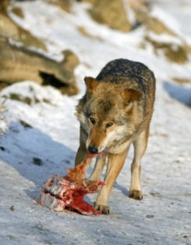**Energy loss between trophic levels**

Why is there such a low % of energy transferred at each stage of a food chain?

1.………………………………………………………………………………………………………………………………….

2. ……………………………………………………………………………………………………………….……………….

3. ……………………………………………………………………………………………………………………………….

4. ……………………………………………………………………………………………………………………………….

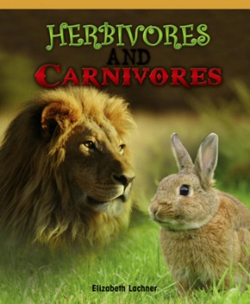Why do carnivores have a much higher secondary productivity than herbivores?

**Questions**

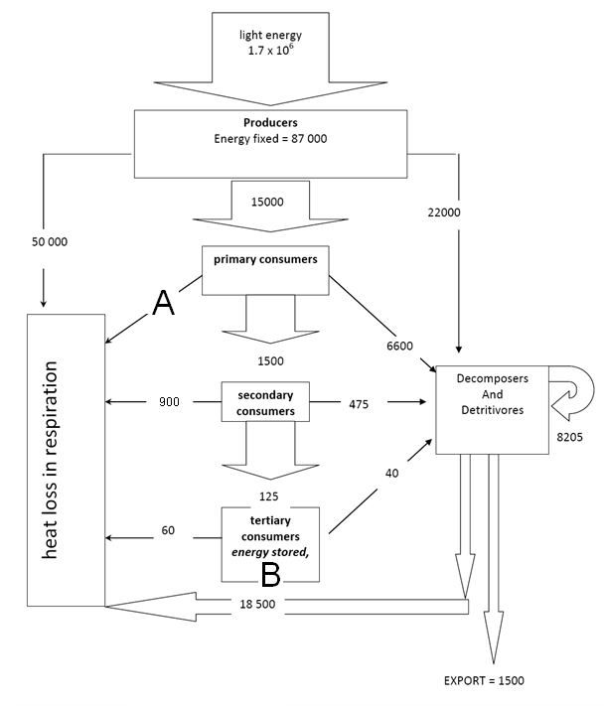1) How much energy is lost in respiration by the primary consumers (labelled A)?

2) How much energy is stored by the tertiary consumers (labelled B)?

3) Calculate the percentage efficiency for the secondary consumers.

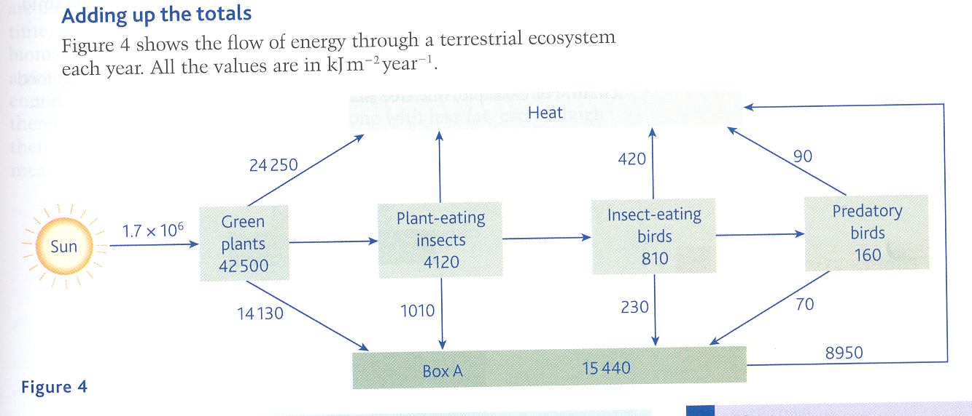

1. Give the name of the group of organisms represented by Box A. …………………………..
2. Which group of organisms are secondary consumers? ……………………………………….
3. Calculate the percentage efficiency with which light energy is transferred to energy in green plants. Show your working.

………………………………………………………………………………………………………………………………………………………………………………………………………………………………………………………………………………………………………………………………………………………………………………………………………………………………………………………

1. State 3 reasons why so little of the solar energy is transferred to energy in green plants.

………………………………………………………………………………………………………………………………………………………………………………………………………………………………………………………………………………………………………………………………………………………………………………………………………………………………………………………

1. Calculate the amount of energy that is lost as heat from plant-eating insects. Show your working.

………………………………………………………………………………………………………………………………………………………………………………………………………………………………………………………………………………………………………………………………………………………………………………………………………………………………………………………

**Productivity and Farming Methods.**

Intensive farming tries to produce as much food as efficiently as possible at the lowest possible production cost. Consumers benefit from ‘low cost food’ but the use of artificial fertilisers, pesticides, herbicides, fungicides, etc. all leave traces of these chemicals on the food.

Research the farming methods that are used to increase yields by increasing the efficiency.

1. **Growing crops by hydroponics**

2. **Crops grown in glasshouses**

3. **Fish farming/aquaculture**

4. **Battery farming of animals**

**Exam Questions**

**Q1.** The diagram shows the transfer of energy through a cow. The figures are in kJ × 106 year–1.

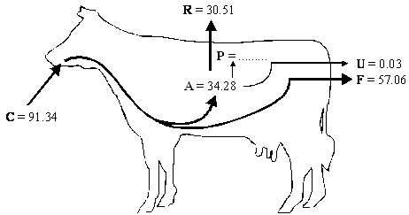

**Key**:       **A** = energy absorbed from the gut  
**C** = energy consumed in food  
**F** = energy lost in faeces  
**P** = energy used in production of new tissue  
**R** = energy lost by respiration  
**U** = energy lost in urine

(a)     (i)      Complete the following equation for the energy used in the production of new tissue. Use only the letters **C**, **F**, **R** and **U**.

**P** = ......................................................................................................

**(1)**

(ii)     Calculate the value of **P**.

**P** = ................................... kJ × 106 year–1

**(1)**

(b)     It has been estimated that an area of 8100 m2 of grassland is needed to keep one cow. The productivity of grass is 21 135 kJ m–2 year–1. What percentage of the energy in the grass is used in the production of new tissue in one cow? Show your working.

Answer ....................................... %

**(2)**

(c)     Keeping cattle indoors, in barns, leads to a higher efficiency of energy transfer.

Explain why.

......................................................................................................................

......................................................................................................................

**(1)**

**(Total 5 marks)**

**Q2.**          Scientists measured the mean temperature in a field each month between March and October. The table shows their results.

|  |  |  |
| --- | --- | --- |
|  | **Month** | **Mean temperature /°C** |
|  | March | 9 |
|  | April | 11 |
|  | May | 14 |
|  | June | 17 |
|  | July | 20 |
|  | August | 18 |
|  | September | 16 |
|  | October | 14 |

(a)     The gross productivity of the plants in the field was highest in July.

Use the data in the table to explain why.

......................................................................................................................

......................................................................................................................

......................................................................................................................

......................................................................................................................

......................................................................................................................

**(2)**

(b)     (i)      Give the equation that links gross productivity and net productivity.

.............................................................................................................

**(1)**

(ii)     The net productivity of the plants in the field was higher in August than in July. Use the equation in part (b)(i) and your knowledge of photosynthesis and respiration to suggest why.

.............................................................................................................

.............................................................................................................

.............................................................................................................

.............................................................................................................

**(2)**

(c)     A horse was kept in the field from March to October. During the summer months, the horse was able to eat more than it needed to meet its minimum daily requirements.

Suggest how the horse used the extra nutrients absorbed.

......................................................................................................................

......................................................................................................................

......................................................................................................................

**(1)**

(d)     The horse’s mean energy expenditure was higher in March than it was in August. Use information in the table to suggest why.

......................................................................................................................

......................................................................................................................

......................................................................................................................

......................................................................................................................

**(2)**

**(Total 8 marks)**

**Q3.**In some countries, pigs are reared in intensive units in which the temperature is controlled. Agricultural  
scientists investigated the effect of temperature on pig growth and on the efficiency with which the pigs  
converted food to biomass.

(a)     (i)      In the investigation, the scientists used pigs of the same breed, with similar genotypes.  
Explain why.

...............................................................................................................

...............................................................................................................

...............................................................................................................

...............................................................................................................

...............................................................................................................

**(2)**

(ii)     The pigs were allowed to eat as much food as they wanted.  
How could this have decreased the reliability of any conclusions drawn from the  
investigation?

...............................................................................................................

...............................................................................................................

...............................................................................................................

...............................................................................................................

...............................................................................................................

**(2)**

The table shows the results of this investigation.

|  |  |  |
| --- | --- | --- |
| **Temperature / °C** | **Mean growth rate / kg per day** | **Efficiency of conversion of food to biomass /%** |
| 0 | 0.54 | 19 |
| 10 | 0.80 | 42 |
| 20 | 0.85 | 48 |
| 30 | 0.45 | 37 |
| 35 | 0.31 | 37 |

(b)     (i)      Describe the effect of temperature on mean growth rate.

...............................................................................................................

...............................................................................................................

...............................................................................................................

**(1)**

(ii)     A student concluded from these data that the mean growth rate of the pigs was fastest at 20 °C.  
Do you agree with this conclusion? Explain your answer.

...............................................................................................................

...............................................................................................................

...............................................................................................................

...............................................................................................................

**(2)**

(c)     (i)      Pigs can survive at temperatures above 35 °C. Use the data to suggest why scientists did **not** carry out any investigations at temperatures higher than 35 °C.

...............................................................................................................

...............................................................................................................

...............................................................................................................

...............................................................................................................

...............................................................................................................

**(2)**

(ii)     The efficiency of conversion of food to biomass is lower at 0 °C than it is at 20 °C.  
Suggest an explanation for the lower efficiency.

...............................................................................................................

...............................................................................................................

...............................................................................................................

...............................................................................................................

...............................................................................................................

**(2)**

(d)     Pigs require a mixture of fibre and protein in their food. The greater the ratio of fibre to protein, the less  
the food costs.

Scientists took five large groups of pigs. They fed each group a different high-fibre food. Each of the foods contained fibre from different plant species, but they all had the same energy content. The scientists fed a control group of pigs a low-fibre food with the same energy content. After 10 days, the scientists compared  
the masses of the pigs fed on high-fibre food to those fed on low-fibre food.

The graph shows the results of the investigation. The bars represent ±2 standard errors of the mean.

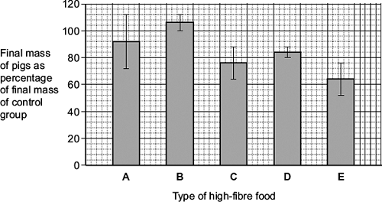

A farmer saw these results and concluded that he should replace his pigs’ usual food with food **B**.  
Evaluate this conclusion.

........................................................................................................................

........................................................................................................................

........................................................................................................................

........................................................................................................................

........................................................................................................................

........................................................................................................................

........................................................................................................................

........................................................................................................................

*(Extra space)* .................................................................................................

........................................................................................................................

........................................................................................................................

........................................................................................................................

**(4)**

**(Total 15 marks)**

**Q4.**

Ecologists developed a method for estimating the biomass of trees in a plantation.

The plantation consisted of trees of the same species.

They collected samples of wood from trees. For each sample they:

•        determined the density of the freshly cut wood

•        dried the wood in an oven at 103 °C for 24 hours

•        determined the volume of the dried wood sample

•        determined the density of the dried wood.

The table below shows data about one wood sample.

|  |  |  |  |
| --- | --- | --- | --- |
| **Volume of freshly cut wood sample**  **/ dm3** | **Density of freshly cut wood**  **/ g per dm3** | **Volume of dried wood sample**  **/ dm3** | **Density of dried wood sample**  **/ g per dm3** |
| 1.345 | 993.0 | 1.125 | 769.0 |

(a)     The loss of mass of the wood sample was due to loss of water. Water has a density of 1 g per cm3.

Use the data in the table to calculate the percentage of water in the freshly cut wood sample. Show your working.

Percentage of water = __________________________________

**(2)**

(b)     The ecologists dried the samples in an oven at 103 °C for 24 hours. Describe how the ecologists could have determined whether or not this drying removed all the water from a sample of wood.

___________________________________________________________________

___________________________________________________________________

___________________________________________________________________

___________________________________________________________________

___________________________________________________________________

**(2)**

(c)     Ecologists then investigated the relationship between the diameter of the trunk of the trees and their biomass.

The graph below shows their results. Each point is the result for **one** tree.

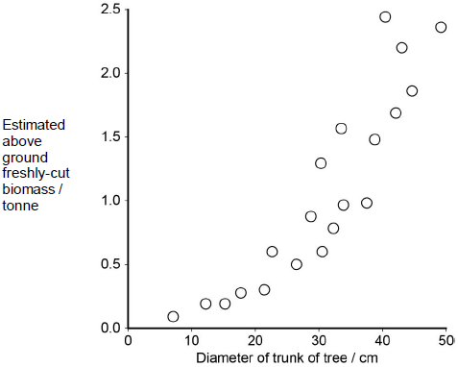

What does the graph show about the relationship between the diameter of the trunk of the trees and their biomass?

___________________________________________________________________

___________________________________________________________________

___________________________________________________________________

___________________________________________________________________

___________________________________________________________________

**(2)**

(d)     Plantations of trees are often created to remove carbon dioxide from the atmosphere, to help to balance the carbon dioxide released by burning fossil fuels.

For different species of tree, information is available for:

•        the relationship between diameter of trunk and freshly cut biomass

•        the percentage of water in fresh-cut wood

•        the mean dried density of wood.

Using only the information provided in part **(c)**, suggest how the mass of carbon in the wood of a plantation of trees of a particular species could be estimated.

Start with measuring the diameter of a large number of trees.

Assume that the dry biomass of a tree consists of biological molecules that contain carbon.

___________________________________________________________________

___________________________________________________________________

___________________________________________________________________

___________________________________________________________________

___________________________________________________________________

___________________________________________________________________

___________________________________________________________________

___________________________________________________________________

___________________________________________________________________

___________________________________________________________________

**(4)**

**(Total 10 marks)**