**Q1.**

Plants have pigments that absorb light energy for photosynthesis. These pigments include two types of chlorophyll and a group of pigments known as carotenoids. Different species of plant contain different amounts of these pigments. The pigments that each plant species has are adaptations to where and how they live; their ecological niche.

**Figure 1** shows the absorption of light of different wavelengths by chlorophyll a, chlorophyll b and carotenoids.

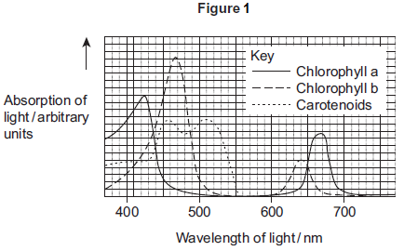

A scientist investigated the energy in light of different wavelengths reaching the ground in a forest. She measured the energy in

•        direct sunlight

•        sunlight that had passed through the leaves of trees.

**Figure 2** shows her results.

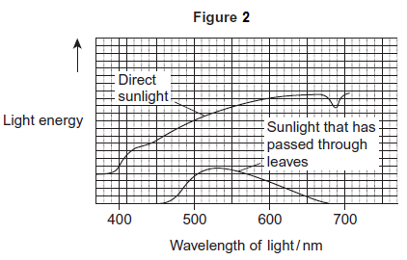

(a)     Use **Figure 1** to describe the absorption of light of different wavelengths by chlorophyll a.

___________________________________________________________________

___________________________________________________________________

___________________________________________________________________

___________________________________________________________________

**(2)**

(b)     Few species of plant can live below large trees in a forest.  
Use the information in **Figure 1** and **Figure 2** to suggest why.

___________________________________________________________________

___________________________________________________________________

___________________________________________________________________

___________________________________________________________________

___________________________________________________________________

**(3)**

(c)     In leaves at the top of trees in a forest, carbon dioxide is often the limiting factor for photosynthesis.  
Use your knowledge of photosynthesis to suggest and explain **one** reason why.

___________________________________________________________________

___________________________________________________________________

___________________________________________________________________

___________________________________________________________________

**(2)**

**(Total 7 marks)**

**Q2.**

The diagram shows the light-dependent reactions of photosynthesis.

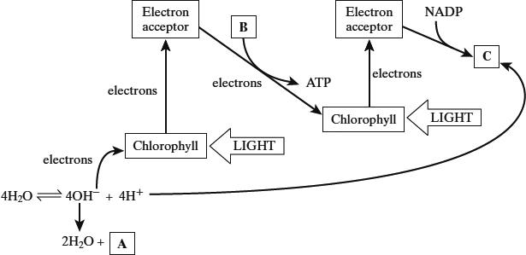

(a)     In which part of a chloroplast do the light-dependent reactions occur?

___________________________________________________________________

**(1)**

(b)     Name the substances in boxes **A**, **B** and **C**.

**A** ________________________________

**B** _______________ + _______________

**C** ________________________________

**(3)**

(c)     Use information in the diagram to explain

(i)      the role of chlorophyll in photolysis;

______________________________________________________________

______________________________________________________________

______________________________________________________________

______________________________________________________________

______________________________________________________________

______________________________________________________________

**(3)**

(ii)     how the energy of light is converted into chemical energy in the light-dependent reactions.

______________________________________________________________

______________________________________________________________

______________________________________________________________

______________________________________________________________

______________________________________________________________

______________________________________________________________

**(3)**

(d)     In an investigation, single-celled algae were kept in bright light and were supplied with carbon dioxide containing radioactive carbon atoms. After 300 seconds, the carbon dioxide supply was turned off. The graph shows how the concentrations of carbon dioxide, glycerate 3-phosphate (GP) and ribulose bisphosphate (RuBP) changed.

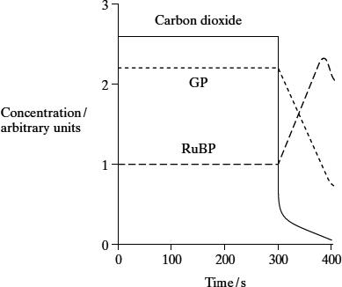

(i)      Explain why, between 0 seconds and 300 seconds, the concentration of radioactive GP remained constant.

______________________________________________________________

______________________________________________________________

______________________________________________________________

______________________________________________________________

______________________________________________________________

______________________________________________________________

**(3)**

(ii)     Explain why, between 300 seconds and 380 seconds, the concentration of radioactive RuBP increased.

______________________________________________________________

______________________________________________________________

______________________________________________________________

______________________________________________________________

**(2)**

**(Total 15 marks)**

**Q3.**

The percentage of light absorbed by an aquatic plant was measured when it was exposed to different wavelengths. The rate of photosynthesis was also measured at each wavelength of light. The results are shown in the graph.

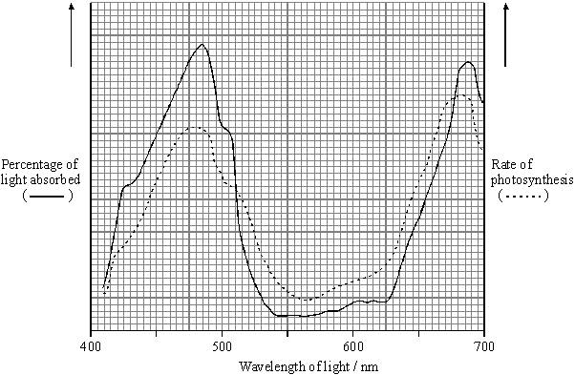

(a)     Describe and explain the relationship between light absorption and the rate of photosynthesis for the wavelengths of light between 410 nm and 500 nm.

___________________________________________________________________

___________________________________________________________________

___________________________________________________________________

___________________________________________________________________

**(2)**

(b)     Give **one** dependent variable you could measure in order to determine the rate of photosynthesis in an aquatic plant.

___________________________________________________________________

**(1)**

(c)     Use the graph to identify the range of wavelengths of light that would be green in colour.

Give a reason for your answer.

Wavelengths __________ to __________ nm

Reason ____________________________________________________________

___________________________________________________________________

**(2)**

(d)     A suspension of chloroplasts was isolated from an aquatic plant and a reagent was added. The reagent is blue when oxidised and is colourless when reduced.

(i)      The suspension of chloroplasts in blue reagent was exposed to sunlight. The blue colour disappeared. Use your knowledge of the light-dependent reactions of photosynthesis to explain why.

______________________________________________________________

______________________________________________________________

______________________________________________________________

______________________________________________________________

**(2)**

(ii)     Another suspension of chloroplasts was set up as before. Small quantities of ADP and phosphate ions were added and then the tube was exposed to light. The blue colour disappeared more quickly. Explain why.

______________________________________________________________

______________________________________________________________

______________________________________________________________

**(2)**

**(Total 9 marks)**

**Q4.**

During photosynthesis, carbon dioxide reacts with ribulose bisphosphate (RuBP) to form two molecules of glycerate 3-phosphate (GP). This reaction is catalysed by the enzyme Rubisco. Rubisco can also catalyse a reaction between RuBP and oxygen to form one molecule of GP and one molecule of phosphoglycolate. Both the reactions catalysed by Rubisco are shown in **Figure 1**.

**Figure 1**

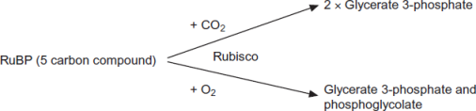

(a)     (i)      Where exactly in a cell is the enzyme Rubisco found?

______________________________________________________________

**(1)**

(ii)     Use the information provided to give the number of carbon atoms in **one** molecule of phosphoglycolate.



**(1)**

(b)     Scientists investigated the effect of different concentrations of oxygen on the rate of absorption of carbon dioxide by leaves of soya bean plants. Their results are shown in **Figure 2**.

**Figure 2**

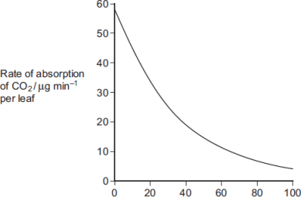

                                Concentration of oxygen / %

Use **Figure 1** to explain the results obtained in **Figure 2**.

___________________________________________________________________

___________________________________________________________________

___________________________________________________________________

___________________________________________________________________

___________________________________________________________________

**(2)**

(c)     Use the information provided and your knowledge of the light-independent reaction to explain why the yield from soya bean plants is decreased at higher concentrations of oxygen. Phosphoglycolate is not used in the light-independent reaction.

___________________________________________________________________

___________________________________________________________________

___________________________________________________________________

___________________________________________________________________

___________________________________________________________________

**(3)**

**(Total 7 marks)**

**Q5.**

Gas exchange in an aquatic plant was investigated by placing shoots in tubes containing bromothymol blue indicator solution. Bromothymol blue indicator is yellow below pH 6, green between pH 6.1 and 7.5, and blue at pH 7.6 and above. Into each of four tubes, **A**, **B**, **C** and **D**, 10 cm3 of bromothymol blue solution were placed. Each tube was closed with a bung and left for 10 minutes. Similar-sized shoots of an aquatic plant were then placed into each of tubes **A**, **B** and **C**. The tubes were treated as shown in the diagram.

They were then placed at equal distances from a 60 watt lamp and left for one hour.

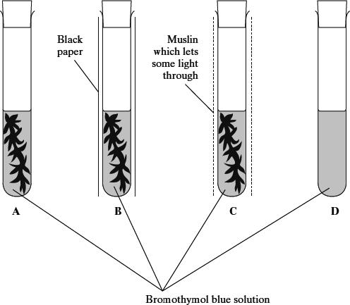

The table shows the initial and final colours of the indicator in the four tubes.

|  |  |  |  |
| --- | --- | --- | --- |
| **Tube** | **Treatment** | **Initial colour of indicator** | **Colour of indicator after one hour** |
| **A** | Uncovered | Green | Blue |
| **B** | Covered with black paper | Green | Yellow |
| **C** | Covered with muslin | Green | Green |
| **D** | Uncovered | Green | Green |

(a)     Explain the results for

tube **A**;

___________________________________________________________________

___________________________________________________________________

___________________________________________________________________

tube **B**;

___________________________________________________________________

___________________________________________________________________

___________________________________________________________________

tube **C**.

___________________________________________________________________

___________________________________________________________________

___________________________________________________________________

___________________________________________________________________

**(4)**

(b)     (i)      Explain how the results from tube **D** help to confirm that the explanations for the other tubes are valid.

______________________________________________________________

______________________________________________________________

**(1)**

(ii)     Explain why all the tubes were placed the same distance from the lamp.

______________________________________________________________

______________________________________________________________

**(1)**

**(Total 6 marks)**