**Q1.** (a)  Describe the process of glycolysis.

___________________________________________________________________

___________________________________________________________________

___________________________________________________________________

___________________________________________________________________

___________________________________________________________________

___________________________________________________________________

___________________________________________________________________

___________________________________________________________________

___________________________________________________________________

___________________________________________________________________

_________________________________________________________________**(4)**

(b)  Malonate inhibits a reaction in the Krebs cycle.

Explain why malonate would decrease the uptake of oxygen in a respiring cell.

___________________________________________________________________

___________________________________________________________________

___________________________________________________________________

___________________________________________________________________

___________________________________________________________________

_________________________________________________________________**(2)**

**(Total 6 marks)**

**Q2.** (a)     Describe the part played by the inner membrane of a mitochondrion in producing ATP.

___________________________________________________________________

___________________________________________________________________

___________________________________________________________________

___________________________________________________________________

___________________________________________________________________

_________________________________________________________________**(3)**

(b)     A scientist investigated ATP production in a preparation of isolated mitochondria. He suspended the mitochondria in an isotonic solution and added a suitable respiratory substrate together with ADP and phosphate. He bubbled oxygen through the preparation.

(i)      Why was the solution in which the mitochondria were suspended isotonic?

______________________________________________________________

____________________________________________________________**(1)**

(ii)     Explain why the scientist did **not** use glucose as the respiratory substrate.

______________________________________________________________

______________________________________________________________

______________________________________________________________

______________________________________________________________

____________________________________________________________**(2)**

(iii)     Explain why the oxygen concentration would change during this investigation.

______________________________________________________________

____________________________________________________________**(1)**

**(Total 7 marks)**

**Q3.** Some plant seeds can respire aerobically and anaerobically. A summary of the process of anaerobic respiration is shown below.



(a)     (i)      Where in a cell does **stage 1** occur?

____________________________________________________________**(1)**

(ii)      Explain how **stage 2** enables **stage 1** to continue.

______________________________________________________________

______________________________________________________________

______________________________________________________________

____________________________________________________________**(2)**

(b)     The Respiratory Quotient (RQ) can provide information on the type of respiration taking place in an organism. The following equation is used to calculate the RQ.



(i)      What would be the RQ for aerobic respiration of glucose?



**(1)**

(ii)      A student calculated that the RQ of germinating seeds was 1.8.

Use the information provided to explain this result.

______________________________________________________________

______________________________________________________________

______________________________________________________________

____________________________________________________________**(2)**

(c)     Aerobic respiration produces more ATP per molecule of glucose than anaerobic respiration.

Explain why.

___________________________________________________________________

___________________________________________________________________

___________________________________________________________________

_________________________________________________________________**(2)**

**(Total 8 marks)**

**Q4.** (a)    The table contains statements about three stages of respiration.

Complete the table with a tick if the statement in the first column is true for each stage of respiration in an animal.

|  |  |  |  |
| --- | --- | --- | --- |
|  | **Glycolysis** | **Link reaction** | **Krebs cycle** |
| Occurs in mitochondria |  |  |  |
| Carbon dioxide produced |  |  |  |
| NAD is reduced |  |  |  |

**(3)**

(b)     The following reaction occurs in the Krebs cycle.



A scientist investigated the effect of the enzyme inhibitor malonate on this reaction. The structure of malonate is very similar to the structure of succinate. The scientist added malonate and the respiratory substrate, pyruvate, to a suspension of isolated mitochondria. She also bubbled oxygen through the suspension.

(i)      Explain why the scientist did not use glucose as the respiratory substrate for these isolated mitochondria.

______________________________________________________________

______________________________________________________________

______________________________________________________________

______________________________________________________________

____________________________________________________________**(2)**

(ii)     Explain how malonate inhibits the formation of fumarate from succinate.

______________________________________________________________

______________________________________________________________

______________________________________________________________

______________________________________________________________

____________________________________________________________**(2)**

(iii)    The scientist measured the uptake of oxygen by the mitochondria during the investigation. The uptake of oxygen decreased when malonate was added. Explain why.

______________________________________________________________

______________________________________________________________

______________________________________________________________

______________________________________________________________

____________________________________________________________**(2)**

**(Total 9 marks)**

**Q5.** Researchers investigated the effect of cyanide on oxygen uptake by mitochondria. They prepared a suspension of mitochondria from animal cells and a suspension of mitochondria from plant cells. They placed the suspensions in separate flasks containing isotonic solution, started the timer and began recording the concentration of oxygen in each flask.

•        After 5 minutes, they added a respiratory substrate and ADP to each flask.

•        After 13 minutes, they added cyanide solution to each flask.

The graph below shows their results. From **P** to **R** the curves for animal and plant mitochondria overlap.

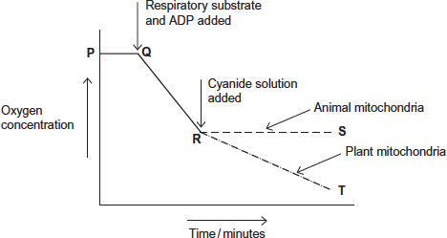

(a)     Explain the line between **P** and **Q**.

___________________________________________________________________

___________________________________________________________________

___________________________________________________________________

_________________________________________________________________**(2)**

(b)     (i)      Explain the line between **Q** and **R**.

______________________________________________________________

______________________________________________________________

____________________________________________________________**(2)**

(ii)     The respiratory substrate and ADP added after 5 minutes (**Q**) were part of a buffered isotonic solution.

What other substance would the buffer or solution have to contain?

______________________________________________________________

____________________________________________________________**(1)**

(c)     Describe and explain the difference between line **R** to **S** (animal mitochondria) and line **R** to **T** (plant mitochondria).

___________________________________________________________________

___________________________________________________________________

___________________________________________________________________

___________________________________________________________________

___________________________________________________________________

___________________________________________________________________

_________________________________________________________________**(4)**

**(Total 9 marks)**

**Q6.** Yeast cells can respire aerobically or anaerobically. A student used the apparatus shown in **Figure 1** to measure the rate of respiration in yeast.

She:

•        positioned the flask in a water bath so that the yeast culture reached a constant temperature

•        then left the apparatus for one hour before starting her investigation.

**Figure 1**

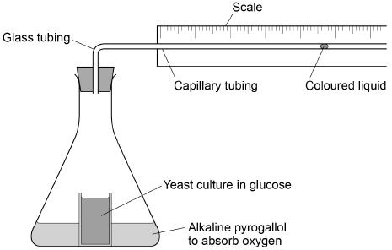

(a)     Suggest **one** reason why it was important that the student left the apparatus for one hour after the yeast culture reached a constant temperature.

___________________________________________________________________

_________________________________________________________________**(1)**

(b)     During her investigation, the coloured liquid moved to the right.

Explain why it moved to the right.

___________________________________________________________________

___________________________________________________________________

___________________________________________________________________

___________________________________________________________________

___________________________________________________________________

___________________________________________________________________

_________________________________________________________________**(2)**

(c)     The student found that the coloured liquid moved 1.5 cm in 24 hours. The diameter of the lumen (hole) of the capillary tubing was 1 mm.

The volume of a capillary tubing is given by *π*r2*l*, where *π* is 3.14 and *l* = length.

Calculate the volume of gas produced in cm3 hour–1.

Show your working.

Answer = ____________________ cm3 hour–1

**(2)**

**Figure 2** shows a typical population growth curve for yeast under laboratory conditions.

**Figure 2**

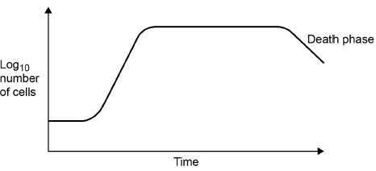

(d)     Explain why a log scale is used to record the number of cells.

___________________________________________________________________

___________________________________________________________________

___________________________________________________________________

**(1)**

(e)     Many yeast cells die during the death phase.

Suggest **one** reason why.

___________________________________________________________________

___________________________________________________________________

___________________________________________________________________

___________________________________________________________________

**(1)**

(f)      The following equation can be used to make predictions of the growth in the population of yeast cells under ideal laboratory conditions.

**Xt = X0 *e*rt**

Xt = the population after a certain time

X0 = the population at the start

*e* = 2.72 (base of natural logarithm)

r = growth rate

t = time period in hours over which r applies

A population of 2000 yeast cells was left for 10 hours.

The value for the growth rate was 0.5

Assuming no yeast cells died, calculate the predicted size of the population after 10 hours. Show your working.

Answer = ____________________

**(2)**

**(Total 9 marks)**

**Q7.** The figure below shows the apparatus used for measuring the rate of oxygen consumption in aerobic respiration by seeds.

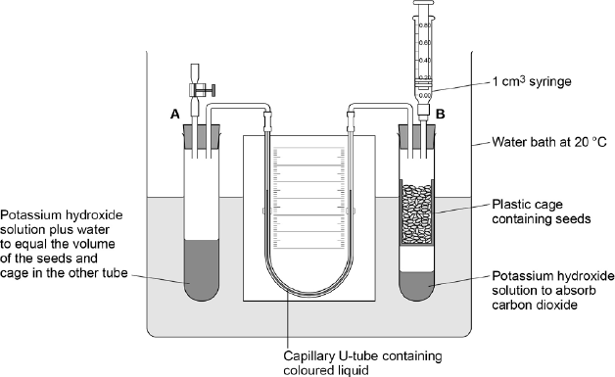

(a)     For the first 10 minutes, the tap attached to tube **A** was left open and the syringe from tube **B** was removed.

Suggest **three** reasons why the apparatus was left for 10 minutes.

1. _________________________________________________________________

___________________________________________________________________

2. _________________________________________________________________

___________________________________________________________________

3. _________________________________________________________________

_________________________________________________________________**(3)**

(b)     Suggest and explain why the chosen temperature was 20 °C for this experiment.

___________________________________________________________________

___________________________________________________________________

___________________________________________________________________

_________________________________________________________________**(2)**

After 10 minutes, the tap attached to tube **A** was closed and the syringe was attached to tube **B**. Every minute, the syringe plunger was moved until the levels in the U-tube were the same. The reading on the syringe volume scale was then recorded.

The results are shown in the table below.

|  |  |
| --- | --- |
| **Time / minutes** | **Reading on syringe  volume scale / cm3** |
| 0 | 0.84 |
| 1 | 0.81 |
| 2 | 0.79 |
| 3 | 0.76 |
| 4 | 0.73 |
| 5 | 0.70 |
| 6 | 0.68 |
| 7 | 0.66 |
| 8 | 0.63 |
| 9 | 0.62 |
| 10 | 0.58 |

(c)     During the experiment, the coloured liquid in the tubing moved towards tube **B**.  
Explain what caused this.

___________________________________________________________________

___________________________________________________________________

___________________________________________________________________

___________________________________________________________________

___________________________________________________________________

**(3)**

(d)     The mass of the seeds was 1.6 g. Use the information in the table above to calculate the rate of oxygen consumption in cm3 g–1 hour–1 by the seeds.

Show your working.

Rate = ____________________ cm3 g–1 hour–1**(2)**

**(Total 10 marks)**