Q1. The diagram shows the transfer of energy through a cow. The figures are in kJ × 10⁶ year^{–1}.
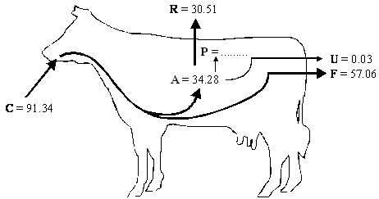
Key: A = energy absorbed from the gut
C = energy consumed in food
F = energy lost in faeces
P = energy used in production of new tissue
R = energy lost by respiration
U = energy lost in urine
(a) (i) Complete the following equation for the energy used in the production of new tissue. Use only the letters C, F, R and U.
P = ......................................................................................................
(1)

(ii) Calculate the value of P.

P = ................................... kJ × 10⁶ year^{–1}
(1)

(b) It has been estimated that an area of 8100 m² of grassland is needed to keep one cow. The productivity of grass is 21 135 kJ m^{–2} year^{–1}. What percentage of the energy in the grass is used in the production of new tissue in one cow? Show your working.

Answer ....................................... %
(2)

(c) Keeping cattle indoors, in barns, leads to a higher efficiency of energy transfer.
Explain why.
......................................................................................................................
......................................................................................................................
(1)
(Total 5 marks)
Q2. Scientists measured the mean temperature in a field each month between March and October. The table shows their results.

 | Month | Mean temperature /°C
 | March | 9
 | April | 11
 | May | 14
 | June | 17
 | July | 20
 | August | 18
 | September | 16
 | October | 14

(a) The gross productivity of the plants in the field was highest in July.
Use the data in the table to explain why.
......................................................................................................................
......................................................................................................................
......................................................................................................................
......................................................................................................................
......................................................................................................................
(2)
(b) (i) Give the equation that links gross productivity and net productivity.
.............................................................................................................
(1)

(ii) The net productivity of the plants in the field was higher in August than in July. Use the equation in part (b)(i) and your knowledge of photosynthesis and respiration to suggest why.
.............................................................................................................
.............................................................................................................
.............................................................................................................
.............................................................................................................
(2)
(c) A horse was kept in the field from March to October. During the summer months, the horse was able to eat more than it needed to meet its minimum daily requirements.
Suggest how the horse used the extra nutrients absorbed.
......................................................................................................................
......................................................................................................................
......................................................................................................................
(1)
(d) The horse’s mean energy expenditure was higher in March than it was in August. Use information in the table to suggest why.
......................................................................................................................
......................................................................................................................
......................................................................................................................
......................................................................................................................
(2)
(Total 8 marks)
Q3.In some countries, pigs are reared in intensive units in which the temperature is controlled. Agricultural
scientists investigated the effect of temperature on pig growth and on the efficiency with which the pigs
converted food to biomass.
(a) (i) In the investigation, the scientists used pigs of the same breed, with similar genotypes.
Explain why.
...............................................................................................................
...............................................................................................................
...............................................................................................................
...............................................................................................................
...............................................................................................................
(2)

(ii) The pigs were allowed to eat as much food as they wanted.
How could this have decreased the reliability of any conclusions drawn from the
investigation?
...............................................................................................................
...............................................................................................................
...............................................................................................................
...............................................................................................................
...............................................................................................................
(2)
The table shows the results of this investigation.

Temperature / °C | Mean growth rate /  kg per day | Efficiency of conversion of  food to biomass /%
0 | 0.54 | 19
10 | 0.80 | 42
20 | 0.85 | 48
30 | 0.45 | 37
35 | 0.31 | 37

(b) (i) Describe the effect of temperature on mean growth rate.
...............................................................................................................
...............................................................................................................
...............................................................................................................
(1)
(ii) A student concluded from these data that the mean growth rate of the pigs was fastest at 20 °C.
Do you agree with this conclusion? Explain your answer.
...............................................................................................................
...............................................................................................................
...............................................................................................................
...............................................................................................................
(2)

(c) (i) Pigs can survive at temperatures above 35 °C. Use the data to suggest why scientists did not carry out any investigations at temperatures higher than 35 °C.
...............................................................................................................
...............................................................................................................
...............................................................................................................
...............................................................................................................
...............................................................................................................
(2)
(ii) The efficiency of conversion of food to biomass is lower at 0 °C than it is at 20 °C.
Suggest an explanation for the lower efficiency.
...............................................................................................................
...............................................................................................................
...............................................................................................................
...............................................................................................................
...............................................................................................................
(2)
(d) Pigs require a mixture of fibre and protein in their food. The greater the ratio of fibre to protein, the less
the food costs.
Scientists took five large groups of pigs. They fed each group a different high-fibre food. Each of the foods contained fibre from different plant species, but they all had the same energy content. The scientists fed a control group of pigs a low-fibre food with the same energy content. After 10 days, the scientists compared
the masses of the pigs fed on high-fibre food to those fed on low-fibre food.
The graph shows the results of the investigation. The bars represent ±2 standard errors of the mean.
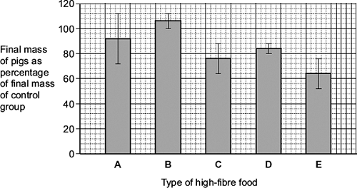

A farmer saw these results and concluded that he should replace his pigs’ usual food with food B.
Evaluate this conclusion.
........................................................................................................................
........................................................................................................................
........................................................................................................................
........................................................................................................................
........................................................................................................................
........................................................................................................................
........................................................................................................................
........................................................................................................................
(Extra space) .................................................................................................
........................................................................................................................
........................................................................................................................
........................................................................................................................
(4)
(Total 15 marks)
Q4.
Ecologists developed a method for estimating the biomass of trees in a plantation.
The plantation consisted of trees of the same species.
They collected samples of wood from trees. For each sample they:
• determined the density of the freshly cut wood
• dried the wood in an oven at 103 °C for 24 hours
• determined the volume of the dried wood sample
• determined the density of the dried wood.
The table below shows data about one wood sample.

Volume of freshly cut wood sample  / dm³ | Density of freshly cut wood  / g per dm³ | Volume of dried wood sample  / dm³ | Density of dried wood sample  / g per dm³
1.345 | 993.0 | 1.125 | 769.0

(a) The loss of mass of the wood sample was due to loss of water. Water has a density of 1 g per cm³.
Use the data in the table to calculate the percentage of water in the freshly cut wood sample. Show your working.
Percentage of water = __________________________________
(2)

(b) The ecologists dried the samples in an oven at 103 °C for 24 hours. Describe how the ecologists could have determined whether or not this drying removed all the water from a sample of wood.
___________________________________________________________________
___________________________________________________________________
___________________________________________________________________
___________________________________________________________________
___________________________________________________________________
(2)
(c) Ecologists then investigated the relationship between the diameter of the trunk of the trees and their biomass.
The graph below shows their results. Each point is the result for one tree.
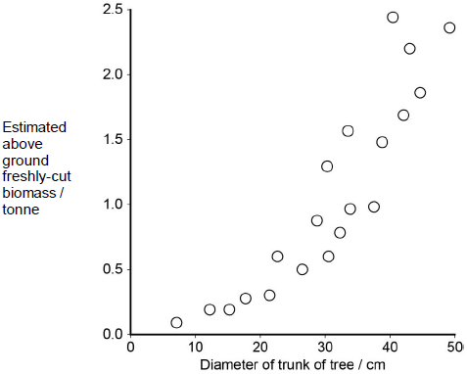
What does the graph show about the relationship between the diameter of the trunk of the trees and their biomass?
___________________________________________________________________
___________________________________________________________________
___________________________________________________________________
___________________________________________________________________
___________________________________________________________________
(2)
(d) Plantations of trees are often created to remove carbon dioxide from the atmosphere, to help to balance the carbon dioxide released by burning fossil fuels.
For different species of tree, information is available for:
• the relationship between diameter of trunk and freshly cut biomass
• the percentage of water in fresh-cut wood
• the mean dried density of wood.
Using only the information provided in part (c), suggest how the mass of carbon in the wood of a plantation of trees of a particular species could be estimated.
Start with measuring the diameter of a large number of trees.
Assume that the dry biomass of a tree consists of biological molecules that contain carbon.
___________________________________________________________________
___________________________________________________________________
___________________________________________________________________
___________________________________________________________________
___________________________________________________________________
___________________________________________________________________
___________________________________________________________________
___________________________________________________________________
___________________________________________________________________
___________________________________________________________________
(4)
(Total 10 marks)

