**3.5.4 Nutrient Cycles and Fertilisers - Answers**

**Answer the questions**

The graph below represents data from an investigation in which the same crop was grown on 6 identical plots of land, in the same area. The land was treated with 5 types of fertiliser at a controlled application rate of 140kg total nitrogen per hectare. 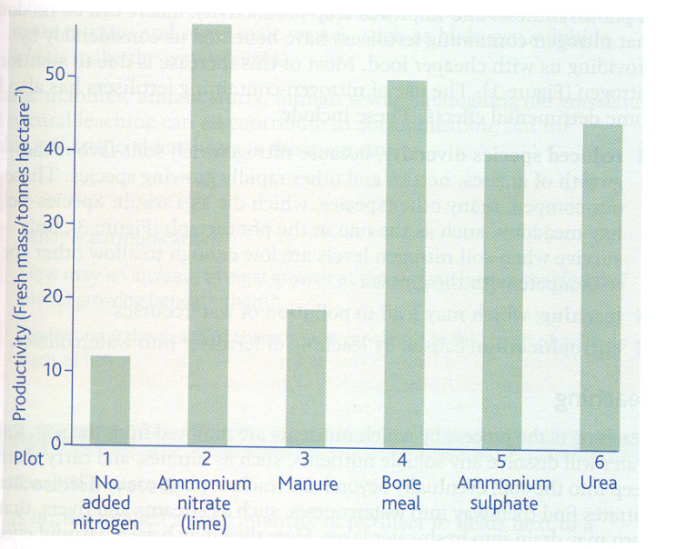

1. Manure, bone meal, urea
2. To act as a control to show that any changes in productivity were the result of the nitrogen-containing fertiliser being added.
3. Nitrogen is needed for proteins/amino acids/chlorophyll and DNA and therefore for plant growth. Nitrogen shortage may limit the production of proteins and DNA and hence growth. Its addition increases productivity.
4. Some forms of fertilisers contain more actual nitrogen than others and so different masses are added to ensure that the total nitrogen added was always the same (140 kg ha -1)
5. The data do not support the view. While ammonium nitrate brings about the greatest increase in productivity, ammonium sulphate produces a smaller increase than both urea and bone meal. Therefore the investigation suggests that only some ammonium salts are better.

**Complete the sentences using the words in bold**

Plants and animals need nitrogen to synthesise some essential **amino acids** (to make **proteins**) and **nucleic acids** (to make **DNA**, **RNA** and **ATP**). As with carbon, the ultimate source of nitrogen in the **food chain** is from the atmosphere via plants, however, although the atmosphere is 78% nitrogen (N2), plants can't use it in that form. Instead they need **bacteria** to convert it into usable nitrogen compounds first.

1. Nitrogen fixation

* **mutualistic** bacteria, found in root nodules of leguminous plants (peas, beans), can fix nitrogen into **ammonia** (NH3) which can then be converted into other nitrogenous compounds and used directly by the plant (in return the plants provides the bacteria with **carbohydrates**)
* Alternatively, free-living **nitrogen-fixing** bacteria can convert atmospheric gas into **ammonia** which then undergoes nitrification. This process normally happens under **aerobic** conditions
* Nitrogen fixation can also happen spontaneously when **lightning** passes through the atmosphere, again this will then undergo nitrification
* Nitrogen fixation can also be conducted artificially on an industrial scale. The **Haber** process produces ammonia from atmospheric nitrogen to make fertilisers

2. Ammonification

* Nitrogen compounds from dead organisms are turned into ammonia by **saprobiontic** bacteria
* Animal waste also contains compounds (such as **urea**) that are turned into ammonia

3. Nitrification

* This is the conversion of ammonia into **nitrate** ions by nitrifying bacteria, which can then be used by the plant - the ammonia comes either from nitrogen fixation by **free-living** nitrogen-fixing bacteria or **ammonification** by decomposing bacteria
* Firstly, certain species of nitrifying bacteria synthesise **nitrites** (NO2-) from ammonia
* Secondly, other species of nitrifying bacteria convert the nitrite into to **nitrates** (NO3-)
* This process requires oxygen so **aerobic** conditions are essential. Nitrification is therefore most efficient in soil with lots of air spaces by ploughing and good drainage

4. Denitrification

* Nitrates in the soil may be converted back into nitrogen gas by **denitrifying** bacteria before they are used by the plants
* These bacteria use the nitrates to carry out **respiration** and produce nitrogen gas. This happens under anaerobic conditions such as in **waterlogged** soil.

**Complete the diagram with the name and formula of the missing nitrogen compounds**

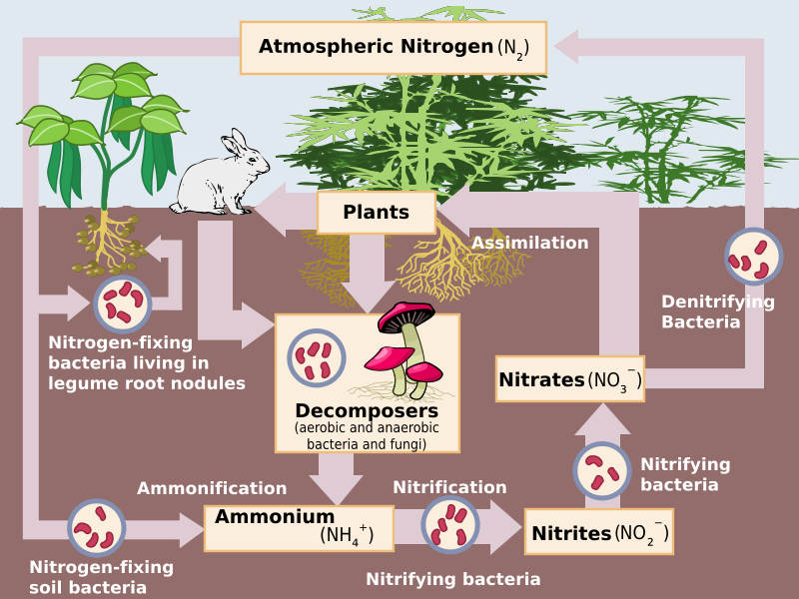

**farming** makes large demands on soil because mineral ions (such as nitrates) are continually being taken up by the crops. In natural ecosystems the minerals are returned when the plant **dies** and is decomposed but in agricultural ecosystems the plants are **harvested** and transported away for consumption (taking the mineral ions with them) and are rarely returned to the same area. This makes it necessary to **replenish** the minerals or plant growth will be affected.

As a result, farmers use **fertilisers** containing mostly nitrogen, phosphorus and potassium compounds. Organic (natural) fertilisers include animal **waste** (manure), composted plant matter and bone meal, while **inorganic** (artificial) fertilisers are mostly derived from the Haber process. Fertilising the land results in plants that develop earlier, grow taller and have a greater leaf area; collectively this increases the rate of photosynthesis and so increases **productivity**. Inorganic fertilisers have a number of benefits, such as having a known **composition**, being **cleaner** to apply, being more concentrated so they are easier to transport and more immediately releasing the nutrients, but they are also more expensive and are more likely to be leached out of soils (dissolved in water and washed away) and can cause **eutrophication**.

* Nitrates leached from fertilised fields stimulate growth of algae in **rivers** and **lakes**
* Large amounts of algae block **light** from reaching the plants below and plants die as they are unable to **photosynthesise**
* **bacteria** feed on the dead plant matter and an increased numbers of bacteria reduce the **oxygen** concentration in water by carrying out aerobic respiration
* **fish** and invertebrate organisms die as there isn't enough oxygen resulting in a significant reduction in species **diversity**

This occurs particularly with inorganic fertilisers because they are more **soluble** than organic fertilisers and they do not need to be **broken down** into more simple compounds.

Reduced species diversity can also occur on land since nitrogen-rich soils favour the growth of grasses, nettles and other rapidly growing species. This causes more **competition** against other species, which may then die out.